Cookbook:Your virtual Kitchen
Project Documentation
Project Title: Cookbook-Your virtual kitchen

Team ID
Team Leader: Tamilselvi K & tamilselvitnnsisters@gmail.com
Team Member: Subhiksha.N & subhiksha265@gmail.com
Team Member: Roshini P & roshiniparthiban2310@gmail.com
Team Member: Swathi D & swathiaarthi2006@gmail.com

Introduction – Your Virtual Kitchen
Welcome to Your Virtual Kitchen, a place where flavors meet creativity and everyday cooking becomes a joyful experience. In today’s fast-paced world, food is more than just fuel – it is comfort, culture, and connection. This cookbook is designed to be your trusted companion, guiding you through simple recipes, innovative twists, and timeless classics that you can prepare right in your own kitchen.
Cooking is often seen as a challenge, especially for beginners. With endless recipes online, it can feel overwhelming to decide what to make and how to get started. Your Virtual Kitchen bridges this gap by offering easy-to-follow instructions, clear ingredient lists, and helpful tips that bring confidence to every cook. Whether you are preparing your very first dish or experimenting with new flavors, this collection ensures that cooking remains enjoyable rather than stressful.
What makes this cookbook special is its focus on accessibility. Recipes are explained in straightforward steps, avoiding complicated jargon, so that anyone – from students learning to cook away from home to busy parents juggling work and family – can create wholesome meals. Alongside everyday favorites, you will also discover unique dishes inspired by different cuisines, encouraging you to explore global tastes without leaving your home.
Beyond just recipes, Your Virtual Kitchen inspires creativity. Each section encourages you to adjust flavors, substitute ingredients, and make the recipes truly your own. After all, cooking is not only about following instructions but also about expressing individuality, love, and care through food.
So, put on your apron, gather your ingredients, and step into Your Virtual Kitchen. Together, let’s turn ordinary meals into extraordinary memories.

Source code:

import React from 'react'
import '../styles/Footer.css'
import { useNavigate } from 'react-router-dom'

const Footer = () => {

const navigate = useNavigate()

return (
<div className='footer'>

<h3>Delish Diary!... </h3>

<div className="footer-options">
<ul>
<li onClick={()=>navigate(/)}>Home</li>
<li onClick={()=>navigate(/category/Chicken)}>Chicken</li>
<li onClick={()=>navigate(/category/Breakfast)}>Breakfast</li>
</ul>
<ul>
<li onClick={()=>navigate(/category/Dessert)}>Dessert</li>
<li onClick={()=>navigate(/category/Goat)}>Goat</li>
<li onClick={()=>navigate(/category/Lamb)}>Lamb</li>
</ul>
<ul>
<li onClick={()=>navigate(/category/Pasta)}>Pasta</li>
<li onClick={()=>navigate(/category/Seafood)}>Seafood</li>
<li onClick={()=>navigate(/category/Starter)}>Starter</li>
</ul>
<ul>
<li onClick={()=>navigate(/category/Vegan)}>Vegan</li>
<li onClick={()=>navigate(/category/Side)}>Side</li>
<li onClick={()=>navigate(/category/Miscellaneous)}>Miscellaneous</li>
</ul>
</div>

<hr />
<p>Delish Diary!... - &copy; 2023 - All Rights Reserved</p>
</div>
)
}

export default Foot

Output Screenshot :
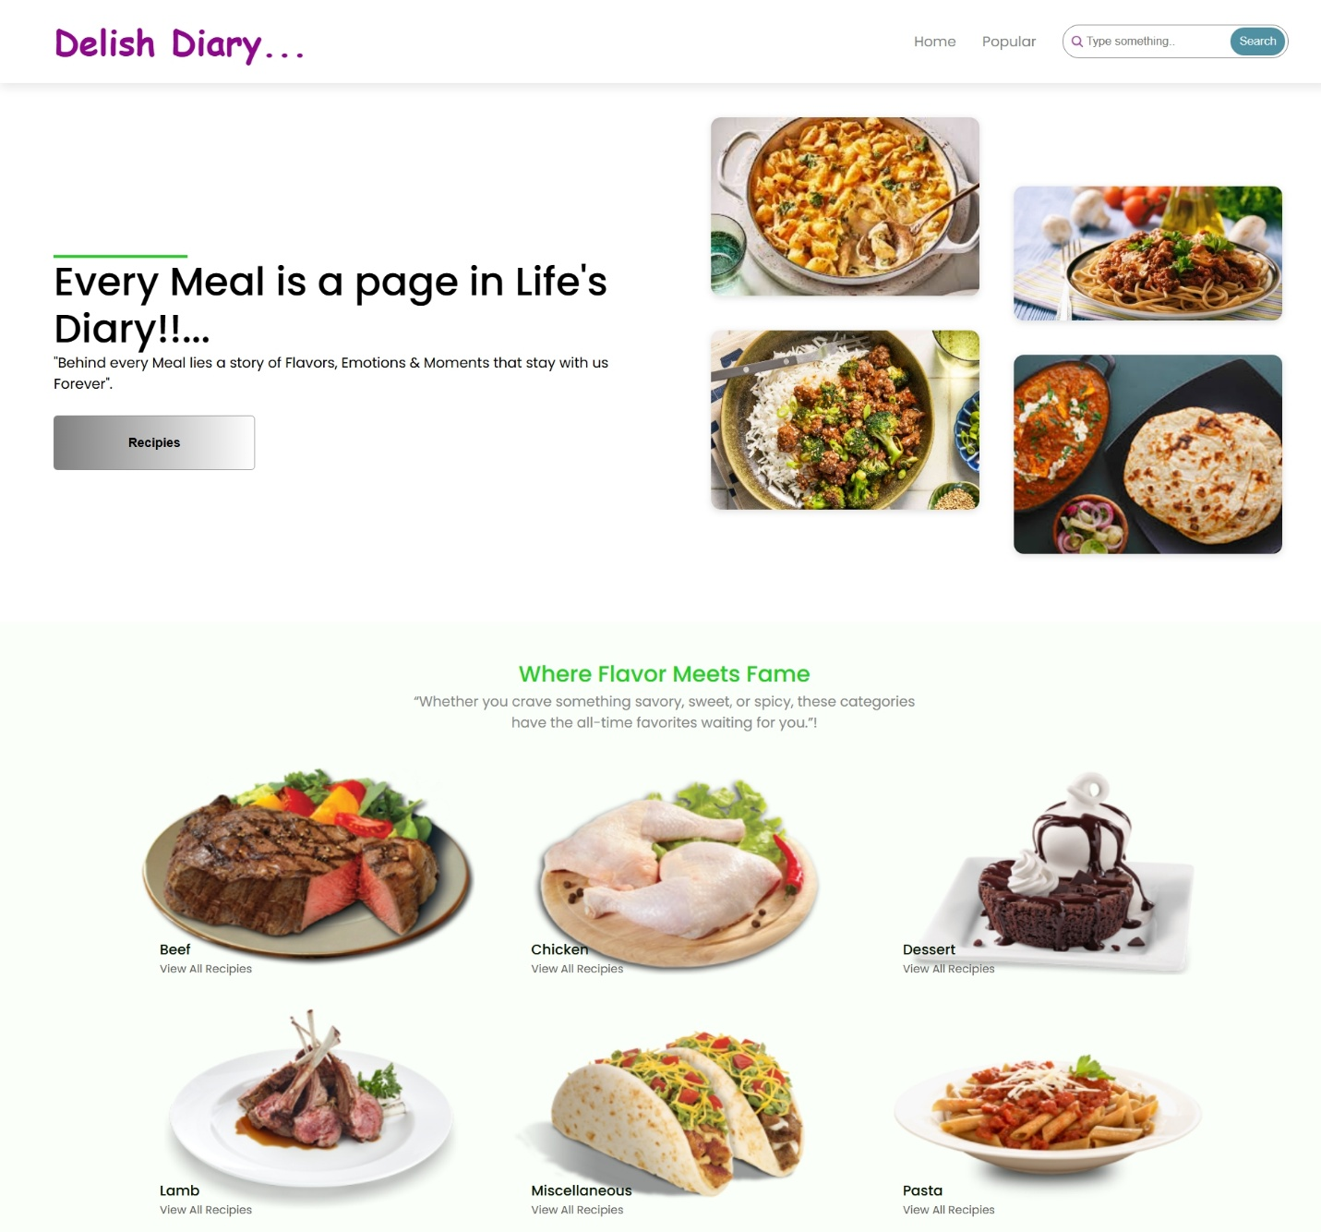

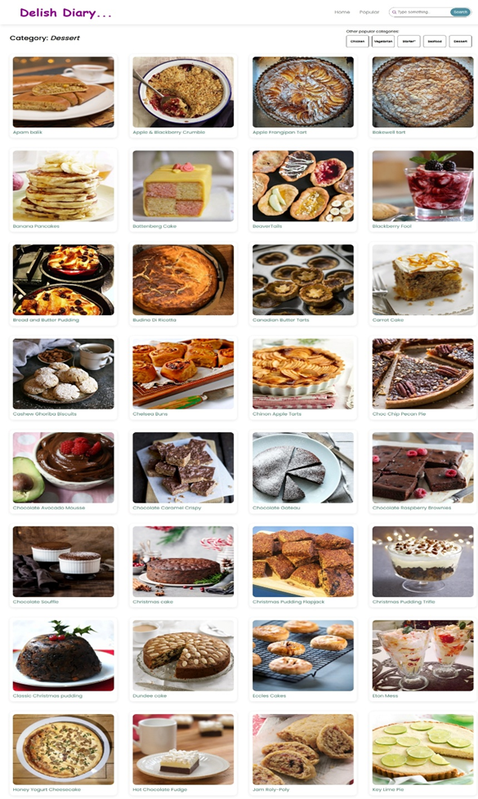

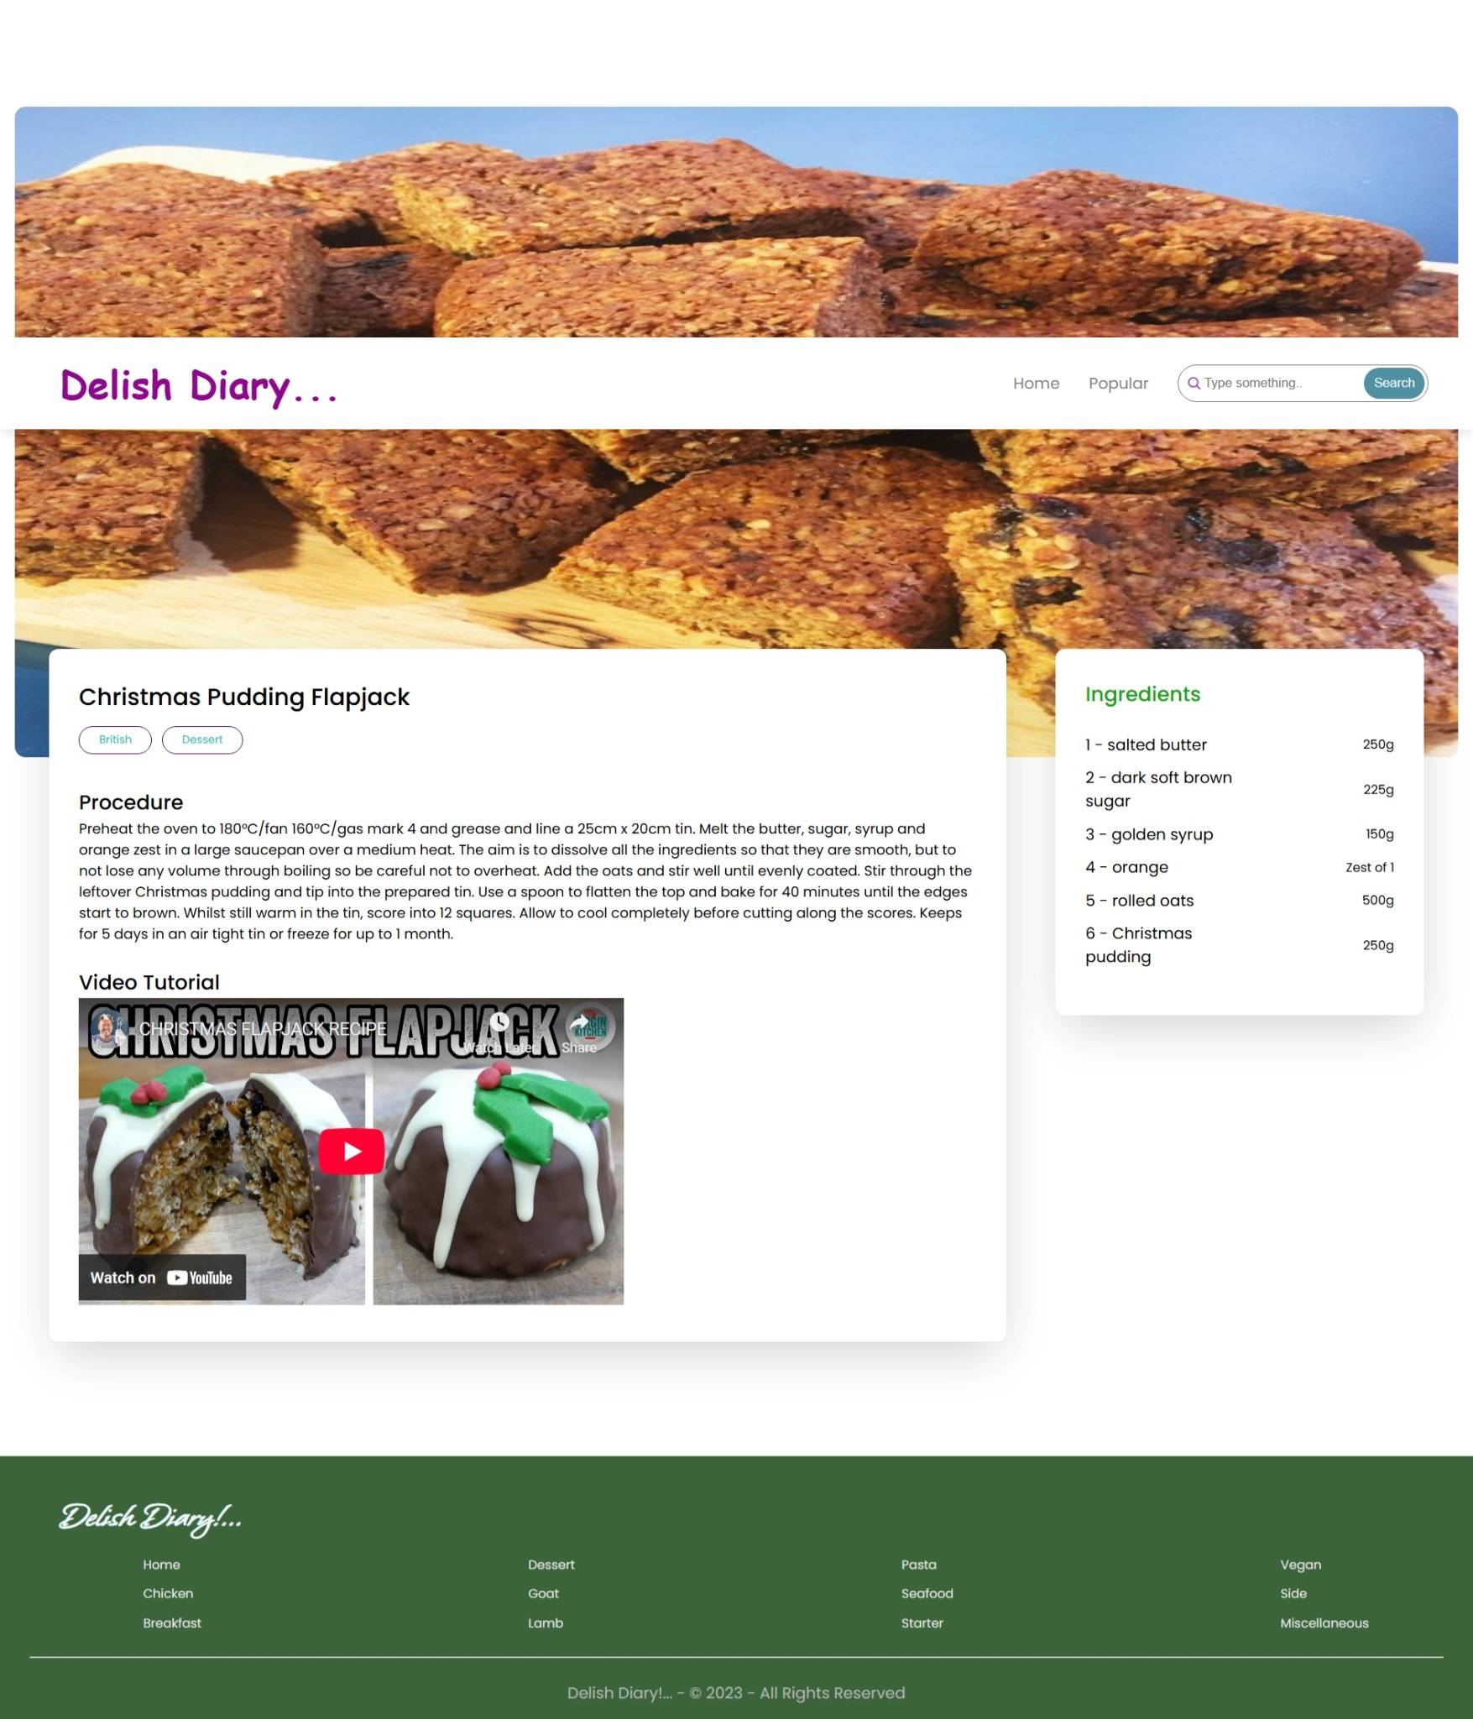

Code website demo link:

https://drive.google.com/file/d/1tqeVbLtPJDpcxQvJmWfJ7IVugNwRNSXC/view?usp=drivesdk

