Cloudflare Turnstile CAPTCHA
Integration Guide
Step-by-step setup for Next.js with Cloudflare Workers

Step 1: Create a Turnstile Widget
Open the following URL in your browser to access the Cloudflare Turnstile Dashboard:

https://dash.cloudflare.com/?to=%2F%3Aaccount%2Fturnstile

Follow these steps in order:
- Select your account from the account selector at the top of the dashboard. 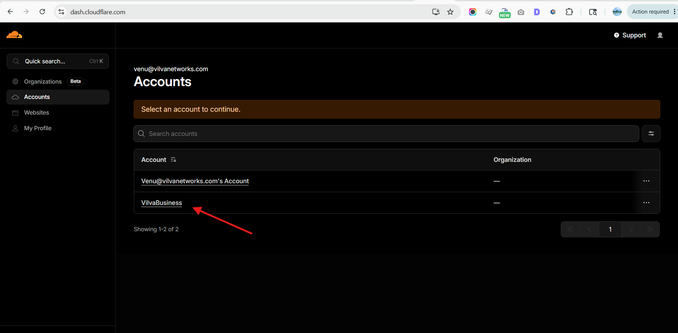
- Click the Add Widget button. 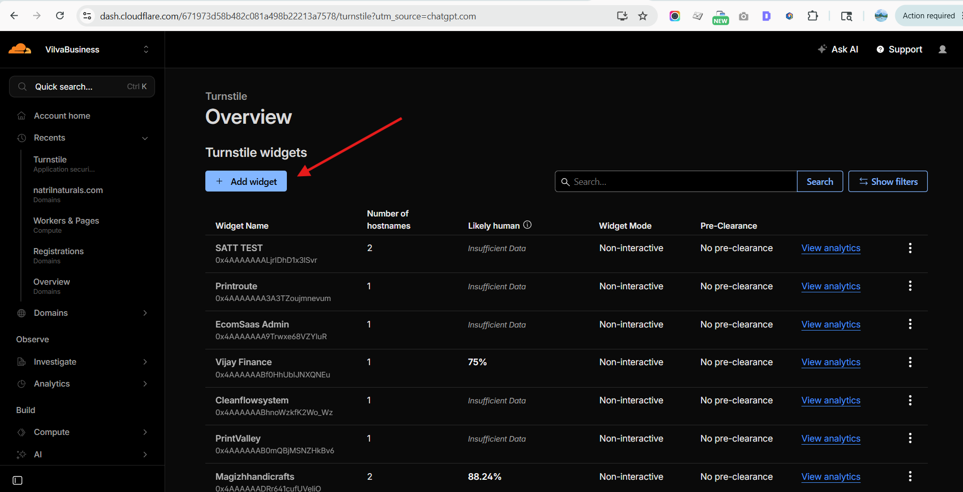
- A new screen will open. Enter a Widget Name in the provided field. 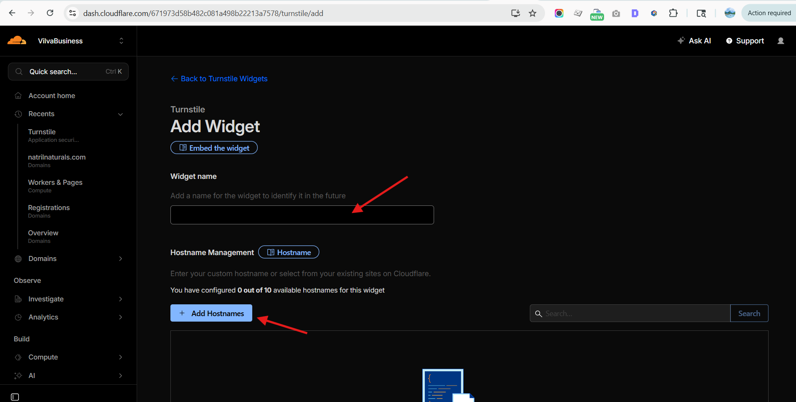

- Click the Add Hostname button. A search screen will appear — search for your project hostname and click Add to confirm. 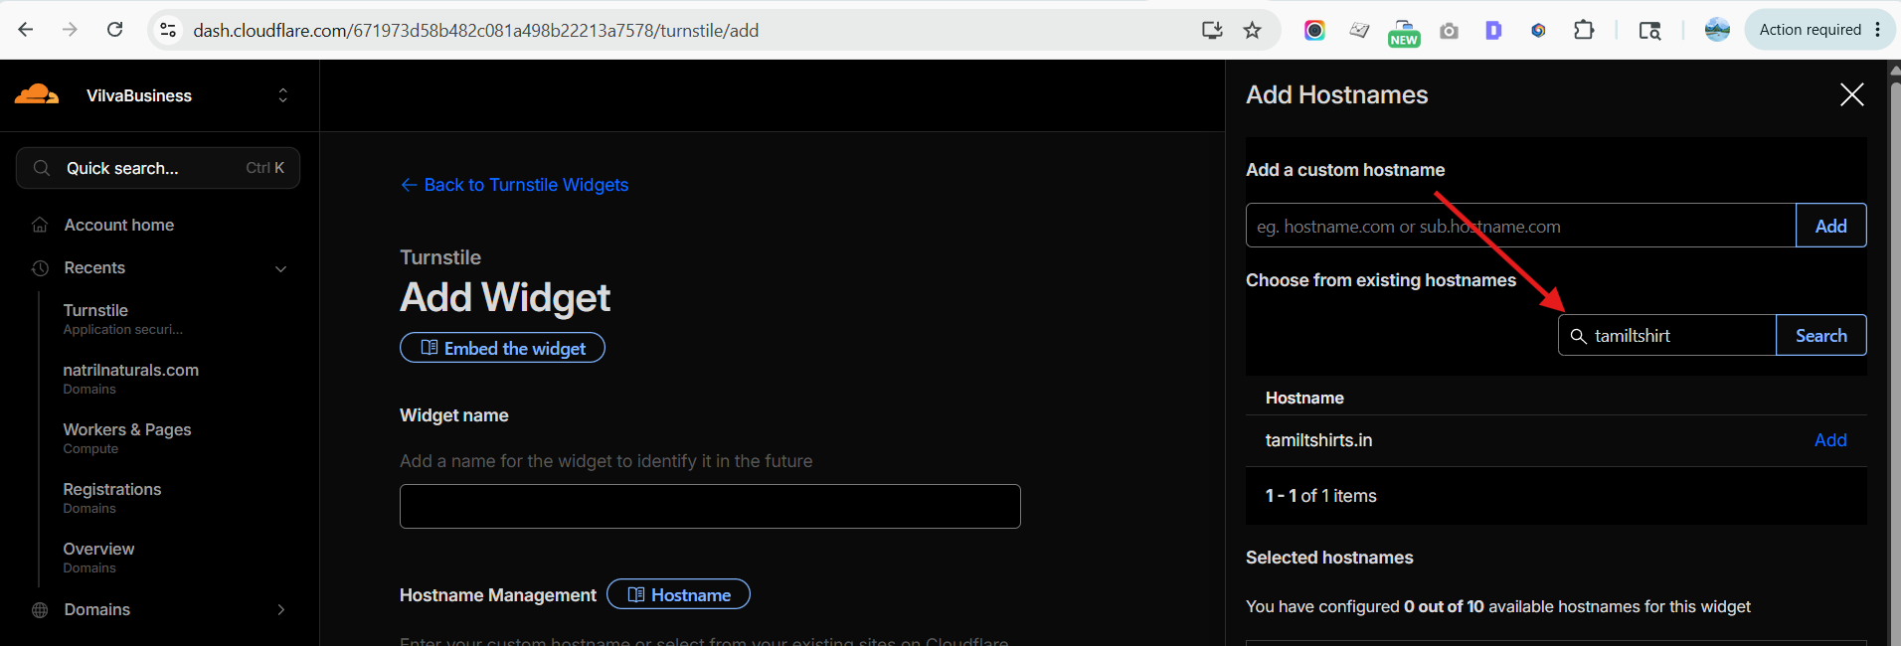

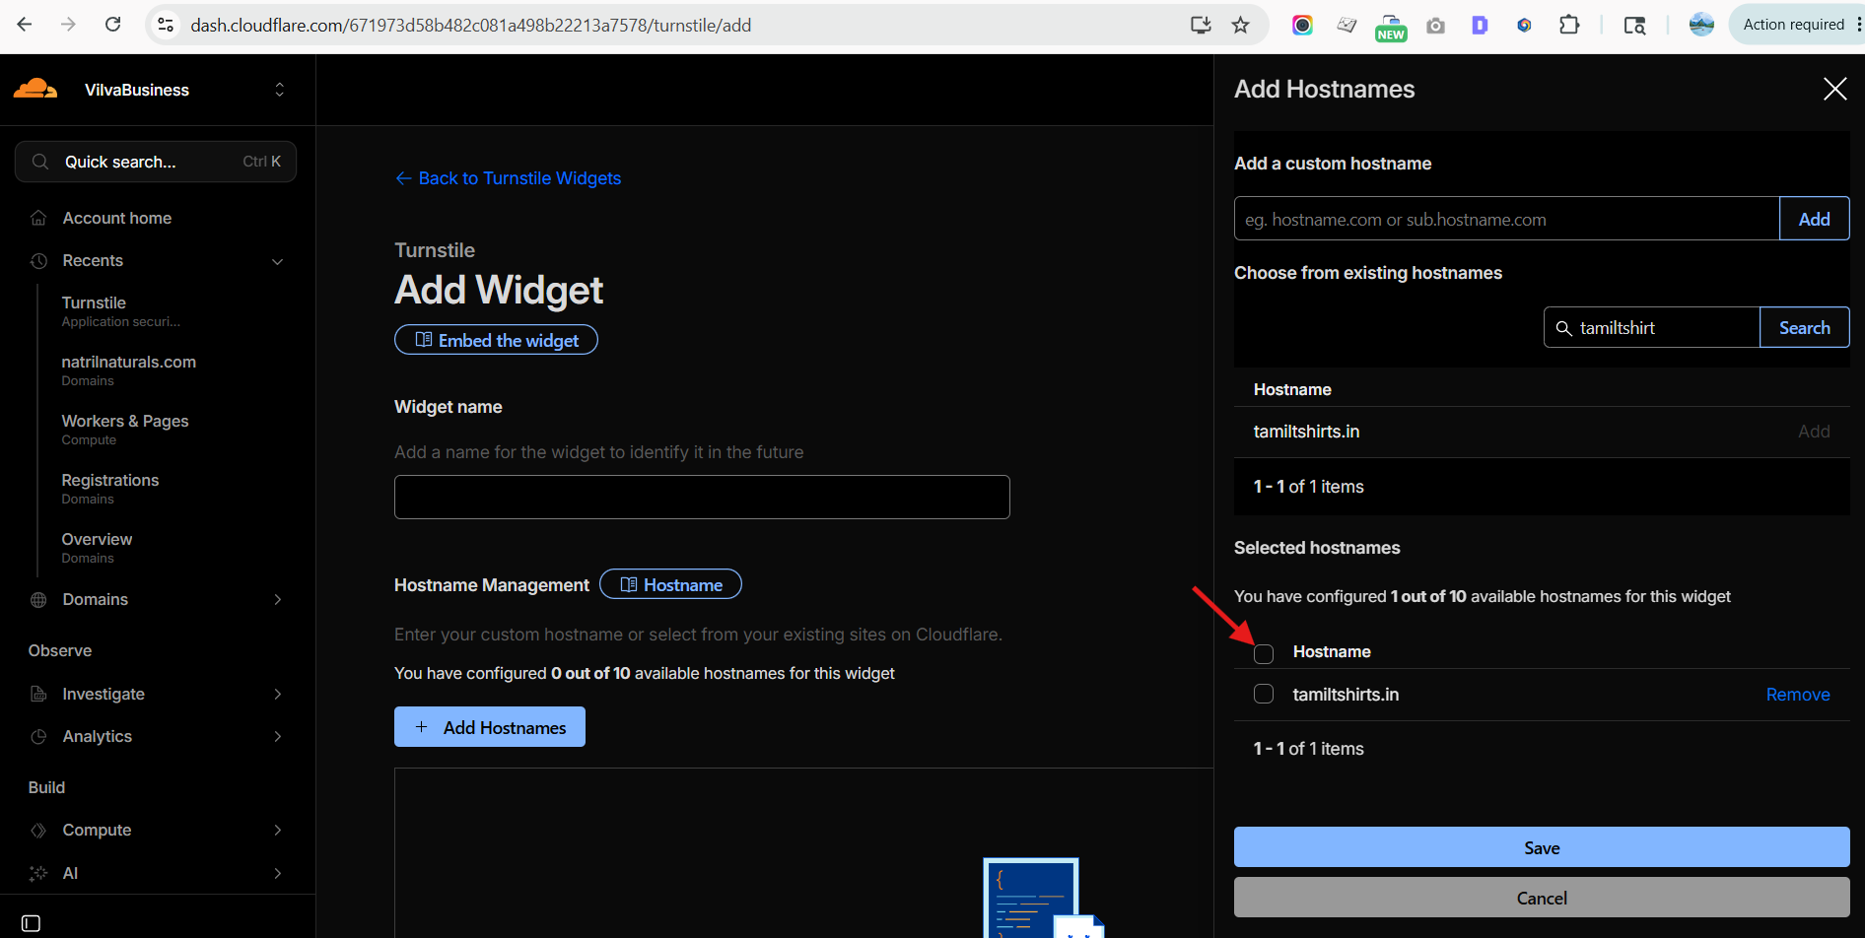

- Verify the hostname is correct, then on the next screen configure the following settings:

a | Hostname — confirm it is correctly listed.
b | Widget Mode — select the appropriate mode for your use case.
c | Non-Interactive — check this option to enable invisible challenge mode.
d | Skip future security rule challenges for verified visitors — set this to No.
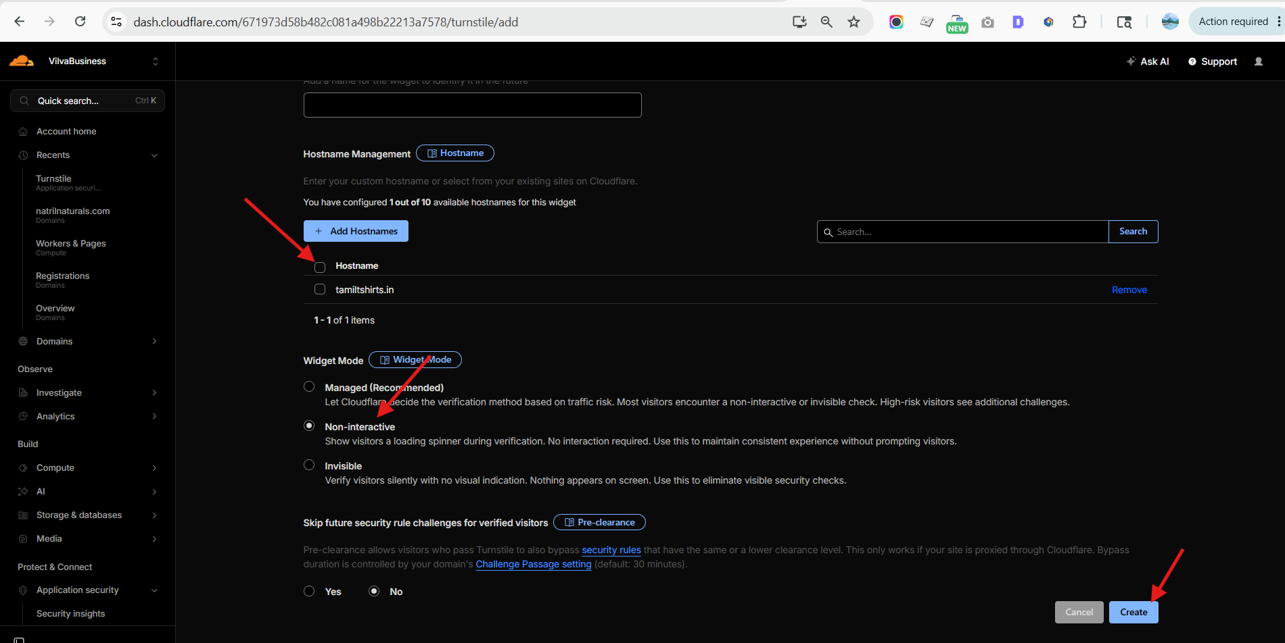
- Click the Create button to generate your widget credentials.

After creation, Cloudflare will provide two keys:

1 | Site Key — used in your frontend code (publicly visible).
2 | Secret Key — used in your backend/server-side validation (keep this private).

Copy and save both keys — you will need them in the next step.

Step 2: Configure Environment Variables in Cloudflare
Navigate to your Cloudflare Dashboard and follow this path:

Compute » Workers & Pages » [Your Project] » Settings » Variables and Secrets

Add the following two environment variables:

1 | Create a variable named NEXT_PUBLIC_TURNSTILE_SITE_KEY — paste the Site Key from Step 1, then click Save.
2 | Create a variable named TURNSTILE_SECRET_KEY — paste the Secret Key from Step 1, then click Save.

Step 3: Install the Turnstile Package
Open your project in VS Code. In the terminal, run the following command to install the Cloudflare Turnstile package:

npm install @marsidev/react-turnstile

Step 4: Integrate Turnstile in Your Component
After the package is installed, open the form component or page where you want to add the CAPTCHA widget.

4.1 Import the Component
Add the following import statement at the top of your file:

import { Turnstile, type TurnstileInstance } from "@marsidev/react-turnstile";

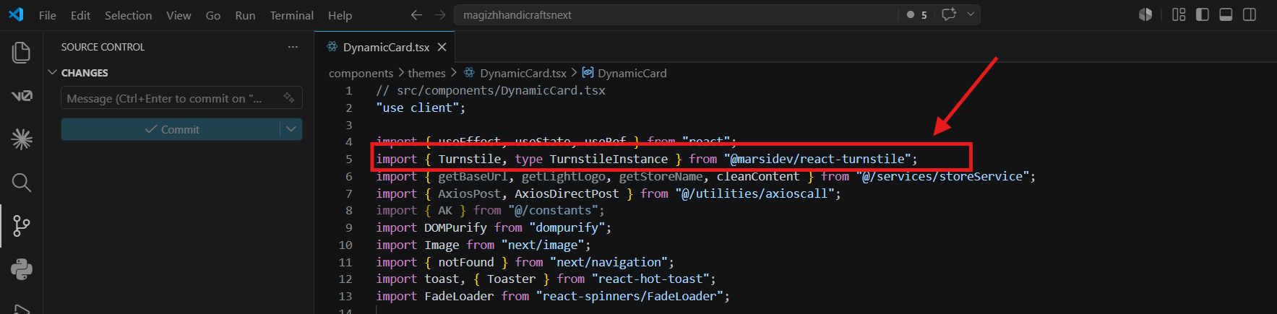

4.2 Add the Turnstile Widget
Place the following JSX code inside your component where the CAPTCHA should appear:

<Turnstile ref={turnstileRef} siteKey={process.env.NEXT_PUBLIC_TURNSTILE_SITE_KEY!} onSuccess={(token: string) => setCaptchaToken(token)} onExpire={() => setCaptchaToken(null)} onError={() => setCaptchaToken(null)} />

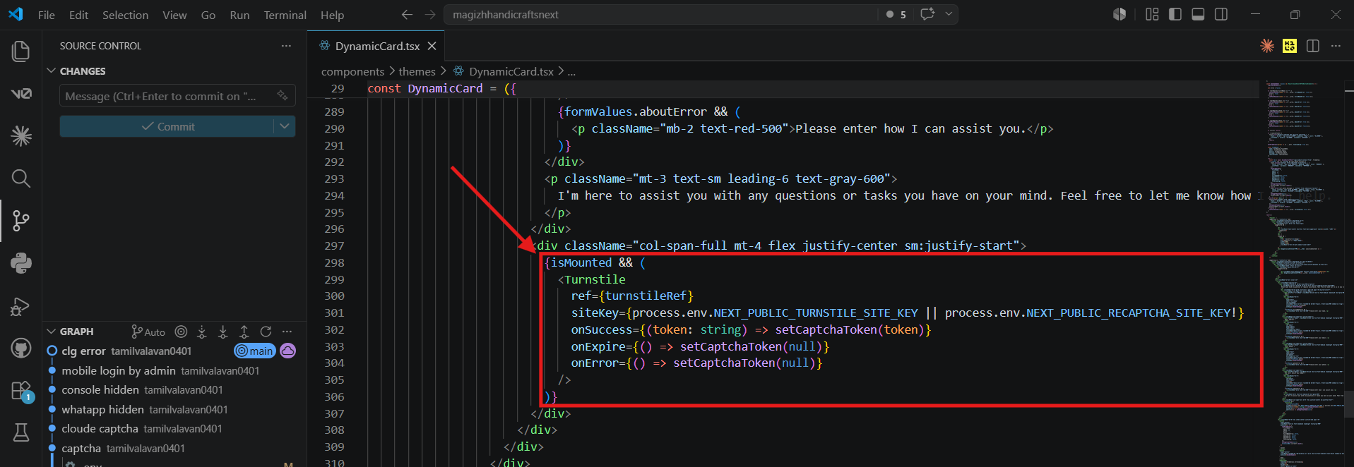

Step 5: Build and Deploy
Once all setup steps are complete, run the following command in your terminal to build the project:
npm run build

After a successful build, push your changes to Git. Your Cloudflare Turnstile CAPTCHA integration will be live on your deployed site.

⚠ Important Note: Cloudflare Turnstile only works on a live (deployed) website. It will NOT function correctly on localhost during local development.
