R.SIDDHARTH

2018503556

MO-BATCH

JAVA PROGRAMS

LAB - 3

1.To Write a java program that generates a unique-id for the students enrolled in a quiz competition. The program should generate the unique id with a combination of the student’s name, roll number and the order of their arrival. The program should then display the details of students in last- in-first out order.

CODE:

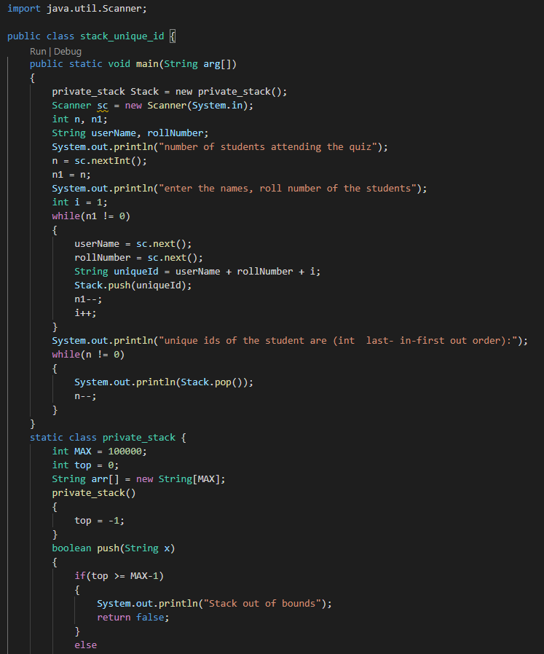

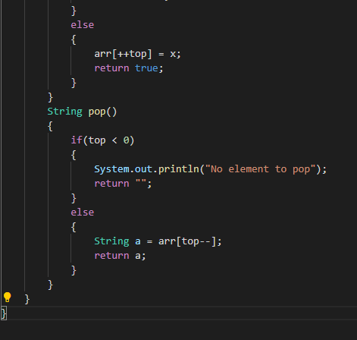

OUTPUT:

