* 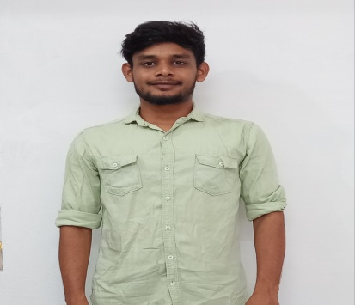
* **CONTACT ME**
* 93608 10502
* ta[milvendhan.anna178@gmail.com](mailto:milvendhan.anna178@gmail.com)
* Linked.com/in/tamil-vendhan-0761772a1/
* 4/141,Sathy road, PT.palayam, Gobi, Erode, Tamil Nadu, PIN-638506.
* **EDUCATION**
* **Master of science :** **Microbiology** | 2020-2022 | Palanisamy college of Arts – Perundurai.
* **Bachelor of science : Microbiology** | 2017-2020 | Palanisamy college of Arts – Perundurai.
* **Higher Secondary Certificate :** 2016-2017 | Sri Ragavendra hr.sec.school – Sathyamangalam.
* **Secondary School Leaving Certificate :** 2014-2015 | Amala hr.sec.school **--** Gobichettipalayam.
* **LANGUAGES**
* Tamil – native.
* English – Professional.
* Telugu – Basic.
* **WORK EXPERIENCE**
* **Front-end developer:** Segolsys tech | 2022-2023

Erode, Tamil Nadu, India - 638011.

* **PROJECTS**

1. ***Portfolio Website:***

* **Description:** Responsive personal portfolio website showcasing skills and projects**.**
* **Technologies Used:** HTML, CSS, Bootstrap.
* **Achievements:** Clean UI design, proficiency in HTML/CSS/Bootstrap.

1. ***Kooblu Website:***

* **Description:** Official website for Kooblu, highlighting professional services.
* **Technologies Used:** HTML, CSS, JS, React, Bootstrap.
* **Achievements:** Successful launch, proficiency in web technologies.

1. ***Customer Service Chatbot:***

* **Description:** Implemented a React-based chatbot for customer support.
* **Technologies Used:** HTML, CSS, JS, React, Bootstrap, NLP.
* **Achievements:** Improved response times, enhanced user satisfaction..
* **SKILLS**

|  |  |  |
| --- | --- | --- |
| * HTML (Hyper Text Markup Lang) | * Bootstrap | * Git,GitHub |
| * CSS (Cascading Style sheet) | * JavaScript | * Frameworks-React |

**TAMILVENDHAN**

*Front-end developer*

* **PROFILE**

Qualified and highly motivated professional web developer with one year experience. You’ll discover a reliable, Detail-oriented, and extremely hard working quality in me; who will serve as a model to encourage other staff members to demonstrate the same high standard of professionalism.