CSE 4128: Image Processing and Computer Vision Laboratory
Assignment No:02
Assignment Name: Segmentation

By

Md Rauful Islam Tamim
Roll: 2007009



Department of Computer Science and Engineering
Khulna University of Engineering & Technology
Khulna 9203, Bangladesh
August, 2025
- Histogram Equalization
Lab3 Tasks

1.Take an input gray scale image and apply histogram equalization to enhance contrast:
1.1 Apply Histogram Equalization
a) HE1 = Manual_equalizeHist(input_image)
b) HE2 = cv2.equalizeHist(input_img)

1.2 Show the following outputs:
Input Image Output Images (HE1 and HE2)
Input Histogram Histogram of HE1
Input CDF CDF of HE1

Lab Tasks Output:

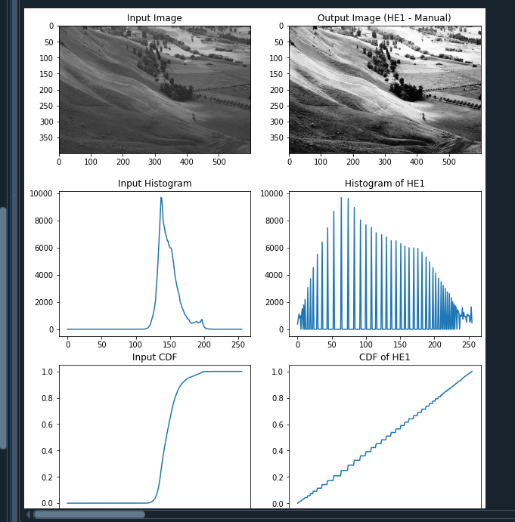

Figure 1: Histogram Equalization

- Assignment 1

1. Take an input color image and apply histogram equalization to enhance c contrast.
1.1 For the RGB image, apply histogram equalization to each of the 3 channels separately. Merge the 3 channels to view the enhanced image.
1.2 Convert the RGB image to the HSV image and apply histogram equalization only in the Value channel. Merge the new equalized value channel with the other two to generate the final output equalized image.
2. Show the histogram of input and the equalized image
3. Show the histogram of CDF and PDF calculated from the input and output images.

Solutions

1. Take an input color image and apply histogram equalization to enhance c contrast.

1.1 For the RGB image, apply histogram equalization to each of the 3 channels separately. Merge the 3 channels to view the enhanced image.

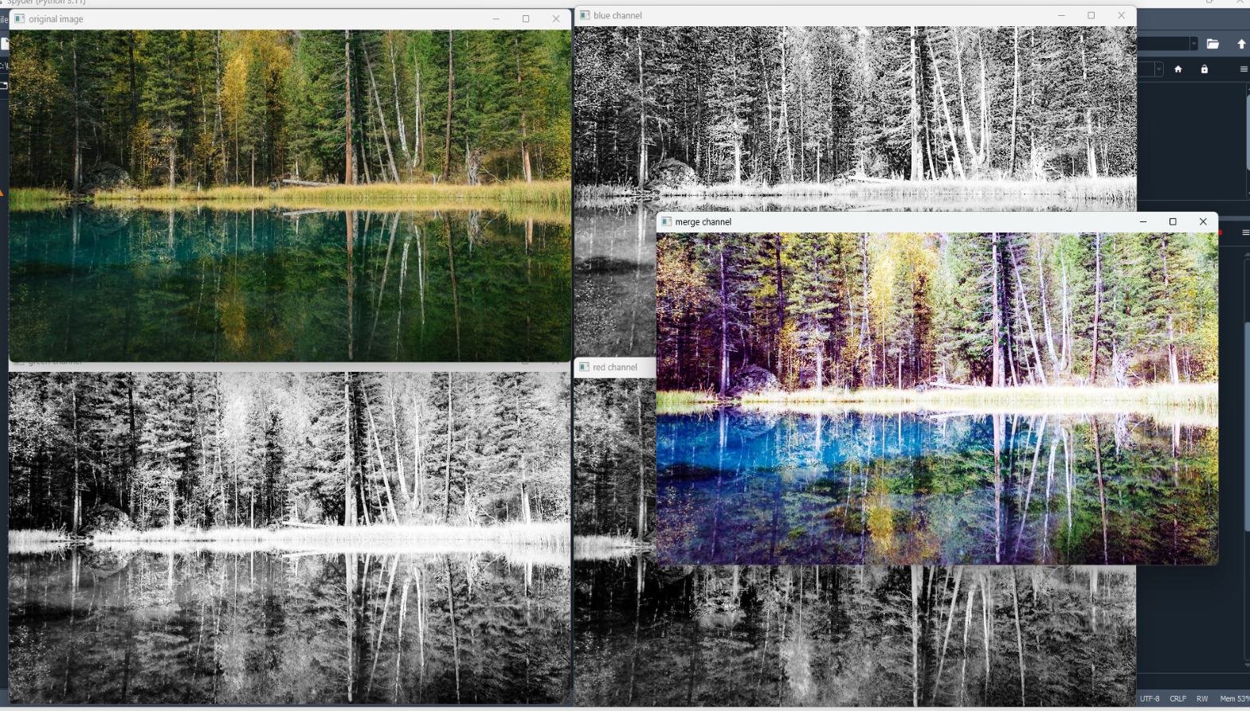
Figure 1.1: Original Image , Equalize 3 channel Images and Merged Image

1.2 Convert the RGB image to the HSV image and apply histogram equalization only in the Value channel. Merge the new equalized value channel with the other two to generate the final output equalized image.

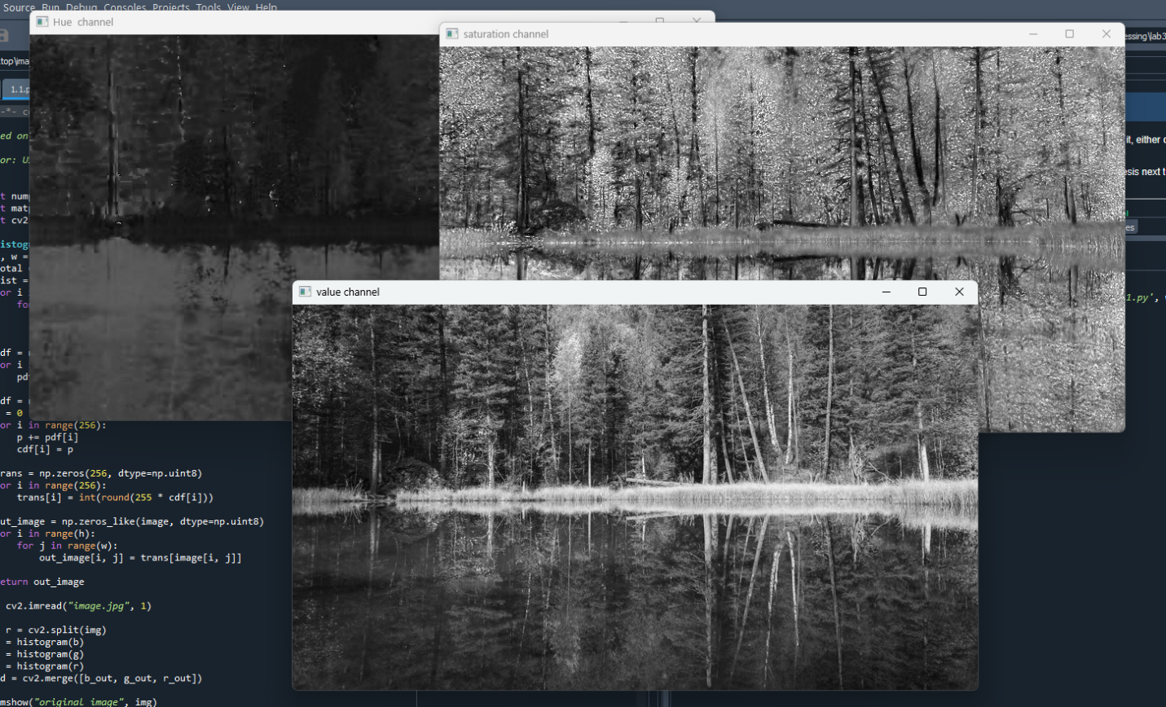
Figure 1.2.1: HSV channel output images

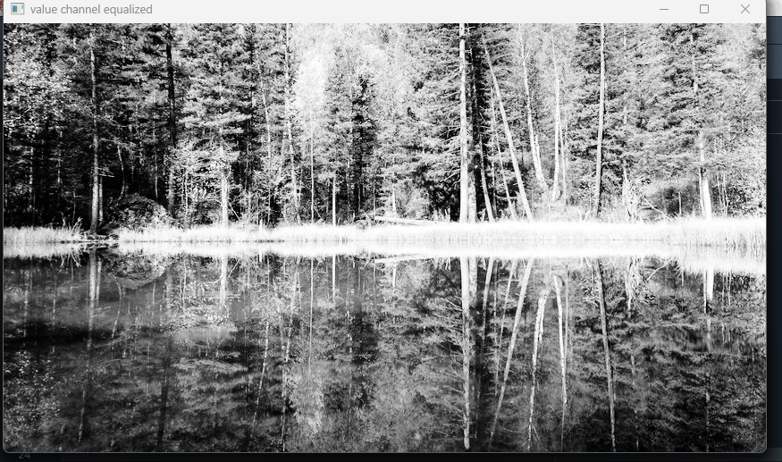
Figure 1.2.2: Value Channel Equalized Image

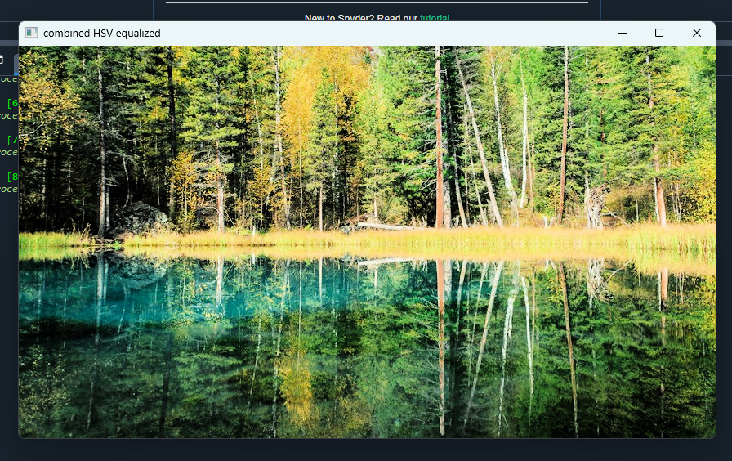
Figure1.2.3: Combined HSV Equalized Images
2. Show the histogram of input and the equalized image
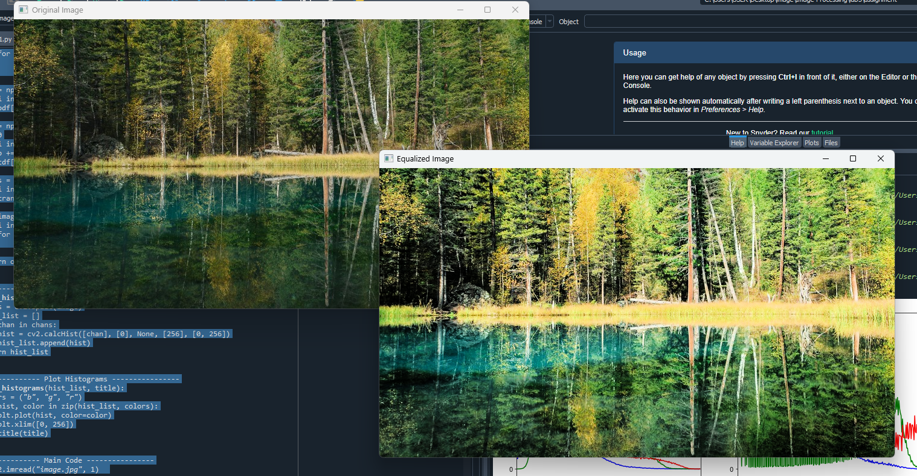
Figure 2.1: Original and Equalized Images

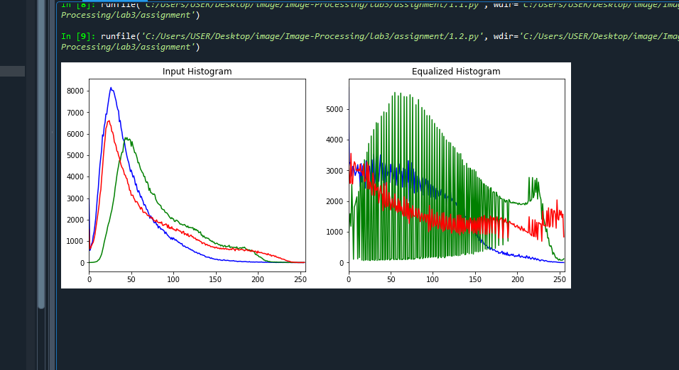
Figure 2.2: Input Histogram and Equalized Histogram

3. Show the histogram of CDF and PDF calculated from the input and output images.

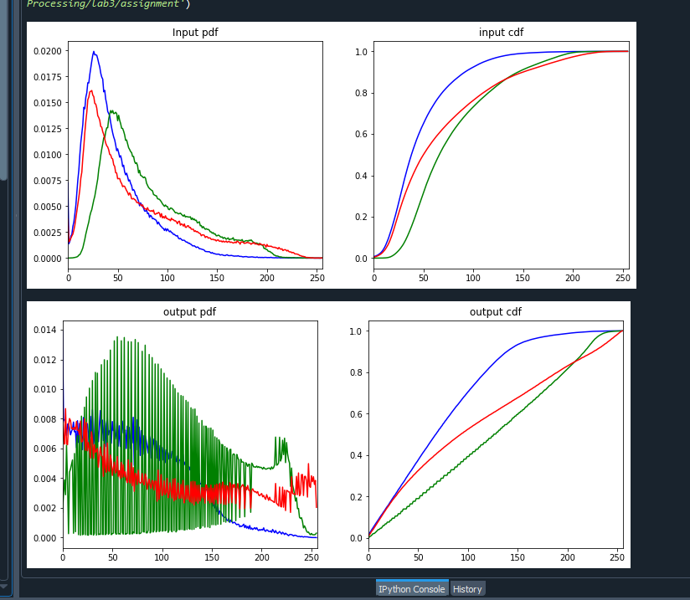

Figure 3.1: PDF and CDF of input and output images

- Assignment 2

- Histogram Matching (Specification)-- where the target histogram follows an Erlang distribution.
- Instructions:
- Generate the target histogram using Erlang distribution and plot it for visualization. Take shape parameter (k) and scale parameter (µ) as user input.

- Apply histogram matching to update the histogram of an input grayscale image to the target one.
- Show the input and output image.
- Plot the Histogram, PDF, and CDF of both input and output images.

Solutions

- Generate the target histogram using Erlang distribution and plot it for visualization. Take shape parameter (k) and scale parameter (µ) as user input.
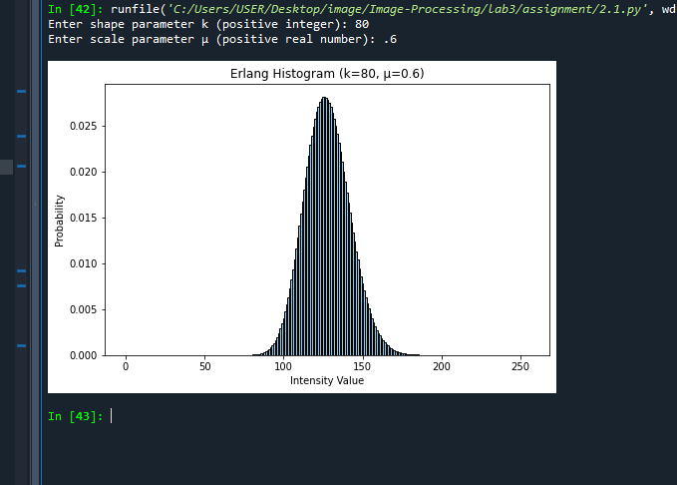

Figure 2.1.1: Histogram using Erlang distribution

- Apply histogram matching to update the histogram of an input grayscale image to the target one.
3. Show the input and output image.

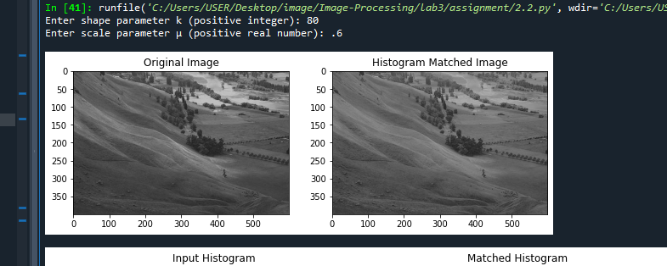

Figure 2.1: Input histogram and specified histogram

4.Plot the Histogram, PDF, and CDF of both input and output images.

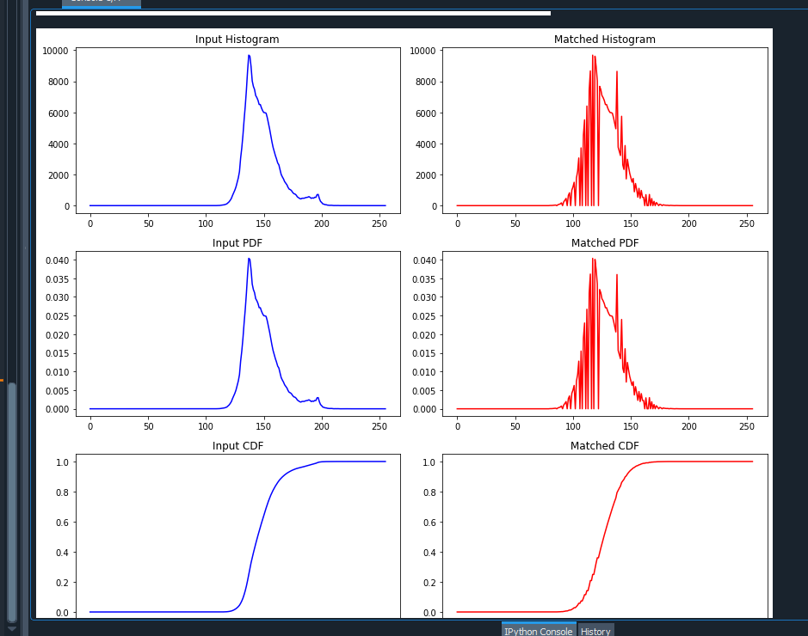

Figure 4.1: histogram , pdf, cdf of input and output images

