United International University
School of Business and Economics
Real-Life Project: NLP & Sentiment Analysis
Online Review Sentiment Analysis: Flipkart and Twitter
Deliverable 4: Result Interpretation and Report
Name | Tamim Ahmed
Student ID | 905253015
Group | Individual submission
Date | 3 October 2026
GitHub repository | https://github.com/tamim271/review-sentiment-analysis_repo-tamim_ahmed

1. OBJECTIVE AND DATA
The aim of this project is to build a pipeline that can take a raw product review or tweet, classify it as positive, neutral, or negative, and then use those classifications to understand how customers feel about an online store’s products and services.
Instead of using the sample file provided with the class, I created my own synthetic dataset using src/generate_dataset.py. Although the sample file is useful for demonstration, it is relatively easy for a model to learn from. Its 1,000 rows contain only 497 distinct sentences, and the star ratings are spread across 1 to 5 for both positive and negative labels. My generator creates more varied examples by combining product features, service-related aspects such as delivery, packaging, price, customer care, and returns, as well as different openers, closers, and platform styles. It also deliberately includes more challenging cases, such as negation (“not worth the money”), mixed opinions, sarcasm, and posts where customers are still waiting to form an opinion. Around 2% of the labels are also intentionally flipped to simulate the type of disagreement that can occur between human annotators.
To see whether the trend analysis could pick up meaningful events, I also built three specific events into the dataset: a delivery crunch during the festive sales period in October and November 2025; the launch of a smartwatch in February 2026 that initially had battery and app-sync problems, which were resolved through a firmware update in May; and delivery delays during the monsoon period in July and August 2026.
The final dataset contains 2,000 unique texts covering 12 products, with dates ranging from October 2025 to September 2026. Of these, 1,207 are Flipkart reviews, and 793 are tweets. Overall, 46% of the texts are positive, 30% are negative, and 24% are neutral. The star ratings broadly match the sentiment labels, with average ratings of 4.32 for positive reviews, 2.88 for neutral reviews, and 1.68 for negative reviews. However, ratings are not used as an input to the model, since doing so would effectively give the model the answer in advance.

2. THE PIPELINE IN BRIEF
Preprocessing. I first converted all text to lowercase, removed URLs and @mentions, and kept the words from hashtags, so #fail became “fail”. Instead of removing emojis, I converted them into simple sentiment tokens such as emo_pos, emo_neg, and emo_neu. I also expanded contractions, so “doesn’t” became “does not”, shortened elongated words such as “sooo”, and then tokenised the text using NLTK before removing stopwords.
One important decision was to keep negation and contrast words. NLTK’s English stopword list includes words such as “not”, “no”, “never” and “but”. As a result, the standard class-demo cleaning process would turn “not good at all” into simply “good”, which changes the meaning of the original sentence. I therefore kept these words in the text. In five-fold cross-validation on the training data, this preprocessing approach improved the macro-F1 score from 0.933 to 0.947.
Features and split. I split the dataset into 80% training and 20% test data using stratification, giving 1,600 training reviews and 400 test reviews. This ensures that the proportion of each sentiment class remains similar in both sets. I selected the TF-IDF settings using cross-validation on the training data only.
Using unigrams alone produced a score of 0.946 regardless of the number of features, mainly because the dataset contains only 431 distinct words. Adding bigrams slightly improved the score to 0.947 once at least 2,000 features were allowed. This makes sense because phrases such as “not worth”, “very disappointed” and “three stars” can carry meaning that individual words cannot capture on their own. Adding trigrams reduced the score to between 0.904 and 0.932, largely because they introduced around 2,000 phrases that appeared only once or very rarely. The final bigram vocabulary contains 2,075 terms, so setting max_features = 2,000 retains almost the entire vocabulary while also preventing the feature space from growing unnecessarily if more data are added.
Models. I trained four different classifiers, with each model placed inside its own scikit-learn Pipeline and paired with its own vectoriser. This prevents information from the test set, including its vocabulary, from leaking into the training process during cross-validation. Logistic Regression was included as a fast linear model that provides interpretable feature weights and probability estimates. Multinomial Naive Bayes provides a standard baseline for text classification. Linear SVM is a max-margin linear classifier and is particularly well suited to sparse, high-dimensional TF-IDF features. Random Forest was included as a non-linear alternative to assess whether word interactions could improve classification. Finally, VADER, a sentiment lexicon that does not require model training, was used as an additional baseline.

3. MODEL COMPARISON
Table 1. Results on the same held-out test set (n = 400). Precision, recall, and F1 are weighted averages; macro-F1 weights the three classes equally. The last column is five-fold cross-validation on the training set.
Model | Accuracy | Precision | Recall | F1 (w) | F1 (macro) | CV macro-F1
Linear SVM | 0.960 | 0.960 | 0.960 | 0.960 | 0.954 | 0.961 ± 0.019
Random Forest | 0.945 | 0.945 | 0.945 | 0.945 | 0.939 | 0.933 ± 0.020
Logistic Regression | 0.935 | 0.935 | 0.935 | 0.934 | 0.928 | 0.947 ± 0.019
Multinomial NB | 0.903 | 0.902 | 0.903 | 0.902 | 0.890 | 0.899 ± 0.026
VADER lexicon (no training) | 0.658 | 0.649 | 0.658 | 0.644 | 0.610 | n/a
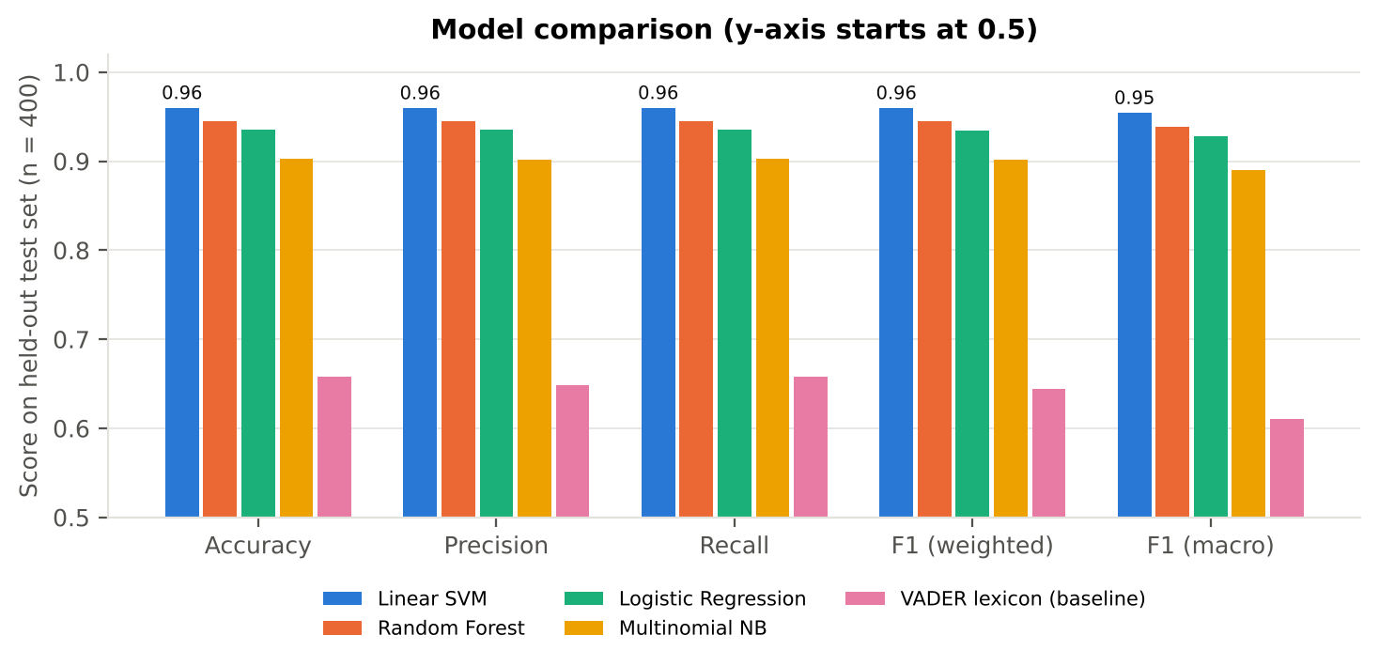
Figure 1. All five approaches on five metrics (y-axis starts at 0.5).
All four trained models perform substantially better than VADER, which achieves an accuracy of 0.658. This suggests that training on the dataset helps the models pick up domain-specific language, including expressions such as “returning”, “three stars,” and “#refundplease”, that a general sentiment lexicon may not capture well.
Linear SVM performs best across all the main metrics, with an accuracy of 0.960, a macro-F1 of 0.954, and the highest cross-validation score at 0.961 ± 0.019. The cross-validation result also suggests that its performance is not simply the result of getting a particularly favourable train-test split.
The differences between SVM, Random Forest and Logistic Regression are relatively small, at around 1.5–2.5 percentage points, or roughly 6–10 reviews in the test set. Logistic Regression also performs slightly better than Random Forest in cross-validation, so the difference between those two models should not be treated as particularly meaningful. Naive Bayes performs less well, which is likely related to its assumption that words are independent of one another. That assumption is less suitable when positive and negative terms can appear together in the same review.
Based on these results, I would use Linear SVM as the main model. It achieves the highest macro-F1, which is particularly relevant because the neutral class is the smallest and also the most difficult to classify. It also has the strongest cross-validation performance and trains in less than a second. If the application needs a confidence or probability score for each review, such as when uncertain cases need to be referred to a human reviewer, Logistic Regression would be a useful alternative because it provides probability estimates directly.

4. WHAT THE CONFUSION MATRIX SHOWS
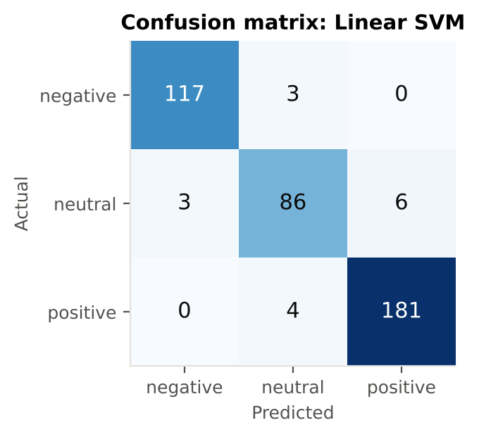  Figure 2. Confusion matrix, Linear SVM (test set, n = 400). | Table 2. Test-set accuracy by type of text: Linear SVM vs. VADER.
  Type of review | n | SVM | VADER
  Plain opinion | 243 | 98% | 75%
  Mixed (pros and cons) | 79 | 100% | 53%
  Negation | 27 | 96% | 89%
  Wait-and-see (neutral) | 28 | 100% | 46%
  Sarcasm | 12 | 100% | 0%
  Flipped label (noise) | 11 | 0% | 27%
The model almost never confuses positive and negative reviews. No positive review was classified as negative, and no negative review was classified as positive. Most of the errors instead involve deciding whether a review expresses a clear opinion at all.
Neutral is the most difficult class to identify, with a recall of 0.905 and an F1 score of 0.915, compared with around 0.97 for the positive and negative classes. The most common individual error is a neutral review being classified as positive, which happens in 6 out of 95 cases. There are several possible explanations for this. First, neutral reviews do not have a distinct vocabulary of their own. They are often defined by the absence of a strong opinion or by a balance between positive and negative points, such as “Pros: … Cons: …”. As a result, they can contain words associated with either sentiment. Second, neutral is the smallest class, accounting for 24% of the dataset. Finally, it is arguably the most subjective category, so human annotators may be more likely to disagree about whether a particular review should be considered neutral.
The detailed error analysis supports this interpretation. Eleven of the SVM’s 16 errors come from the deliberately flipped labels included in the synthetic data. For example, “Build quality is solid and reliable.” is labelled as neutral but predicted as positive. In this case, the model’s prediction appears reasonable, while the label is intentionally incorrect. The five remaining errors are mostly short reviews where a procedural or neutral-sounding statement, such as “Requested an exchange for a different size” or “Support said a technician will visit”, dominates a brief but stronger opinion such as “Total waste of money”.
The 100% scores for sarcasm and mixed reviews shown in Table 2 should also be interpreted cautiously. The sarcastic examples generated for this dataset use a relatively small number of recurring patterns, which means the model may have learned those patterns rather than genuinely understanding sarcasm. This is supported by the VADER results: it correctly classified none of the 12 sarcastic tweets, which gives a better indication of how difficult sarcasm can be in real-world sentiment analysis.

5. SENTIMENT TRENDS
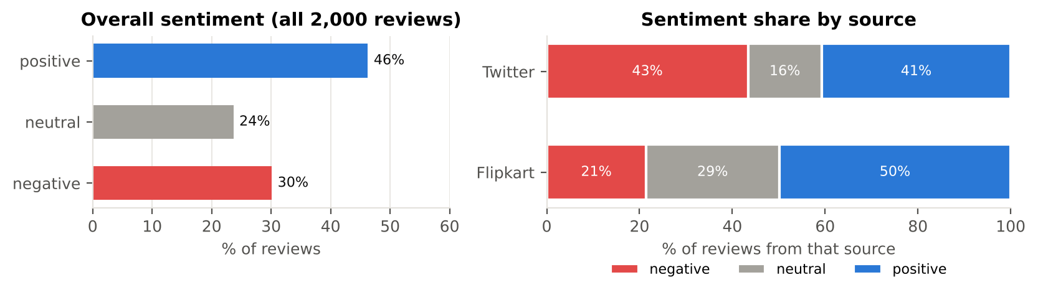
Figure 3. Overall sentiment and sentiment by source.
Overall and by source. Customers are broadly satisfied (46% positive), but a sizeable minority (30%) is unhappy. The two platforms behave very differently. Twitter is twice as negative as Flipkart (43% against 21%) and far less neutral (16% against 29%). People tend to tweet when something goes very well or very badly, and they tag the brand to get a reply, while marketplace reviews are often prompted after delivery and include measured "it's okay" verdicts. Customer service accounts for 28% of Twitter complaints but only 5% on Flipkart, which suggests Twitter is where customers go after support has failed them.
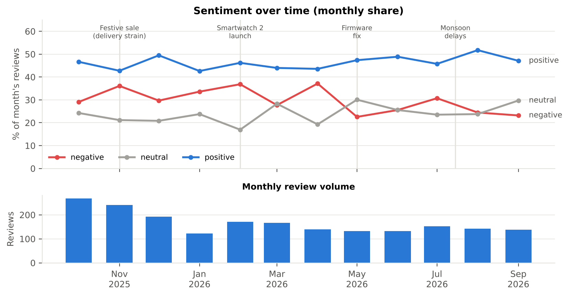
Figure 4. Monthly sentiment share (top) and review volume (bottom).
Over time. Review volume peaks during the festive sale (268 reviews in October and 241 in November), and so does negativity (36.1% negative in November). Delivery causes 44% of negative reviews in the sale and monsoon months, compared with 8% in the other months, which explains the second rise in July (30.7%). The February–April rise is almost entirely the smartwatch: without it, March would have been the calmest month of the year (19% negative). Apart from the July monsoon rise, sentiment is at its best from May onwards. Each month has only 120–270 reviews, so a single month's share can move by 3–4 points by chance; patterns that last several months are more reliable than any single point.
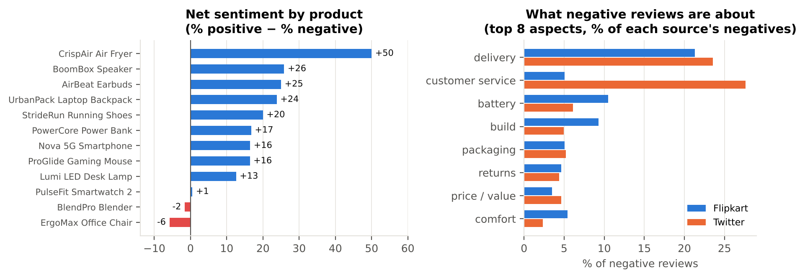
Figure 5. Net sentiment (% positive − % negative) by product, and the topics of negative reviews.
By product and topic. Net sentiment ranges from +50 for the CrispAir Air Fryer to -6 for the ErgoMax Office Chair; the BlendPro Blender (-2) is the only other product below zero. Delivery is the leading complaint overall (first on Flipkart and second on Twitter, behind customer service); battery life and build quality are the main product complaints on Flipkart. The smartwatch's overall score (+1) hides two very different products (Figure 6): before the firmware fix, 76% of its reviews were negative (net -64); afterwards, only 14% were (net +43).
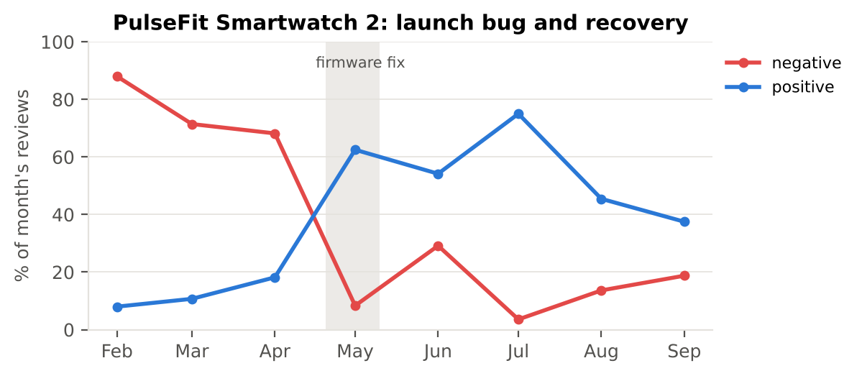
Figure 6. PulseFit Smartwatch 2: monthly share of positive and negative reviews (20–30 reviews per month).

6. LIMITATIONS AND HOW TO IMPROVE
- Synthetic, template-based data inflate the scores. This is the most important limitation. I tested the trained models on 36 reviews I wrote by hand in phrasing the generator never uses. Accuracy fell from 96% to 47% for the SVM (42–50% across the four models), below the untrained VADER lexicon (61%). The SVM recognised only 3 of 12 positive reviews, because phrases such as "saved my back" or "bone dry" never appear in training. Some of the most heavily weighted terms, such as "honestly" and "go" (from "Go for it"), are artefacts of the templates. The class sample shows the same problem in a more extreme form: the pipeline scores 100% there because half its rows are duplicates.
- Sarcasm and context. A bag of words and bigrams ignore longer word order, so real sarcasm ("Oh lovely, a 'brand new' speaker with someone else's fingerprints") cannot be memorised the way the templated version was.
- Subjective neutral class and label noise. Only 2% of labels were flipped, yet they caused 11 of 16 errors. In real data, people often disagree on whether a review is neutral or mildly positive, so the measured accuracy is limited by label quality as much as by the model.
- Class imbalance and language. Neutral makes up only 24% of the data; stratification and macro-F1 reduce this problem but do not remove it. The model also handles English only, while many customers in South Asia write in Bangla, Hindi, or romanised mixes ("product ta valo na").
Improvement. The most useful next step is to train on a few thousand real, human-labelled reviews and replace TF-IDF with a fine-tuned pre-trained transformer (DistilBERT, or multilingual XLM-RoBERTa for code-mixed text), keeping a held-out set of real reviews as the test. A transformer recognises paraphrases such as "saved my back" and takes word order into account. A cheaper interim step is to combine the SVM with VADER and use the lexicon's verdict when the SVM's decision margin is small.

7. BUSINESS IMPLICATIONS
If I were advising this retailer, the analysis would point to six actions:
- Fix delivery first. It is the most common complaint overall and accounts for almost half of all complaints in peak months. Add courier capacity and set realistic delivery dates before festive sales and the monsoon, and send delay notices before customers have to ask.
- Treat Twitter as a customer-service channel. Twitter is 43% negative, and these complaints are public. Monitor brand mentions in real time and set a response target (for example, under one hour), since more than a quarter of Twitter complaints are about support itself.
- Investigate the two products with negative net sentiment. For the ErgoMax chair (assembly, missing screws, build) and the BlendPro blender (jar quality), raise the issues with suppliers, improve assembly instructions, and check incoming stock.
- Watch new launches closely. The smartwatch went from net -64 to +43 once the bug was fixed. A weekly dashboard that flags any product whose negative share jumps would have caught the problem in its first week rather than after three months of damage.
- Build on strengths. The air fryer (+50), speaker, and earbuds are clear favourites. Feature them in campaigns and ask satisfied buyers to leave reviews.
- Use the model for triage, not as the final word. Given the generalisation gap, retrain it on the company's real reviews and have a person check low-confidence cases before acting on its numbers.

8. CONCLUSION
A TF-IDF and Linear SVM pipeline, with negation-aware preprocessing, classifies this synthetic review data with 96% accuracy and recovers all three business events built into it: the sale-season and monsoon delivery problems, and the smartwatch launch and recovery. Neutral reviews are the hardest to classify, and most remaining errors come from noisy labels. The hand-written challenge set is a reminder that strong scores on synthetic data do not guarantee strong scores on real customers' language. The next step is real, labelled data and a context-aware model. The code, data, notebook, and all figures are in the GitHub repository, which can be run from start to finish with one command.

