Exploring extremes values (ES and SD)

#### Load packages

#### Calculate effect size in standardized mean difference (Hedges’ g)

#### EXPLORATORY ANALYSIS OF EXTREME EFFECTS —-

#### How many studies has a effect size >= 5 and sd >=3? How much % they represent of the library?

[1] "There are 27 studies with extremes ES and SD, representing 4.813 % of the total."

#### How many publications they represent? are they nested?

# A tibble: 11 × 3  
# Groups: species [2]  
 species id count  
 <chr> <chr> <int>  
 1 mice 72 6  
 2 mice 15 4  
 3 rat 21 4  
 4 mice 111 2  
 5 mice 125 2  
 6 mice 199 2  
 7 mice 30 2  
 8 rat 140 2  
 9 mice 2 1  
10 mice 26 1  
11 mice 6 1

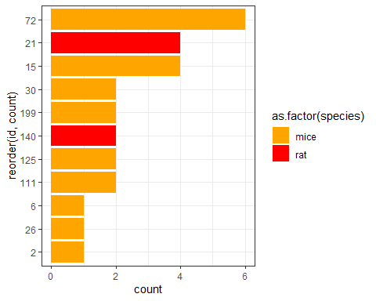

#### All studies from these publications present a extreme effect size?

## mice

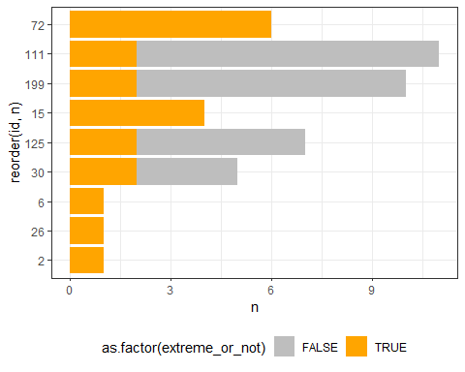

## rat

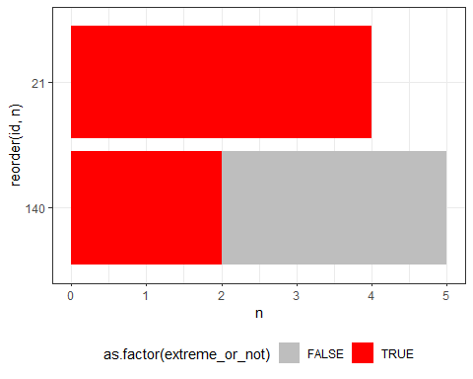

#### What are the characteristics of these studies?

## pop:

|  |
| --- |
|  |

|  |
| --- |
|  |

## int:

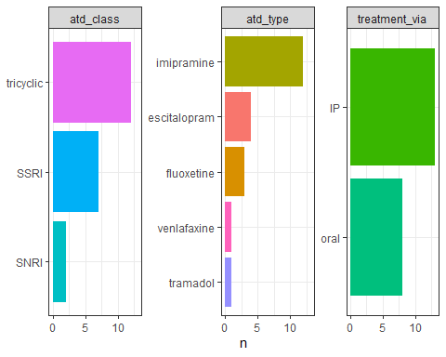

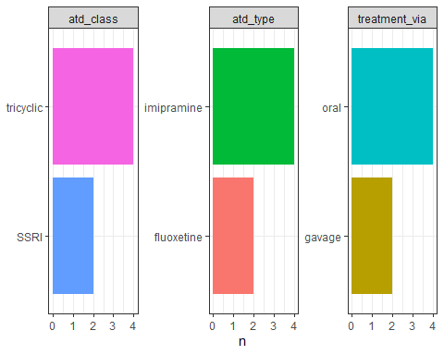

## out:

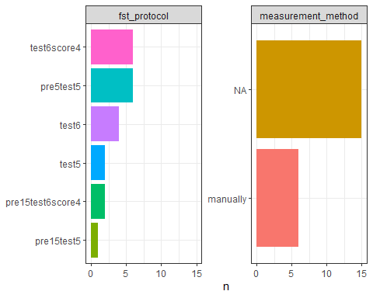

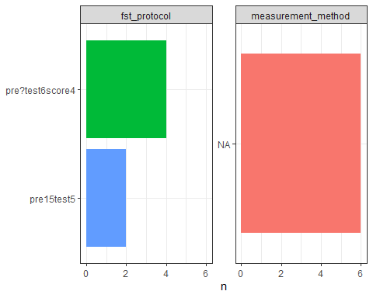

## validity:

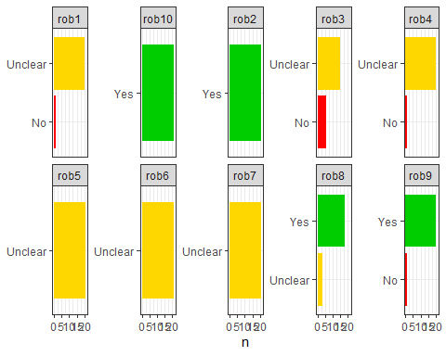

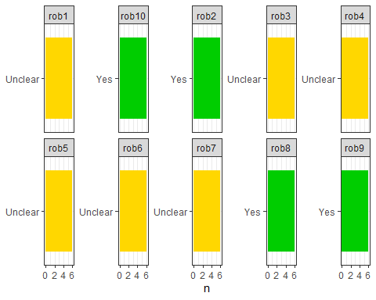

##### What’s the effect size from the studies that reported not doing practices to ganrantee internal quality?

# A tibble: 1 × 8  
 min max mean median min_sd max_sd mean_sd median_sd  
 <dbl> <dbl> <dbl> <dbl> <dbl> <dbl> <dbl> <dbl>  
1 -0.845 60.5 5.52 1.27 0.332 12.4 1.41 0.590

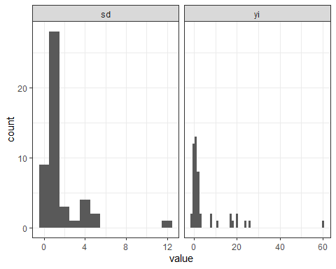

#### Are these studies nested?

# A tibble: 21 × 2  
# Groups: id [21]  
 id n  
 <chr> <int>  
 1 85 7  
 2 72 6  
 3 86 6  
 4 20 4  
 5 25 3  
 6 100 2  
 7 134 2  
 8 18 2  
 9 219 2  
10 224 2  
11 69 2  
12 11 1  
13 165 1  
14 2 1  
15 212 1  
16 58 1  
17 6 1  
18 74 1  
19 8 1  
20 9 1  
21 96 1

#### Are these studies considered extremes?

extreme_or_not n   
1 FALSE 40   
2 TRUE 8