**Department of**

**Computer Science & Engineering**

**University of Dhaka**

Course: CSE 4103

**Iron Man With His Car**

Computer Graphics Lab Project

|  |  |
| --- | --- |
| **Submitted to:**  Ms. Shuvra Chakraborty | **Submitted by**:  Tamim Addari(19)  Arafat Ahmed Tanim(57) |

## 1. Abstract

This is Project built on top of opengl and blender.We took the professional approach of how real world games and graphics application are made.

An artist designs the piece in software like 3ds,Blender or Maya and then programmers import them to opengl to do programming on them.

We used blender to generate a model and then load it into opengl for viewing and zooming in and out.

We used texture mapping to render the Model in opengl with a process named as UV-mapping.

## 2. Table of Contents

-------------------------

1. Blender
2. Opengl
3. Summary

## 3. Blender:

* We first imported the skeletal model used for the [crysis][1] games as our base model.
* Using blender we then designed an iron-man suit on top of the body.
* We then gave the iron-man necessary diffuse,specular and ambient lighting effect through blender.
* Then we UV-unwraped each of the meshes separately. [UV-mapping is a process of mapping a 2D texture to a 3D object, by UV-unwrapping we do the opposite , we project a 3D object into a 2D texture]
* Then we created a texture and then baked the lighting into the unwrapped texture.
* After this , we exported the materials into a wavefront(.obj) file along with the materials.
* There is a seperate mtl file which describes the material positions.

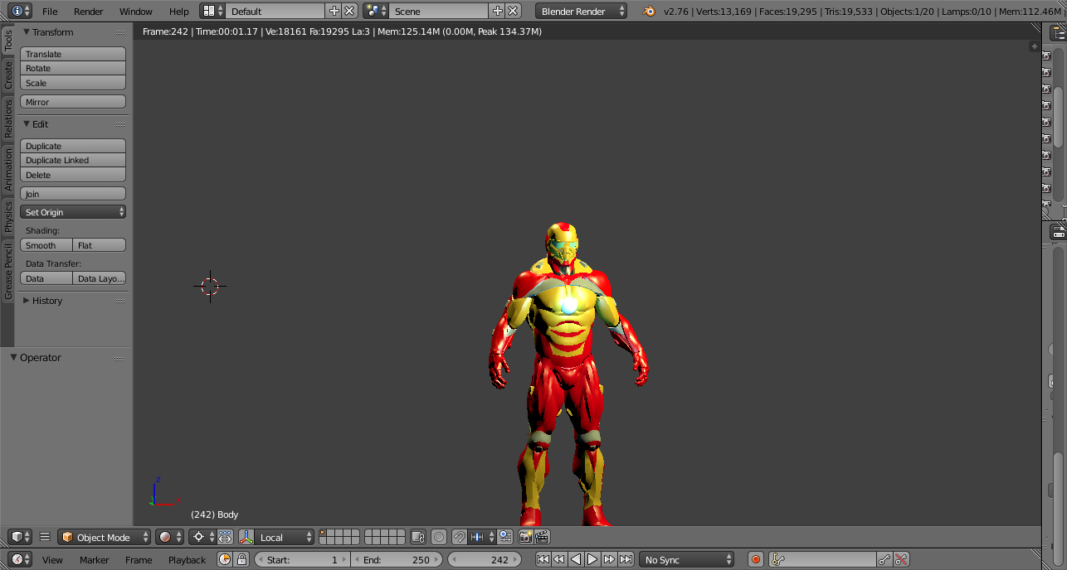

Fig: Iron Man in Blender

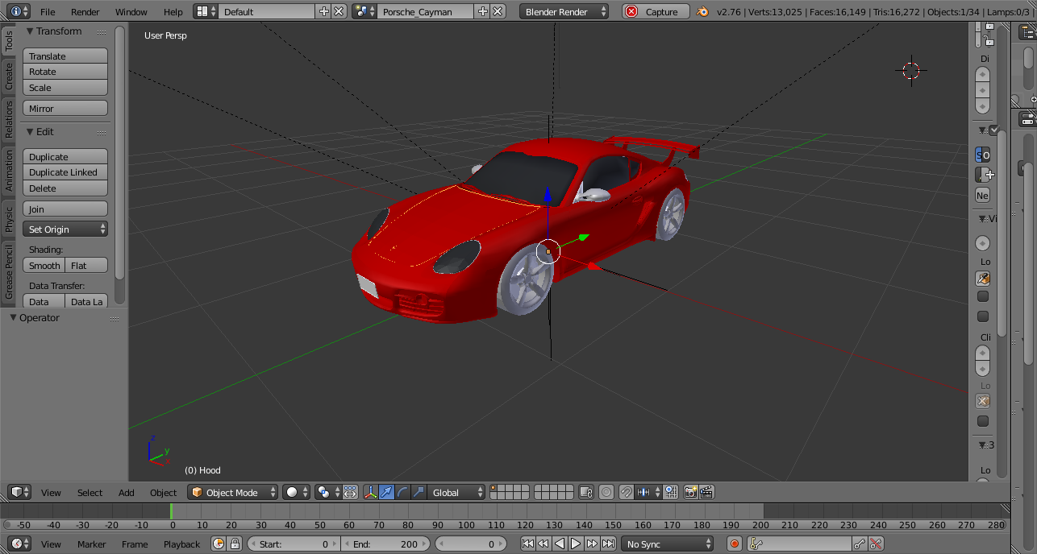

Fig: Car in Blender

## 4. Opengl:

* For importing the obj information of vertices we used assimp importer.
* We loaded the exported materials and vertices along with vertex normals to the model.
* We then used the assimps aiscene to load the meshes recursively.
* After loading the mesh we then draw each of the meshes independently.
* After drawing the meshes we multiply by model view matrix to send it to the proper position.
* We change the view through input from the mouse and keyboard

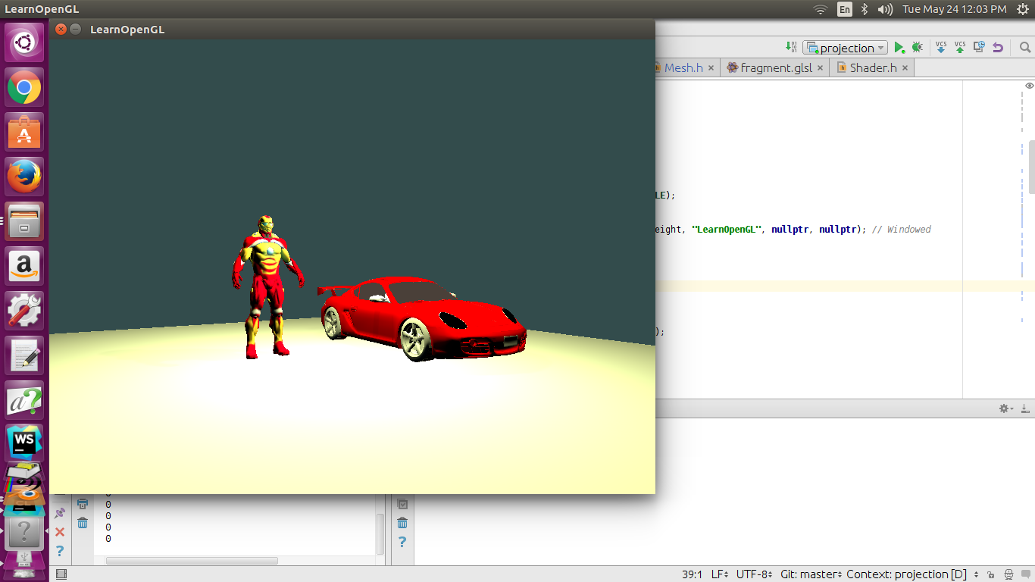

Fig: Car and ironman in opengl

[1]: http://www.ea.com/crysis