

**ASSESSMENT 2- BUSINESS PROCESS ANALYSIS AND REDESIGN**

**CONTRIBUTOR**

EZEKIEL JESUDOSS SAMSON KAMALANATHAN | 30431554

SHERINA RUTH KUNTLA | 30415669

TAMIM HASAN | 30432576

10/08/2023

Table of Contents

INTRODUCTION 3

BUSINESS PROCESS MODELLING REPORT FOR CAR INSURANCE FIRM 3

REVISED BUSINESS PROCESS MODEL 3

LIST OF CHANGES 4

PROCESS MODEL FOR ANALYZING AND GENERATING ACTION PLAN 5

PROCESS MODEL FOR DECISION MAKING 5

7PMG DISCUSSION FOR ANALYZING AND GENERATING THE ACTION PLAN 6

7PMG DISCUSSION FOR DECISION MAKING 7

CYCLE TIME FOR **ANALYZE AND GENERATE ACTION PLAN** MODEL 7

CYCLE TIME FOR DECISION MAKING PROCESS MODEL 8

REDESIGN FOR: ANALYZE AND GENERATE ACTION PLAN (PART A) 9

REDESIGN FOR: DECISION MAKING (PART B) 10

AUTOMATE: ANALYZE AND GENERATE ACTION PLAN 11

CONCLUSION 12

PERSONAL REFLECTIONS 13

SHERINA RUTH KUNTLA – 30415669 13

TAMIM HASAN – 30432576 13

EZEKIEL JESUDOSS SAMSON KAMALANATHAN – 30431554 14

REFERENCES 15

# INTRODUCTION

This business process report focuses on optimizing the car insurance claim registration process. The process involves the claim being received by the insurance company’s customer service representative, which is then sent to the claim handler and then the claims manager for decision making. This report includes the revising of the existing model, evaluating adherence to industry guidelines, calculating the cycle times, identifying design flaws, and exploring automation potential.

Two process fragments representing essential business operations are presented as comprehensive process models with start and end events in this report. It also determines how well each process model follows Process Modelling Guidelines (7PMG)(Mendling, Reijers, & van der Aalst, 2010). Furthermore, process cycle times for the two models are estimated, noting all the assumptions that were made. Redesign techniques by Reijers and Mansar (2005) were used to identify and address design faults in present as-is models. The impact of heuristic measures on the Devil’s Quadrangle was discussed. Finally, prospective automation opportunities for one of the process models are investigated using a systematic five-step technique. This complete method seeks to increase service quality and operational efficiency by optimizing the car insurance claim registration procedure.

# BUSINESS PROCESS MODELLING REPORT FOR CAR INSURANCE FIRM

## REVISED BUSINESS PROCESS MODEL

An outline of the activities and processes of the insurance firm employees is as follows:

The Customer Service Representatives ensure the completeness of incoming claims, request missing information, register complete claims, monitor for decisions, manage customer satisfaction surveys, and measure customer satisfaction levels. The claim is then forwarded to the claim’s handler.

The Claims Handler verifies insurance policies, assesses claim seriousness, transmits forms, verifies completeness, enters claims into the system, requests revisions, if necessary, analyses claims, obtains accident reports for complex cases, generates preliminary estimates, and provides action plans. The claim is then sent to the claims manager for decision-making.

The claims manager is in charge of making final claim decisions, updating files, and communicating outcomes. They also handle situations where consumer satisfaction is low, performing reviews and providing apologies for improvements, or taking no further action if no answer is received within two months.

The figure below is the revised BPMN process model with necessary assumptions to make the model more efficient.

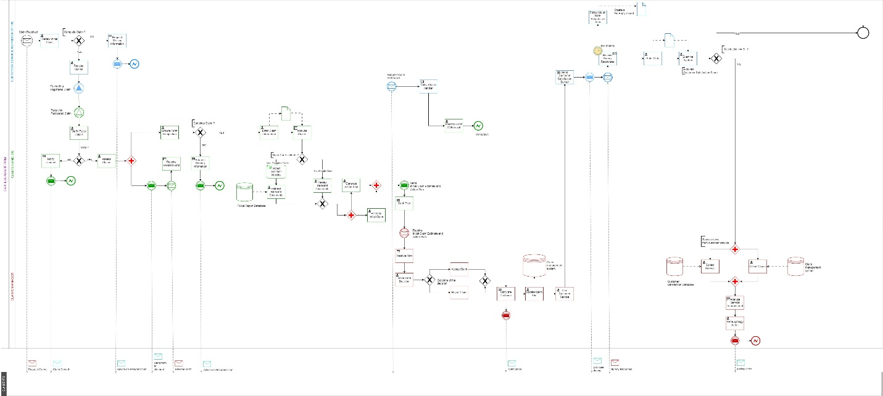

FIGURE 1: REVISED BPMN PROCESS MODEL

Following are the major assumptions and revisions made to the as-is model:

* If a claimant wishes to withdraw their claim at any stage during the claims process, they must first notify the customer representative. The representative would inform the claims handler, resulting in the cancellation of the claim.
* After assessing each claim, the claims handler categorizes it as simple or complex. In the case of complex claims, they arrange for vehicle inspections, and in the case of simple claims, they analyse the necessary documents.

## LIST OF CHANGES

1. **Incorporate Exception Handling**: Address scenarios involving customer claim withdrawals prior to finalization, ensuring appropriate protocols are in place.
2. **Ensure Proper Sequence Flows**: Rectify instances where certain activities lack outgoing sequence flows, such as in the step "request missing info," ensuring a coherent flow of actions.
3. **Improve Activity Naming**: Enhance clarity by revising poorly named activities, promoting a standardized and understandable nomenclature throughout the process.
4. **Sequence Flow Optimization**: Rectify the absence of incoming sequence flows in intermediate events, ensuring seamless integration and logical progression within the workflow.
5. **Enhance Exception Handling**: Implement effective strategies for handling exceptions, including enforcing time limits for survey submissions, thereby streamlining the process and ensuring timely responses.
6. **Adhere To Symbolic Standards**: Ensure accurate usage of all symbols and conventions, maintaining consistency and coherence in the representation of activities and decision points within the process.

## PROCESS MODEL FOR ANALYZING AND GENERATING ACTION PLAN

The first essential business process operation chosen is the analysis and generation of an initial estimate and action plan for a confirmed claim. The claims handler is in charge of this critical procedure. The BPMN model below depicts this process, with the start event representing the entry of claim information into the database and the end event representing the completion of the estimation and plan, which is then provided to the claims manager. For complex claims, it is assumed that accident vehicles are inspected, and for simple claims, it is assumed that relevant documentation are reviewed and they are shown as activities in the model.

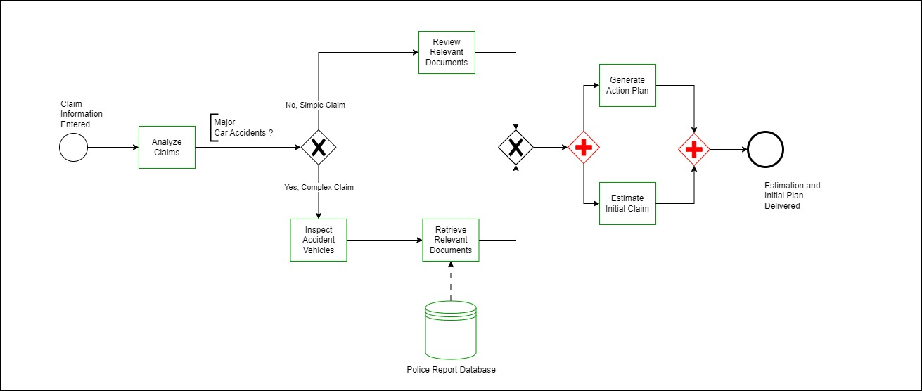

FIGURE 2: ANALYZE AND GENERATE ESTIMATION AND ACTION PLAN

## PROCESS MODEL FOR DECISION MAKING

The second key process chosen is the claims manager's decision-making phase. The start event in this process model represents the manager receiving the plan, while the end event is specified as the customer service representative's notification. This procedure also includes an assumption, presuming that the manager will review the generated action plan and the original estimate before making a final choice.

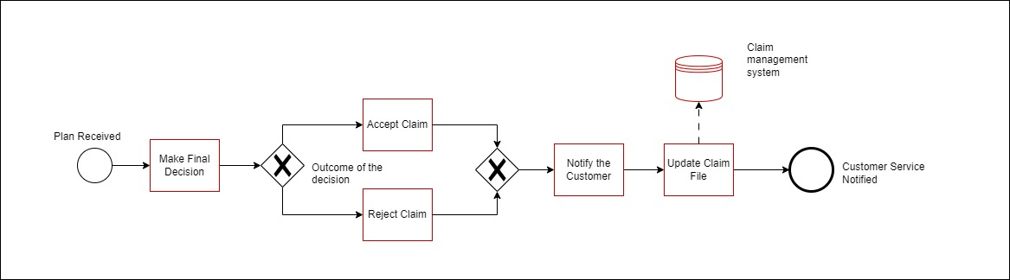

FIGURE 3: DECISION MAKING

## 7PMG DISCUSSION FOR ANALYZING AND GENERATING THE ACTION PLAN

The 7PMG (Process Modelling Guidelines) provide a foundation for developing clear and effective business process models. They provide an emphasis on best practices that improve model clarity, consistency, and alignment with organizational goals. 7PMG guidelines are as follows(Mendling, Reijers, & van der Aalst, 2010):

G1: Use as few elements in the model as possible

G2: Minimize the routing paths per element

G3: Use one start and one end event

G4: Model as structured as possible

G5: Avoid OR-gateways

G6: Use verb-object activity labels

G7: Decompose a model with more than 30 elements

The process of analyzing and generating the action plan model adheres to the 7PMG guidelines as follows:

G1- 13 elements are used to explain the process fragment, all of which are necessary for the complete understanding of the process.

G2- The routing paths is designed straightforwardly with the necessary input and output arcs and gates. Assumptions were made only where needed, like inspecting accident vehicles after categorizing that the claim is complex.

G3- For better analysis of the process, one start and one end event have been used.

G4- Following the guidelines, the process model is structured with split and respective join connectors. The XOR split for categorizing the claim is joined back by an XOR connector. The AND split for generating the action plan and estimating initial claim is ended at a join AND connector.

G5- OR gates have been avoided for errors and paradoxes.

G6- The process model’s activities were carefully labelled according to the “verb-object” style and the even as “noun -past participle verb”. Example for activity is ‘claim information entered’ and for activity- ‘Analyze claim’.

G7- The guideline of having not more than 30 elements is taken into consideration while creating the model.

## 7PMG DISCUSSION FOR DECISION MAKING

The Decision-making model adheres to the 7PMG guidelines as follows:

G1- 11 elements are used to explain the process fragment, all of which are necessary for the complete and clear understanding of the process.

G2- Routing path for the decision-making model has only one XOR split, which is necessary as it determines the decision taken by the manager.

G3- For clear analysis of the process, one start and one end event have been used.

G4- An XOR split is used to categorize the decision of the manager which is then joined back by another XOR connector.

G5- OR gates have not been used as the process did not necessitate one.

G6- Proper labels, adhering to the rules were given to the activities and events in order to maintain consistency and clarity. Example for activity is ‘Make final decision’.

G7- The process fragment is simple with not more than 30 elements.

## CYCLE TIME FOR **ANALYZE AND GENERATE ACTION PLAN** MODEL

One of the major processes involved in the insurance company is analyzing and generating a plan for the claim. For this process model, the following assumptions have been made:

Investigating the accident vehicle as an activity is assumed after analyzing the claim.

We are assuming that 25% (p1) of the accidents fall under complex and 75% (p2) under simple.

Cycle time for the process activities:

|  |  |
| --- | --- |
| **Activity** | **Cycle Time** |
| Analyse claim (A) | 2 days |
| Inspect accident vehicles (B) | 3 days |
| Retrieve relevant documents (C) | 2 days |
| Review relevant documents (D) | 2 days |
| Generate action plan (E) | 3 days |
| Estimate Initial claim (F) | 3 days |

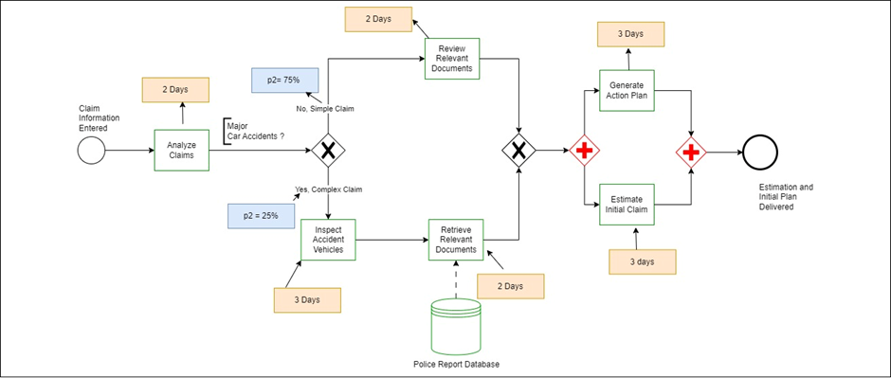

FIGURE 4: CYCLE TIME FOR PROCESS MODEL 1

**CALCULATION**:

Cycle Time (CT) = A + [p1×(B+C)] + (p2×D) + E

=2+ [25%× (3+2)] +(75%×2) + 3

= 2+ (0.25×5) + (0.75×2) + 3

= 2+ 1.25 + 1.5 +3

= 7.75 Days

Both the activities (E and F) in the AND block is assumed to have the same cycle time. Hence, we consider their time just once. The cycle time for the analysis and generation of the action plan model is 10.25 days.

## CYCLE TIME FOR DECISION MAKING PROCESS MODEL

Another major process involved is decision-making, which is done by the claims manager. For this process model, the following assumptions have been made:

Before the final decision is made, the generated plan and initial estimate are reviewed.

We are assuming that 80% (p1) of the claims are accepted and 20% (p2) are denied.

Cycle time for the process activities:

|  |  |
| --- | --- |
| **Activity** | **Cycle time** |
| Review generated action plan (A) | 2 days |
| Make final decision (B) | 1 day |
| Accept claim (C) | 1 day |
| Reject claim (D) | 1 day |
| Notify the customer (E) | 2 days |
| Update claim file (F) | 1 day |

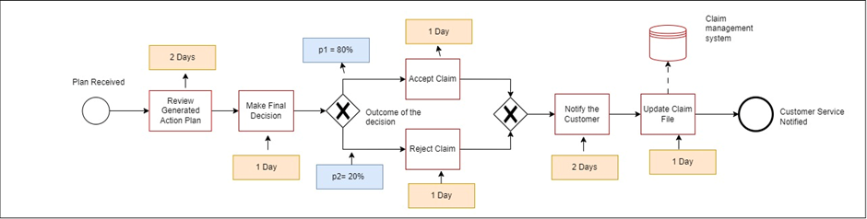

FIGURE 5: CYCLE TIME FOR PROCESS MODEL 2

**CALCULATION**:

Cycle Time (CT) = A + B + (p1 × C) + (p2 × D) + E + F

                        = 2 + 1 + (80% × 1) + (20% × 1) + 2 + 1

                        = 3 + 0.8 + 0.2 + 3

                        = 7 Days

The cycle time for decision-making is 7 days.

## REDESIGN FOR: ANALYZE AND GENERATE ACTION PLAN (PART A)

Rethinking and re-organizing business processes to enhance the quality of products and services is called Business process redesign. By applying Reijers and Mansar (2005), the following are the two design flaws in the as-is model:

CUSTOMER WITHDRAWAL REQUEST

By applying the customer element of the process redesign, the as-is model lacked a process where the claimant could withdraw the claim at any stage of the process. To overcome this flaw, we have redesigned the process, giving the claimant the option to withdraw their claim by notifying the customer representative. The customer representative would inform the claims handler, resulting in the cancellation of the claim.

VECHICLE INSPECTION

As per the process operation element of the process redesign, the second design flaw in the model was that the claims handler categorizes the claim as simple or complex. However, it was identified that in cases of complex claims, a vehicle inspection is a necessary step. Hence, after assessing each claim and categorizing it as a complex claim, they arrange for vehicle inspections to assess the validity of the claim thoroughly.

## REDESIGN FOR: DECISION MAKING (PART B)

IMPACTS OF HEURISTICS METHOD IN THE DEVIL’S QUADRANGLE.

|  |  |  |  |  |
| --- | --- | --- | --- | --- |
|  | **TIME** | **COST** | **QUALITY** | **FLEXIBILITY** |
| CUSTOMER WITHDRAWAL REQUEST | - | - | + | + |
| VECHICLE INSPECTION | - | - | + | . |
| Positive effect - (+)  Negative effect – (-)  Neutral effect – (.) |

**TIME**

1. CUSTOMER WITHDRAWAL REQUEST: Adding an additional customer withdrawal request will increase the processing time.
2. VEHICLE INSPECTION: physically performing a vehicle inspection will increase the process time.

**COST**

1. CUSTOMER WITHDRAWAL REQUEST: This process has a negative impact as it may cause cost to the overall process.
2. Vehicle Inspection: Vehicle Inspection will have a negative impact by adding additional cost. However, it is a necessary cost for the process.

**QUALITY**

1. CUSTOMER WITHDRAWAL REQUEST: There is a positive impact on the quality of customer satisfaction.
2. VEHICLE INSPECTION: Vehicle Inspection helps in assessing the validity of the complexness. Hence, there is a positive impact on the process.

**FLEXIBILTY**

1. CUSTOMER WITHDRAWAL REQUEST: As the customer has the option to request withdrawal at any stage of the process, it adds flexibility, making it a positive impact.
2. VEHICLE INSPECTION: There is a neutral impact on flexibility for vehicle inspection.

## AUTOMATE: ANALYZE AND GENERATE ACTION PLAN

Automating an entire or a small section of a process with the help of a software system is known as the Automated business process (Dumas et al., 2018).For a BPMS to interpret, precise specifications are required for an Executable process model(Dumas et al., 2018).and it can be achieved by following the Five-Step method.

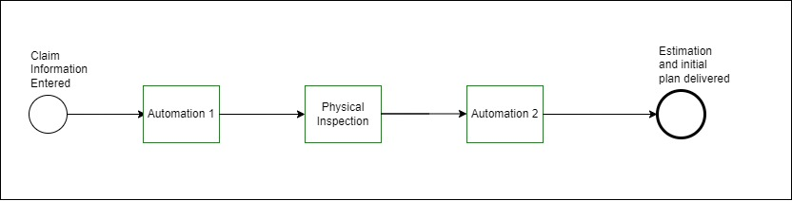

FIGURE 6: AUTOMATED PROCESS MODEL

STEP 1:

To automate a process, the first step is to identify which part of the process to automate and apply the principle that not all processes can be automated. In the Analyze and Generate action plan model, the process of analyzing the seriousness of the claim can be automated by building a metric from which the software can grade and determine if the claim is a simple claim or a complex claim. Also, by building further metrics and guidelines, we can automate where the software can review the documents, generate an action plan from a range of pre-defined action plan templates, calculate and estimate an initial claim, and forward the action plan to the manager.

STEP 2:

The second step to automating this process is to review the manual tasks. In the automated analyse and generate action plan model, the second phase of the process is a manual task where the claim’s handler receives the system-generated result that the claim is complex. Then the claim’s handler physically inspects the car to check the validity of the result and takes appropriate actions to receive the relevant documents from the police database. Once these processes are done, the claim’s handler starts the rest of the automated processes.

STEP 3:

The next step of the automation process is to complete the process model. Information can often be neglected while building a process, considering it might be irrelevant. However, in the automated analyses and generate action plan model, all the information and details are carefully considered and included in the process for completion. Furthermore, all data objects essential for the process have been included and satisfy the third step of the automation process.

STEP 4:

The fourth step in the process involves achieving an appropriate level of granularity for the process model, which can be done through either aggregation, where multiple tasks are assigned to a single resource, or refinement, where tasks are separated if they are too broad(Dumas et al., 2018). Aggregation or refinement of tasks were not performed in this model.

STEP 5:

The final step in the process is to define execution properties, which entails detailing how all elements of the process will be implemented within the Business Process Management System (BPMS) (Dumas et al., 2018). The following are the model’s elements and the execution properties:

|  |  |
| --- | --- |
| **ELEMENTS** | **EXECUTION PROPERTY** |
| ENTER CLAIM INFORMATION | Entering the completed claim details in the Claim Management System. |
| ANALYZE THE CLAIM | Analysing the seriousness of the claim. |
| RETRIEVE POLICE DOCUMENT | For Complex claims, retrieving appropriate documents form the police. |
| GENERATE AN ACTION PLAN | Create action plans based on claim analysis |
| ESTIMATE INTIAL CLAIM | Calculate initial claim amounts using predefined algorithms. |
| SEND THE ACTION PLAN TO MANAGER | Route action plans to managers for review and further action. |

# CONCLUSION

In summary, this report has focused on optimizing the existing car insurance claim processing. The report involved revising the existing process model, calculating cycle times, addressing design flaws, and exploring automation opportunities. We followed the 7PMG process modelling guidelines and incorporated heuristic measures in the Devil’s Quadrangle for a comprehensive assessment. Furthermore, the automation process was also analyzed using the 5-step technique with the aim of improving operational efficiency. Overall, this report signifies the process analysis and redesign in the given car insurance business.

# PERSONAL REFLECTIONS

## SHERINA RUTH KUNTLA – 30415669

Throughout the course, especially during this process analysis and redesign assignment, I realized that the lectured and lab tutorials were of great help. To begin, my knowledge of BPMN (Business Process Model and Notation) and process modelling methodologies enabled me to build precise and thorough process models. I was able to properly model processes using the ideas learned in our course. I have learned to work as a team and it greatly helped expand my knowledge as we brainstormed in building the BPMN models.

Second, the course taught the principles for process modelling and analysis very clearly. I was able to go back to the lectures and ppt slides whenever we were stuck. This understanding enabled me to examine existing procedures objectively, identify bottlenecks, and propose improvements. The concept of heuristics and design faults, which we discussed extensively, was especially useful in identifying areas for improvement.

In terms of personal insights, I've realized the importance of process optimization in streamlining operations and increasing efficiency. Understanding how to identify and solve design faults has given me a more strategic approach to process analysis. Process modelling is now evident to me as a realistic instrument for creating real-world improvements in corporate processes, not merely a theoretical exercise. Looking ahead, I believe the knowledge and teamwork abilities I've gained in this course will have a big impact on my professional career. In many businesses, the ability to model, analyses, and modify business processes is extremely valuable. It allows me to contribute to process improvement projects, improve organizational efficiency, and provide better results for customers and stakeholders. This knowledge may be applied to a variety of professions and industries, making me a more adaptable and valuable addition to future companies.

Finally, the knowledge obtained from our assignment has given me a solid foundation in process modelling and analysis. It has not only helped me complete assignments successfully, but it has also given me vital insights that I hope will impact my future profession.

## TAMIM HASAN – 30432576

In completing the process modeling and analysis assignment, I found myself relying heavily on what I learned during our course. The knowledge from our modules shaped how I approached these tasks. Using BPMN concepts and process analysis techniques, I built a clear and detailed process model. The feedback I got from the first assignment was crucial. It helped me fix mistakes, clear up confusion, and make sure the activities in the process diagram made sense.

A big lesson I took away was the importance of handling exceptions in business processes. This insight changed how I redesigned the process. I focused on solving issues like incomplete data or a claimant withdrawing his or her claims in the middle of the process. During the assignment's initial stages, I revisited our process modeling skills, incorporating feedback to enhance my understanding. Following the 7PMG guidelines that we discussed in class was pivotal. It was not just about correctness but also about aligning my work with industry standards. This adherence ensured that my models were not only accurate but also industry relevant. I learned the importance of clear activity naming and accurate sequence flows, rectifying issues to deepen my understanding of BPMN diagrams' practical applications.

Adhering to Mendling et al.’s 7PMG guidelines became my mantra during the redesign. This meticulous approach, aligning my work with industry best practices, provided a structured framework for my efforts. It helped me critically evaluate my redesigns, pinpointing areas for enhancement. This process not only polished my existing skills but also instilled in me a keen eye for detail, crucial in professional scenarios.

The calculation of process cycle times brought quantitative analysis into play, balancing the qualitative insights from process redesign. This holistic perspective emphasized the necessity of accuracy without compromising efficiency. The delicate equilibrium between these factors became evident, imparting a lesson invaluable for my future ventures.

Looking forward, I see how this knowledge will shape my career. Businesses are really into optimizing their processes, so being good at BPMN and process analysis is super important. Understanding processes well helps me solve problems, finding better ways of doing things. And in a time where automation is changing industries, knowing how to model processes sets the stage for automation. This skill ensures I stay valuable in the changing world of organizational efficiency.

In summary, the course knowledge gave me a deeper understanding of how process modeling and analysis work in the real world. I am confident that this knowledge will play a significant role in my future career, enabling me to contribute meaningfully to any organization's efficiency and effectiveness.

## EZEKIEL JESUDOSS SAMSON KAMALANATHAN – 30431554

HOW I APPLIED THE KNOWLEDGE LEARNED FROM COURSE TO THE ASSIGNMENT

Personally, accomplishing the process modelling assignment came with a lot of challenges. I had to brainstorm many ideas and refer various concepts to optimally do the tasks allocated to me. However, throughout this assignment the lectures notes and study materials available helped find all the information I needed. Going through the study materials, understanding it, and applying it practically for my assignment made me understand even clearer. For instance, the clear-cut definition and principles explained for the 5 steps automation model, helped me understand the what’s and how’s to optimally automate a process model. Applying what is studied was pivotal in ensuring that the assignment we worked on was in good standard and exceptional quality.

MY PERSONAL INSIGHTS INTO THE LEARNED KNOWLEDGE FROM THE COURSE

By undertaking this course, I have learned the significance of a business process model in any business and how it helps to narrow down the understanding and the step-by-step approaches in building them. By learning the various guidelines such as 7PMG, I understood the principles on how to build a process model. Applying what I learned in lab each week, I got to learn all the elements and objects of the Business model, their uses, and the application of it. Finally, building an overall process model and reporting it professionally through the assignments help me gain insights of how business models are developed and worked in the industry. Working alongside a team, sharing our insights during meetings, and helping each other out in complicated stages and knowledge sharing has given me a positive impact for the future and I am looking forward to applying it in my career.

HOW I FEEL THIS KNOWLEDGE WILL HELP ME IN MY FUTURE CAREER

I genuinely feel that I have gained valuable knowledge and hands on experience in process optimization. Modern organizations are constantly looking to develop the processes and having ability to model, analyses and redesign business processes would enhance my career and make me an important asset to the company. Also, gaining insights on automation principles can be vital as automation is a prominent trend in today’s corporate milieu.

Overall, undertaking this course has been very informative and boosted my knowledge and skills towards my successful career building. I am confident that with this knowledge I can foster to the industry needs and be an asset to my workplace.

# REFERENCES

Dumas, M., La Rosa, M., Mendling, J., & Reijers, H. A. (2018). *Fundamentals of business process management* (Vol. 2). Springer.

Mendling, J., Reijers, H. A., & van der Aalst, W. M. (2010). Seven process modeling guidelines (7PMG). *Information and software technology*, *52*(2), 127-136.