Name:

## Explain the following equation



The amount of electromagnetic radiance, L (watts m-2 sr-1; watts per meter squared per steradian) recorded within the IFOV of an optical remote sensing system (e.g., a picture element in a digital image) is a function of:



where,

= wavelength (spectral response measured in various bands or at specific frequencies). Wavelength (l) and frequency (u) may be used interchangeably based on their relationship with the speed of light (c) where .

sx,y,z = x, y, z location of the picture element and its size (x, y)

t = temporal information, i.e., when and how often the information was acquired

q = set of angles that describe the geometric relationships among the radiation source (e.g., the Sun), the terrain target of interest (e.g., a corn field), and the remote sensing system

P = polarization of back-scattered energy recorded by the sensor

W = radiometric resolution (precision) at which the data (e.g., reflected, emitted, or back-scattered radiation) are recorded by the remote sensing system.

## The Remote Sensing Process (4-steps)

* Statement of the problem: Formulate Hypothesis, Select Appropriate Logic, Select Appropriate Model
* Data Collection : In situ measurements, Collateral Data, Remote Sensing
* Data-to-Information Conversion: Analog visual Image Processing, Digital Image Processing, Hypothesis Testing
* Information Presentation: Image Metadata, Accuracy Assessment, Analog and Digital, Statistics, Graphs

## Angular Information

There is always an angle of incidence associated with the incoming energy that illuminates the terrain and an angle of exitance from the terrain to the sensor system. This *bidirectional* nature of remote sensing data collection is known to influence the spectral and polarization characteristics of the at-sensor radiance, *L,* recorded by the remote sensing system.

Remote sensing systems record very specific angular characteristics associated with each exposed silver halide crystal or pixel. The angular characteristics are a function of:

* location in a three-dimensional sphere of the illumination source (e.g., the Sun for a passive system or the sensor itself in the case of RADAR, LIDAR, and SONAR) and its associated azimuth and zenith angles,
* orientation of the terrain facet (pixel) or terrain cover (e.g., vegetation) under investigation, and
* location of the suborbital or orbital remote sensing system and its associated azimuth and zenith angles.

## Is Remote Sensing Art?

Visual image interpretation brings to bear not only scientific knowledge but all of the experience that a person has obtained in a lifetime. The synergism of combining scientific knowledge with real-world analyst experience allows the interpreter to develop heuristic rules of thumb to extract information from the imagery. Some image analysts are superior to other image analysts because they 1) understand the scientific principles better, 2) are more widely traveled and have seen many landscape objects and geographic areas, and/or 3) have the ability to synthesize scientific principles and real-world knowledge to reach logical and correct conclusions. Thus, remote sensing image interpretation is both an art and a science.

## Example of biophysical variable and RS system

Biophysical Variables: Some biophysical variables can be measured directly by a remote sensing system. This means that the remotely sensed data can provide fundamental biological and/or physical (biophysical) information directly, generally without having to use other surrogate or ancillary data.

For example, a thermal infrared remote sensing system can record the apparent temperature of a rock outcrop by measuring the radiant energy exiting its surface. Similarly, it is possible to conduct remote sensing in a very specific region of the spectrum and identify the amount of water vapor in the atmosphere. It is also possible to measure soil moisture content directly using microwave remote sensing techniques. NASA’s Moderate Resolution Imaging Spectrometer (MODIS) can be used to measure absorbed photosynthetically active radiation (APAR) and leaf area index (LAI). The precise x, y location, and height (z) of an object can be extracted directly from stereoscopic aerial photography, overlapping satellite imagery (e.g., SPOT), light detection and ranging (LIDAR) data, or interferometric synthetic aperture radar (IFSAR) imagery.

Name:

## Path Radiance

Path radiance includes diffuse sky irradiance radiance from neighboring areas on the ground. This path radiance generally introduces unwanted radiometric noise in the remotely sensed data and complicates the image interpretation process.

## Atmospheric Window

In certain parts of the spectrum such as the visible region (0.4 - 0.7 mm), the atmosphere does not absorb all of the incident energy but transmits it effectively. Parts of the spectrum that transmit energy effectively are called “atmospheric windows”.

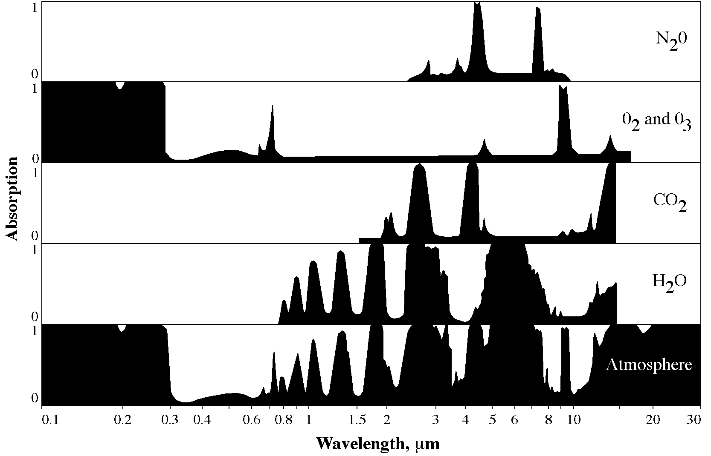

## Lambertian Surface

If the surface is so rough that there are no individual reflecting surfaces, then scattering may occur. Lambert defined a perfectly diffuse surface; hence the commonly designated Lambertian surface is one for which the radiant flux leaving the surface is constant for any angle of reflectance to the surface normal.

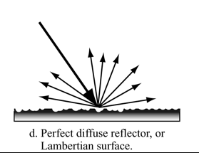

## Wein’s Displacement Law

In addition to computing the total amount of energy exiting a theoretical blackbody such as the Sun, we can determine its dominant wavelength (l*max*) based on *Wein's displacement law*:



where *k* is a constant equaling 2898 mm K, and *T* is the absolute temperature in kelvin. Therefore, as the Sun approximates a 6000 K blackbody, its dominant wavelength (lmax) is 0.48 mm:



where s is the Stefan-Boltzmann constant, 5.66697 x 10-8 W m-2 K-4.

**Quiz 3 (3 & 4 일부분)**

## A few examples of aerial image acquisitions for reconnaissance

1. In First World War, the use of aerial photographs was used to make relatively accurate maps of planning military strategies. It also enabled detection records on the movement of troops and the stockpiling and supply of military supplies.
2. In addition, in World War II, aerial photography was used for more accurate bombing and post-bomber damage assessment.
3. Aerials were used to obtain information over a wide geographic area. For example, the United States used aerial photographs to make a reconnaissance on Soviet and Chinese terrain, including nuclear refining facilities.

## Describe how Corona image was ortho-rectified as much as you know

CORONA image contains camera parameters (focal length, scan rate and orientation) and thus a mathematical description of distortions caused by the CORONA camera. Once panoramic sensor model equations are defined, the model parameters are estimated with the help of GCPs in a least square process. After these parameters are estimated, they can be used to map ground points (latitude, longitude, and height) to a particular pixel in the image. A CORONA image can be projected on a ground surface or DEM by using these parameters.

## Four Types of Resolutions

1. Spatial resolution

Spatial resolution refers to the minimum unit pixel size of a target that a sensor can observe in remote sensing. The smaller pixel size means the higher spatial resolution.

1. Temporal resolution

Time resolution refers to the time it takes for satellites to re-observate the same area, and the higher time resolution mean the more frequent they visit the same area, making it easier to analyze successive changes in target area.

1. Spectral resolution

The number or size of specific wavelengths in the electromagnetic spectrum detected by the remote sensing equipment, which is the smallest area of wavelength that can be detected by the detector. Usually defined in micrometer units. The more the detector decomposes and detects radiation from an object means the better spectral resolution.

1. Radiometric resolution

Radiometric resolution is the capacity of the instrument to distinguish differences in light intensity or reflectance. The greater the radiometric resolution, the more accurate the sensed image will be. Radiometric resolution is routinely expressed as a bit number, typically in the range of 8 to 16 bits.

## Compare two combinations: f/8 1/60sec vs f/4 1/250 sec in camera exposure

When comparing f/8 and f/4, f/4 means that the aperture of the camera is larger, and we can see that the amount of light entering the sensor at the same time is greater and the exposure is greater. When comparing 1/60 and 1/250, we can see that 1/250 shutter speed is faster and that the exposure time is reduced.

Name:

## 8 parameters of photo interpretation and present example of texture analysis

* Size
* Shape
* Shadow
* Tone and Color
* Texture
* Pattern
* Height and depth
* Site, Situation and Association

Example of texture analysis:

Sometimes two features that have very similar spectral characteristics (same tone, and color), we can use texture characteristics to distinguish between them.

We often use the texture adjectives smooth (uniform, homogeneous), intermediate, and rough (coarse, heterogeneous).

Grass and road have a smooth texture, freshly cut pine logs have a coarse texture.

Refs: [Page 115, Remote Sensing of the Environment](https://drive.google.com/file/d/11Q4m39TDg5_joW4gzBefsvkhOxRT4Dbj/view?usp=sharing)

## Subtractive Color Theory

We use subtractive color theory when we paint or work with filters.

Subtractive color theory based on the use of the complementary color dyes – yellow, magenta, and cyan.

Eg: If we projected white light onto yellow filter: we got red, green light.

Use magenta filter: we got green and blue light.

Use cyan filter: we got blue and green light.

…

Refs: [Page 80, Remote Sensing of the Environment](https://drive.google.com/file/d/11Q4m39TDg5_joW4gzBefsvkhOxRT4Dbj/view?usp=sharing)

## RGV vs. HIS coordinate system

RGB coordinates system: Red, green, blue

HIS coordinates system: Hue (color), Intensity, Saturation

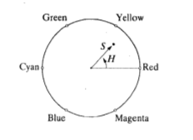

## Pan-sharpening

Pan sharpening is a process of merging high-resolution panchromatic and lower resolution multispectral imagery to create a single high-resolution color image.

Methods:

Gram-Schmidt Pan Sharpening

Pricipan Components (PC)

NNDiffuse Pan Sharpening

Color Normalized (CN)

Refs: <http://gsp.humboldt.edu/OLM/Courses/GSP_216_Online/lesson4-1/pan-sharpen.html>

Name:

## Prove the following

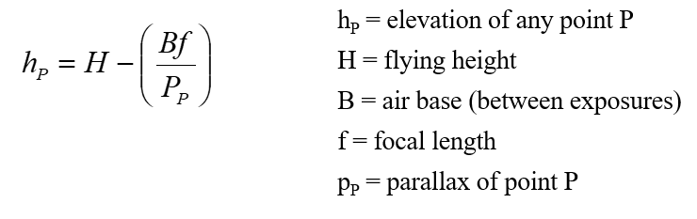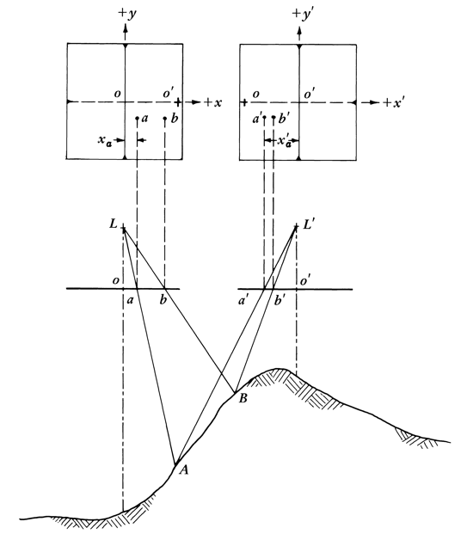

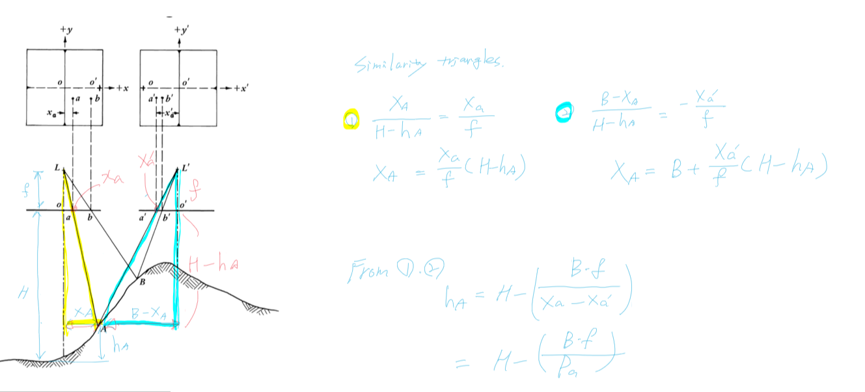

Similarity Triangles

1)

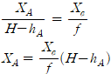

2)

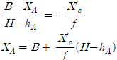

From 1), 2)

DRW00003be0bcc2

## Explain the following equation

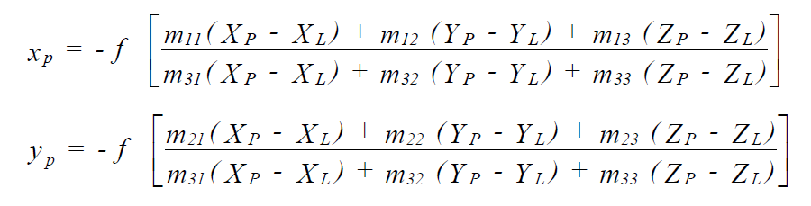

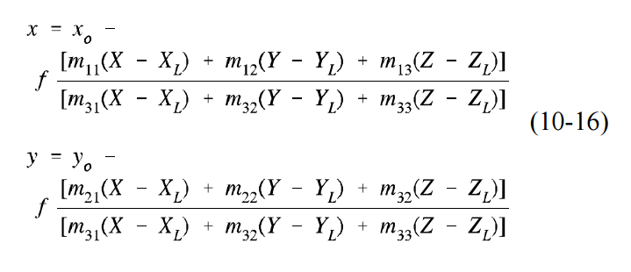

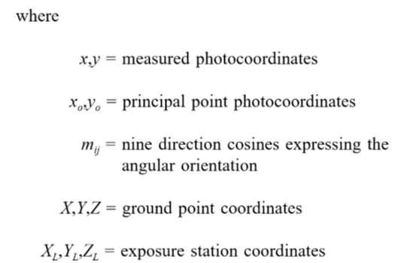

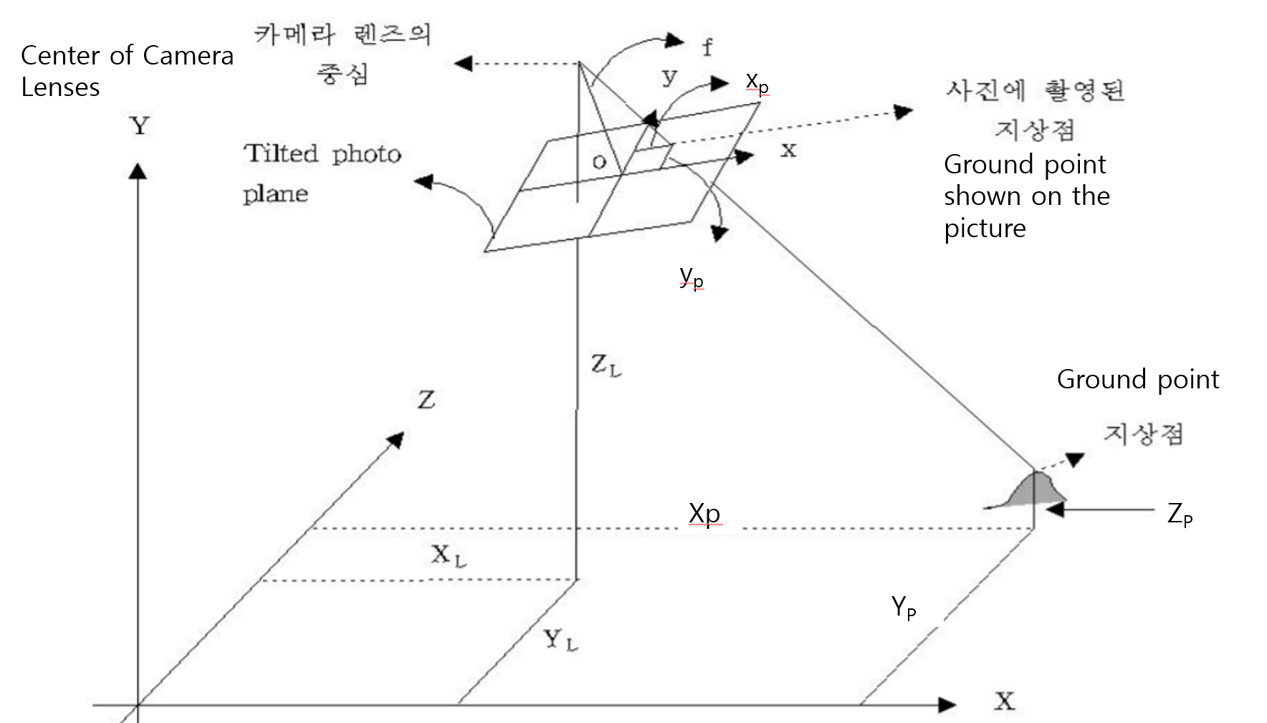

공간상의 임의의 점(대상물의 점 : XP, YP, ZP))과 그에 대응하는 사진상의 점(像點 :

x,y)및 사진기의 투영중심이 동일직선상에 있어야 하는 조건을 공선조건이라 한다.

공간상의 한점에서 출발한 빛은 (렌즈의)투영중심을 지나 필름상의 점으로 맺히므로 이 세점은 동일직선 상에 존재해야 한다.

An arbitrary point in space (object point: XP, YP, ZP) and the corresponding point on the photograph (Image: The condition that x,y) and the projection center of the camera must be on the same line is called the collinear condition.

Since the light from one point in space passes through the projection center (of the lens) and reaches the point on the film, these three points must exist on the same straight line.

공선조건식은 3점의 지상기준점을 이용하여 투영중심 O의 좌표와 표정인자()를 구하는 공간후방교회법과 공간후방교회법에 의해 결정된 6개의 표정인자와 상점(x,y)를 이용하여 새로운 지상점의 좌표(X,Y,Z)를 구하는 공간전방교회법에 이용된다.

The collinear conditional formula is used in the space intersection method to obtain the coordinates (X,Y,Z) of a new ground point with the coordinates of the projection center O and the factor () and determined 6 factor and point on the film that was obtained from Space Resection.

공간 후방교회법 (Space Resection)

공간 전방교회 (Sapce Intersection)

<보충, Supplement>

Sorry, I couldn’t fully understand, so if you don’t understand well about my things, check the refrences uploaded together. Good Luck!

1. 카메라 위치 좌표와 지상좌표 차이 (Diffrence between camera and ground point)

DRW00003acc8437

1. 지상(대상)좌표와 사진좌표 사이의 회전에 따른 좌표계산 (Rotation between ground point and camera )

DRW00003acc843d

M : 3차원 회전행렬 (카메라의 자세 변화에 대한 회전 조정을 위한 행렬)

(3 dimensional rotation matrix for adjustment of camera pose change)

1. 스케일 조정 (Scaling)

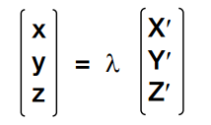

1)+2)+3) is

DRW00003acc8452 DRW00003acc8454

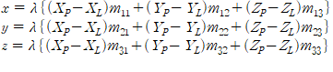

DRW00003acc8459

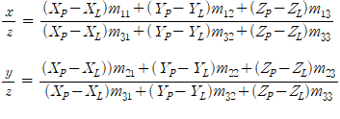

Z = f

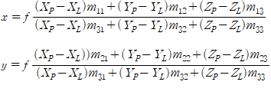

## Explain relief displacement

대상물(또는 지표면)에 기복(起伏)이 있을 경우, 연직으로 촬영하여도 축척은

동일하지 않으며, 사진면에서 연직점을 중심으로 방사상의 변위가 생기는데 이를

기복변위(relief displacement)라 한다.

If there are relief displacement on the object (or surface), the scale is not the same, and there is a radial displacement around the vertical point in the photo plane.

It is called relief displacement.

기복변위는 단카메라의 카메라 중심점에서의 사진상의 점까지의 거리 r, 지상고도 H, 대상물의 높이 h가 모두 비례 관계에 있는 원리를 이용하여 측정함.

△r = r*h/H 은 기복변위를 나타내는 식이다.

The relief displacement is measured using the principle that the distance(r) from the camera center point of the short camera to the point on the picture, the ground elevation (H), and the height of the object(h) are all in proportion.

Δr = r*h/H is an equation representing the undulation displacement.

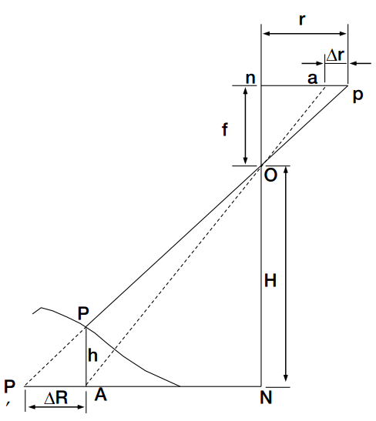 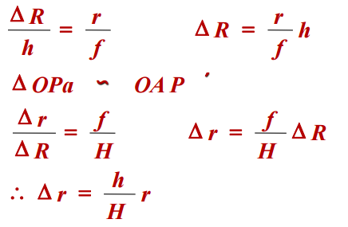

## Blackbody vs. Graybody

Blackbody is theoretical construct that absorbs all the radiantenergy striking it and radiates energy at the maximum possible rate perunit area at each wavelength for any given temperature. No objects in nature are true blackbodies.

Emissivity, ε , is the ratio between the radiant fluxexiting a real-world selective radiating body (Fr) and a blackbody at thesame temperature (Fb). Blackbody in thermal equilibrium has an emissivity ε= 1.0. but All selectively radiating bodies have emissivities ranging from 0 to < 1 that fluctuate depending upon the wavelengths of energy being considered. A graybody outputs a constant emissivity that is less thanone at all wavelengths.

## Kirchoff’s Radiation Law

We apply this law to take into account an object’s emissivity when we use thermal infrared remote sensing to measure an object’s true kinetic temperature.

This incident energy interacts with terrain materials. The amount of radiant flux reflected from the surface (Φr), the amount of radiant flux absorbed by the surface (Φα), and the amount of radiant flux transmitted through the surface (Φτ) can be carefully measured as we apply the principle of conservation of energy and attempt to keep track of what happens to all the incident energy.

Φ*i*λ=Φ*r*λ+Φαλ +Φτλ

Dividing each of the variables by the original incident radiant flux Φ*i*λ

1 = *r*λ + αλ + τλ

Where *r*λ is spectral hemispherical reflectance by the terrain, αλ is spectral hemispherical absorptance, and τλ is spectral hemispherical transmittance

the infrared portion of the spectrum the spectral emissivity of an object generally equals its spectral absorptance, i.e. αλ = ελ.(”good absorbers are good emitters and good reflectors are poor emitters”)

Also, most real-world materials are usually opaque to thermal infrared radiation, meaning that little radiant flux exits from the other side of the terrain element. Therefore, we may assume transmittance, τλ = 0.

1 = *r*λ + ελ

it explains If reflectivity increases then emissivity must decrease. If emissivity increases then reflectivity must decrease. Forexample, water absorbs almost all incident energy and reflects verylittle. Therefore, water is a very good emitter and has a high emissivityclose to 1. Conversely, a sheet metal roof reflects most of the incidentenergy, absorbs very little, yielding an emissivity much less than 1. Therefore, metal objects such as cars, aircraft, and metal roofs almostalways look very cold (dark) on thermal infrared imagery

## Diurnal Temperature Cycle

The diurnal cycle encompasses 24 hours. Beginning at sunrise, the earth beginsintercepting mainly short wavelength energy (0.4 - 0.7 m) from the Sun. From about6:00 am to 8:00 pm, the terrain intercepts the incoming short wavelength energy andreflects much of it back into the atmosphere where we can use optical remote sensors tomeasure the reflected energy. However, some of the incident short wavelength energy isabsorbed by the terrain and then re-radiated back into the atmosphere as thermalinfrared long wavelength radiation (3 - 14 m). The outgoing longwave radiationreaches its highest value during the day when the surface temperature is highest. Thispeak usually lags two to four hours after the midday peak of incoming shortwaveradiation, owing to the time taken to heat the soil. The contribution of reflected shortwavelength energy and emitted long wavelength energy causes an energy surplus to take place during the day. Both incoming and outgoing shortwave radiation becomezero after sunset (except for light from the moon and stars), but outgoing longwave radiation continues all night.

## Example of Thermal Infrared Remote Sensing

**10.4 – 12.5 μm (thermal infrared).** This band measures the amount of infrared radiant energy emitted from surfaces. The apparent temperature is a function of the emissivities and the true (kinetic) temperature of the surface. It is useful for locating geothermal activity, thermal inertia mapping for geologic investigations, vegetation classification, vegetation stress analysis, and soil moisture studies. The band often captures unique information on differences in topographic aspect in mountainous areas.

1) Water Pollution Monitoring: Identification of Thermal Effluent in the Savannah Rivera thermal infrared detector

2)Thermal Infrared Residential Insulation Surveys

3)Thermal Infrared Commercial/Industrial Roof Moisture Surveys

4)Analysis of the Urban Heat Island Effect

5)Use of Thermal Infrared Imagery for ForestryApplications

6)Remote Sensing Plant Stress Degree Days

## Goniometer and BRDF

The bidirectional reflectance distribution function (BRDF) quantifies the geometric

radiance distribution which results from light incident in any direction. Most terrain surfaces (soil, vegetation, and even water) reveal a relationship between the amount of reflected radiance, and 1) the geometric characteristics of the Sun’s irradiance,

and 2) the sensor viewing geometry.

Scientists have developed instruments to measure the bidirectional reflectance distribution function of various surface. One of the most useful instruments is the goniometer.

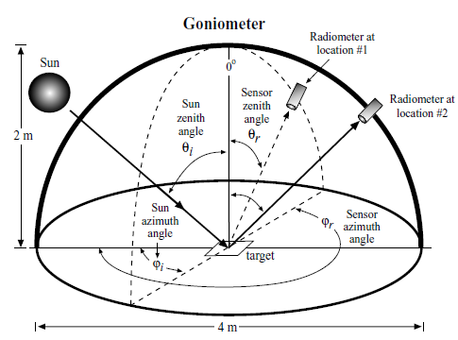

## Limitations and potential of RS for crop yield estimation

Limitations :

The accuracy of a remote sensing derived crop classification map is always dependent upon there **being a significant difference in the spectral response** between the various crop types. The only way to identify when this maximum contrast among spectral response should take place is to evaluate the phenological crop calendars and select **the appropriate dates of imagery for analysis**. Then classification maps can be used to predict the amount of acreage in specific crops at a given instant in time. Such information coupled with agricultural-meteorological models can be used to predict crop yield.

Potential : Early assessment of yield reductions help in strategic planning to meet the demands

## Tasseled Cap Transformation

Tasseled Cap Transformation is about **orthogonal transformation** of the original **Landsat MSS data** space to **a new four-dimensional feature space**(soil brightness index(B), greenness vegetation index(G), yellow stuff index(Y), none-such(N)

*B* = 0.332*MSS1* + 0.603*MSS2* + 0.675*MSS3* + 0.262*MSS4*

*G* = – 0.283*MSS1* – 0.660*MSS2* + 0.577*MSS3* + 0.388*MSS4*

*Y* = – 0.899*MSS1* + 0.428*MSS2* + 0.076*MSS3* – 0.041*MSS4*

*N* = – 0.016*MSS1* + 0.131*MSS2* – 0.452*MSS3* + 0.882*MSS4*

**Visible, near-infrared, and middle-infrared coefficients** for transforming **Landsat Thematic Mapper imagery** into **brightness, greenness, and wetness variables**

*B* = 0.2909*TM*1 + 0.2493*TM*2 + 0.4806*TM*3 +

0.5568*TM*4 + 0.4438*TM*5 + 0.1706*TM*7

*G* = – 0.2728*TM*1 – 0.2174*TM*2 – 0.5508*TM*3 +

0.7221*TM*4 + 0.0733*TM*5 – 0.1648*TM*7

*W* = 0.1446*TM*1 + 0.1761*TM*2 + 0.3322*TM*3 +

0.3396*TM*4 – 0.6210*TM*5 – 0.4186*TM*7

The tasseled cap transformation is a global vegetation index. Theoretically, it can be used anywhere in the world to disaggregate the amount of soil brightness, vegetation, and moisture content in individual pixels in a Landsat MSS or Thematic Mapper image. Practically, however, it is better to compute the coefficients based on local conditions.

## EVI

EVI(Enhanced Vegetation Index) is a modified NDVI with soil adjustment factor L, two coefficients, C1, and C2, which describe the use of blue band in correction of the red band for atmospheric aerosol scattering. The EVI has improved sensitivity to high biomass.

BRDF is given by

$$EVI=\frac{p_{nir}-p_{red}}{p_{nir}+C1*p_{red}-C2*p_{blue}+L}(1+L)$$

Where, C1, C2, L are empirically determined as 6.0, 7.5, 1.0

qz 10. ch 12.

## USGS Level 1, 2, 3, 4

They are landcover classification system level by USGS and the minimum remote sensing resolutions required to provide such data are following.

|  |  |  |  |
| --- | --- | --- | --- |
| Land Use/Cover | Temporal resolution | Spatial resolution | Spectral band |
| USGS Level 1 | 5-10yr | 20-100m | VIS-NIR-MIR-Radar |
| USGS Level 2 | 5-10yr | 5-20m | VIS-NIR-MIR-Radar |
| USGS Level 3 | 3-5yr | 1-5m | Pan-Vis-NIR-MIR |
| USGS Level 4 | 1-3yr | 0.25-1m | Pan |

Urban land-use and land-cover classes in Levels I through IV have temporal attribute requirements ranging from 1 – 10 years. General sensors have temporal resolutions of < 55 days, so the temporal resolution of the land-use/land-cover attributes is satisfied by the current and proposed sensor systems.

## Design a Remote Sensing based algorithm for population estimation

One of the techniques is based on the use of the Level I – III land-use information. This approach assumes that land use in an urban area is closely correlated with population density.

1. Establish an empirical value for the population density for each land use by field survey or census data (e.g., multiplefamily residential housing may contain five persons per pixel when using 30 × 30 m Thematic Mapper data; rural forested areas might have only 0.20 persons per pixel).

2. By measuring the total area for each land-use category, we can estimate the total population for that category.

3. Summing the estimated totals for each land-use category provides the total population projection.

## Present an urban application using historical aerial images

Based on remote sensing data of historical aerial images, iron and steel heat-processing industries can be identified. There is an example of historical aerial photograph of a small portion of the Bethlehem Steel Company at Sparrows Point, MD, in 1952, which recorded numerous long buildings that house the steel rolling mills and blast furnaces, many support buildings, and considerable smoke from large stacks.

## Explain the following equation

*Lv = f* [*wc(), SMc(), Chlc(), wc()* ]

This equation is used when conducting water quality studies or trying to predict water productivity using remote sensing data. $L_{v}$ represents the subsurface volumetric radiance, which is the radiance from the downwelling solar and sky radiation that actually penetrates the air-water interface, interacts with the water and organic/inorganic constituents, and then exists the water column toward the sensor without encountering the bottom.

$L_{v}$ is a function of the concentration of pure water ($w$), inorganic suspended minerals ($SM$), organic chlorophyll *a* ($Chl$), dissolved organic material ($DOM$), and the total amount of absorption and scattering attenuation that takes place in the water column due to each of these constituents, $c(λ)$

## How to estimate ocean chlorophyll using remote sensing

$$Chl=x{\left[\frac{L\left(λ_{1}\right)}{L\left(λ_{2}\right)}\right]}^{y}$$

A relationship between selected spectral bands and ocean chlorophyll concentration ($Chl$) using the above equation. $L\left(λ_{1}\right)$, and $L\left(λ_{2}\right)$ are the upwelling radiances at selected wavelengths recorded by the remote sensing system and $x$ and $y$ are empirically derived constants.

However, this approach does not take into account the absorption and scattering characteristics of the inorganic and organic constituents of the study area. It is successful in the mid-ocean, chlorophyll pigments are the principal colorant of Case I (e.g., deep ocean) waters.

## Secchi Depth

Secchi depth is measured with secchi disk indicating suspended sediment in water bodies. The disk is used to measure water transparency or turbidity in bodies of water. The disk is mounted on a pole or line and lowered slowly down in the water. The depth at which the disk is no longer visible is taken as a measure of the transparency of the water.

## Discrimination of clouds and snow

When remote sensed images contain both cloud and snow, it is possible to utilize the middle-infrared portion of the spectrum to differentiate between snow and cloud cover. Throughout the visible and near-infrared portions of the spectrum, cloud and snow reflect approximately equal amount of radiant flux. However, in the middle-infrared portion of the spectrum (especially 1.5-2.5μm) clouds continue to reflect a substantial amount of energy, while snow reflectance drops near zero. In this region clouds have a very high reflectance and appear white in the imagery, while the snow has a very low reflectance and appears black.

