Exercise: The Author and Book Classes

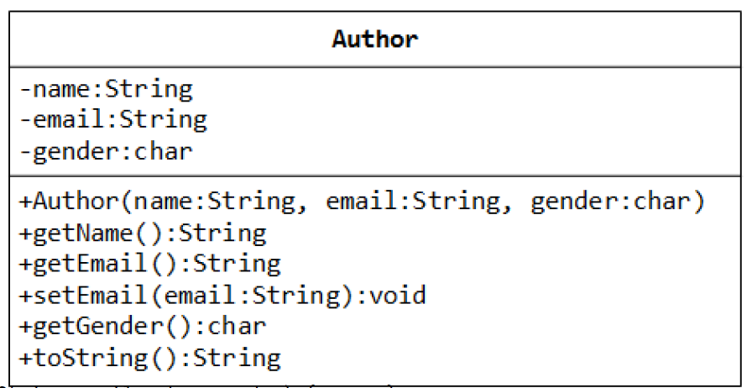A class called Author is designed

as shown in the class diagram. It

contains:

Three private instance

variables: name ﴾String﴿, email

﴾String﴿, and gender ﴾char of

either 'm' or 'f'﴿;

One constructor to initialize the

name, email and gender with

the given values;

public Author (String name, String email, char gender) {......}

﴾There is no default constructor for Author, as there are no defaults for name, email and gender.﴿

public getters/setters: getName(), getEmail(), setEmail(), and getGender();

﴾There are no setters for name and gender, as these attributes cannot be changed.﴿

A toString() method that returns "*author‐name (gender) at email*", e.g., "Tan Ah Teck ﴾m﴿ at

ahTeck@somewhere.com".

Write the Author class. Also write a *test program* called TestAuthor to test the constructor and public methods.

Try changing the email of an author, e.g.,

Author anAuthor = new Author("Tan Ah Teck", "ahteck@somewhere.com", 'm');

System.out.println(anAuthor); // call toString()

anAuthor.setEmail("paul@nowhere.com")

System.out.println(anAuthor);

A class called Book is designed as shown in the class diagram. It contains:

Four private instance variables: name ﴾String﴿, author ﴾of the class Author you have just created, assume

that each book has one and only one author﴿, price ﴾double﴿, and qtyInStock ﴾int﴿;

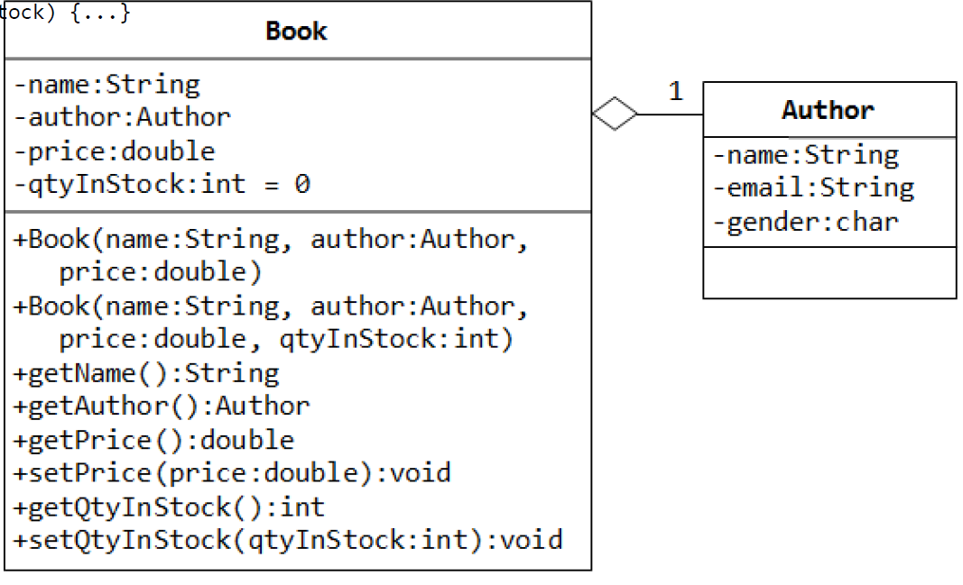Two constructors:

public Book (String name, Author author, double price) {...}

public Book (String name, Author author, double price,

int qtyInStock) {...}

public methods

getName(),

getAuthor(),

getPrice(),

setPrice(),

getQtyInStock(), setQtyInStock().

toString() that returns "*'book‐name' by author‐name (gender) at email*".

﴾Take note that the Author's toString() method returns "*author‐name (gender) at email*".﴿

Write the class Book ﴾which uses the Author class written earlier﴿. Also write a test program called TestBook to test

the constructor and public methods in the class Book. Take Note that you have to construct an instance of Author

before you can construct an instance of Book. E.g.,

Author anAuthor = new Author(......);

Book aBook = new Book("Java for dummy", anAuthor, 19.95, 1000);

// Use an anonymous instance of Author

Book anotherBook = new Book("more Java for dummy", new Author(......), 29.95, 888);

Take note that both Book and Author classes have a variable called name. However, it can be differentiated via the

referencing instance. For a Book instance says aBook, aBook.name refers to the name of the book; whereas for an

Author's instance say auAuthor, anAuthor.name refers to the name of the author. There is no need ﴾and not

recommended﴿ to call the variables bookName and authorName.

TRY:

1. Printing the name and email of the author from a Book instance. ﴾Hint: aBook.getAuthor().getName(),

aBook.getAuthor().getEmail()﴿.

2. Introduce new methods called getAuthorName(), getAuthorEmail(), getAuthorGender() in the Book

class to return the name, email and gender of the author of the book. For example,

public String getAuthorName() { ...... }