## Exercise: The MyTime Class

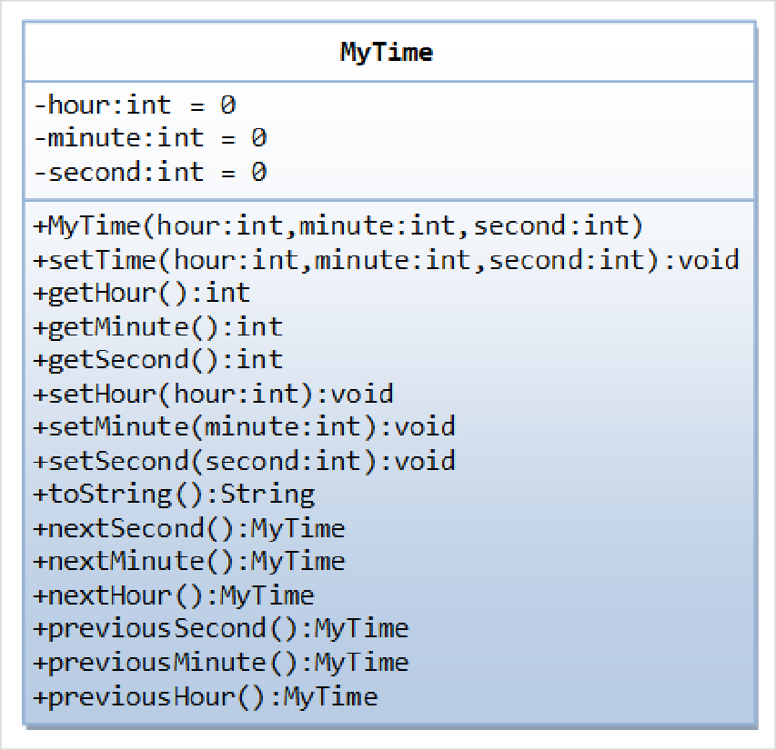A class called MyTime, which models a time instance, is designed as shown in the class diagram.

It contains the following private

instance variables:

hour: between 0 to 23.

minute: between 0 to 59.

Second: between 0 to 59.

The constructor shall invoke the setTime() method ﴾to be described later﴿ to set the instance variable.

It contains the following public

methods:

 setTime(int hour, int minute, int second): It shall check if the given hour, minute and second are valid before setting the instance variables.

﴾Advanced: Otherwise, it shall throw an

IllegalArgumentException with the message "Invalid hour, minute, or second!".﴿

Setters setHour(int hour), setMinute(int minute), setSecond(int second): It shall check if the parameters are valid, similar to the above.

Getters getHour(), getMinute(), getSecond(). toString(): returns "HH:MM:SS".

nextSecond(): Update this instance to the next second and return this instance. Take note that the

nextSecond() of 23:59:59 is 00:00:00.

nextMinute(), nextHour(), previousSecond(), previousMinute(), previousHour(): similar to the above.

Write the code for the MyTime class. Also write a test program ﴾called TestMyTime﴿ to test all the methods defined in the MyTime class.

## Exercise: The MyDate Class

A class called MyDate, which models a date instance, is defined as shown in the class diagram. The MyDate class contains the following private instance variables:

year ﴾int﴿: Between 1 to 9999.

month ﴾int﴿: Between 1 ﴾Jan﴿ to 12 ﴾Dec﴿.

day ﴾int﴿: Between 1 to 28|29|30|31, where the last day depends on the month and whether it is a leap year for Feb ﴾28|29﴿.

It also contains the following private static variables ﴾drawn with underlined in the class diagram﴿:

strMonths ﴾String[]﴿, strDays ﴾String[]﴿, and dayInMonths ﴾int[]﴿: static variables, initialized as shown, which are used in the methods.

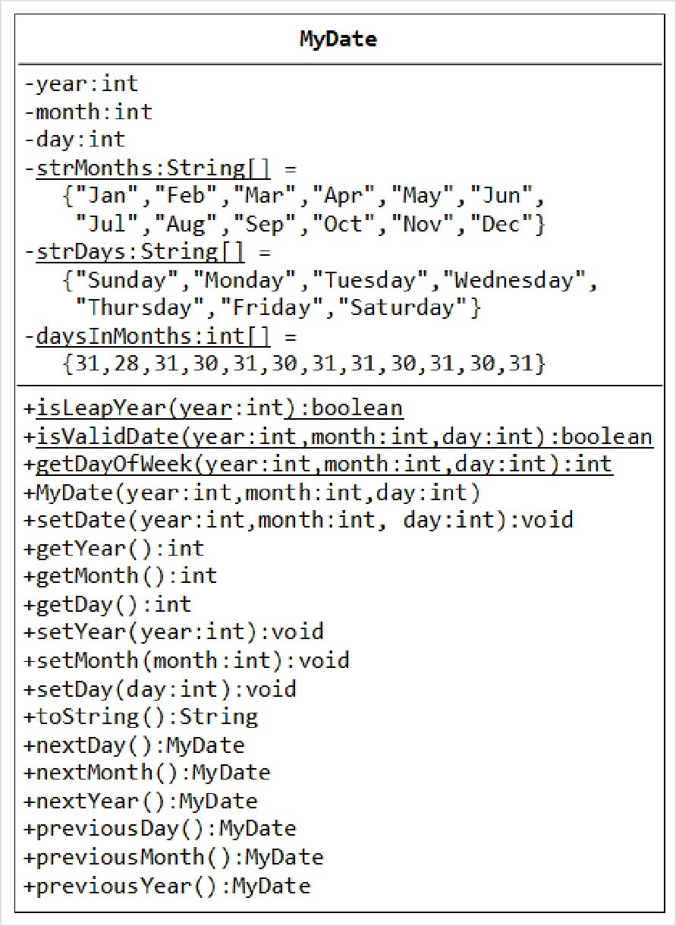The MyDate class has the following public static methods ﴾drawn with underlined in the class diagram﴿:

isLeapYear(int year):

returns true if the given year is a leap year. A year is a leap year if it is divisible by 4 but not by 100, or it is divisible by 400.

 isValidDate(int year, int month, int day): returns true if the given year, month, and day constitute a valid date. Assume that year is between 1 and 9999, month is between 1

﴾Jan﴿ to 12 ﴾Dec﴿ and day shall be between 1 and 28|29|30|31 depending on the month and whether it is a leap year on Feb.

 getDayOfWeek(int year, int month, int day): returns the day of the week, where 0 for Sun, 1 for Mon, ..., 6 for Sat, for

the given date. Assume that the [date is valid. Read the earlier exercise on how to determine the day of the week ﴾or Wiki](https://www3.ntu.edu.sg/home/ehchua/programming/java/J2a_BasicsExercises.html#dateutil) "Determination of the day of the week"﴿.

The MyDate class has one

constructor, which takes 3 parameters: year, month and day. It shall invoke setDate() method ﴾to be described later﴿ to set the instance variables.

The MyDate class has the following public methods:

setDate(int year, int month, int day): It shall invoke the static method isValidDate() to verify that the given year, month and day constitute a valid date.

﴾Advanced: Otherwise, it shall throw an IllegalArgumentException with the message "Invalid year, month, or day!".﴿

setYear(int year): It shall verify that the given year is between 1 and 9999.

﴾Advanced: Otherwise, it shall throw an IllegalArgumentException with the message "Invalid year!".﴿

setMonth(int month): It shall verify that the given month is between 1 and 12.

﴾Advanced: Otherwise, it shall throw an IllegalArgumentException with the message "Invalid month!".﴿

setDay(int day): It shall verify that the given day is between 1 and dayMax, where dayMax depends on the

month and whether it is a leap year for Feb.

﴾Advanced: Otherwise, it shall throw an IllegalArgumentException with the message "Invalid month!".﴿

getYear(), getMonth(), getDay(): return the value for the year, month and day, respectively.

toString(): returns a date string in the format "xxxday d mmm yyyy", e.g., "Tuesday 14 Feb 2012".

nextDay(): update this instance to the next day and return this instance. Take note that nextDay() for 31 Dec 2000 shall be 1 Jan 2001.

nextMonth(): update this instance to the next month and return this instance. Take note that nextMonth()

for 31 Oct 2012 shall be 30 Nov 2012.

nextYear(): update this instance to the next year and return this instance. Take note that nextYear() for

29 Feb 2012 shall be 28 Feb 2013.

﴾Advanced: throw an IllegalStateException with the message "Year out of range!" if year > 9999.﴿

previousDay(), previousMonth(), previousYear(): similar to the above.

Write the code for the MyDate class.

Use the following test statements to test the MyDate class:

MyDate d1 = new MyDate(2012, 2, 28); System.out.println(d1); // Tuesday 28 Feb 2012

System.out.println(d1.nextDay()); // Wednesday 29 Feb 2012

System.out.println(d1.nextDay()); // Thursday 1 Mar 2012

System.out.println(d1.nextMonth()); // Sunday 1 Apr 2012

System.out.println(d1.nextYear()); // Monday 1 Apr 2013

MyDate d2 = new MyDate(2012, 1, 2);

System.out.println(d2); // Monday 2 Jan 2012

System.out.println(d2.previousDay()); // Sunday 1 Jan 2012

System.out.println(d2.previousDay()); // Saturday 31 Dec 2011

System.out.println(d2.previousMonth()); // Wednesday 30 Nov 2011

System.out.println(d2.previousYear()); // Tuesday 30 Nov 2010

MyDate d3 = new MyDate(2012, 2, 29); System.out.println(d3.previousYear()); // Monday 28 Feb 2011

// MyDate d4 = new MyDate(2099, 11, 31); // Invalid year, month, or day!

// MyDate d5 = new MyDate(2011, 2, 29); // Invalid year, month, or day!

Write a test program that tests the nextDay() in a loop, by printing the dates from 28 Dec 2011 to 2 Mar 2012.