PRIYADARSHINI COLLEGE OF ENGINEERING, NAGPUR
Department of Information Technology

BLOCKCHAIN TECHNOLOGY MINI PROJECT REPORT
CHARITYCHAIN
Transparent Charity Donation Tracking Using Blockchain

Submitted by
Tamini Agre
Third Year – Information Technology | Semester V | Section A

Submitted to
Department of Information Technology

Academic Year: 2026–2027

DECLARATION
I hereby declare that the mini project titled “CharityChain: Transparent Charity Donation Tracking Using Blockchain” is prepared for academic learning and demonstration. The implementation and report should be reviewed, tested, and completed by me before submission. Any screenshots, deployment addresses, and transaction hashes included in the final submitted copy must be captured from my own execution. I understand that the prototype is not audited and is not intended to process real donations.
Student Signature: __________________________
Date: __________________ Place: Nagpur

ACKNOWLEDGEMENT
I express my sincere gratitude to the faculty members of the Department of Information Technology, Priyadarshini College of Engineering, Nagpur, for providing the opportunity to study and implement a practical application of Blockchain Technology. I am thankful for the guidance and academic support that helped me understand smart contracts, transactions, and decentralized applications. I also acknowledge the open-source tools and documentation used to build this educational prototype.

ABSTRACT
CharityChain is a blockchain-based prototype designed to demonstrate transparent charity campaign management and donation tracking. Traditional donation processes may depend on a central organization to maintain records, which can make independent verification difficult for donors. CharityChain uses a Solidity smart contract deployed on an Ethereum-compatible development network to store campaign information, record donations, and control fund withdrawal. Each donation is submitted as a blockchain transaction, and contract events provide a traceable record of important actions. The beneficiary address is specified when a campaign is created, and only that beneficiary can withdraw the collected amount. A lightweight web interface built with HTML, CSS, JavaScript, and ethers.js can connect to MetaMask and interact with the deployed contract. The project illustrates smart-contract rules, wallet-based identity, transaction execution, event logs, and the role of consensus in maintaining a shared ledger. It is intended strictly for educational testing; it does not prove that a real-world charity is legitimate or guarantee how funds are used after withdrawal.

TABLE OF CONTENTS
- 1. Introduction
- 2. Problem Statement
- 3. Objectives
- 4. Scope and Limitations
- 5. Blockchain Platform and Tools Used
- 6. System Architecture
- 7. Smart Contract Design
- 8. Implementation and Execution
- 9. Testing and Results
- 10. Screenshots and Outputs
- 11. Security and Ethical Considerations
- 12. Conclusion
- 13. Future Scope
- 14. References
- Appendix A: GitHub Repository Structure

1. INTRODUCTION
Blockchain is a distributed digital ledger in which transactions are grouped into blocks and linked using cryptographic hashes. Copies of the ledger are maintained by network participants, and a consensus mechanism helps the network agree on the valid history. Once a transaction is confirmed, changing the historical record is designed to be difficult and detectable.
A smart contract is a program deployed to a blockchain. It executes predefined rules when users submit transactions. In a donation application, a smart contract can maintain campaign totals and enforce rules such as who is permitted to withdraw collected funds. This reduces reliance on a single editable database for the donation record.
CharityChain is a small educational decentralized application (DApp). It allows the contract owner to create a campaign, allows wallets to donate cryptocurrency to an active campaign, records donor contributions and campaign totals, and restricts withdrawal to the beneficiary named at creation. The frontend offers a simple way to call contract functions through a browser wallet.

2. PROBLEM STATEMENT
In a conventional donation workflow, information about campaigns and received donations may be stored in databases controlled by one organization. Donors may have limited ability to independently inspect the record, and administrators must be trusted to maintain accurate totals. The project addresses the record-transparency part of this problem by storing campaign totals and donation transactions on a blockchain and enforcing withdrawal permissions in a smart contract.

3. OBJECTIVES
- To understand the basic structure and operation of a blockchain network.
- To write and compile a Solidity smart contract for charity campaign management.
- To create campaigns with a beneficiary, description, and fundraising goal.
- To record donations and update campaign totals through blockchain transactions.
- To restrict withdrawal so that only the assigned beneficiary can withdraw the collected funds.
- To demonstrate transaction receipts and smart-contract events.
- To connect a browser-based interface to a wallet using ethers.js and MetaMask.
- To document the source code, execution steps, tests, and limitations in a GitHub repository.

4. SCOPE AND LIMITATIONS

4.1 Scope
The prototype supports campaign creation by the contract owner, public donations to active campaigns, public inspection of campaign data, beneficiary-only withdrawal, campaign closure by the owner, and event-based transaction tracing. It is suitable for local demonstrations and test networks.

4.2 Limitations
- The contract is an academic prototype and has not undergone a professional security audit.
- It does not verify the real-world identity, honesty, or legal status of a charity or beneficiary.
- It does not automatically prove how funds are spent after they are withdrawn.
- Blockchain transactions may require gas fees on public networks; test networks use valueless test assets.
- The owner is a privileged role and can create or close campaigns.
- The sample interface requires the deployed contract address and matching ABI to be configured before use.

5. BLOCKCHAIN PLATFORM AND TOOLS USED
Tool / Technology | Purpose | Use in Project
Solidity 0.8.20 | Smart-contract programming language | Defines campaign state, donation rules, permissions, and events.
Ethereum-compatible blockchain | Distributed transaction ledger | Stores contract state and transaction history.
Remix IDE | Browser-based Solidity IDE | Compile, deploy, and interact with the contract.
Remix VM / test network | Development environment | Test transactions without real donations.
MetaMask | Browser wallet | Connects a user account and signs transactions for the frontend.
HTML and CSS | Frontend structure and design | Displays campaign cards and forms.
JavaScript | Frontend behaviour | Validates input and calls contract methods.
ethers.js v6 | Blockchain JavaScript library | Connects to the provider and sends contract transactions.
GitHub | Version control and project hosting | Stores source code, README, and documentation.

6. SYSTEM ARCHITECTURE
The system has four main layers: the user interface, wallet/provider, smart contract, and blockchain network. A donor enters an amount in the browser interface. The frontend asks the wallet to approve and sign the transaction. The signed transaction is submitted to the selected blockchain network. The contract checks its conditions, updates the campaign state, and emits an event. After confirmation, the frontend can refresh and read the updated state.
- User / Donor / Beneficiary — uses the interface or calls contract functions in Remix.
- Frontend — HTML, CSS, JavaScript, and ethers.js display data and construct contract calls.
- Wallet / Provider — MetaMask or Remix account signs transactions and connects to the network.
- CharityChain Smart Contract — checks permissions, records donations, and controls withdrawal.
- Blockchain Network — executes the contract and stores the resulting state and transaction history.
SYSTEM FLOW
Donor / Owner / Beneficiary
↓
Web Interface (HTML, CSS, JavaScript + ethers.js) or Remix IDE
↓ wallet signs transaction
Ethereum-compatible development network
↓
CharityChain.sol — validation, state update, event emission
↓
Confirmed transaction and updated campaign record

6.1 Transaction flow
- The owner deploys the contract; the deploying address becomes the owner.
- The owner creates a campaign and specifies the beneficiary address and fundraising goal.
- A donor chooses an active campaign and submits a positive ETH amount.
- The contract checks that the campaign exists, is active, and the amount is greater than zero.
- The contract updates the campaign total and the donor's contribution mapping, then emits DonationReceived.
- The beneficiary calls withdrawFunds. The contract checks the caller and whether funds have already been withdrawn.
- After a successful withdrawal, the campaign is marked inactive and withdrawn, and FundsWithdrawn is emitted.

7. SMART CONTRACT DESIGN
The main contract file is contracts/CharityChain.sol. It uses Solidity version ^0.8.20 and defines the state and rules of the application.

7.1 Data structure
Each Campaign stores an ID, payable beneficiary address, title, description, fundraising goal in wei, total donations in wei, active status, and withdrawn status. The campaigns mapping stores campaign records by ID. The donations mapping stores the total amount donated by a wallet to a particular campaign.

7.2 Main functions
Function | Access / Input | Purpose
constructor() | Runs once at deployment | Sets the deploying address as owner.
createCampaign(...) | Owner only | Creates a campaign after validating beneficiary, title, and goal.
donate(campaignId) | Any wallet; payable | Accepts positive ETH for an active campaign and updates totals.
withdrawFunds(campaignId) | Campaign beneficiary only | Transfers the recorded amount and marks the campaign withdrawn.
closeCampaign(campaignId) | Owner only | Stops further donations to an active campaign.
getCampaign(campaignId) | Read-only | Returns the campaign fields for display.
owner(), campaignCount(), donations(...) | Read-only getters | Expose owner, count, and a donor's contribution.

7.3 Events
- CampaignCreated — emitted when a campaign is created.
- DonationReceived — emitted for each successful donation and includes campaign ID, donor, amount, and timestamp.
- FundsWithdrawn — emitted after a beneficiary withdraws collected funds.
- CampaignClosed — emitted when the owner closes a campaign.

7.4 Access control and validation
The onlyOwner modifier restricts campaign creation and closure to the contract owner. The withdrawal function checks that the caller equals the beneficiary address. Other checks reject an invalid beneficiary, empty title, zero goal, missing campaign, inactive campaign, zero donation, and repeated withdrawal. These checks illustrate how smart contracts enforce rules independently of the frontend.

8. IMPLEMENTATION AND EXECUTION

8.1 Compile and deploy using Remix
- Open https://remix.ethereum.org/ in a browser.
- Create a file named CharityChain.sol and paste the code from the contracts folder.
- Open Solidity Compiler, select version 0.8.20 (or a compatible 0.8.x compiler), and compile.
- Open Deploy & Run Transactions and select Remix VM for a safe local demonstration.
- Click Deploy. The account that deploys the contract becomes the owner.
- Copy an available test account address as the beneficiary.
- Call createCampaign with beneficiary address, title Flood Relief, description Demo campaign for flood-affected families, and goalWei 1000000000000000000 (1 ETH expressed in wei).
- To donate, select a test account, enter campaign ID 1, set transaction Value to 0.1 ether, and call donate.
- Switch to the beneficiary account and call withdrawFunds(1).
- Call getCampaign(1) and inspect transaction receipts and emitted events.

8.2 Configure the web frontend
- Deploy the contract to a network accessible to MetaMask.
- Copy the deployed contract address into CONTRACT_ADDRESS in frontend/app.js.
- Copy the complete ABI generated by Remix into the ABI array if needed; ensure it matches the deployed contract.
- Serve the frontend folder using VS Code Live Server or another local static server.
- Unlock MetaMask, choose the same network, and connect the wallet.
- Create a campaign using the form, donate from a different account, and use the beneficiary wallet to withdraw.
Note: The provided ABI in app.js is a minimal human-readable ABI for the included methods and events. If the frontend fails because of an ABI mismatch, use the ABI generated by Remix for the exact compiled contract.

9. TESTING AND RESULTS
Testing should be performed on Remix VM or a test network. A successful transaction is recorded in the selected development chain and the contract state changes only after execution. The test checklist is also supplied in docs/TESTING_CHECKLIST.md.
Test case | Expected output | Status to fill after running
Compile contract | Compilation succeeds with no errors | Pending execution
Create valid campaign | Campaign ID increments; CampaignCreated event appears | Pending execution
Donate positive amount | Total and donor contribution increase; DonationReceived appears | Pending execution
Donate zero amount | Transaction reverts | Pending execution
Withdraw as beneficiary | Funds transfer; campaign becomes inactive/withdrawn | Pending execution
Withdraw as another wallet | Transaction reverts | Pending execution
Withdraw twice | Second attempt reverts | Pending execution
Close campaign as owner | Campaign becomes inactive; CampaignClosed appears | Pending execution
Do not mark tests as passed until they have actually been executed. Replace the status column with the observed result after testing.

10. SCREENSHOTS AND OUTPUTS
Insert your own screenshots in the spaces below after running the project. The report intentionally does not use fabricated screenshots or transaction hashes.

Screenshot 1: Solidity compilation
Capture Remix showing CharityChain.sol compiled successfully.

Observed output / transaction hash: ______________________________________________

Screenshot 2: Contract deployment
Capture the deployed contract in Remix and the development account/network.

Observed output / transaction hash: ______________________________________________

Screenshot 3: Campaign creation
Capture the createCampaign transaction and CampaignCreated event.

Observed output / transaction hash: ______________________________________________

Screenshot 4: Donation transaction
Capture donate transaction with the Value field and transaction receipt/event.

Observed output / transaction hash: ______________________________________________

Screenshot 5: Campaign state
Capture getCampaign output showing the donation total and active status.

Observed output / transaction hash: ______________________________________________

Screenshot 6: Beneficiary withdrawal
Capture successful withdrawal and updated withdrawn status.

Observed output / transaction hash: ______________________________________________

Screenshot 7: Frontend
After configuring the address and ABI, capture the CharityChain page and connected wallet.

Observed output / transaction hash: ______________________________________________
Illustrative preview images (these are design/architecture previews, not captured transaction evidence). Replace or supplement these with your own screenshots from Remix and the connected frontend after running the project.
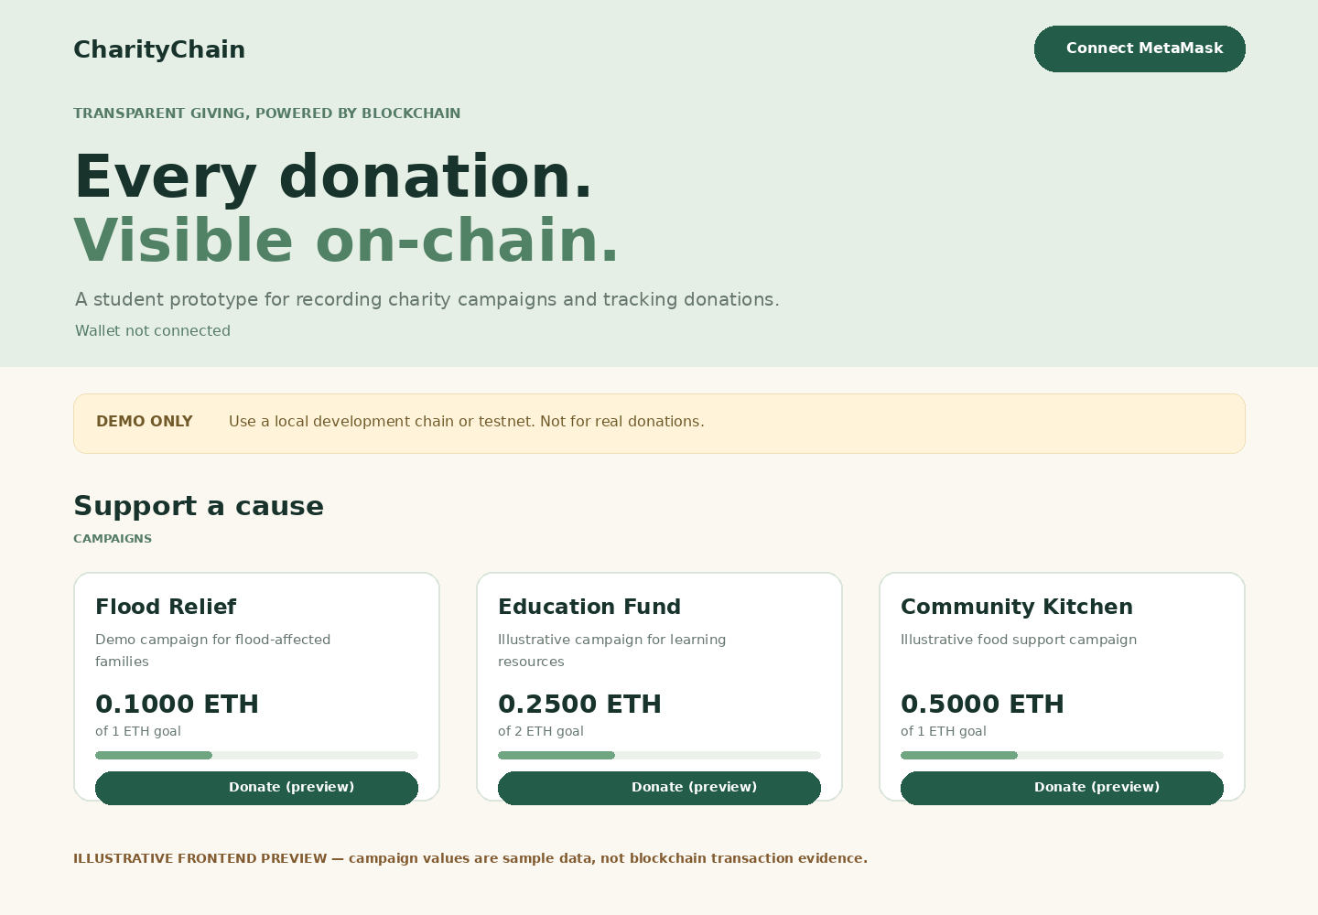
Figure 10.1: Illustrative CharityChain frontend preview.
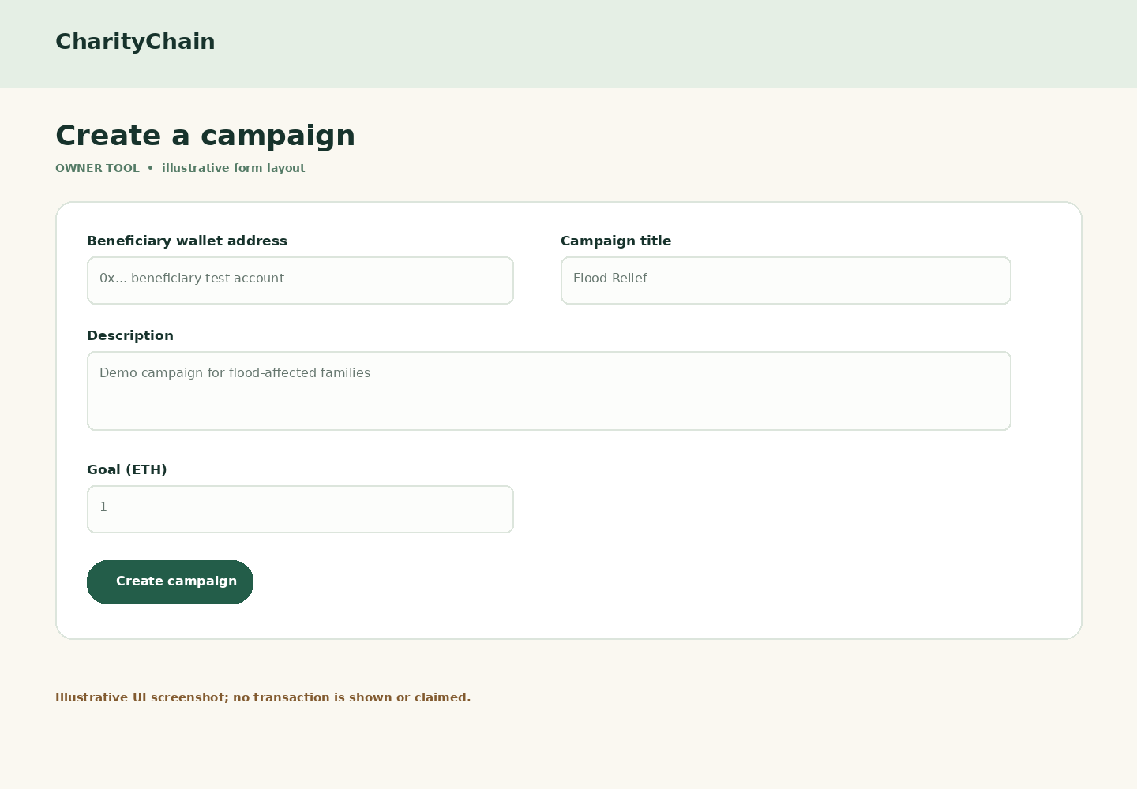
Figure 10.2: Illustrative campaign creation form preview.
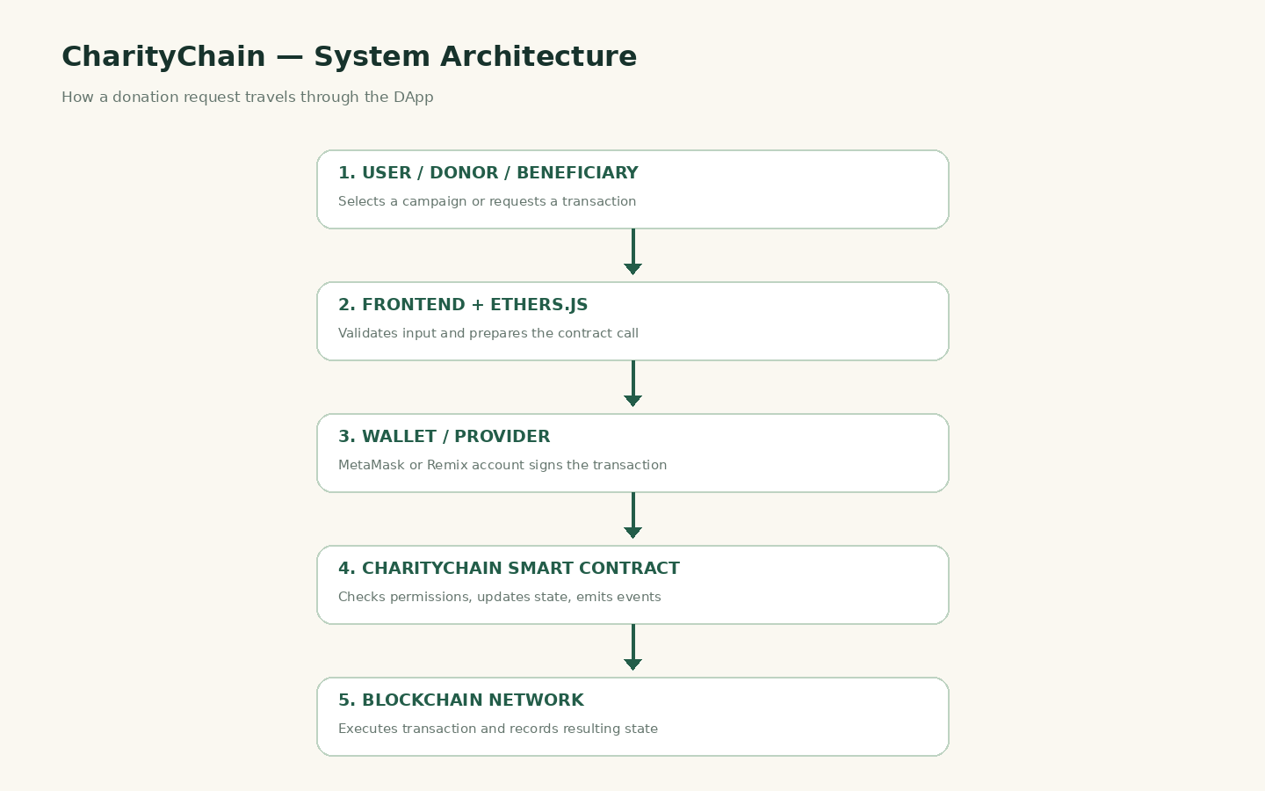
Figure 10.3: CharityChain system architecture preview.

11. SECURITY AND ETHICAL CONSIDERATIONS
- Use Remix VM or a test network for the demonstration. Do not send real donations through this academic prototype.
- Never share a wallet seed phrase or private key. The application should never request either.
- Blockchain data is generally public and permanent; do not store donor names, addresses, medical details, or other sensitive information on-chain.
- The contract has not been audited. A real deployment requires professional review and more comprehensive testing.
- The prototype tracks funds received and withdrawn by the contract, but it cannot verify how the beneficiary spends funds after withdrawal.
- Only use test wallets and valueless test assets for screenshots and classroom evaluation.

12. CONCLUSION
CharityChain demonstrates how blockchain and Solidity smart contracts can support transparent recording of charity campaigns and donations. It uses on-chain state to track campaign goals and received amounts, mappings to associate donations with wallets, events to expose important transactions, and access checks to restrict withdrawal to the designated beneficiary. Remix provides a simple environment for compiling and testing the contract, while a browser interface using ethers.js and MetaMask demonstrates how a DApp interacts with a blockchain. The project meets the learning goals of smart-contract design, transaction execution, access control, and decentralized application development. Its results must be verified by running the included test cases; it is an educational prototype rather than a production charity platform.

13. FUTURE SCOPE
- Add automated unit tests using Hardhat and a continuous integration workflow.
- Add a multi-signature approval process for withdrawals.
- Use a pull-payment pattern and stronger security controls after expert review.
- Add campaign milestones and publish verifiable proof-of-use documents off-chain with on-chain hashes.
- Add optional decentralized storage for public campaign documents without putting private data on-chain.
- Support multiple campaign creators with a governance and verification process.
- Improve accessibility, mobile layout, transaction history, and block-explorer links.
- Conduct an independent smart-contract audit before any real-world use.

14. REFERENCES
- Solidity Documentation, https://docs.soliditylang.org/
- Remix IDE, https://remix.ethereum.org/
- Ethereum Developer Documentation, https://ethereum.org/en/developers/docs/
- ethers.js Documentation, https://docs.ethers.org/
- MetaMask Documentation, https://support.metamask.io/
- GitHub Docs, https://docs.github.com/

APPENDIX A: GITHUB REPOSITORY STRUCTURE
Upload the full project folder to a repository you own. A recommended layout is:
- README.md — project description, requirements, and execution instructions
- contracts/CharityChain.sol — Solidity smart contract
- frontend/index.html — user interface
- frontend/style.css — layout and visual styling
- frontend/app.js — wallet connection and contract interaction
- docs/TESTING_CHECKLIST.md — testing plan
- report/CharityChain_Project_Report.docx — editable report
- report/CharityChain_Project_Report.pdf — exported PDF after final edits
- screenshots/ — genuine screenshots captured during your own execution

APPENDIX B: IMPORTANT TERMS
Blockchain: A shared ledger replicated across network participants and updated through an agreed protocol.
Smart contract: A program deployed to a blockchain that executes rules when transactions call its functions.
DApp: A decentralized application that uses a blockchain contract as part of its backend.
Wallet: Software that manages blockchain accounts and signs transactions; it should keep private keys secret.
Gas: A measure of computation paid for when executing transactions on an Ethereum-compatible network.
Wei: The smallest denomination of ETH; 1 ETH equals 10^18 wei.
Event: A log emitted by a contract that helps external applications and users observe important actions.
Consensus: The protocol by which network participants agree on valid blockchain state and transaction ordering.

APPENDIX C: ILLUSTRATIVE UI AND ARCHITECTURE PREVIEWS
The following images document the proposed interface and system architecture. They are illustrative previews, not proof of a successful blockchain transaction. For academic evidence, capture your own Remix compilation, deployment, transaction receipts, and final frontend after connecting a deployed contract.

C.1 CharityChain landing page preview
Figure C.1: Illustrative campaign cards and donation interface. Values are sample display data.

C.2 Campaign creation form preview
Figure C.2: Illustrative owner campaign form. This image does not represent a submitted transaction.

C.3 System architecture
Figure C.3: Logical flow from user interaction to the blockchain ledger.

