Forward Looking Infrared (FLIR) Surveys

Background
FLIR surveys were performed across study sites in Illinois to collect data on white-tailed deer for abundance counts and density estimation.
Procedure
Two FLIR ADK’s were used to record video along road transects within each site. The FLIR’S were either mounted on the backseat windows of a vehicle or on top of the vehicle via a magnet. Both methods positioned the FLIR’s to face outward towards the side of the road. The surveys began ½ hour before sunset and proceeded for 2 hours past sunset. Each transect was driven at the speed limit ranging from 15 – 55 mph. The speed, direction of travel, and coordinates of each transect was recorded during each visit with the Bad Elf Standard GNSS Receiver. This information can be provided if needed as pre-data processing and organizing proceeds.
FLIR ADK specifications
FLIR | Information
Teledyne/FLIR ADK 2.0 – USB, 60 Hz, 24 deg  HFOV  P/N: 40640U024-6PAAX | FLIR ADK Datasheet  FLIR ADK Manual

Data folder descriptions
Folder | Description
TON_Videos_LS | TON = Site location (Touch of Nature)  LS = Left side window
TON_Videos_RS | TON = Site location (Touch of Nature)  RS = Right side window

Goal
The goal is to automatically detect and count the number of white-tailed deer spotted in each FLIR video. Ideally, each detection should include a measure of uncertainty or confidence score for each detected deer.
Example:
The image below is a still frame from FLIR video recorded at one of the surveys sites with red boxes manually placed around the 3 detected deer for visualization.
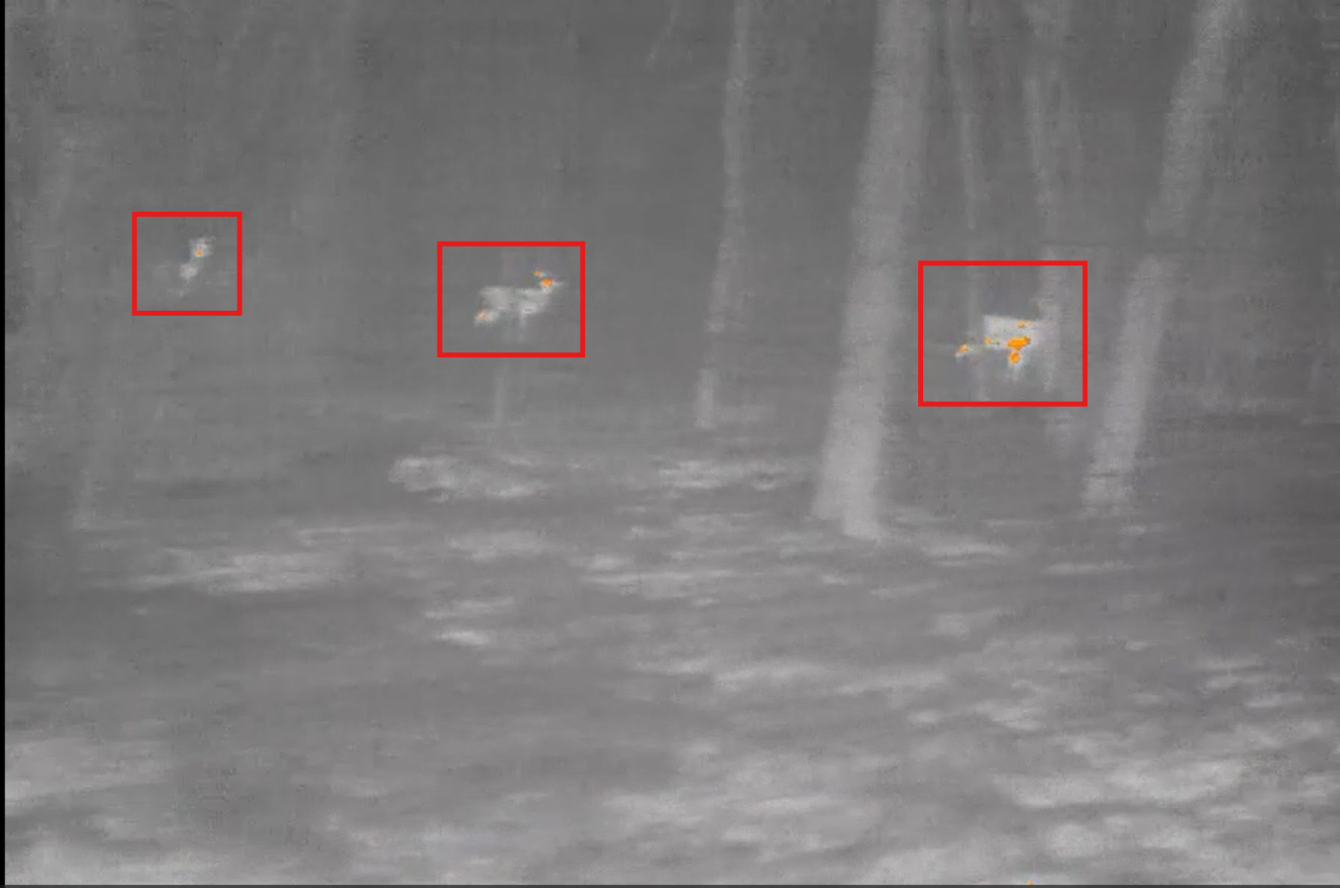

This is the same group of 3 deer from the same video, but 1 second forward to show as the transect is being driven, the FLIR detects individual deer better or worse due to vegetation obstruction, distance, or topography.
