Name: Lưu Minh Quân

ID: ITITIU15033

D.

1.

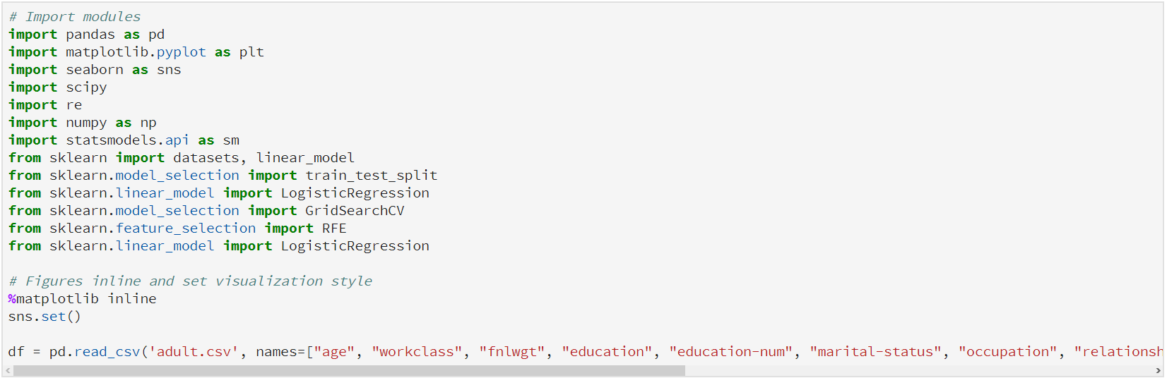

2.

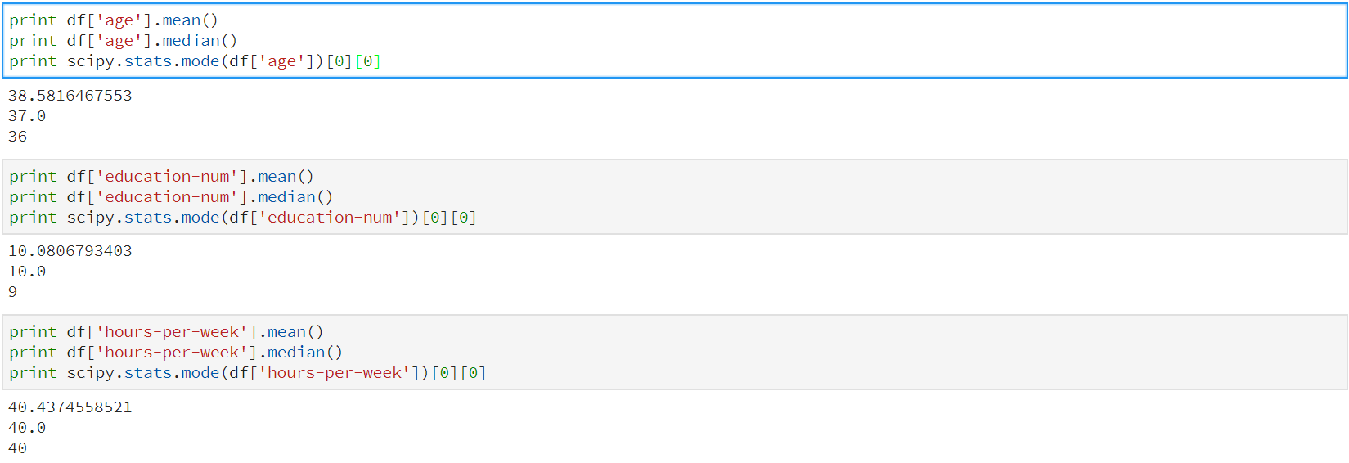

3.

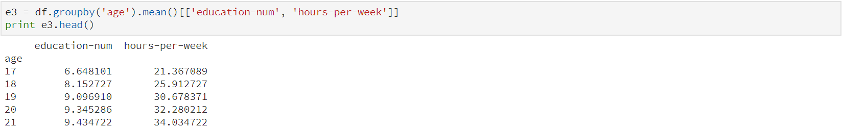

4.

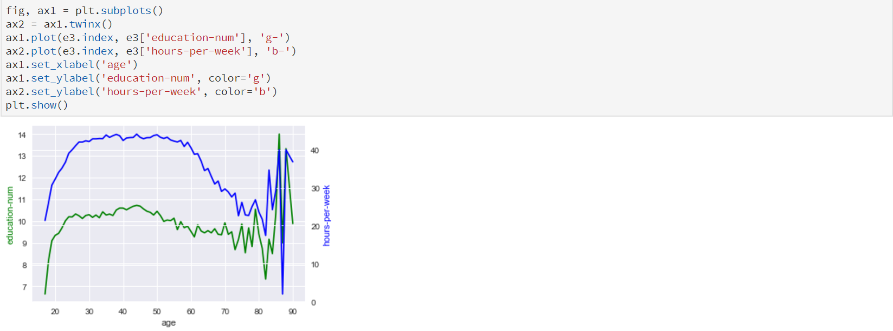

5 and 6.

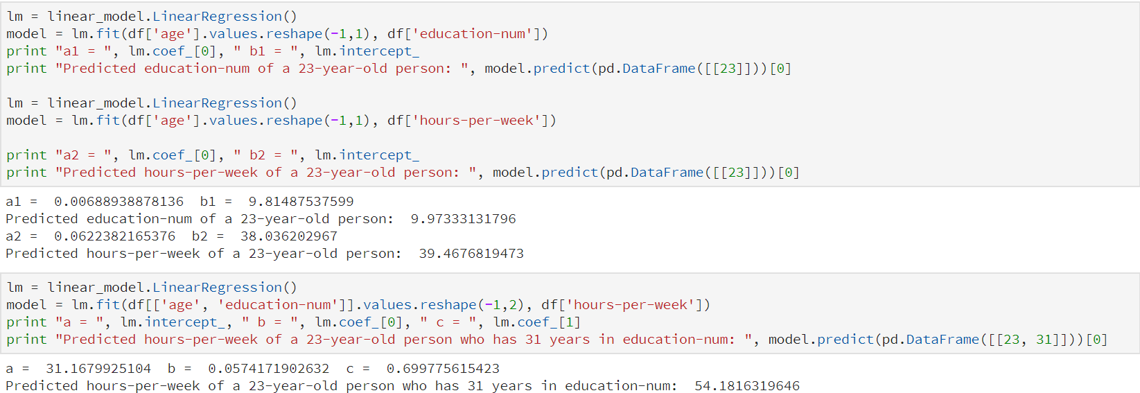

E.

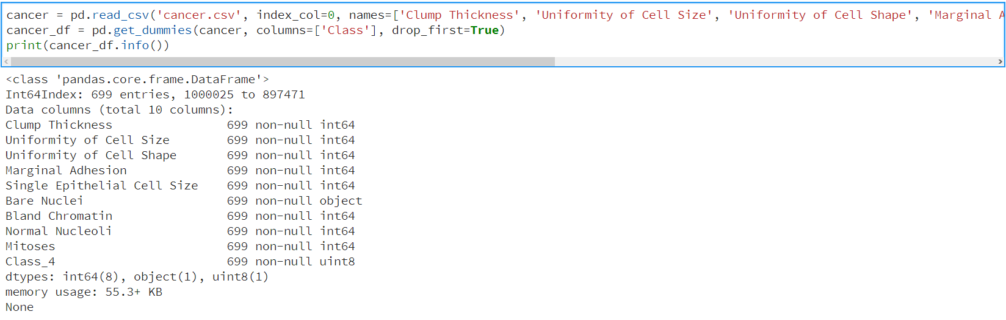

Bare Nuclei need to clean, because its type is object

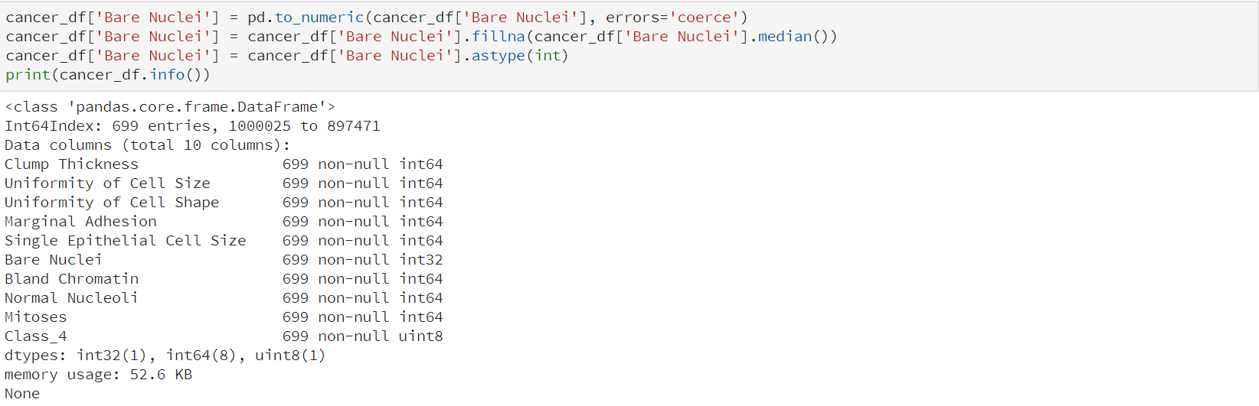

After cleaning Bare Nuclei, use Logistics Regression

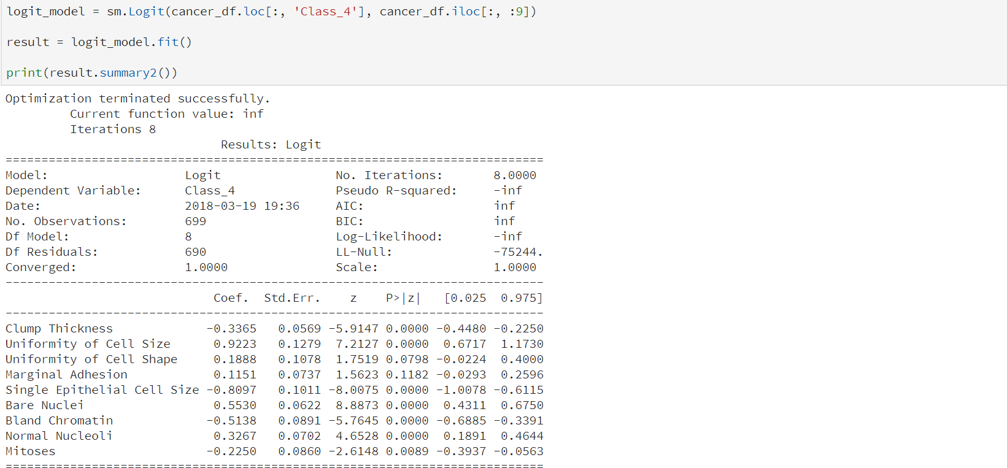

Because P-value of all attributes except Uniformity of Cell Shape and Marginal Adhesion is less than 0.05, so all of these attributes is important to model