The **union** operation automatically eliminates duplicates, unlike the **select** clause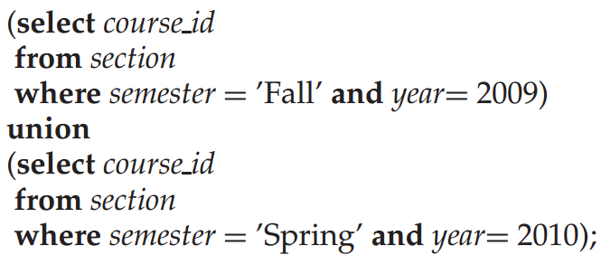

To find the set of all courses taught in the Fall 2009 as well as in Spring 2010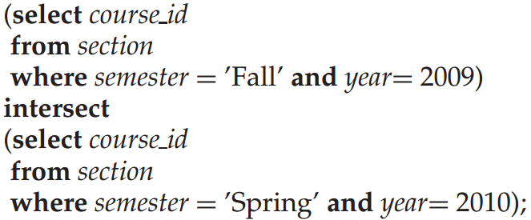

The **intersect** operation automatically eliminates duplicates

To find all courses taught in the Fall 2009 semester but not in the Spring 2010 semester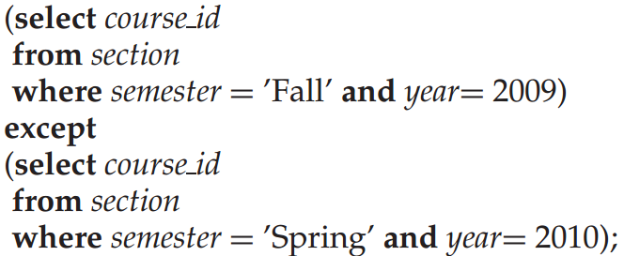

It performs set difference

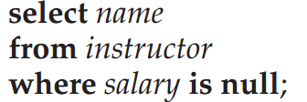

**3.7 Aggregate Functions**

• Average: **avg**  
• Minimum: **min**  
• Maximum: **max**  
• Total: **sum**  
• Count: **count**

**3.7.1 Basic Aggregation**

Query: ‘Find the average salary of instructions in the Computer Science department’

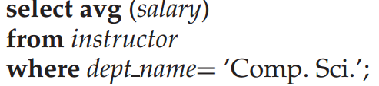

The database system may give an arbitrary name to the result relation attribute

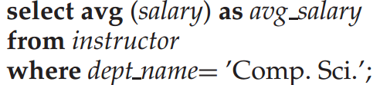

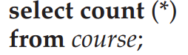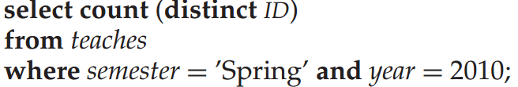 3.7.2 **Aggregation with Grouping**

Query “Find the average salary in each department.”

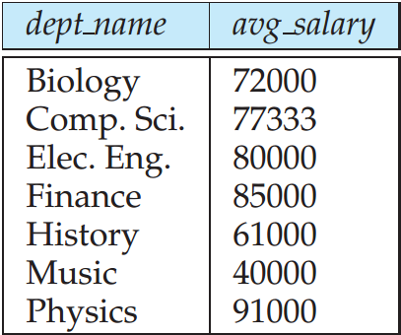 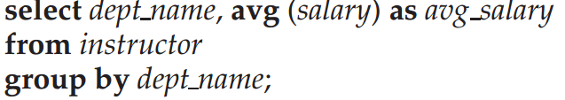 “Find the number of instructors in each department who teach a course in the Spring 2010 semester.”

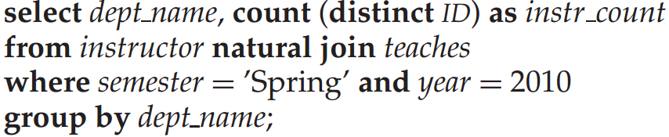

3**.7.3 The Having Clause**

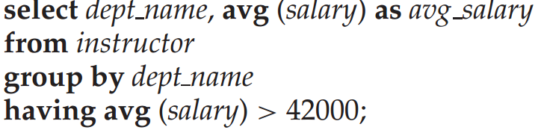

query “For each course section offered in 2009, find the average total credits ( tot cred) of all students enrolled in the section, if the section had at least 2 students.”

