Linear Regression
- Math

Set 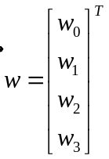 is the variable needing to optimize and 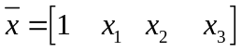 (x bar) is the input. The formulas is written: 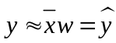
- The error needs to optimize: 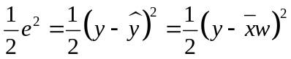
- Loss function: 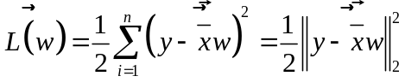
- Optimize Loss function by 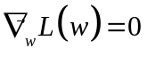
- Using chain rule to find derivatives: 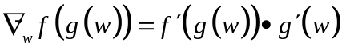
- Notice: 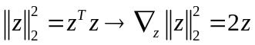
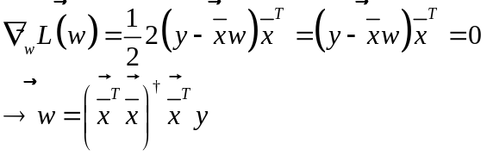
2. Linear Criteria
- Linear based on 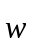 not and can be 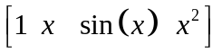

Gradient Descent
- Gradient Descent
- GD for Univariate
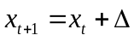 in which ∆ is the opposite direction of 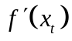
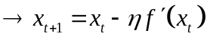
- GD for multi-univariate
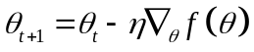 in which 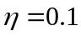
- Stopping criteria: 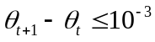
- Numerical GD
- Usually it’s hard to compute derivative so use definition of derivative to compute:
Numerical GD: 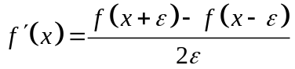
- Momentum
- Idea: Normal GD just considers the trend/ derivative of the function, so it’s easy to fall into local minimum. To avoid it, you add more speed at the time you compute to trend of function, so the marble can get over the local minimum
- Weakness: Because you add speed, when the marble comes to global minimum, it will oscillate before stopping
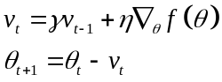 in which 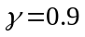
- Nesterov accelerated gradient (NAG)
- If you just know the momentum coefficient 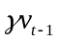 , you can predict the position of the marble 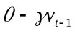
- Apply this position to find the gradient: 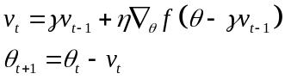
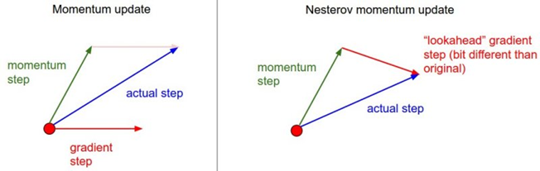
- Other GD Model
- Batch GD (Batch = all)
- To update 1 θ, you need to use all data point 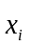
- When data has many observations, Batch GD becomes so complex. E.g. if you register fb account, batch GD needs to run all data again to update θ
- Online Learning is when database is updated many times, every time it adds another data point. One GD model to solve Online Learning is Stochastic GD
- Stochastic GD
- At one time, you just need to calculate loss function based on one , then update θ . Then, apply this process to all data point
- Above procedure is called epoch
- Batch GD will get 1 θ after 1 epoch, but with SGD, 1 epoch will get N θ. It will make SGD slower, on the other hand, SGD just needs to run fewer epochs than Batch GD
- E.g. When you have new database, you need to run 10 times SGD to find θ. After adding a few data points, you just need to run <1 epoch to find new θ
- Notice:
o After epoch, you need to shuffle the order of data points
o You can also apply momentum or NAG to 