Design and Development of a Web-Based Student Freelance Marketplace and Skill Management System
(NexusWork Platform)
A Project Documentation Submitted in Partial Fulfillment of the Requirements for the Degree of [Degree Name] in [Field of Study]
Prepared by:
[Team Member 1 Full Name] — [ID Number]
[Team Member 2 Full Name] — [ID Number]
[Team Member 3 Full Name] — [ID Number]
Advisor: [Advisor Full Name]
Department: [Department Name]
[University Name]
August 2026

Approval Page
This project documentation, "Design and Development of a Web-Based Student Freelance Marketplace and Skill Management System," has been submitted for examination with the approval of the undersigned advisor and examiners.
Advisor: _______________________ Signature: _______________ Date: _______________
Examiner 1: _______________________ Signature: _______________ Date: _______________
Examiner 2: _______________________ Signature: _______________ Date: _______________

Declaration
We, the undersigned, declare that this project is our original work, prepared under the guidance of our advisor. All sources of material used for this project have been duly acknowledged and referenced. This work has not been submitted for any degree or diploma in any other institution.
Name: _______________________ Signature: _______________ Date: _______________
Name: _______________________ Signature: _______________ Date: _______________
Name: _______________________ Signature: _______________ Date: _______________

Acknowledgement
We would like to express our sincere gratitude to our advisor, [Advisor Name], for the guidance, patience, and support provided throughout this project, and to the [Department Name] for the resources and opportunity to undertake this work. We also thank the university staff who assisted with the verification-workflow requirements review, and our test participants who took part in early usability walkthroughs.

Abstract
Freelancing has become an increasingly viable way for university students to gain real-world experience, apply academic skills commercially, and build a professional track record before graduation. However, students face structural barriers to entering the freelance economy: limited visibility of their skills to potential clients, difficulty establishing trust without an existing track record, and a lack of institutional mechanisms connecting academic skill development to income-generating opportunities. This project proposes and documents the design of NexusWork, a Web-Based Student Freelance Marketplace and Skill Management System that connects verified university students with clients — individuals, companies, university departments, NGOs, and government organizations — for freelance and project-based work, while giving the university a formal role in verifying student identity, certifying skills, and tracking employment outcomes. The system combines a conventional freelance marketplace workflow (project posting, bidding, contracts, milestone-based escrow payment, and reviews) with a university-integrated skill verification and portfolio layer, and an AI-assisted recommendation engine for matching students to projects. This document covers the background and justification for the project, a review of related systems, full functional and non-functional requirements, system architecture and database design, a module-by-module system design, the implementation approach, testing strategy, deployment plan, project management artifacts, and a template for reporting results following implementation.
Keywords: student freelancing, skill verification, marketplace platform, escrow payment, AI-assisted matching, MERN stack.

Table of Contents

List of Figures
- Figure 1: System Architecture Diagram
- Figure 2: Entity Relationship Diagram (ERD)
- Figure 3: Use Case Diagram
- Figure 4: Activity Diagram — Core Project Lifecycle
- Figure 5: Sequence Diagram — Proposal-to-Payment Flow
- Figure 6: Class Diagram
- Figure 7: Component Diagram
- Figure 8: Deployment Diagram
- Figure 9: Project Gantt Chart

List of Tables
- Table 1: Comparative Analysis — General Platforms vs. NexusWork
- Table 2: Stakeholder Analysis
- Table 3: Functional Requirements
- Table 4: Non-Functional Requirements
- Table 5: Risk Analysis
- Table 6: Database Schema Summary
- Table 7: Data Dictionary (Selected Enumerations)
- Table 8: Work Breakdown Structure
- Table 9: Budget Estimation

List of Abbreviations
Abbreviation | Meaning
AI | Artificial Intelligence
API | Application Programming Interface
CDN | Content Delivery Network
ERD | Entity Relationship Diagram
FR | Functional Requirement
JWT | JSON Web Token
LLM | Large Language Model
MERN | MongoDB, Express.js, React, Node.js
MVP | Minimum Viable Product
NFR | Non-Functional Requirement
REST | Representational State Transfer
TLS | Transport Layer Security
UAT | User Acceptance Testing
UI/UX | User Interface / User Experience
UML | Unified Modeling Language
WBS | Work Breakdown Structure

Chapter One: Introduction

1.1 Background of Freelancing and Digital Employment
Freelancing — independent, project-based work performed outside a traditional employment contract — has grown into a substantial segment of the global labor market, driven by the spread of internet access, digital payment systems, and platforms that connect independent workers with clients regardless of geography. This shift, often referred to as part of the broader "gig economy," has changed how organizations source specialized skills and how individuals build income and career capital, moving away from a model where employment is tied to a single, long-term employer (Kenney & Zysman, 2016; Kässi & Lehdonvirta, 2018).

1.2 Student Freelancing Concept
University students represent a specific and underserved segment of the freelance labor market. They typically possess current, formally taught technical and creative skills (programming, design, writing, data analysis) but lack the professional track record, client network, and time-tested reputation that established freelancers rely on to win work. Student freelancing refers to the practice of undertaking freelance projects while enrolled in a degree program, allowing students to apply coursework commercially, earn income, and build a portfolio before graduation.

1.3 Gig Economy and Remote Work
The rise of remote work — accelerated by broader shifts in how organizations structure teams — has made location largely irrelevant for many categories of freelance work (software development, design, writing, translation, data analysis). This is directly relevant to student freelancers, who can take on paid project work around a class schedule without needing to relocate or commit to fixed office hours.

1.4 Digital Skills Marketplace
A digital skills marketplace is a platform where the "product" being transacted is a person's skill or service rather than a physical good — the platform's core function is to reduce the search, verification, and trust costs that would otherwise make it hard for a buyer of a service (a client) and a seller (a freelancer) to find and safely transact with each other (Hagiu & Wright, 2015).

1.5 Problem Statement
Existing general-purpose freelance marketplaces (e.g., large global platforms) are not designed around the specific needs of university students: they offer no mechanism for a student's academic institution to verify identity or certify skill claims, they compete students against globally experienced freelancers on an unequal footing, and they provide no structured link between coursework, skill development, and paid project opportunities. As a result, many capable students either avoid freelancing altogether or struggle to establish enough trust to win their first projects.

1.6 Project Justification
A platform purpose-built for the student freelance context — with the university itself as a trust-conferring participant — addresses the specific barriers described above. University-backed identity and skill verification gives clients a meaningfully different trust signal than an anonymous online profile, and a platform scoped to students (rather than the entire global freelance labor pool) reduces the competitive disadvantage students face on general marketplaces.

1.7 General Objective
To design and develop a web-based platform that connects verified university students offering freelance services with clients seeking project-based work, incorporating university-backed skill verification, secure milestone-based payment, and AI-assisted matching.

1.8 Specific Objectives
- To design a system architecture and database supporting student, client, university, and administrator roles.
- To implement student registration, academic/skill verification, and portfolio management.
- To implement project posting, bidding, contract, and milestone-based escrow payment workflows.
- To implement a rating and reputation system for both students and clients.
- To implement an AI-assisted recommendation module for project–freelancer matching.
- To implement role-based security, dispute management, and an administrative reporting dashboard.
- To test the system for functional correctness, security, and usability.

1.9 Research Questions
- How can a digital platform verify student skill claims in a way that is credible to clients without creating excessive administrative burden on the university?
- What platform mechanisms most effectively reduce payment and delivery risk for both students and clients in a student freelance context?
- How can AI-assisted matching improve the efficiency of connecting student freelancers to suitable projects compared to manual search?

1.10 Scope of the Project
The system covers: student and client registration and profiles; university-side skill/identity verification; project posting, search, and bidding; contract and milestone management; escrow-based payment; messaging and file sharing; ratings and reviews; an AI-assisted recommendation module; a dispute management process; and an administrative dashboard for platform oversight and university reporting. It covers both a web application and, at a design level, a companion mobile application.

1.11 Limitations
Given the project timeline and team size, the initial implementation prioritizes a core working system (registration, verification, posting, bidding, contracts, milestones, payment, reviews, and one AI-assisted feature) over the full set of advanced/long-tail features described in Chapter Four's module list (e.g., blockchain-based certificate verification, full mobile application, multi-language support), which are documented as designed but scheduled for future phases.

1.12 Significance of the Project
For students, the platform provides income opportunities and portfolio-building tied directly to verified academic skills. For clients, it provides access to a vetted, cost-effective talent pool with an institutional trust layer. For the university, it provides visibility into student employment outcomes and a mechanism to connect coursework to real-world application. For the broader institution, it demonstrates a replicable model for university-integrated digital labor platforms.

1.13 Target Users
Student Freelancers, Clients (individuals, companies, university departments, NGOs, government organizations), University staff (verification and administration), and the Platform Administrator.

1.14 Development Methodology
The system is developed using an Agile, iterative methodology, with work divided into three parallel tracks (Core Marketplace, Workspace & Trust, AI/Search/Admin) delivered across weekly sprints, with a shared integration checkpoint at the end of each week. This approach was chosen over a strict Waterfall model because requirements for the AI-assisted and university-verification components are expected to be refined as the team learns from early testing.

1.15 Project Deliverables
- This documentation
- The working web application (frontend and backend source code)
- The database schema and seed data
- API documentation
- Test cases and results
- A deployment guide
- A user manual for each user role

Chapter Two: Literature Review

2.1 Freelance Marketplace Systems
General-purpose freelance marketplaces operate on a common core model: a client posts a project or job description, freelancers submit proposals (bids), the client selects a freelancer, work is delivered, and payment is released — typically through an escrow mechanism that holds client funds until work is approved. This model is well established and provides a proven foundation, but as reviewed in Section 2.14, existing implementations are not designed for the specific trust and verification needs of a student population (Agrawal et al., 2015).

2.2 Digital Labor Platforms
Beyond project-based freelancing, digital labor platforms also include task-based gig work (short, well-defined tasks) and talent-agency models (a platform that vets and represents workers). The system documented here follows the project-based freelance model, since it best fits the kind of substantive, skill-intensive work (software projects, design work, research assistance) students are positioned to deliver.

2.3 Student Employment Platforms
University career services and job boards typically focus on connecting students to traditional internships and post-graduation employment, not freelance project work — leaving a gap for students who want paid, skill-relevant work during their studies without a formal employment relationship.

2.4 Online Marketplace Models
Two-sided marketplace theory identifies "liquidity" (having enough of both supply and demand present simultaneously) and "trust" as the two central challenges any marketplace platform must solve before it can scale (Hagiu & Wright, 2015). This project's design directly targets the trust problem through university-backed verification, and targets liquidity by scoping the platform to a defined, engaged student population rather than the entire freelance labor market.

2.5 Skill Management Systems
Skill management systems track an individual's competencies, typically through self-declaration, assessment, or third-party certification, and are increasingly used to power search, matching, and recommendation features rather than serving as a static record.

2.6 Talent Management Platforms
Enterprise talent management platforms (used internally by large organizations) demonstrate the value of combining a skills taxonomy with project/assignment matching — a pattern this project adapts to an external, marketplace context.

2.7 Project Management Systems
Lightweight project management tooling (task boards, milestones, file sharing, progress tracking) is increasingly expected as a baseline feature of any platform mediating ongoing work, rather than a separate tool clients and freelancers must adopt independently — informing the inclusion of the Project Management Module (Section 4.11) as a first-class part of this system rather than an external integration.

2.8 Online Payment Systems
Escrow-based online payment — where a platform holds funds from a payer until a condition is met, then releases them to the payee — is the standard mechanism for de-risking marketplace transactions between parties without an existing trust relationship, and is adopted here for milestone-based project payments (Section 4.13).

2.9 Reputation and Rating Systems
Rating and review systems are the primary trust signal on most marketplace platforms, but are known to suffer from reciprocity bias (raters softening negative feedback to avoid retaliation) (Fradkin et al., 2015) — a limitation this project addresses by combining ratings with objective, measured indicators (on-time delivery, verified skill credentials) rather than relying on star ratings alone.

2.10 Artificial Intelligence in Recruitment
AI-assisted matching in recruitment and marketplace contexts typically combines structured signals (skills, experience, availability) with unstructured text (job descriptions, profiles) via embedding-based similarity search, improving on pure keyword search by capturing semantic relevance. This project's AI Recommendation Module (Section 4.15) applies this approach to project–freelancer matching.

2.11 Skill Recommendation Systems
Skill recommendation systems suggest learning paths or certifications based on gaps between a user's current profile and market demand — a pattern reflected in this project's Learning and Training Module (Section 4.17).

2.12 Online Learning Integration
Integrating a learning/training component directly into a marketplace platform allows skill development and income-generating opportunity to reinforce each other — a freelancer who loses a bid due to a skill gap can be routed directly to relevant training rather than leaving the platform.

2.13 Portfolio Management Systems
Digital portfolio systems allow freelancers to showcase completed work, and are most effective when portfolio entries can be built automatically from verified platform activity (completed, client-approved projects) rather than requiring freelancers to manually curate and self-report their history.

2.14 Existing Freelance Platforms
Established general-purpose platforms (large global marketplaces) offer broad talent pools and mature payment infrastructure, but share common weaknesses relevant to this project: no institutional identity/skill verification layer, significant competitive disadvantage for new or unproven freelancers (including students) against established freelancers with long track records, and no mechanism connecting platform activity back to an educational institution.

2.15 Comparative Analysis
Dimension | General Freelance Platforms | Proposed Student Platform (NexusWork)
Identity/skill verification | Self-reported or platform-administered testing | University-backed academic and skill verification
Competitive pool | Global, all experience levels | Scoped to verified students
Institutional involvement | None | University verifies students, certifies skills, receives employment analytics
Portfolio building | Manual | Auto-built from approved milestones
Learning integration | Minimal or none | Directly integrated skill-gap-to-training pathway
Table 1: Comparative Analysis — General Platforms vs. NexusWork

2.16 Research Gap
No widely available platform currently combines a conventional freelance marketplace workflow with formal, university-backed identity and skill verification and university-facing employment analytics — this is the specific gap this project addresses.

2.17 Conceptual Framework
The system is conceptually organized around four cooperating actors — Student Freelancer, Client, University, and Platform Administrator — connected through a project lifecycle (registration and verification → project posting → bidding → contract → delivery → review → payment → portfolio growth), with the AI recommendation layer and the university verification layer operating as cross-cutting services that inform multiple stages of that lifecycle rather than sitting at a single point in it.

Chapter Three: System Analysis and Requirements

3.1 Existing Student Employment Process
Today, a student seeking paid project work typically relies on informal channels — personal networks, general freelance platforms, or ad hoc referrals from faculty — with no structured, university-connected process for matching verified skills to available project work.

3.2 Problems of Existing Systems
- Limited access to freelance opportunities relevant to a student's specific skill set and availability
- Lack of visibility into student skills for potential clients
- Difficulty for clients to find and trust freelancers with no established track record
- No structured student portfolio management tied to verified academic and project work
- Payment trust problems on both sides (clients risking non-delivery, freelancers risking non-payment)
- Lack of university involvement in verifying students or tracking employment outcomes

3.3 Proposed System
A web-based platform where students register and are verified through their university, build a skill and portfolio profile, browse or are matched to posted projects, submit proposals, work under a milestone-based contract with escrow-protected payment, and build a growing, verifiable portfolio and reputation from completed work — with the university able to view aggregate employment and skill-demand analytics for its student body.

3.4 Stakeholder Analysis
Stakeholder | Interest
Student Freelancer | Access to relevant paid work; fair payment; portfolio growth
Client | Access to vetted, cost-effective student talent; project delivered on time and to spec
University | Visibility into student employment/skill outcomes; institutional reputation from producing employable graduates
Platform Administrator | Platform integrity, dispute resolution, sustainable commission-based revenue
Table 2: Stakeholder Analysis

3.5 User Types
Visitor (unauthenticated browsing), Student Freelancer, Client, University Staff (verification/reporting role), Platform Administrator, Moderator/Support (sub-roles under Administrator).

3.6 Functional Requirements
ID | Requirement
FR-01 | Students register with university-issued email or student ID for verification eligibility
FR-02 | University staff can review and approve/reject student verification requests
FR-03 | Students register and manage skills, with optional assessment-based verification
FR-04 | Clients register and post projects with description, required skills, budget, and deadline
FR-05 | Students browse/search projects and submit proposals (bid price, delivery time, cover note)
FR-06 | Clients review proposals and accept one to form a contract
FR-07 | Contracts define milestones with amounts and due dates
FR-08 | Clients fund milestones via escrow before work begins on that milestone
FR-09 | Students submit work per milestone; clients approve, request revision, or dispute
FR-10 | Approved milestone funds release to the student's wallet
FR-11 | Both parties submit ratings/reviews after contract completion
FR-12 | An AI recommendation module suggests projects to students and suggests matched freelancers to clients
FR-13 | Students maintain a portfolio; approved milestones can be added to it
FR-14 | A dispute process allows either party to escalate a milestone disagreement for administrator review
FR-15 | The Administrator manages users, disputes, categories, and platform-wide reporting
FR-16 | University staff can view aggregate, anonymized student employment/skill analytics
FR-17 | The system supports messaging and file sharing scoped to an active contract
FR-18 | The system generates invoices and payment history records
Table 3: Functional Requirements

3.7 Non-Functional Requirements
Category | Requirement
Performance | Core pages (project search, dashboard) load within 2 seconds under normal load
Scalability | Backend services are stateless and horizontally scalable
Usability | Core flows (post project, submit proposal, approve milestone) completable within a few clicks from the dashboard
Availability | Target 99% uptime for core marketplace functions
Security | See Section 3.8
Maintainability | Modular codebase organized by domain (users, projects, contracts, payments)
Portability | Web application accessible from any modern browser; API designed to also support a future mobile client
Table 4: Non-Functional Requirements

3.8 Security Requirements
- Password hashing (bcrypt) and JWT-based session authentication
- Role-based access control enforced at the API layer for all four actor types
- University verification data handled with restricted access limited to the university-staff role and the platform administrator
- All payment operations logged in an immutable audit trail
- Input validation and sanitization on all user-submitted content (project descriptions, proposals, messages)
- HTTPS/TLS enforced in production

3.9 Payment Requirements
- Milestone-based escrow: client funds are held by the platform until a milestone is approved
- A production payment gateway appropriate to the deployment market — e.g., Stripe where supported, or a regional processor such as Chapa, SantimPay, or Telebirr for markets where Stripe does not support local payouts — integrated behind a common internal interface; Stripe test mode is used for development and demonstration regardless of the eventual production gateway
- Commission deducted from freelancer payout at release, at a transparent, published rate
- Payment history and downloadable statements available to both students and clients

3.10 Integration Requirements
- Payment gateway integration (see Section 3.9)
- Email/notification delivery service for account and transaction notifications
- University identity-verification process (initially manual/staff-reviewed; API-based integration with a university student information system is a documented future enhancement, not required for the initial release)

3.11 Hardware and Software Requirements
The following minimum environment supports development, testing, and initial production deployment of the system.

3.11.1 Development Environment
Item | Minimum Specification
Processor | Quad-core CPU, 2.0 GHz or higher
Memory (RAM) | 8 GB (16 GB recommended for running the full stack plus local MongoDB)
Storage | 20 GB free disk space
Operating System | Windows 10/11, macOS 12+, or a modern Linux distribution
Runtime | Node.js 18 LTS or later, npm or yarn
Database | MongoDB 6.x (local) or a MongoDB Atlas free-tier cluster
Editor/Tools | VS Code, Git, Postman or curl

3.11.2 Client-Side (End-User) Requirements
Item | Minimum Specification
Device | Any desktop, laptop, tablet, or smartphone with a modern web browser
Browser | Latest two versions of Chrome, Firefox, Edge, or Safari (with JavaScript and cookies enabled)
Connectivity | A stable internet connection (broadband or mobile data)

3.11.3 Production Server-Side Requirements
Item | Minimum Specification
Application server | 2 vCPU / 4 GB RAM per instance (managed hosting platform), horizontally scalable
Database | MongoDB Atlas shared or dedicated cluster sized to expected concurrent load
Static hosting/CDN | Any CDN-backed static hosting provider for the built React bundle
TLS certificate | Valid TLS certificate for HTTPS (managed automatically by most hosting platforms)

3.12 Data Privacy and Ethical Considerations
Because the platform stores verified student identity data, academic verification evidence, and payment records, it is treated as handling sensitive personal data throughout its design. The following principles guide the handling of that data:
- Data minimization: only the identity and enrollment evidence needed to establish verification eligibility is collected; documents submitted for verification are retained only as long as needed for audit purposes and are not exposed outside the university-staff and administrator roles (Section 3.8).
- Purpose limitation: university-facing analytics (Section 4.21) are aggregated and anonymized before being surfaced to university staff, so individual student activity is not exposed beyond what verification and dispute-resolution roles require.
- Informed consent: students and clients are shown what data is collected and how it is used (verification, matching, payment processing, analytics) during registration, consistent with standard data-protection practice.
- Payment data handling: card and payout details are handled by the payment gateway (Section 3.9) under its own PCI-DSS compliance scope; the platform itself stores only transaction references, not raw card data.
- Right to erasure/export: account deletion and data-export requests are handled through the Administrator role, subject to retention required for financial/audit records.

3.13 Feasibility Study
Technical feasibility: the required stack (React, Express.js, MongoDB, standard payment/notification integrations) is well within the team's existing skill set (MERN, as demonstrated on a prior project) and does not require unproven technology. Economic feasibility: development uses free-tier or low-cost hosting, database, and payment sandbox services during the project period, keeping direct costs minimal; ongoing revenue is designed around a commission on completed transactions. Operational feasibility: the university verification step requires a small amount of staff time per student but does not require new university infrastructure — a designated staff member reviewing submitted student ID/enrollment evidence is sufficient for the initial release. Schedule feasibility: given the three-person team and one-month timeline discussed for the working prototype, the full module list in Chapter Four is treated as the complete design target, with a prioritized subset (Chapter Three's core functional requirements plus one AI-assisted feature) as the implementation target for the current project period; remaining modules are documented for future phases (Section 10.3).

3.14 Risk Analysis
Risk | Likelihood | Impact | Mitigation
University verification process becomes a bottleneck | Medium | Medium | Start with a lightweight, manual staff-review process; automate later
Payment integration delays | Low | High | Use gateway test mode early; abstract payment logic behind an internal module
Scope exceeds team capacity in project timeframe | High | Medium | Explicit prioritization of core modules (Ch. 3.6) over advanced modules (Ch. 4) for the initial build
Low initial liquidity (too few students/clients to match) | Medium | Medium | Launch within a single university/department first, expand after validating the core loop
Team coordination/integration issues (3-person team) | Medium | Medium | Weekly integration checkpoints; shared component library and API contracts agreed up front
Table 5: Risk Analysis

Chapter Four: System Design

4.1 System Architecture

4.1.1 Web Application
A React (Vite) single-page application served to browsers, communicating with the backend over a REST API and a WebSocket connection (Socket.io) for real-time messaging and notifications.

4.1.2 Mobile Application
Designed at the architecture level to be a React Native application reusing the same backend API; not part of the initial implementation scope (see Section 1.11).

4.1.3 Database Server
MongoDB, accessed via Mongoose from the Express.js backend, hosting all core collections (see Section 4.2).

4.1.4 Payment Gateway
Integrated behind an internal Payments module (Section 3.9) so the specific processor can be swapped without changing business logic elsewhere in the system.

4.1.5 Notification System
A notification service fanning out to in-app and email channels (push notifications documented for the future mobile client), triggered by events such as proposal status changes, milestone deadlines, and messages.
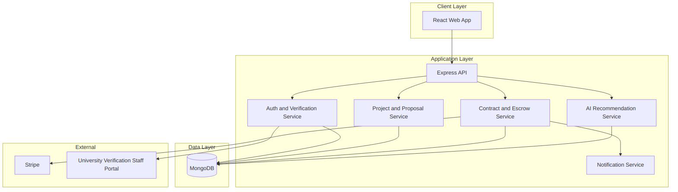
Figure 1: System Architecture Diagram

4.2 Database Design

4.2.1 Entity Relationship Diagram
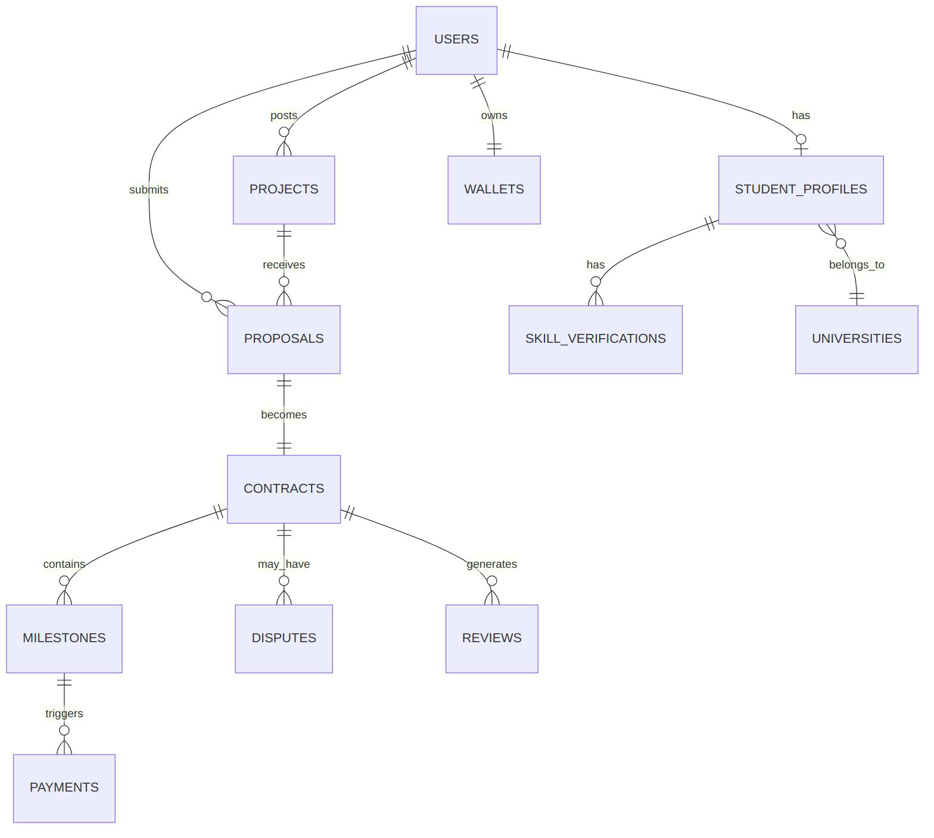
Figure 2: Entity Relationship Diagram (ERD)

4.2.2 Database Schema
Collection | Key Fields
Users | email, password_hash, role (student, client, university_staff, admin), status
StudentProfiles | user_id, university_id, enrollment_status, verification_status, bio
Universities | name, domain (for email verification), contact_staff
SkillVerifications | student_id, skill, verification_method, verified_by, verified_at
Projects | client_id, title, description, required_skills, budget, deadline, status
Proposals | project_id, student_id, price, delivery_time, cover_note, status
Contracts | proposal_id, client_id, student_id, status, signed_at
Milestones | contract_id, title, amount, due_date, status
Payments | milestone_id, amount, direction, processor_ref
Wallets | user_id, balance, currency
Reviews | contract_id, reviewer_id, reviewee_id, rating, text
Disputes | milestone_id, opened_by, status, resolution_summary
Messages | contract_id, sender_id, body, attachments
Table 6: Database Schema Summary

4.2.3 Data Dictionary
Field | Type | Description
verification_status | enum | pending, verified, rejected — tracks university review of a student
skill.verification_method | enum | self_declared, assessment, university_certified
contract.status | enum | pending_signature, active, completed, terminated
milestone.status | enum | not_funded, funded, delivered, approved, disputed, released
Table 7: Data Dictionary (Selected Enumerations)

4.3 UML Design

4.3.1 Use Case Diagram
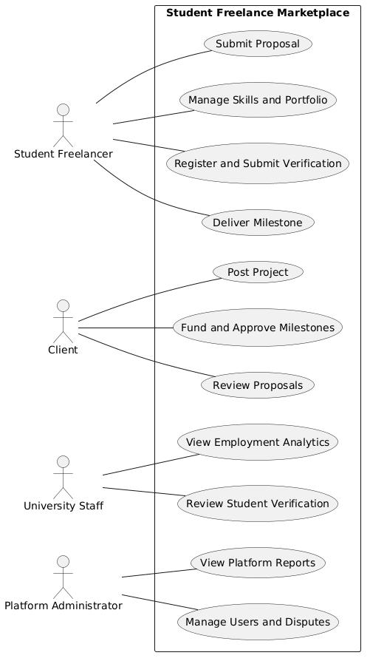
Figure 3: Use Case Diagram

4.3.2 Activity Diagram
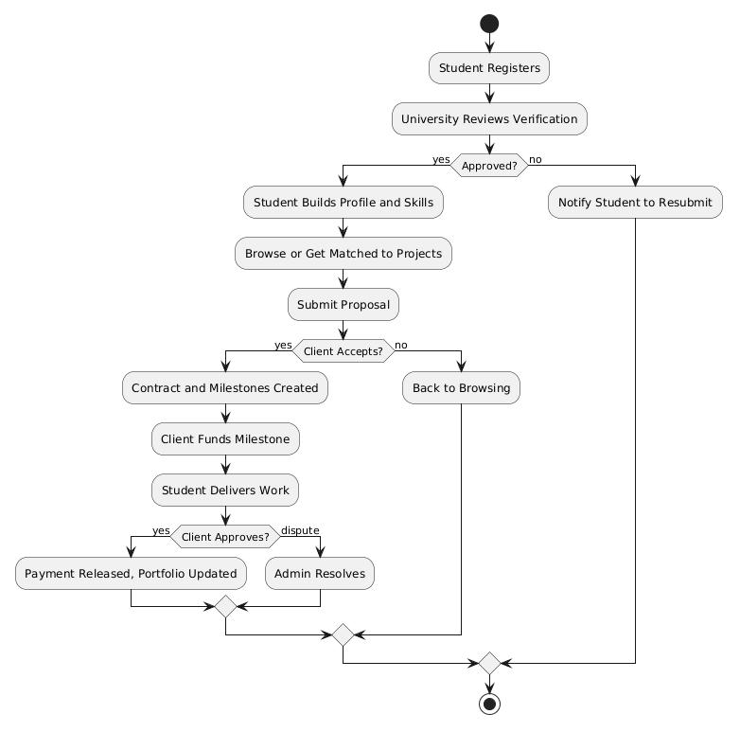
Figure 4: Activity Diagram — Core Project Lifecycle

4.3.3 Sequence Diagram
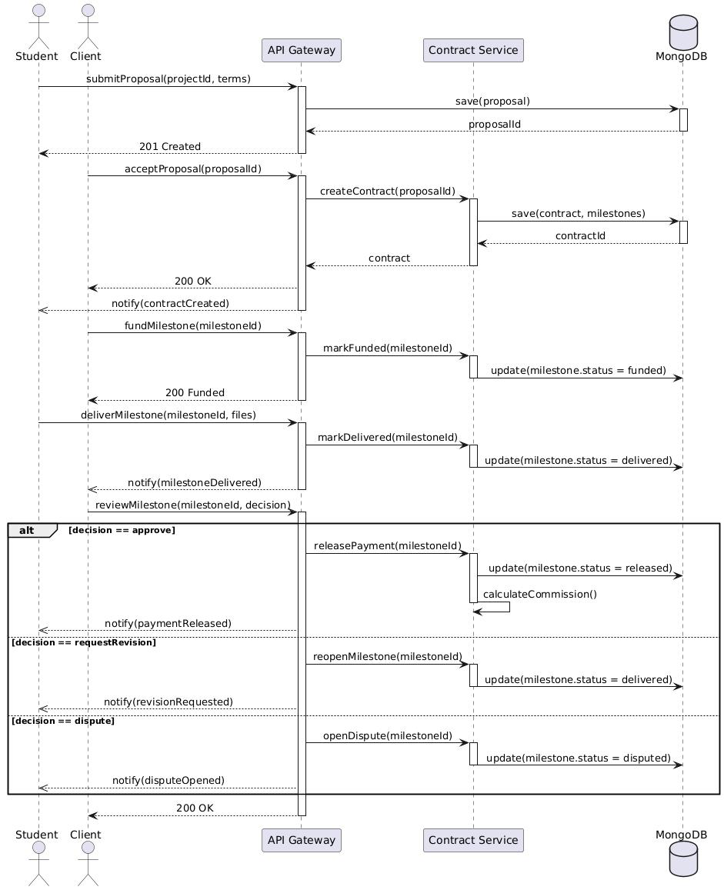
Figure 5: Sequence Diagram — Proposal-to-Payment Flow

4.3.4 Class Diagram
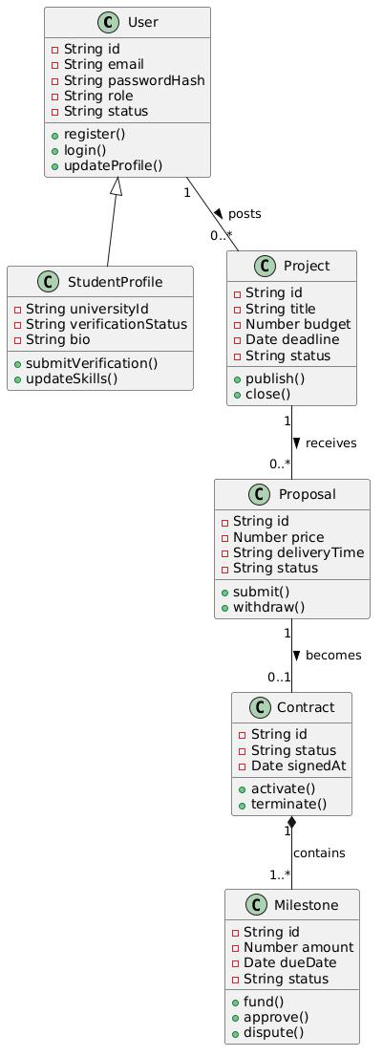
Figure 6: Class Diagram

4.3.5 Component Diagram
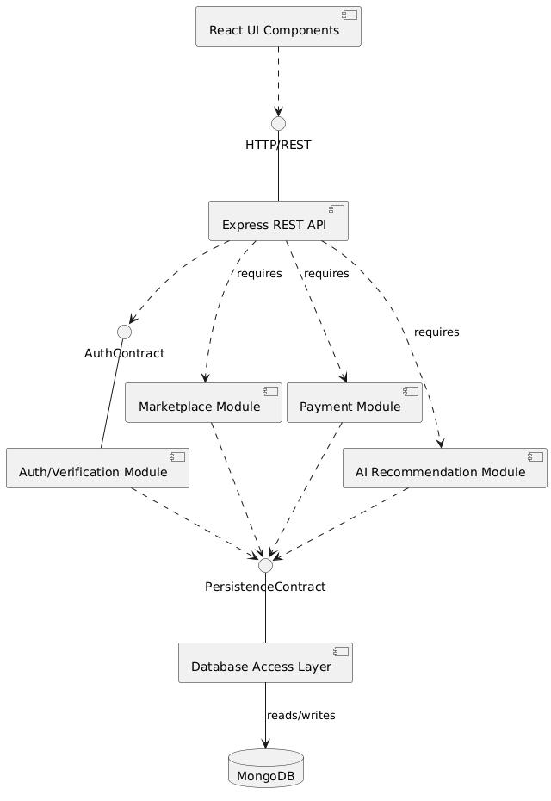
Figure 7: Component Diagram

4.3.6 Deployment Diagram
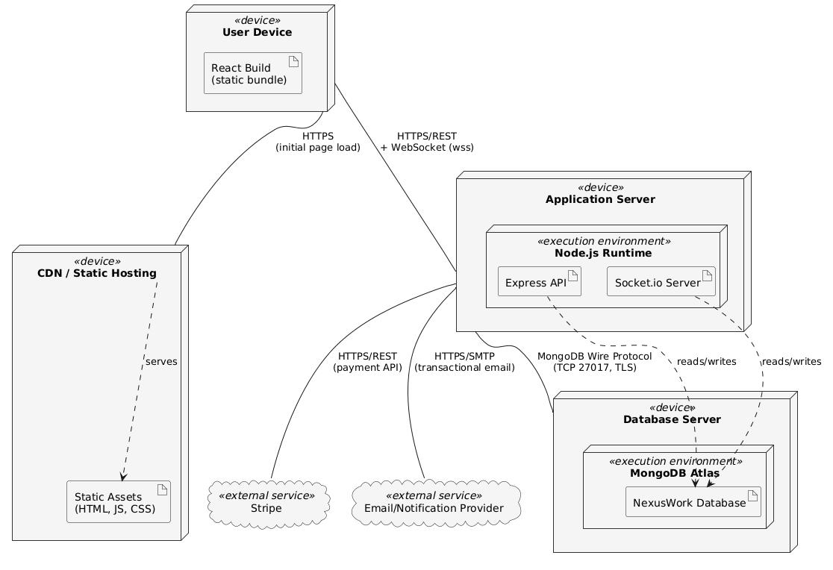
Figure 8: Deployment Diagram

System Modules Design

4.4 Student Freelancer Management Module
Features: Student registration; student profile; academic information; university verification; skills registration; experience history; availability status; portfolio management. This module owns the student's core identity record and is the entry point for the university verification workflow (Section 4.20) — a student cannot submit proposals until their verification status is verified.

4.5 Skill Management Module
Features: Skill categories; skill assessment; certification; skill level; technology stack; skill verification. Skills are structured (category + name + level) rather than free-text tags, so they can power search, filtering, and the AI recommendation module (Section 4.15) reliably.

4.6 Client Management Module
Features: Client registration; organization profile; client verification; project history. Supports both individual and organizational clients (companies, university departments, NGOs, government bodies), with organizational clients able to designate multiple posting users under one account.

4.7 Project Posting Module
Features: Project creation; project description; required skills; budget; deadline; attachment upload; project category. Projects are tagged against the same skill taxonomy used in Section 4.5, so posted projects and student skill profiles can be matched directly.

4.8 Project Search Module
Features: Search projects; filter by skill; filter by budget; filter by deadline; recommended projects. Combines direct search/filter with the AI-driven "recommended projects" feed for students, so students aren't solely dependent on manual search.

4.9 Bidding and Proposal Module
Features: Freelancer proposal; price quotation; delivery time; proposal review; proposal acceptance. A student submits one proposal per project; accepting a proposal automatically initiates contract creation (Section 4.10).

4.10 Contract Management Module
Features: Digital agreement; project terms; milestones; contract history. A contract is generated from the accepted proposal's terms and requires both parties to confirm before milestones can be funded.

4.11 Project Management Module
Features: Task management; progress tracking; file sharing; communication; deadline tracking. Provides the working environment for an active contract — the equivalent of a lightweight shared task board so students and clients don't need to coordinate through outside tools.

4.12 Work Submission Module
Features: File submission; version management; client review; revision request; final approval. Tracks multiple submission versions per milestone so a revision cycle doesn't overwrite the delivery history, which also serves as the evidence trail for dispute review (Section 4.19).

4.13 Payment Management Module
Features: Online payment; escrow payment; student withdrawal; invoice generation; payment history; commission management. Implements the milestone-based escrow model described in Section 3.9: client funds are held until milestone approval, then released to the student's wallet minus the platform commission.

4.14 Rating and Review Module
Features: Student rating; client rating; feedback; reputation score. Both parties rate each other after contract completion; the reputation score combines the rating with objective delivery data (see Section 2.9) rather than the star rating alone.

4.15 AI Recommendation Module
Features: Skill-based matching; project recommendation; freelancer recommendation; price suggestion; career recommendation. Uses the structured skill data (Section 4.5) plus project description text to rank student–project matches; also suggests a realistic budget range to clients when posting and a career-relevant skill path to students based on demand patterns.

4.16 Portfolio Management Module
Features: Project showcase; certificate upload; achievement records; resume generation; professional profile. Approved milestones can be added to a student's portfolio with one click (with client consent), so portfolio upkeep doesn't require manual re-entry of completed work.

4.17 Learning and Training Module
Features: Online courses; skill improvement; training recommendations; certification. Connects directly to the skill-gap output of the AI Recommendation Module — a student who loses a bid due to a skill gap is routed to relevant training content.

4.18 Communication Module
Features: Chat system; video meeting integration; notification; message history. Contract-scoped real-time messaging (Socket.io) with a full history retained for dispute evidence; video meetings documented as a future enhancement (Section 10.3) rather than initial scope.

4.19 Dispute Management Module
Features: Complaint submission; dispute review; resolution process; evidence management. Either party can open a dispute on a milestone; the module compiles the relevant message history, submission versions, and milestone status into a single evidence view for the administrator's review.

4.20 University Administration Module
Features: Student verification; skill certification; employment statistics; student performance reports. The university-facing side of the platform: staff review pending student verification requests, certify specific skills where the university can vouch for them (e.g., coursework-based competency), and view aggregate, anonymized statistics on student platform activity.

4.21 Analytics Dashboard
Features: Number of freelancers; active projects; income statistics; popular skills; market demand; university employment reports. A platform-administrator-facing dashboard (with a restricted, aggregate-only view available to university staff) summarizing platform health and, specifically, employment-relevant statistics the university can use in its own reporting.

4.22 Security Module
Features: Authentication; authorization; role-based access; data encryption; audit log; backup. Implements JWT-based authentication, role-based access control across all four actor types, encryption of data at rest and in transit, an append-only audit log for administrative and financial actions, and scheduled database backups — detailed further in Sections 3.8 and 5.9.

Chapter Five: System Implementation

5.1 Development Environment
Node.js LTS, MongoDB (local for development, MongoDB Atlas for deployment), Git/GitHub for version control, VS Code as the primary editor, Postman/curl for API testing. See Section 3.11 for full hardware and software requirements.

5.2 Frontend Development
React (Vite) with Tailwind CSS for styling, React Router for navigation, TanStack Query for server-state management and data fetching (via native fetch, without an additional HTTP client library), organized around a shared UI component library to keep pages visually and structurally consistent across the three-person team.

5.3 Backend Development
Express.js structured by domain (config, models, controllers, routes, middleware, services), using ES modules, with Mongoose for MongoDB access and JWT-based authentication middleware protecting all non-public routes.

5.4 Database Implementation
MongoDB collections implemented as Mongoose schemas per Section 4.2.2, with schema-level validation replacing the constraint enforcement a relational database would otherwise provide.

5.5 API Development
A versioned REST API (/v1/...) following resource-based routing conventions (e.g., POST /v1/projects, POST /v1/proposals, POST /v1/milestones/:id/approve), with a consistent JSON response envelope and standard HTTP status codes. Full endpoint reference to be generated from the implemented API (Appendix E).

5.6 Payment Integration
The payment gateway selected in Section 3.9 is integrated in test/sandbox mode during development for milestone funding and release simulation, abstracted behind an internal Payments service so the specific processor is not hard-coded into business logic elsewhere.

5.7 AI Recommendation Implementation
Implemented as a dedicated service layer wrapping calls to an LLM/embedding provider, combining structured skill/category filters with semantic similarity between project descriptions and student profile/portfolio text to produce a ranked match list.

5.8 Notification Implementation
An event-driven notification service triggered by key state changes (proposal received, milestone funded, milestone delivered, dispute opened), delivering to in-app and email channels.

5.9 Security Implementation
Password hashing via bcrypt; JWT access tokens with a short expiry; role-based middleware guarding every protected route; input validation on all write endpoints; HTTPS enforced at the hosting layer in production.

5.10 Deployment
Containerized (Docker) backend and frontend, deployed to a managed hosting platform (e.g., Render/Railway for the initial release, with a documented path to Kubernetes at higher scale), MongoDB Atlas for the database, and a CDN for static frontend assets.

Chapter Six: System Testing

6.1 Testing Strategy
A layered strategy — unit tests for isolated business logic, integration tests against a test database, and manual end-to-end walkthroughs of the full contract lifecycle — applied incrementally as each module is completed rather than only at the end of the project. Backend unit and integration tests are written with Jest and Supertest; frontend component tests use React Testing Library; end-to-end walkthroughs are performed manually against a seeded staging environment.

6.2 Functional Testing
Verifies each functional requirement in Section 3.6 against its expected behavior (e.g., a proposal cannot be submitted twice by the same student on the same project; a milestone cannot be approved before it is marked delivered).

6.3 User Management Testing
Registration, login, university verification approval/rejection, and role-based access restrictions are tested for each of the four actor types.

6.4 Project Management Testing
Project posting, search/filter accuracy, proposal submission and acceptance, and contract/milestone creation are tested end to end.

6.5 Payment Testing
Milestone funding, approval-triggered release, and commission calculation are tested against the payment gateway's sandbox/test mode (Section 3.9), including failure cases (declined card, insufficient funds simulation).

6.6 Security Testing
Verifies that protected routes reject unauthenticated and under-privileged requests, that passwords are never returned in API responses, and that input validation rejects malformed or oversized payloads.

6.7 Performance Testing
Basic load testing of the project search and proposal submission endpoints to confirm acceptable response times under simulated concurrent use.

6.8 AI Recommendation Testing
Manual evaluation of match quality (does the recommendation module surface relevant projects/students for a representative sample of test profiles) alongside functional testing of the recommendation API's response format and latency.

6.9 User Acceptance Testing
A structured walkthrough of the core lifecycle (register → verify → post/bid → contract → deliver → pay → review) with a small group of representative test users (students and a mock client) providing feedback before the system is considered demo-ready.

6.10 Test Results
Status: Pending execution. This section will report pass/fail counts per module, defects found, and resolution status once the test plan above (Sections 6.1–6.9) has been executed. Recommended structure for the completed section:
- Summary table: module, number of test cases, passed, failed, blocked
- Defect log: ID, description, severity, module, status (open/fixed/deferred)
- Coverage notes: which functional requirements (Section 3.6) are exercised by automated vs. manual tests

Chapter Seven: Deployment and Maintenance

7.1 Cloud Deployment
The application is deployed using a managed hosting platform for both the Express backend and the React frontend build, with MongoDB Atlas as the managed database service.

7.2 Server Configuration
Environment variables (database connection string, JWT secret, payment gateway keys, client URL for CORS) are configured per environment (development, staging, production) and never committed to source control.

7.3 Database Deployment
MongoDB Atlas cluster configured with network access restricted to the application server's IP range and a dedicated database user with least-privilege access.

7.4 Backup and Recovery
Automated daily database backups via MongoDB Atlas's built-in backup service, with a documented manual restore procedure.

7.5 Monitoring
Basic uptime and error-rate monitoring on the deployed application, with a path to more comprehensive metrics/logging tooling as usage grows.

7.6 Maintenance
A defined process for dependency updates, security patch review, and bug triage via GitHub Issues, with the three-person team rotating responsibility for post-deployment monitoring.

Chapter Eight: Project Management

8.1 Project Planning
The project is planned as three parallel tracks (Core Marketplace & Payments, Workspace & Trust, AI/Search/Admin) executed over four weeks, with a shared integration checkpoint each Friday, as detailed in Chapter One's development methodology.

8.2 Work Breakdown Structure
Work Package | Track | Deliverable
Auth, Student/Client/University roles | Core | Working registration, login, verification flow
Projects, Proposals, Contracts, Milestones | Core | Full posting-to-contract workflow
Escrow/Payment integration | Core | Sandbox-mode milestone funding and release
Messaging, file sharing, task tracking | Workspace | Contract-scoped workspace
Ratings, disputes | Workspace | Review and dispute flows
AI recommendation | AI | Working match/recommend endpoint
Search, Admin dashboard | AI | Search and administrative reporting views
Table 8: Work Breakdown Structure

8.3 Gantt Chart
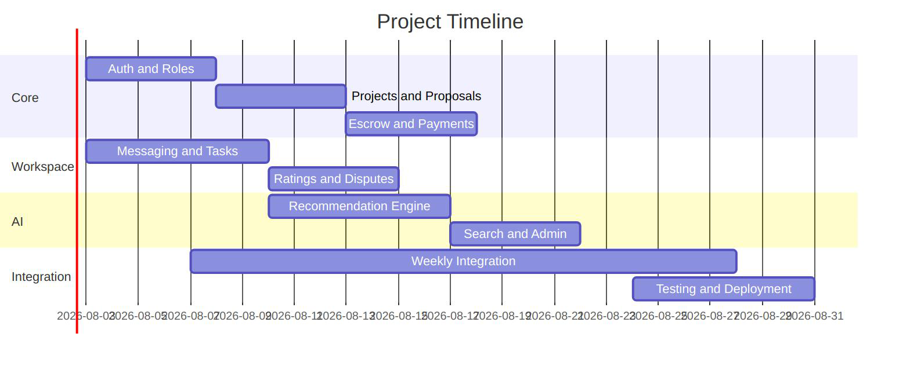
Figure 9: Project Gantt Chart

8.4 Budget Estimation
Item | Estimated Cost
Hosting (backend + frontend, MVP tier) | Low-cost/free tier during development; est. $0–25/month at MVP scale
Database (MongoDB Atlas free/shared tier) | Free tier sufficient for MVP scale; est. $0–9/month if upgraded
Payment gateway | No cost in test/sandbox mode; transaction-based fee (typically 1.5–3.5%) in production
AI/LLM provider usage | Usage-based; budgeted at approx. $20–50 for development/testing volume
Domain name | Approx. $10–15/year
Table 9: Budget Estimation

8.5 Risk Management
See Section 3.14 for the full risk register; project-management-specific risks (schedule slippage, uneven task distribution across the three-person team) are mitigated through the weekly integration checkpoint and a shared task board (GitHub Projects) making progress visible to all team members.

Chapter Nine: Results and Discussion
This chapter is a reporting template. Each section below states what evidence to capture and how to present it; replace the "Status: Pending" line and bracketed prompts with actual results once the corresponding testing (Chapter Six) and demonstration activities have been carried out.

9.1 System Demonstration
Status: Pending. A walkthrough of the working system covering registration through payment, illustrated with screenshots.
Reporting guidance:
- Capture 8–12 annotated screenshots covering: registration, university verification approval, project posting, proposal submission, contract creation, milestone funding, work delivery, milestone approval and payment release, and the review step.
- Include the URL/build reference and date of the demonstrated build.

9.2 Student Registration Results
Status: Pending. Number of test registrations, verification turnaround observed during testing, any issues found in the verification flow.
Reporting guidance:
- Report: total test accounts created, number verified vs. rejected, average staff review turnaround time, and any usability issues raised during Section 6.3 testing.

9.3 Project Matching Results
Status: Pending. Sample evaluation of AI recommendation relevance against a test set of projects and student profiles.
Reporting guidance:
- Report: size of the test set, relevance criteria used, and a simple precision/relevance score (e.g., percentage of top-5 recommendations judged relevant by reviewers), per Section 6.8.

9.4 Payment Results
Status: Pending. Results of sandbox-mode milestone funding/release testing, including edge cases.
Reporting guidance:
- Report: number of test transactions, success rate, commission calculation accuracy, and behavior under the failure cases defined in Section 6.5 (declined card, insufficient funds).

9.5 User Feedback
Status: Pending. Summarized feedback from test students and clients following user acceptance testing (Section 6.9).
Reporting guidance:
- Report: number of UAT participants, task-completion rate for the core lifecycle walkthrough, and a short thematic summary of qualitative feedback (what worked, friction points, feature requests).

9.6 Challenges
Status: Pending. Technical and coordination challenges encountered during development, and how they were resolved.
Reporting guidance:
- Report challenges by category (technical, integration, team coordination, scope) with the resolution or workaround applied to each, referencing the risk register in Section 3.14 where relevant.

Chapter Ten: Conclusion and Recommendations

10.1 Conclusion
This documentation has presented the design of NexusWork, a web-based student freelance marketplace and skill management system that combines a conventional freelance marketplace workflow with university-backed identity and skill verification, addressing a specific, underserved gap identified in Chapter Two between general freelance platforms and the trust and visibility needs of student freelancers.

10.2 Recommendations
It is recommended that the initial deployment be scoped to a single university or department to validate the verification workflow and core marketplace loop before expanding to a broader student population, and that the university verification process be revisited for partial automation once initial manual-review volume is understood.

10.3 Future Enhancements
- Full mobile application
- Blockchain-based certificate verification
- Multi-language support
- Automated university system integration for verification
- Video meeting integration
- Expanded AI career-recommendation features
- Agency/team accounts for group projects

References
Agrawal, A., Horton, J., Lacetera, N., & Lyons, E. (2015). Digitization and the contract labor market: A research agenda. In A. Goldfarb, S. M. Greenstein, & C. E. Tucker (Eds.), Economic analysis of the digital economy. University of Chicago Press.
Fradkin, A., Grewal, E., Holtz, D., & Pearson, M. (2015). Bias and reciprocity in online reviews: Evidence from field experiments on Airbnb. Proceedings of the Sixteenth ACM Conference on Economics and Computation.
Hagiu, A., & Wright, J. (2015). Multi-sided platforms. International Journal of Industrial Organization, 43, 162–174.
Kässi, O., & Lehdonvirta, V. (2018). Online labour index: Measuring the online gig economy for policy and research. Technological Forecasting and Social Change, 137, 241–248.
Kenney, M., & Zysman, J. (2016). The rise of the platform economy. Issues in Science and Technology, 32(3), 61–69.
MongoDB, Inc. (2025). MongoDB manual. https://www.mongodb.com/docs/manual/
Mozilla Developer Network. (2025). Using the Web Storage API / REST architecture reference. https://developer.mozilla.org/
Node.js Foundation. (2025). Node.js documentation. https://nodejs.org/en/docs/
OWASP Foundation. (2025). OWASP top ten web application security risks. https://owasp.org/www-project-top-ten/
Stripe, Inc. (2025). Stripe API documentation. https://stripe.com/docs/api
[Add any additional course texts, standards, or platform documentation cited during the final write-up, in APA 7th edition format.]

Glossary of Terms
Term | Definition
Escrow | A payment arrangement in which funds are held by a neutral third party (here, the platform) until agreed conditions are met, then released to the payee.
Liquidity (marketplace) | The presence of enough active supply (students) and demand (clients) simultaneously for the marketplace to function and grow.
Milestone | A defined portion of a contract's total work and payment, with its own due date, funding, delivery, and approval status.
Reciprocity bias | The tendency of raters in a two-way review system to soften negative feedback to avoid retaliatory negative reviews.
Semantic similarity / embedding search | A matching technique that compares the meaning of text (e.g., a project description and a student profile) rather than only matching exact keywords.
Two-sided marketplace | A platform that creates value by facilitating transactions between two distinct user groups (here, students and clients).

Appendices

Appendix A. Requirements Document
Full functional and non-functional requirements as detailed in Chapter Three. Status: Complete.

Appendix B. Database Design
Full schema and data dictionary as detailed in Section 4.2. Status: Complete.

Appendix C. UML Diagrams
All diagrams as presented in Section 4.3. Status: Complete.

Appendix D. Interface Design
Page-level UI/UX documentation. Status: Pending — to be added as frontend screens are finalized.

Appendix E. API Documentation
Full endpoint reference to be generated from the implemented API, following the conventions in Section 5.5. Status: Pending.

Appendix F. Test Cases
Detailed test case list corresponding to Chapter Six. Status: Pending — to be completed alongside test execution.

Appendix G. User Manual
Step-by-step guide for Student and Client roles. Status: Pending — to be completed once the UI is finalized.

Appendix H. Administrator Manual
Step-by-step guide for Platform Administrator and University Staff roles. Status: Pending — to be completed once the admin dashboard is finalized.

