**KIRBY**

Conversion and visualization of radiation curve data

Contents

App interface:

File Entry Panel....................................................................... 4-5

Sea File Conversion Panel...... 6-7

Graph Emission Panel......... 8

Auxiliary functions:

CST2excel.......................................................................................... 9

Feko2excel........................................................................................ 9

RFXmeas2excel................................................................................ 10

ECmeas2excel................................................................................. 10

ExtractMatrix.................................................................................. 10

App Interface

The app is divided into 3 panels:

1. File feed panel.
2. Panel for converting files to KIRBY csv format.
3. Visualizations control panel.

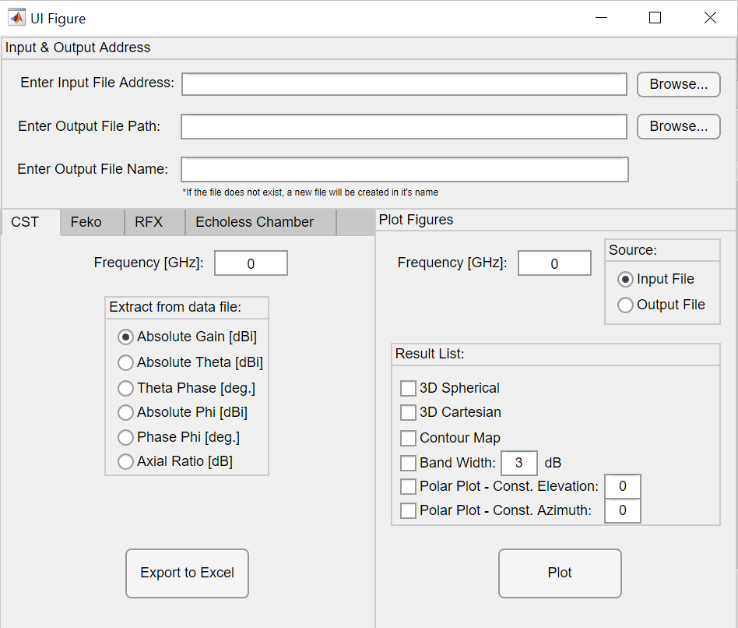

1. File Feed Panel:

In this panel there are 3 receptive fields.

The first field gets the address of the file we want to convert as input. Currently, the application can convert 4 file types – ASCII data files from the CST simulation program, exported files from the simulation program Feko, csv files from measurements on the RFX surface, and csv files of measurements in the echoless chamber.

An example of proper use of the first cell –

C:\Users\user1\Documents\example input file\Example.txt

**Attention!** Enter the full file address (Name & Path) in this field.

The second and third receptive fields together form the address of the file into which we output the final product; The first field takes the path of the directory containing the output file (csv), and the second field takes the name of the file only. The reason these 2 fields are separated from each other is to make it easier to create a new file with a custom name.

Both the first and second receptive fields have a Browse button that allows you to select a file locally from your computer. If the Browse panel is closed Before selecting the file, a notification will be sent in the Command Window.

There are several ways in which these fields can be used:

* To create a new file, enter the path of the directory in which we want to save the file into the second field. Enter the custom name we want to give our new file to the third field (no need to specify the output file format, all files are output as a csv).
* To add more information into an existing csv file (already in KIRBY format), we can use the browse button and select the wanted file. Notice, when using this option, we receive the full path in the second receptive field. The third receptive field should show “Output Name Not Required”.

**Attention!** If receptive fields are left blank, a warning message will appear in the command line and the application will stop processing.

1. File Conversion panel:

The file conversion panel is divided into 4 windows, each responsible for converting a specific file type. Each window has its own "Export to Excel" button so that it knows how to call the correct auxiliary function (details of the auxiliary functions in the next section). For each such window, the app knows how to create a new file containing the information from the input file. Each window can also update an 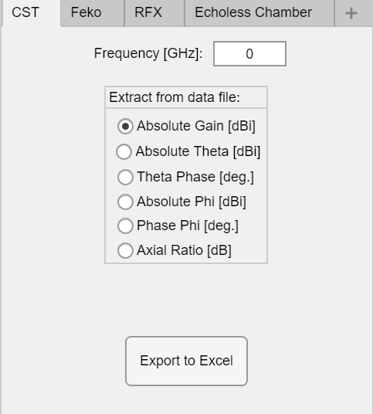existing file with the name that appears in the output field.

* 1. 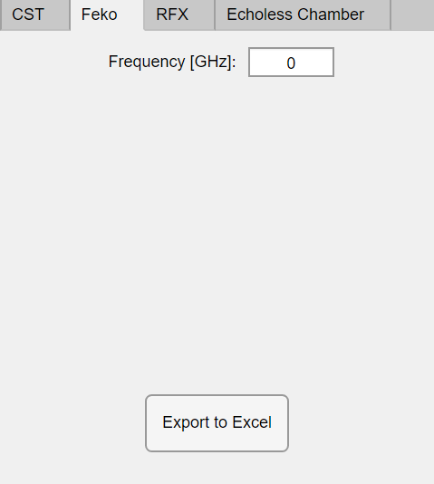**CST window** – In this window, specify the frequency at which the simulation was performed (there is no frequency indicator in the input file itself). In addition, it is necessary to indicate what information we want to extract from the file. The possible types of outputs are dictated by the input file columns extracted from CST. The “Export to Excel” button activates theCST2excel function which outputs a corresponding Excel file.
  2. **Feko window** - In this window, specify the frequency at which the simulation was performed (there is no frequency indicator in the input file itself). In this window you cannot control the type of information since this selection is made within Feko before exporting the data file. The “Export to Excel” button activates 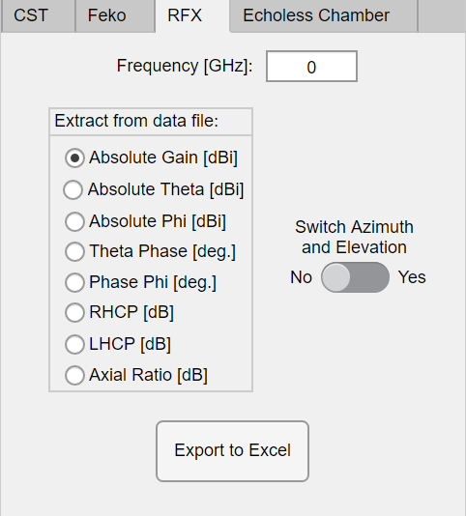theFeko2excel function, which outputs an appropriate Excel file.
  3. **RFX window** – In this window, specify the frequency at which the simulation was performed (there is no frequency indicator in the input file itself). In addition, it is necessary to indicate what information we want to extract from the file. The possible types of outputs are dictated by the input file (i.e., by the RFX measuring instrument). Since in the RFX measuring instrument, we have no way of determining which axis represents polarization E and which axis represents polarization H, the button replacing the azimuth with elevation allows us to transpose the information matrix and thus replace the polarizations if they are opposite to theory. The “Export to Excel” button activates theRFXmeas2excel function which outputs a corresponding Excel file.
  4. **Echoless Chamber window** – In echoless measurements, we get an indication of all the frequencies that have been measured, but usually we will not use all of them. Instead, we fill a list of frequencies of interest separated by semicolons in the first field. In addition, it is possible to choose between the types of information given to us – intensity or phase. Since these measurements are made each time in a different configuration, we need to insert the measurement resolution for both the azimuth and elevation axis. In addition, since the measurements in the echoless chamber are made according to a single elevation in each measurement, we need to enter into the interface the elevation of the current measurement. The “Export to Excel” button activates the Ecmeasexcel function which emits 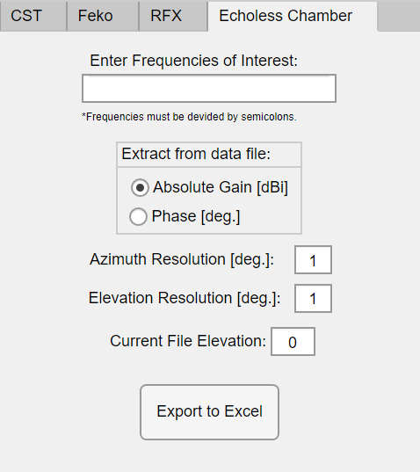a suitable Excel file.

1. Visualizations control panel –

In this panel we need to enter the frequency of the far-field pattern we want to plot. If the frequency does not exist, an error alert will pop up in the Command Window.

The source buttons are designed to shorten file selection processes:

* If we want to convert a file and immediately plot the output, press “Source: Output File”, indicating to use the output file from the recent conversion. In this mode, we use the name that appears in the output field as an input to this panel (of course if the conversion has already been done and the output fields are not empty).
* If we want to enable KIRBY to plot a previously converted file, we can enter its address into the input field and press “Source: Input File”.

Within the Request List, we can select the type of graphs we want using multiple selection:

* 3D Spherical - outputs 3D spherical far-field pattern. (Please note! will not work for a matrix whose dimensions are less than 2).
* 3D Cartesian – outputs 3D cartesian far-field pattern.
* Contour Map – output topographical map of far-field pattern.
* Band Width – Outputs a map that shows which parts of the graph have passed a certain threshold. The same threshold is dictated by the user in the adjacent text box.
* A screenshot of a computer

  Description automatically generatedPolar Plot - emits a fixed elevation/azimuth cross-section at the user's request in the adjacent text box.

Auxiliary functions

To facilitate the inclusion of future functionalities, the application was developed using a functional approach. This tutorial, presented in an editable file format, is designed to enable you, as the future editor, to modify it as required. The same principle applies to the application itself - functional programming simplifies the testing process, allowing you to assess the function before integrating it with Kirby. Additionally, utilizing functional writing practices leads to well-organized and transparent code, thereby enhancing the overall readability of the application. Moving forward, we will proceed to provide an overview of the existing functionalities.

CST2excel:

function [] = CST2excel(Freq, Mode, InputFileAdd, OutputFileAdd)

This function receives the simulation frequency, the type of information you want, the full address of the input file and the full address of the output file.

The function does not return variables, but it does create an Excel file in the destination folder in the appropriate format.

Feko2excel:

function [] = Feko2excel(Freq, InputFileAdd, OutputFileAdd)

This function accepts the simulation frequency, full address of the input file and full address of the output file.

The function does not return variables, but it does create an Excel file in the destination folder in the appropriate format.

RFXmeas2excel:

function [] = RFXmeas2excel(Freq, Mode, SwitchAzEl, InputFileAdd, OutputFileAdd)

This function receives the measured frequency, type of information desired, azimuth or elevation (select one only), full address of the input file and full address of the output file.

The function does not return variables, but it does create an Excel file in the destination folder in the appropriate format.

ECmeas2excel:

function [] = ECmeas2excel_temp(FreqStr, Mode, az_res, el_res, CurrEl, InputFileAdd, OutputFileAdd)

This function receives a string of the frequencies we want to extract from the measurement file, type of information desired, resolution of azimuth, resolution of elevation, elevation of the current file, full address of the input file and full address of the output file.

The function does not return variables, but it does create an Excel file in the destination folder in the appropriate format.

ExtractMatrix:

function [Mat] = ExtractMatrix(Freq, InputFileAdd)

Unlike the previous functions, this function is designed to simplify the code of the graph emission panel.

The function receives a specific frequency and address of an Excel file converted to KIRBY format and returns a matrix containing the information of the far-field pattern. The function knows how to filter all cells that have NaN values (in cases where we do not have a full radiation curve) and return a matrix with only full cells.