1.

import java.util.Scanner;

public class Main{

public static void main(String[] args) {

String s = "Saveetha School of Engineering";

char[] c = s.toCharArray();

int vowel=0;

for (int i = 0; i < s.length(); i++) {

if(s.charAt(i)=='a' || s.charAt(i)=='e' || s.charAt(i)=='i' || s.charAt(i)=='o' || s.charAt(i)=='u')

vowel++;

}

System.out.println("Vowels: " + vowel);

}

}

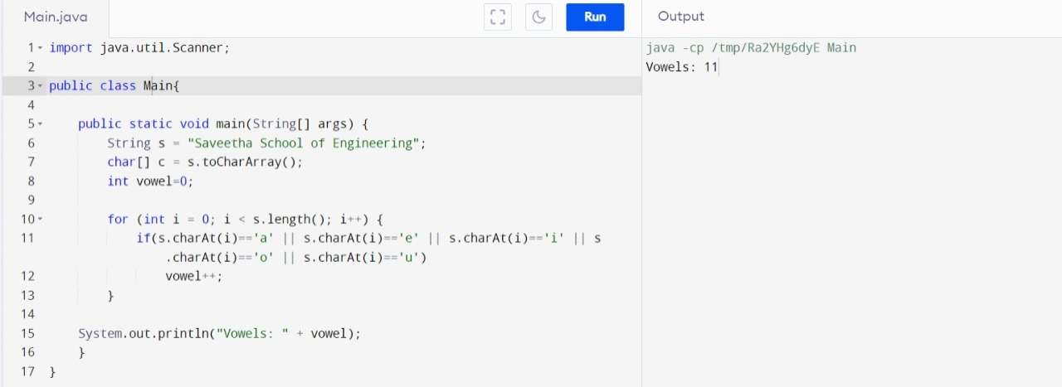

2.

import java.util.Scanner;

public class DiamondPattern

{

public static void main(String args[])

{

int row, i, j, space = 1;

System.out.print("Enter the number of rows you want to print: ");

Scanner sc = new Scanner(System.in);

row = sc.nextInt();

space = row - 1;

for (j = 1; j<= row; j++)

{

for (i = 1; i<= space; i++)

{

System.out.print(" ");

}

space--;

for (i = 1; i <= 2 \* j - 1; i++)

{

System.out.print("\*");

}

System.out.println("");

}

space = 1;

for (j = 1; j<= row - 1; j++)

{

for (i = 1; i<= space; i++)

{

System.out.print(" ");

}

space++;

for (i = 1; i<= 2 \* (row - j) - 1; i++)

{

System.out.print("\*");

}

System.out.println("");

}

}

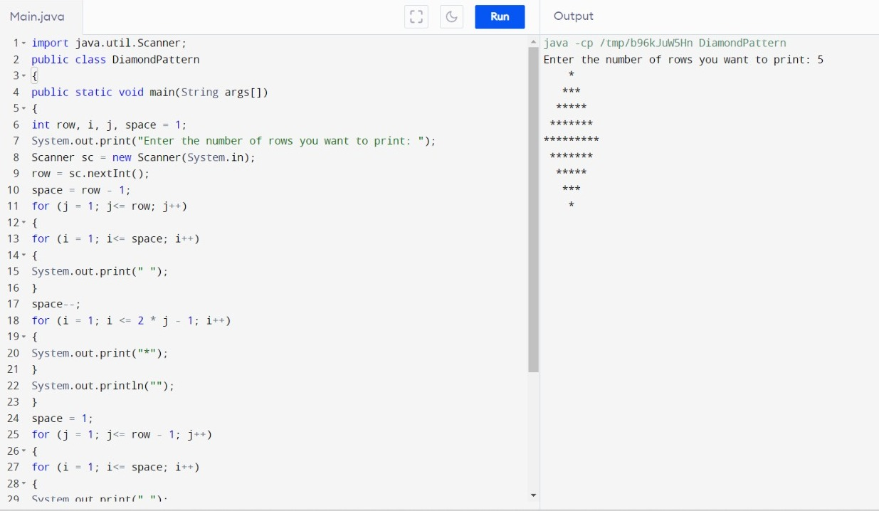}

3.

import java.io.\*;

import java.util.\*;

import java.util.Arrays;

class strde {

public static void main(String[] args) throws Exception

{

String str;

Scanner sc=new Scanner(System.in);

System.out.println("Enter the string:");

str=sc.next();

char arr[] = str.toCharArray();

char temp;

int i = 0;

while (i < arr.length) {

int j = i + 1;

while (j < arr.length) {

if (arr[j] > arr[i]) {

temp = arr[i];

arr[i] = arr[j];

arr[j] = temp;

}

j += 1;

}

i += 1;

}

System.out.println("Alphabetical order:");

System.out.println(arr);

}

}

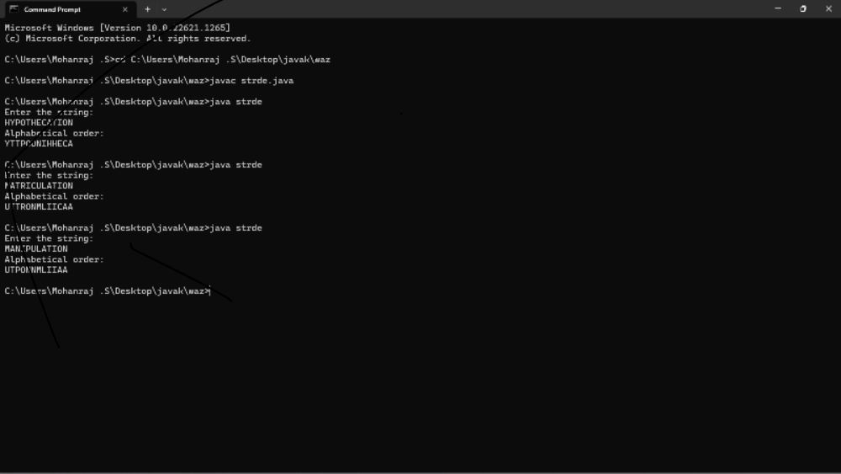

4. import java.util.Scanner;

public class Main

{

public static void main(String[] args)

{

int n;

String temp;

Scanner s = new Scanner(System.in);

System.out.print("Enter number of names you want to enter:");

n = s.nextInt();

String names[] = new String[n];

Scanner s1 = new Scanner(System.in);

System.out.println("Enter all the names:");

for(int i = 0; i < n; i++)

{

names[i] = s1.nextLine();

}

for (int i = 0; i < n; i++)

{

for (int j = i + 1; j < n; j++)

{

if (names[i].compareTo(names[j])>0)

{

temp = names[i];

names[i] = names[j];

names[j] = temp;

}

}

}

System.out.print("Names in Sorted Order:");

for (int i = 0; i < n - 1; i++)

{

System.out.print(names[i] + ",");

}

System.out.print(names[n - 1]);

}

}

