Updated on Nov/26/2022

**Funded several Ph.D. Positions are Available**

**Ph.D. Positions**: We are looking for STRONGLY motivated, creative, and hard-working deep/machine learning Ph.D. students to work on a very exciting project involving areas such as computer vision, machine learning, data mining, GIS and big data, @Computer Science, University of New Orleans (UNO), Louisiana, USA.

Selection Criteria: Better analytic ability and programming skills will be needed. A student with the publication(s), especially in the deep/machine learning/data mining, drones, and image processing/computer vision area, will be given higher preferences. Students with an M.S. degree will be given preference over those with only a B.S. degree. A student who has completed deep/machine learning and/or image processing course(s) will be given a higher preference.

Project Description: We will fly drones (such as eBee +) with various sensors and cameras (such as senseFly S.O.D.A. RGB sensor, Sequoia with E.B. integration kit, etc.) to collect image and sensor data related to multiple levee and culvert faults and will perform relevant research. We will also use state-of-the-art software such as eMotion 3 to design and control drone flight, creating digital twins and data management. We will use various software (such as Pix4Dmapper Pro) to build georeferenced 2D maps and 3D models of the survey area for the study.

These Ph.D. positions are part of very large funding. To learn more about these positions and the relevant team’s tasks, see the job descriptions of “Funded 3 positions …” found [here](https://cs.uno.edu/~tamjid/PositionOpening.html).

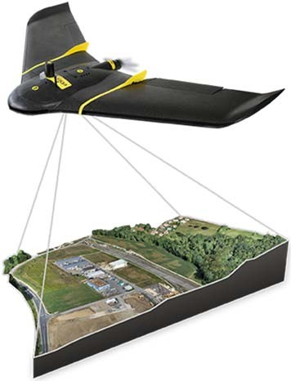

Stipend: The stipend will be competitive. A tuition fee will also be provided.

**How to Apply**: Interested student, please email Dr. Hoque [thoque@uno.edu] your CV (please DO NOT send links but attach files) showing relevant credentials (publications, degree(s), GPA, programming experiences, analytic abilities, etc.) and mention your interest in the project “Deep/machine learning, drone, and computer vision” in the subject line of your email.

What to expect next: If Dr. Hoque asks you to take admission, you may take admission, and admission does not cost much. If you take admission, inform Dr. Hoque, and you will be placed in a **ready-pool**. We will choose competitive candidates from the **ready-pool** with high priority and confirm the selection with short notice.

Note: A place in the ready-pool does not guarantee final selection but enhances the chance.

--- × ---