## Homepage design

## C:\Users\Tam\Desktop\1.png

|  |  |  |  |  |  |  |
| --- | --- | --- | --- | --- | --- | --- |
| Fields | | | | | | |
| No. | **Name** | **Description** | **Mandatory** | **Control**  **Type** | **Data**  **Type** | **Length** |
| 1 | Logo | Logo | No | Label | N/A | N/A |
| 2 | Home | Home button | No | Button | N/A | N/A |
| 3 | Play | Play button | No | Button | N/A | N/A |
| 4 | Sound | Sound button | No | Button | N/A | N/A |

## Menu design

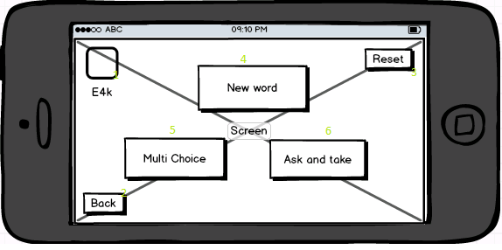

|  |  |  |  |  |  |  |
| --- | --- | --- | --- | --- | --- | --- |
| Fields | | | | | | |
| No. | **Name** | **Description** | **Mandatory** | **Control**  **Type** | **Data**  **Type** | **Length** |
| 1 | Logo | Logo | No | Label | N/A | N/A |
| 2 | Back | Back button | No | Button | N/A | N/A |
| 3 | Reset | Reset button | No | Button | N/A | N/A |
| 4 | New word | Play game button | No | Button | N/A | N/A |
| 5 | Multi choice | Play game button | No | Button | N/A | N/A |
| 6 | Ask and take | Play game button | No | Button | N/A | N/A |

## New word game design

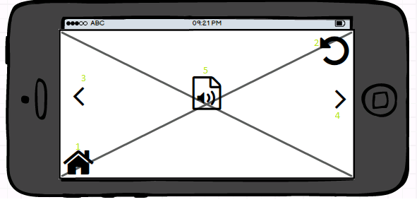

|  |  |  |  |  |  |  |
| --- | --- | --- | --- | --- | --- | --- |
| Fields | | | | | | |
| No. | **Name** | **Description** | **Mandatory** | **Control**  **Type** | **Data**  **Type** | **Length** |
| 1 | Home | Home button | No | Button | N/A | N/A |
| 2 | Relay | Replay button | No | Button | N/A | N/A |
| 3 | Back | Back button | No | Button | N/A | N/A |
| 4 | Next | Next button | No | Button | N/A | N/A |
| 5 | Listen | Image | No | Button | N/A | N/A |

## Multi choice level design

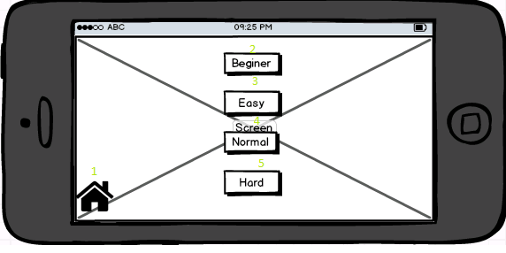

|  |  |  |  |  |  |  |
| --- | --- | --- | --- | --- | --- | --- |
| Fields | | | | | | |
| No. | **Name** | **Description** | **Mandatory** | **Control**  **Type** | **Data**  **Type** | **Length** |
| 1 | Home | Home button | No | Button | N/A | N/A |
| 2 | Beginner | Beginner level button | No | Button | N/A | N/A |
| 3 | Easy | Easy level button | No | Button | N/A | N/A |
| 4 | Normal | Normal level button | No | Button | N/A | N/A |
| 5 | Hard | Hard level button | No | Button | N/A | N/A |

## Multi choice subject design

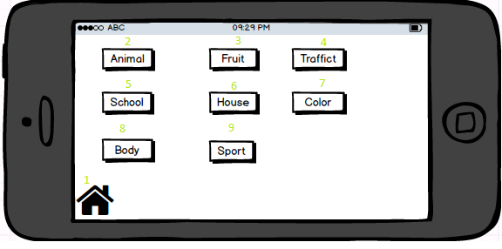

|  |  |  |  |  |  |  |
| --- | --- | --- | --- | --- | --- | --- |
| Fields | | | | | | |
| No. | **Name** | **Description** | **Mandatory** | **Control**  **Type** | **Data**  **Type** | **Length** |
| 1 | Home | Home button | No | Button | N/A | N/A |
| 2 | Animal | Animal subject button | No | Button | N/A | N/A |
| 3 | Fruit | Fruit subject button | No | Button | N/A | N/A |
| 4 | Traffic | Traffic subject button | No | Button | N/A | N/A |
| 5 | School | School subject button | No | Button | N/A | N/A |
| 6 | House | House subject button | No | Button | N/A | N/A |
| 7 | Color | Color subject button | No | Button | N/A | N/A |
| 8 | Body | Body subject button | No | Button | N/A | N/A |
| 9 | Sport | Sport subject button | No | Button | N/A | N/A |

## Multi choice design

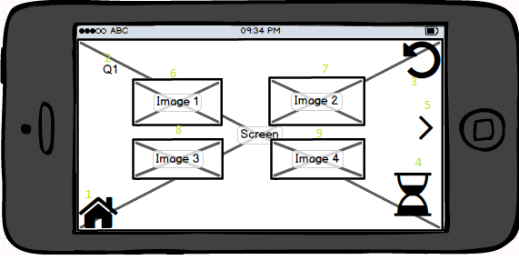

|  |  |  |  |  |  |  |
| --- | --- | --- | --- | --- | --- | --- |
| Fields | | | | | | |
| No. | **Name** | **Description** | **Mandatory** | **Control**  **Type** | **Data**  **Type** | **Length** |
| 1 | Home | Home button | No | Button | N/A | N/A |
| 2 | Question | Number of question | No | Label | N/A | N/A |
| 3 | Replay | Replay button | No | Button | N/A | N/A |
| 4 | Time | Time countdown | No | Time | N/A | N/A |
| 5 | Next | Next button | No | Button | N/A | N/A |
| 6 | Image1 | Image | No | Image | N/A | N/A |
| 7 | Image2 | Image | No | Image | N/A | N/A |
| 8 | Image3 | Image | No | Image | N/A | N/A |
| 9 | Image4 | Image | No | Image | N/A | N/A |

## Multi choice result design

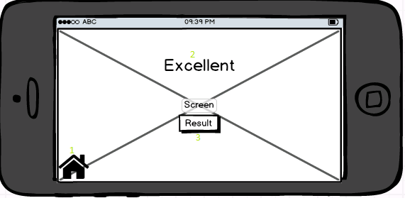

|  |  |  |  |  |  |  |
| --- | --- | --- | --- | --- | --- | --- |
| Fields | | | | | | |
| No. | **Name** | **Description** | **Mandatory** | **Control**  **Type** | **Data**  **Type** | **Length** |
| 1 | Home | Home button | No | Button | N/A | N/A |
| 2 | Result | Result | No | Label | N/A | N/A |
| 3 | ResultBtn | ResultBtn | No | Button | N/A | N/A |

## Multi choice result detail

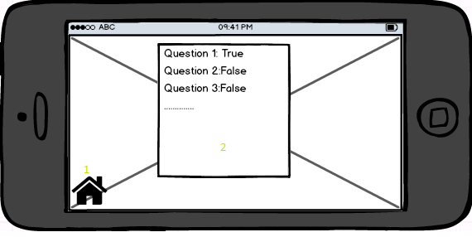

|  |  |  |  |  |  |  |
| --- | --- | --- | --- | --- | --- | --- |
| Fields | | | | | | |
| No. | **Name** | **Description** | **Mandatory** | **Control**  **Type** | **Data**  **Type** | **Length** |
| 1 | Home | Home button | No | Button | N/A | N/A |
| 2 | ResultDt | ResultDetail | No | List | N/A | N/A |

## Ask and take menu design

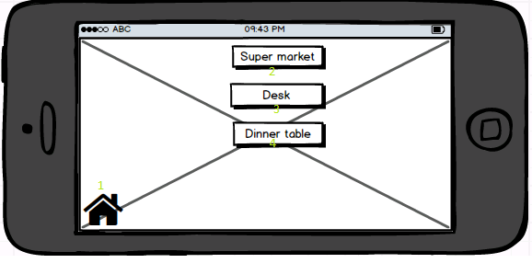

|  |  |  |  |  |  |  |
| --- | --- | --- | --- | --- | --- | --- |
| Fields | | | | | | |
| No. | **Name** | **Description** | **Mandatory** | **Control Type** | **Data Type** | **Length** |
| 1 | Home | Home button | No | Button | N/A | N/A |
| 2 | Supermarket | Supermarket subject button | No | Button | N/A | N/A |
| 3 | Desk | Desk subject button | No | Button | N/A | N/A |
| 4 | DinnerTable | Dinner table subject button | No | Button | N/A | N/A |
|  |  |  |  |  |  |  |

## Ask and take game design

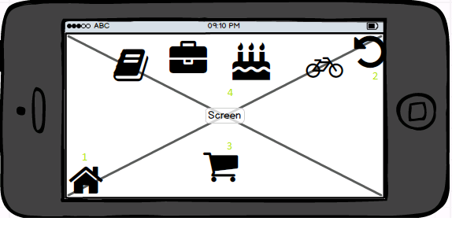

|  |  |  |  |  |  |  |
| --- | --- | --- | --- | --- | --- | --- |
| Fields | | | | | | |
| No. | **Name** | **Description** | **Mandatory** | **Control Type** | **Data Type** | **Length** |
| 1 | Home | Home button | No | Button | N/A | N/A |
| 2 | Replay | Replay button | No | Button | N/A | N/A |
| 3 | Cart | Add items | No |  | N/A | N/A |
| 4 | Items | Item | No |  | N/A | N/A |