# IX. Application Installation

## 9.1 Set up Environments

By default, all machines are confidential before the application is unknown. We need to turn off verify the application.

**Step 1**: Go to settings

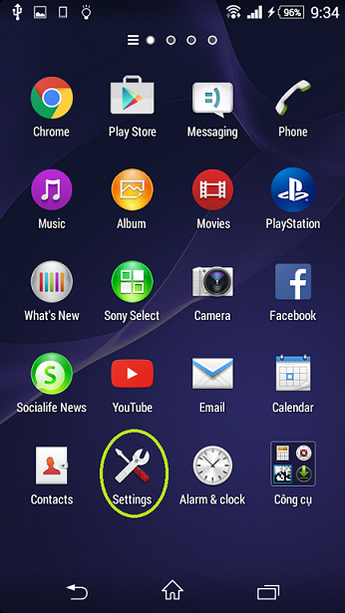

Step2: Go to Security

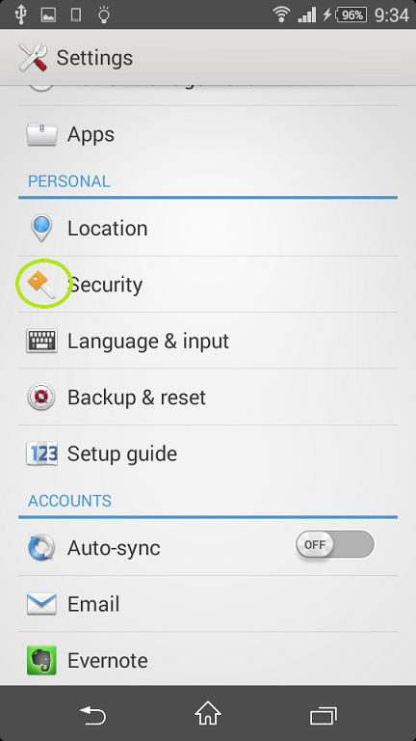

**Step3 :** Turn on Unknown sources

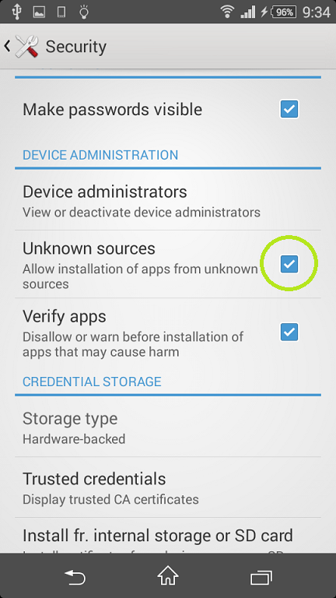

Step4: Open file apk

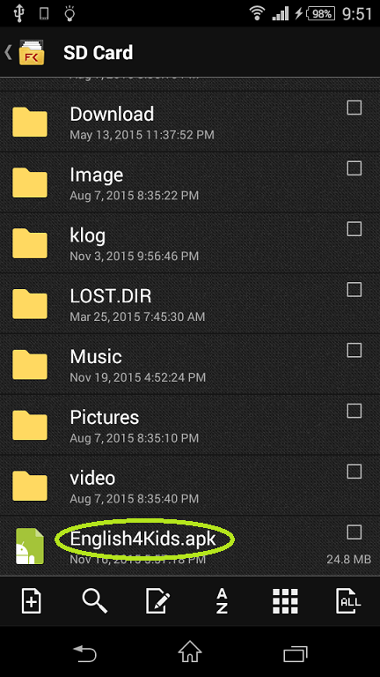

Step5: Click install

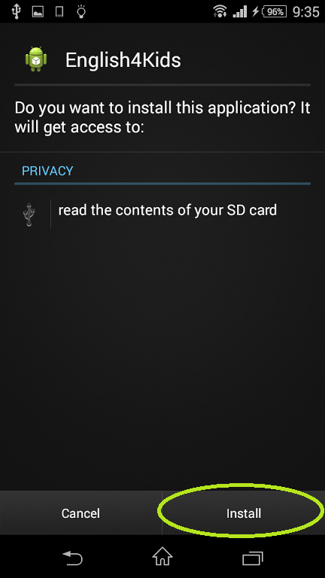

Step6: Wait for install



Step7: App Installed

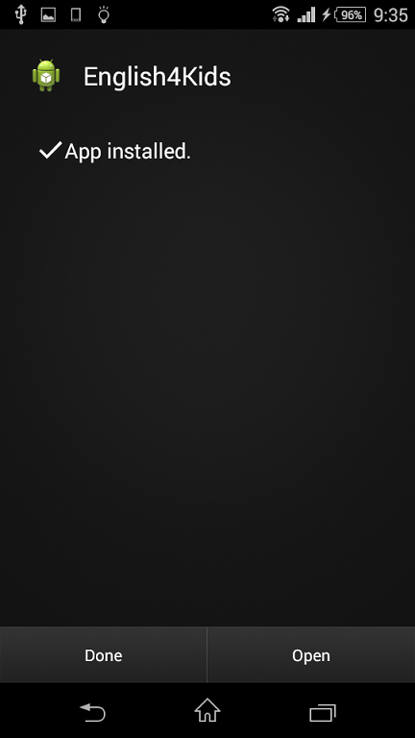

Step8: Successful set up

