# III SOFTWARE REQUIREMENT SPECIFICATION

## 1. Purpose

This chapter outlines functional, non-functional, API and formulas requirements of our system. It also provides some format constraints in common requirements and project success criteria.

All member will word (design, code and test) based on the information provided in this chapter

## 2. Functional Requirements

### 2.1 Use Case Diagram

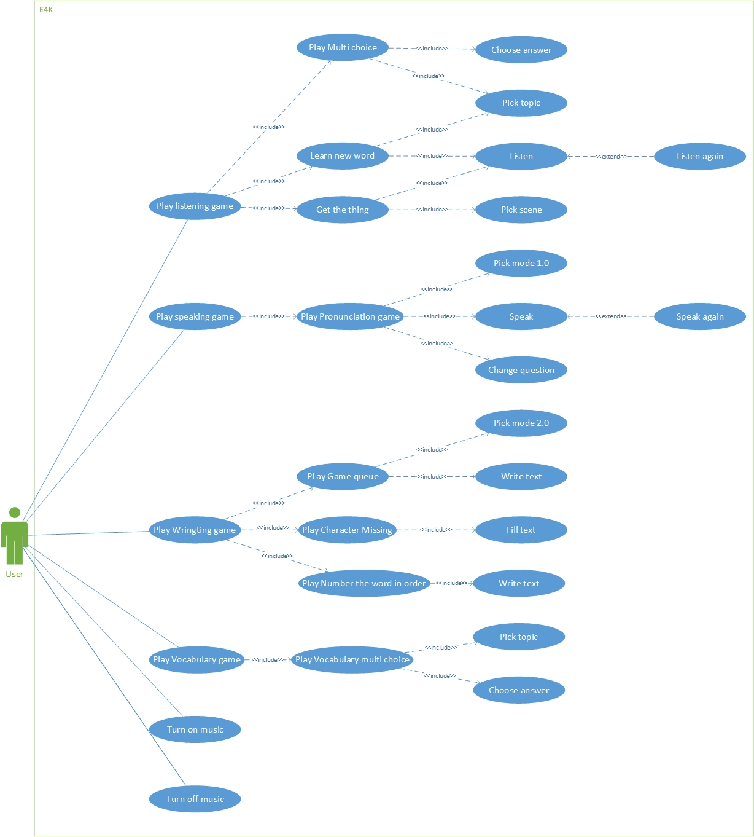

Figure 3‑1 Use case diagram

|  |  |  |
| --- | --- | --- |
| No. | Use-case Name | Summary |
| UC001 | Choose answer | Allows users choose an answer |
| UC002 | Pick topic | Allows users pick a topic |
| UC003 | Listen | Allows users listen new words |
| UC004 | Listen again | Allows users listen new word again |
| UC005 | Pick scene | Allows users pick scene |
| UC006 | Pick mode 1.0 | Allows users pick mode one or two players |
| UC007 | Speak | Allows users speak |
| UC008 | Speak again | Allows users speak again |
| UC009 | Change question | Allows users change question |
| UC010 | Pick mode 2.0 | Allows users pick easy or hard mode |
| UC011 | Fill text | Allows users to fill text missing |
| UC012 | Write text | Allows users write text |
| UC013 | Turn on music | Allows user turn on music |
| UC014 | Turn off music | Allows users turn of music |

### 2.2 Use Cases

***2.2.1 Choose answer***

|  |  |  |  |
| --- | --- | --- | --- |
| **USE CASE 1 SPECIFICATION** | | | |
| **Use-case No.** | UC001 | **Use-case Version** | 1.0 |
| **Use-case Name** | Choose answer | | |
| **Author** | LongNH | | |
| **Date** | 21/09/2015 | **Priority** | High |
| **Actor**:   * Users.   **Summary**:   * This use case allows users to choose an answer.   **Goal**:   * Choose an answer.   **Triggers:**   * Users tap on one of four options given by the system.   **Preconditions**:   * Four options are shown up successfully.   **Post Conditions:**   * There is one alert sound given by the system. * Redirect to next question screen.   **Main Success Scenario:**   |  |  |  | | --- | --- | --- | | No | Actor | Action | | 1 | Users | Users click on one of four options | | 2 | System | Plays an alert sound | | 3 | System | Shows next question |   **Alternative Scenario:**   * None   **Exceptions:**   * N/A   **Relationships:**   * None   **Business Rules:**   * N/A | | | |

***2.2.2 Pick topic***

|  |  |  |  |
| --- | --- | --- | --- |
| **USE CASE 2 SPECIFICATION** | | | |
| **Use-case No.** | UC002 | **Use-case Version** | 1.0 |
| **Use-case Name** | Pick topic | | |
| **Author** | LongNH | | |
| **Date** | 21/09/2015 | **Priority** | High |
| **Actor**:   * Users.   **Summary**:   * This use case allows users to pick a topic.   **Goal**:   * Pick a topic.   **Triggers:**   * Users tap on one of five topics given by the system.   **Preconditions**:   * Five topics are shown up successfully.   **Post Conditions:**   * Pick a topic successfully. * Redirect to question screen.   **Main Success Scenario:**   |  |  |  | | --- | --- | --- | | No | Actor | Action | | 1 | Users | Users tap on one of five topics given by the system | | 2 | System | Display question screen |   **Alternative Scenario:**   * None   **Exceptions:**   * N/A   **Relationships:**   * None   **Business Rules:**   * N/A | | | |

***2.2.3 Listen***

|  |  |  |  |
| --- | --- | --- | --- |
| **USE CASE 3 SPECIFICATION** | | | |
| **Use-case No.** | UC003 | **Use-case Version** | 1.0 |
| **Use-case Name** | Listen | | |
| **Author** | LongNH | | |
| **Date** | 21/09/2015 | **Priority** | High |
| **Actor**:   * Users.   **Summary**:   * This use case allows users to listen.   **Goal**:   * Plays a sound.   **Triggers:**   * Users tap on the image which includes a sound.   **Preconditions**:   * Users are playing in the listening.   **Post Conditions:**   * Make a sound successfully.   **Main Success Scenario:**   |  |  |  | | --- | --- | --- | | No | Actor | Action | | 1 | Users | Tap on the image which includes a sound. | | 2 | System | Plays the sound. |   **Alternative Scenario:**   * None   **Exceptions:**   * N/A   **Relationships:**   * None   **Business Rules:**   * N/A | | | |

***2.2.4 Listen again***

|  |  |  |  |
| --- | --- | --- | --- |
| **USE CASE 4 SPECIFICATION** | | | |
| **Use-case No.** | UC004 | **Use-case Version** | 1.0 |
| **Use-case Name** | Listen again | | |
| **Author** | LongNH | | |
| **Date** | 21/09/2015 | **Priority** | High |
| **Actor**:   * Users.   **Summary**:   * This use case allows users to listen again.   **Goal**:   * Plays the sound again.   **Triggers:**   * Users tap on the image which includes the sound.   **Preconditions**:   * Users are playing in the listening.   **Post Conditions:**   * Make the sound successfully.   **Main Success Scenario:**   |  |  |  | | --- | --- | --- | | No | Actor | Action | | 1 | Users | Users tap on the image which includes the sound. | | 2 | System | Plays the sound. |   **Alternative Scenario:**   * None   **Exceptions:**   * N/A   **Relationships:**   * None   **Business Rules:**   * N/A | | | |

***2.2.5 Pick scene***

|  |  |  |  |
| --- | --- | --- | --- |
| **USE CASE 1 SPECIFICATION** | | | |
| **Use-case No.** | UC005 | **Use-case Version** | 1.0 |
| **Use-case Name** | Pick scene | | |
| **Author** | LongNH | | |
| **Date** | 21/09/2015 | **Priority** | High |
| **Actor**:   * Users.   **Summary**:   * This use case allows users to pick a scene.   **Goal**:   * Pick a scene.   **Triggers:**   * Users tap on one of four scenes given by the system.   **Preconditions**:   * Four scenes are shown up successfully.   **Post Conditions:**   * Pick a scene successfully. * Redirect to question screen.   **Main Success Scenario:**   |  |  |  | | --- | --- | --- | | No | Actor | Action | | 1 | Users | Users tap on one of four scenes given by the system. | | 2 | System | Display question screen |   **Alternative Scenario:**   * None   **Exceptions:**   * N/A   **Relationships:**   * None   **Business Rules:**   * N/A | | | |

***2.2.6 Pick mode 1.0***

|  |  |  |  |
| --- | --- | --- | --- |
| **USE CASE 1 SPECIFICATION** | | | |
| **Use-case No.** | UC006 | **Use-case Version** | 1.0 |
| **Use-case Name** | Pick mode 1.0 | | |
| **Author** | LongNH | | |
| **Date** | 21/09/2015 | **Priority** | High |
| **Actor**:   * Users.   **Summary**:   * This use case allows users to pick a mode.   **Goal**:   * Pick a mode.   **Triggers:**   * Users tap on one of two modes given by the system.   **Preconditions**:   * Two modes are shown up successfully.   **Post Conditions:**   * Pick a mode successfully. * Redirect to question screen.   **Main Success Scenario:**   |  |  |  | | --- | --- | --- | | No | Actor | Action | | 1 | Users | Users tap on one of two modes given by the system | | 2 | System | Displays question screen |   **Alternative Scenario:**   * None   **Exceptions:**   * N/A   **Relationships:**   * None   **Business Rules:**   * N/A | | | |

***2.2.7 Speak***

|  |  |  |  |
| --- | --- | --- | --- |
| **USE CASE 1 SPECIFICATION** | | | |
| **Use-case No.** | UC007 | **Use-case Version** | 1.0 |
| **Use-case Name** | Speak | | |
| **Author** | LongNH | | |
| **Date** | 21/09/2015 | **Priority** | High |
| **Actor**:   * Users.   **Summary**:   * This use case allows users to speak.   **Goal**:   * Shows user pronunciation in text.   **Triggers:**   * Users click on “Start speaking” button and speak out.   **Preconditions**:   * Users are playing in speaking.   **Post Conditions:**   * Shows user pronunciation in text successfully. * Makes an alert sound for correction or not. * Displays a new word.   **Main Success Scenario:**   |  |  |  | | --- | --- | --- | | No | Actor | Action | | 1 | Users | Users click on "Start speaking" button and speak out | | 2 | System | Displays a text | | 3 | System | Makes an alert sound | | 4 | System | Displays a new word |   **Alternative Scenario:**   * None   **Exceptions:**   * N/A   **Relationships:**   * None   **Business Rules:**   * N/A | | | |

***2.2.8 Speak again***

|  |  |  |  |
| --- | --- | --- | --- |
| **USE CASE 1 SPECIFICATION** | | | |
| **Use-case No.** | UC008 | **Use-case Version** | 1.0 |
| **Use-case Name** | Speak again | | |
| **Author** | LongNH | | |
| **Date** | 21/09/2015 | **Priority** | High |
| **Actor**:   * Users.   **Summary**:   * This use case allows users to speak again.   **Goal**:   * Shows user pronunciation in text again.   **Triggers:**   * Users click on “Speak again” button and speak out.   **Preconditions**:   * Users are playing in speaking   **Post Conditions:**   * Shows user pronunciation in text successfully. * Makes an alert sound for correction or not. * Displays a new word.   **Main Success Scenario:**   |  |  |  | | --- | --- | --- | | No | Actor | Action | | 1 | Users | Users click on "Speak again" button | | 2 | System | Displays user pronunciation in text | | 3 | System | Makes an alert sound | | 4 | System | Displays a new word |   **Alternative Scenario:**   * None   **Exceptions:**   * N/A   **Relationships:**   * None   **Business Rules:**   * N/A | | | |

***2.2.9 Change question***

|  |  |  |  |
| --- | --- | --- | --- |
| **USE CASE 1 SPECIFICATION** | | | |
| **Use-case No.** | UC009 | **Use-case Version** | 1.0 |
| **Use-case Name** | Change question | | |
| **Author** | LongNH | | |
| **Date** | 21/09/2015 | **Priority** | High |
| **Actor**:   * Users.   **Summary**:   * This use case allows users to change the current question.   **Goal**:   * Change the current question.   **Triggers:**   * Users click on “Change question” button   **Preconditions**:   * Users are playing in speaking. * There is a question already shown to users.   **Post Conditions:**   * Makes a new question successfully.   **Main Success Scenario:**   |  |  |  | | --- | --- | --- | | No | Actor | Action | | 1 | Users | Users click on “Change question” button | | 2 | System | Displays a new question |   **Alternative Scenario:**   * None   **Exceptions:**   * N/A   **Relationships:**   * None   **Business Rules:**   * N/A | | | |

***2.2.10 Pick mode 2.0***

|  |  |  |  |
| --- | --- | --- | --- |
| **USE CASE 1 SPECIFICATION** | | | |
| **Use-case No.** | UC010 | **Use-case Version** | 1.0 |
| **Use-case Name** | Pick mode 2.0 | | |
| **Author** | TuanDV | | |
| **Date** | 21/09/2015 | **Priority** | High |
| **Actor**:   * Users.   **Summary**:   * This use case allows users pick easy or hard mode.   **Goal**:   * Pick a mode.   **Triggers:**   * Users tap on one of two modes given by the system.   **Preconditions**:   * Two modes are shown up successfully.   **Post Conditions:**   * Pick a mode successfully. * Redirect to question screen.   **Main Success Scenario:**   |  |  |  | | --- | --- | --- | | No | Actor | Action | | 1 | Users | Users tap on one of two modes given by the system | | 2 | System | Displays question screen |   **Alternative Scenario:**   * None   **Exceptions:**   * N/A   **Relationships:**   * None   **Business Rules:**   * N/A | | | |

***2.2.11 Fill text***

|  |  |  |  |
| --- | --- | --- | --- |
| **USE CASE 3 SPECIFICATION** | | | |
| **Use-case No.** | UC011 | **Use-case Version** | 1.0 |
| **Use-case Name** | Fill text | | |
| **Author** | TuanDV | | |
| **Date** | 21/09/2015 | **Priority** | High |
| **Actor**:   * User.   **Summary**:   * This use case allows user to fill text missing.   **Goal**:   * Fill text missing   **Triggers:**   * User tap on where text missing and typing from keybroad   **Preconditions**:   * Question are shown up successfully.   **Post Conditions:**   * User filled character missing   **Main Success Scenario:**   |  |  |  | | --- | --- | --- | | No | Actor | Action | | 1 | User | User tap on where character missing | | 2 | User | User type character from keybroad | | 3 | System | Fill character into where user typed |   **Alternative Scenario:**   * None   **Exceptions:**   * N/A   **Relationships:**   * None   **Business Rules:**   * N/A | | | |

***2.2.12 Write text***

|  |  |  |  |
| --- | --- | --- | --- |
| **USE CASE 3 SPECIFICATION** | | | |
| **Use-case No.** | UC012 | **Use-case Version** | 1.0 |
| **Use-case Name** | Write text | | |
| **Author** | TuanDV | | |
| **Date** | 21/09/2015 | **Priority** | High |
| **Actor**:   * User.   **Summary**:   * This use case allows user to write text   **Goal**:   * Write text   **Triggers:**   * User tap on where text answer and typing from keybroad   **Preconditions**:   * Question are shown up successfully.   **Post Conditions:**   * User filled character in answer   **Main Success Scenario:**   |  |  |  | | --- | --- | --- | | No | Actor | Action | | 1 | User | User tap on answer text | | 2 | User | User type character from keybroad | | 3 | System | Show character into where user typed |   **Alternative Scenario:**   * None   **Exceptions:**   * N/A   **Relationships:**   * None   **Business Rules:**   * N/A | | | |

***2.2.13 Turn on music***

|  |  |  |  |
| --- | --- | --- | --- |
| **USE CASE 3 SPECIFICATION** | | | |
| **Use-case No.** | UC013 | **Use-case Version** | 1.0 |
| **Use-case Name** | Turn on music | | |
| **Author** | TuanDV | | |
| **Date** | 21/09/2015 | **Priority** | High |
| **Actor**:   * Users.   **Summary**:   * This use case allows users turn on music   **Goal**:   * Music is able.   **Triggers:**   * Users tap on the sound icon.   **Preconditions**:   * Sound is off   **Post Conditions:**   * Sound is turned on   **Main Success Scenario:**   |  |  |  | | --- | --- | --- | | No | Actor | Action | | 1 | Users | Tap on sound icon | | 2 | System | Plays the sound |   **Alternative Scenario:**   * None   **Exceptions:**   * N/A   **Relationships:**   * None   **Business Rules:**   * N/A | | | |

***2.2.14 Turn off music***

|  |  |  |  |
| --- | --- | --- | --- |
| **USE CASE 3 SPECIFICATION** | | | |
| **Use-case No.** | UC013 | **Use-case Version** | 1.0 |
| **Use-case Name** | Turn off music | | |
| **Author** | TuanDV | | |
| **Date** | 21/09/2015 | **Priority** | High |
| **Actor**:   * Users.   **Summary**:   * This use case allows users turn off music   **Goal**:   * Music is disable.   **Triggers:**   * Users tap on the sound icon.   **Preconditions**:   * Sound is on   **Post Conditions:**   * Sound is turned off   **Main Success Scenario:**   |  |  |  | | --- | --- | --- | | No | Actor | Action | | 1 | Users | Tap on sound icon | | 2 | System | Music is disable |   **Alternative Scenario:**   * None   **Exceptions:**   * N/A   **Relationships:**   * None   **Business Rules:**   * N/A | | | |

## 3. Non-functional requirements

### 3.1 Availability

Out system must be run daily. The crash must not exceed once per month and when crash, our system should be back after 3 hours maximum.

Prepare a scheduled downtime at midnight to perform backup

### 3.2 Security

User’s information do not be leaked.

### 3.3 Maintainability

Strictly follow the coding convention to help improve readability of source code and make the application more maintainable

Develop application based on Object Oriented Programing paradigm in order to increase maintainability and extendibility.

Follow layered architecture, modular software and component-based development

### 3.4 Performance

Home screen response time should be less than 2 seconds.

The other screen response time should be less than 1 second.

Recognize speech should be less than 2 seconds.

All activity response should be less than 1 second.

### 3.5 Usability

A user should be able to play any English game with no more than three touches.

Flat design and high contrast

Main Navigation is easily identifiable

### 3.6 Compatibility

The application should be run well on:

* + - Android version: Android 2.2 or higher

## 4. Common requirements

| Name | Format |
| --- | --- |
| Speaking time | Max length: 3 seconds |
| Music | Format: *.mp3 Max size: 0.5MB |
| Image | Format: *.jpg Max width: 1000px |

## 5. Success Criteria

| No | Item | Success Criteria |
| --- | --- | --- |
| 1 | Product | All major features are completed. Must be completed on schedule. Mobile application goes live, attract a large and active community. |
| 2 | Team | Broaden our knowledge and improve experience with new technologies. Team-work ability is increased. Team conflicts are well controlled. |