2.7 Configuration management

2.7.1 Introduction
The purpose of this document is to identify an describe Configuration management (CM) process implementing in the project

2.7.2 Roles and Responsibilities
Refer to 2.2.2 section

2.7.3 Configuration management process

2.7.3.1 Identification &Name convention

2.7.3.2 Project Infrastructure
Tool | Purpose | Note
Eclipse | For development | https://www.eclipse.org/downloads ‎
TortoiseSVN | For source code control
Code google | For document and source storage | http://code.google.com

2.7.3.3 Directory structure

Main Folder | Sub Folder | Purpose
Archive |  | To Released version of application
Audit |  | Store and work with Process/Product Review
Final |  | Store final version of application
Reference | Guide | Store Guidelines
Reference | Template | Store Template
Wip | Document | Store SRS, SAD, Test….
Wip | Plan | Store SPM, project plan, task list, schedule
Wip | Source Code | Store Source code
Wip | Daily Report | Store Daily Report
Wip | Meeting minutes | Store meeting minutes
Wip | Q&A | Store Q&A of member
Wip | User | Store User folder and file
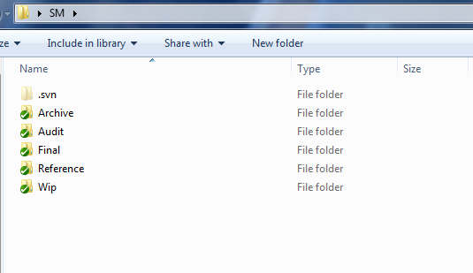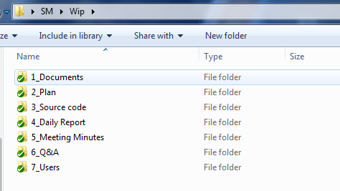

2.7.3.4 Baseline Procedure

2.7.3.4.1 For Document
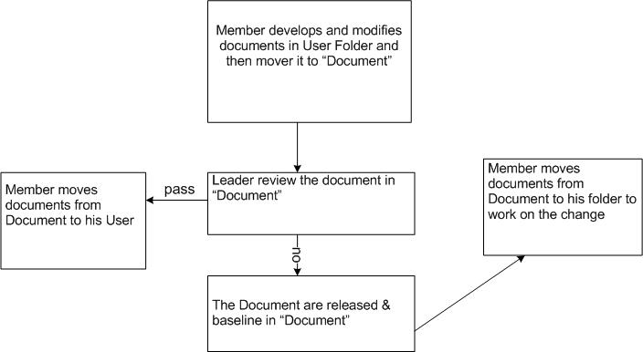

2.7.3.4.2 For Source Code
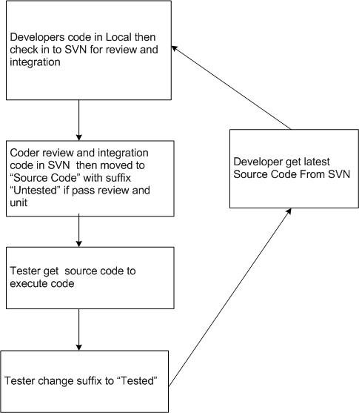

2.7.3.5 Version number rule

2.7.3.5.1 Document
The version level is maintained as a numeric identifier with two components:
Version
Revision
1.1

- Version number, which appears to the left of the decimal.
- Revision number, which appears to the right of the decimal.

Version number
The version number changes only when the core architecture of the item changes, as when an item is completely overhauled, with substantial internal changes. In this case, version 1.0 would become version 2.0.
Revision number
The revision number changes when existing content is changed, but the overall structure and flow of the item remains the same. The normal sequence of revision is 1.0, 1.1, 1.2, and so on.

2.7.3.5.2 Source Code
Software executable and support files
Software executable and support files are generally identified by name and version number, such as “Main DB v1.1a.” The naming convention of each software evolving item is defined by the development team. The version numbering scheme consists of three components:
Version
Revision
1.1a
Update

- Version number, which appears to the left of the decimal.
- Revision number, which appears to the right of the decimal.
- Update level, consisting of a single trailing character.

Version number
The version number changes only when the core architecture of the software item changes, as when moving from one area of the development tool to another, when an application is completely overhauled, or the user interface changes fundamentally. In this case, version 1.1a would become version 2.0.

Revision number
The revision number changes when new features, functionality or other content are added or significantly changed. In normal case, the core architecture or user interface have been extended or limited in some manner. The most common reason for charging the revision number is when adding a new module or other functionality to the software. The normal sequence of revision is 1.0, 1.1, and 1.2 and so on.

Update character
The update character is appended or incremented when the only change to the software item is to correct one or more defects, without the addition of any new functionality. Version 1.1 would become v1.1a, v1.1b and so on. This updating is over ridden when a combination revision, involving bug fixes and new feature additions, is performed. In such a case, the software revision number is incremented and any update indicator is dropped, as in v1.1b to v1.2.

2.7.3.5.3 Other Rule

- Rule for develop : Coding convention (2.4)
- Mail subject name : [SM]<subject>

