Git/Github

Git is a distributed version control system.
In the world of software development, over 90% of developers use a version control system, with Git being the most popular choice. Git is a distributed version control system that allow developers to track changes in code, collaborate seamlessly, and manage projects efficiently. GitHub is built on top of Git, a cloud-based platform that provides a user-friendly interface for hosting, reviewing, and sharing code. Together, Git and GitHub have become essential for modern development, enabling open-source collaboration and enterprise-level project management.

Features of the Git

-Developers contributes to the same project.
-you can revert changes.(one update .we can rollback it)
-you can collaborates to fix issues.(two developers can contribute to fix the bug).
-you can solve conflicts.
-you can organize features (every update ,new features has log file ).

Key Git Concepts
- Repository-(container for the project) A directory where git monitors your project files and records their revision history.(Remote Repository-Local Repository)
- Remote Repository: (the repository on github).
- Local Repository(the repository on the local machine..ex your pc).
- Clone- It created a local copy of a remote repository or local repository on your machine.
- Stage- It Selects specific changes that you want Git to include in the next snapshot.
- Commit-It records the staged changes as a permanent version in the project history.
- Branch- Lets you develop new features or experiment without affecting the main project.
- Merge- Integrates changes from one branch into another.
- Pull- It fetches and applies updates from a remote repository to your local one.
- Push-It Uploads your local commits to a remote repository
.Pull Request-Tell other about changes to pull it from local Repo to remote Repo.
Notes:
-for every project create a repository.
-Create a branch for every enhancement or for every new feature.
-No need to connect to remote repository when you are working.

-Anyone can push and pull depending on permission.

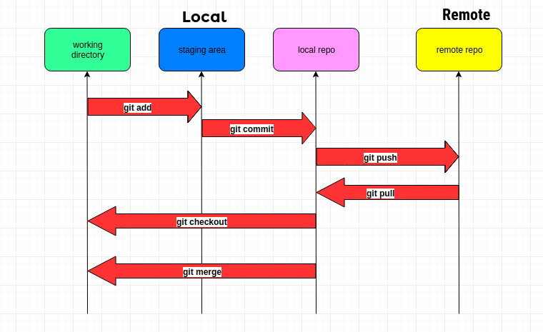

Create GitHub Repository and clone it :

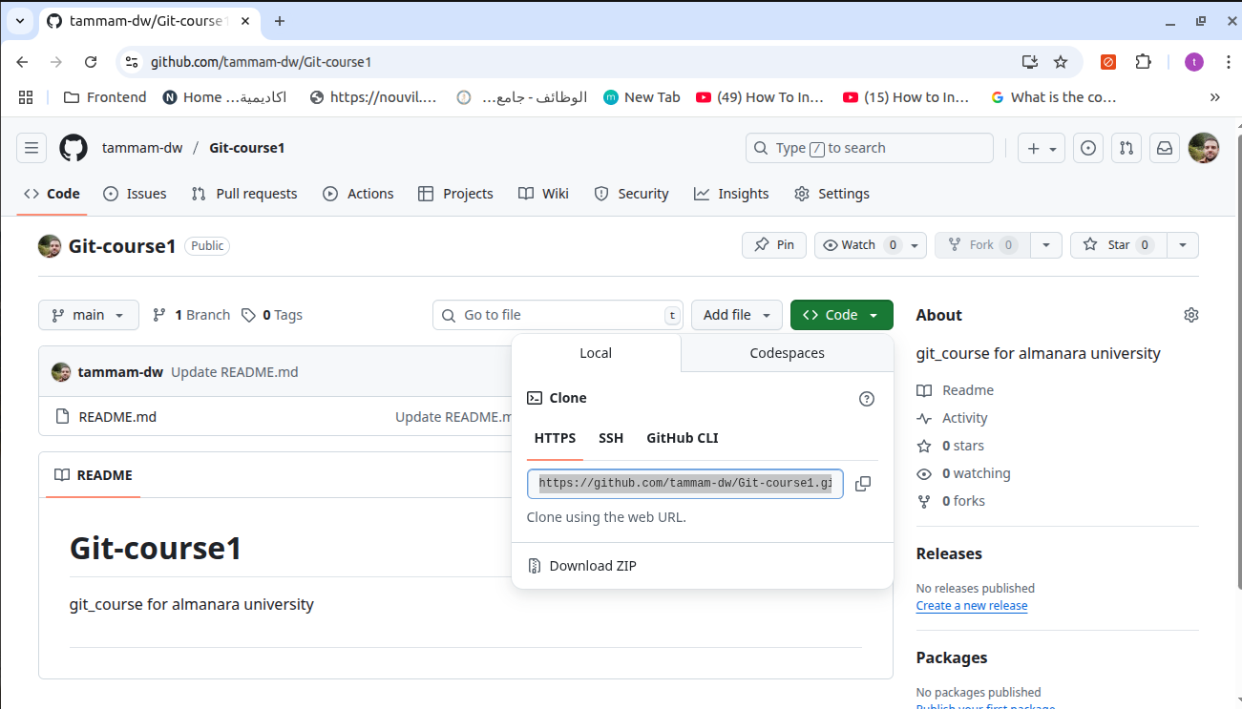
1-Sign up on Github.com
2-create new Repository by clicking by clicking on the (+ ) .
3- copy the url

3-go to the Command Line and go to the Documents folder cd Documents
4- in the command line and inside Documents folder hit the following statement
git clone https://github.com/tammam-dw/Git-course1.git
as follow

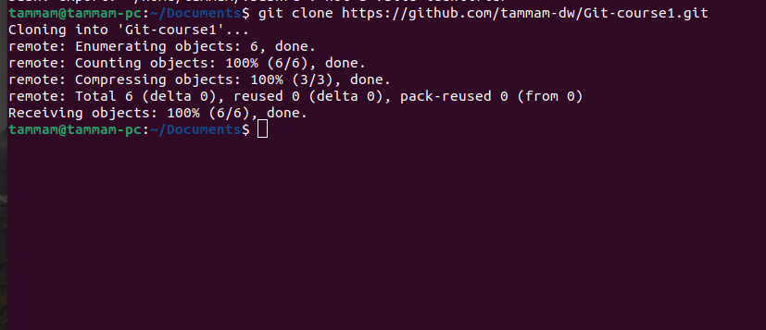
now in the Document/Git-course1 make the following folders(one for html,one for css,and one for js,and one file index.html,and one file inside css named style.css).
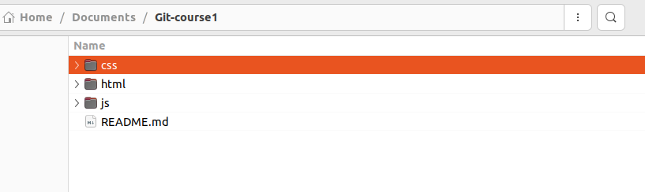
Now in the command line hit the following command git status
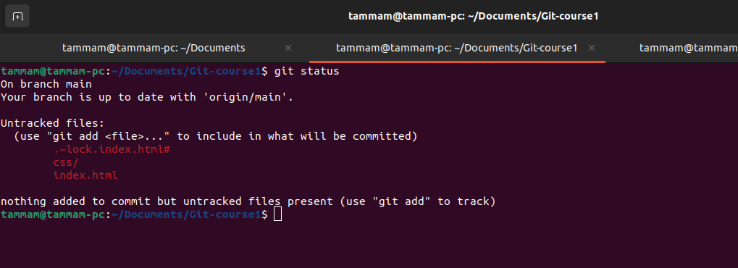
that means there are 2 files we need to add them to the stage area and after that hit the command
git add css/index.css index.html
now again hit the command git status you will get the following
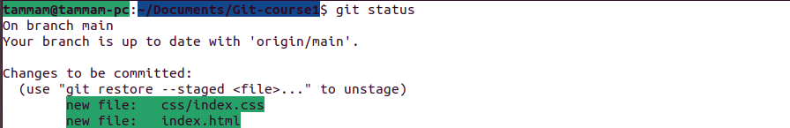
Now if we want to remove one file from staging area, we hit the command
git reset index.html
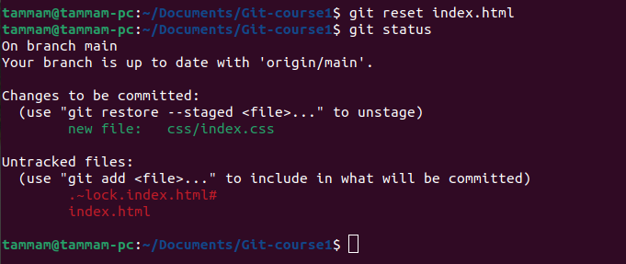

Now if we want to transfer the files from staging area to the Local repo ,hit the following command
git commit -m “ any message you want ”

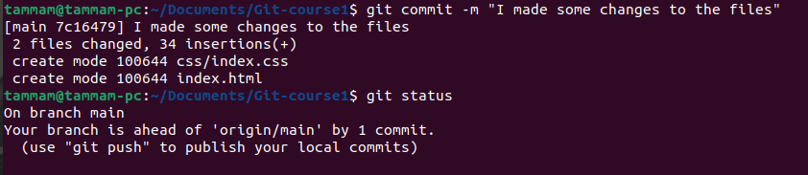
To push the files to the remote Repository on github you need to execute the following command

git remote set-url origin https://<token>@github.com/<username>/<repo>

to generate the token go to the settings/Developer settings.

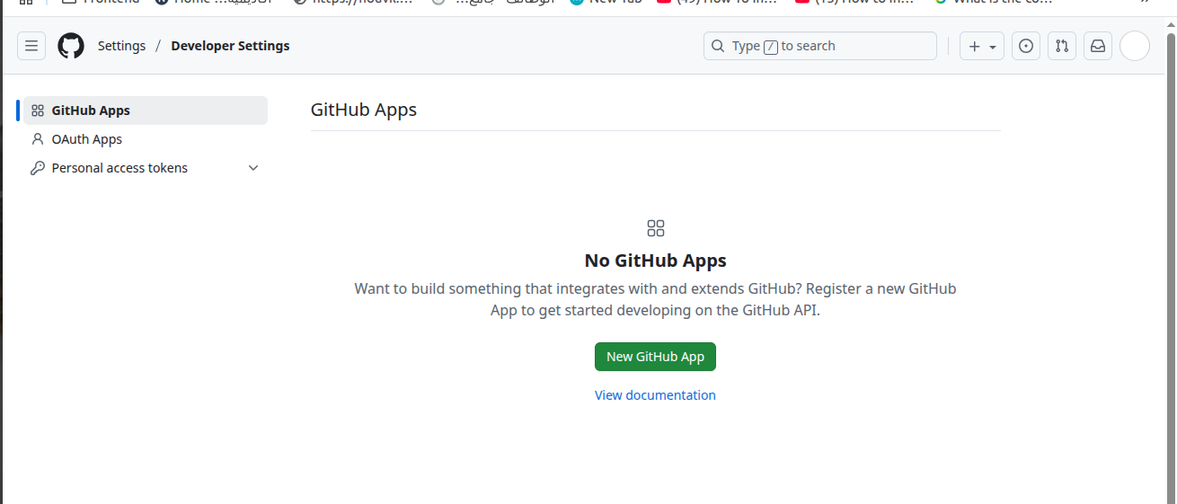

Now in the command line hit the commands

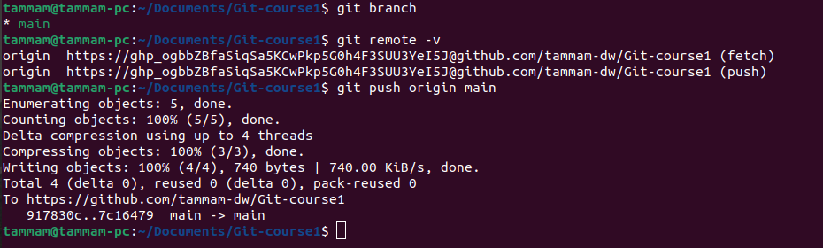

Now in the github.com see the the results

