1. Use Bugmagnet and Fake filler extension for form filling

Click on the fake filter.

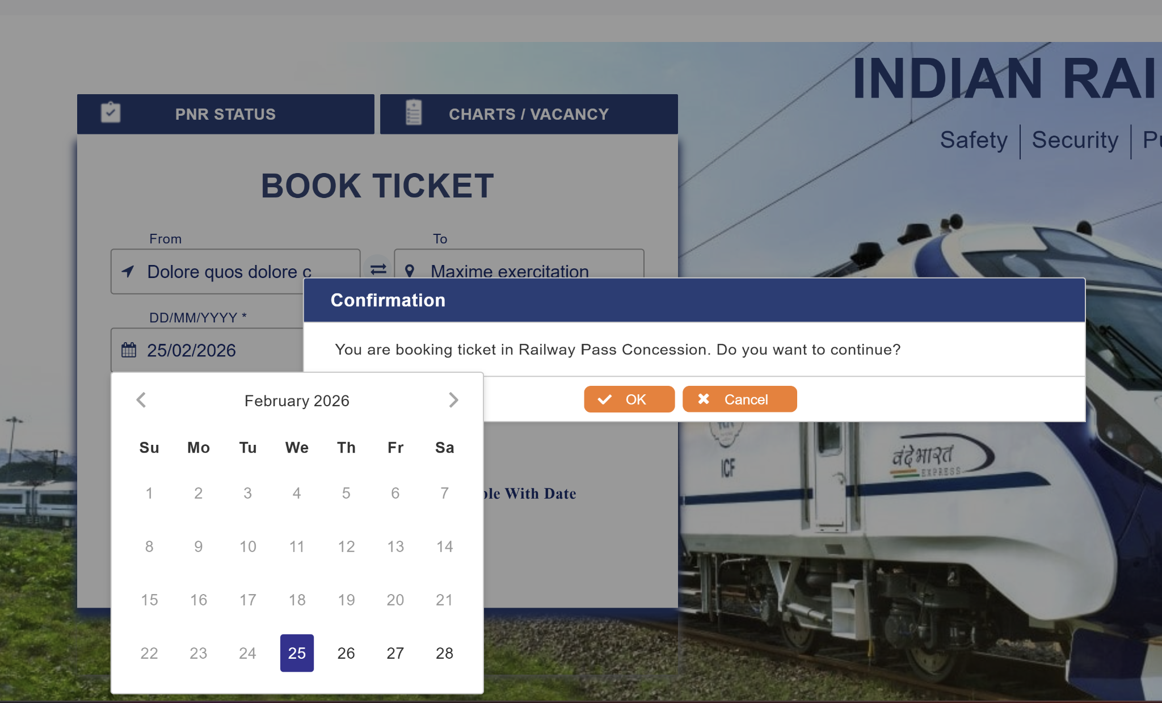

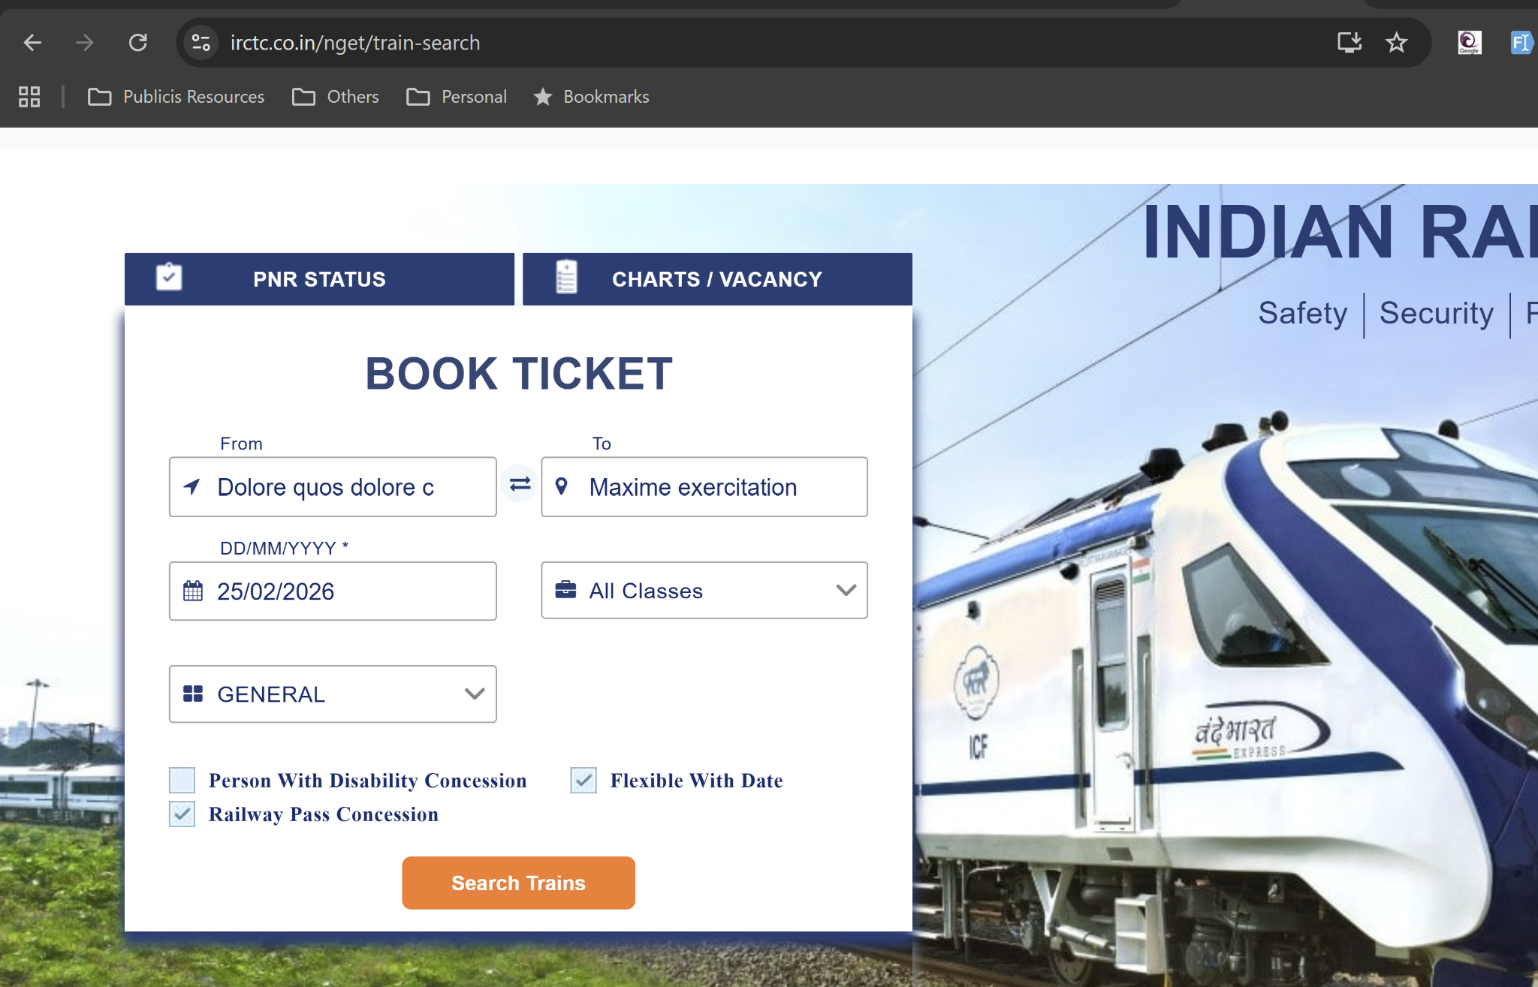

Submit data

2.
Open the Google Sign-in page and select the email field.

Right click on bugmagnet extension →email addresses-> invalid –select format and enter.
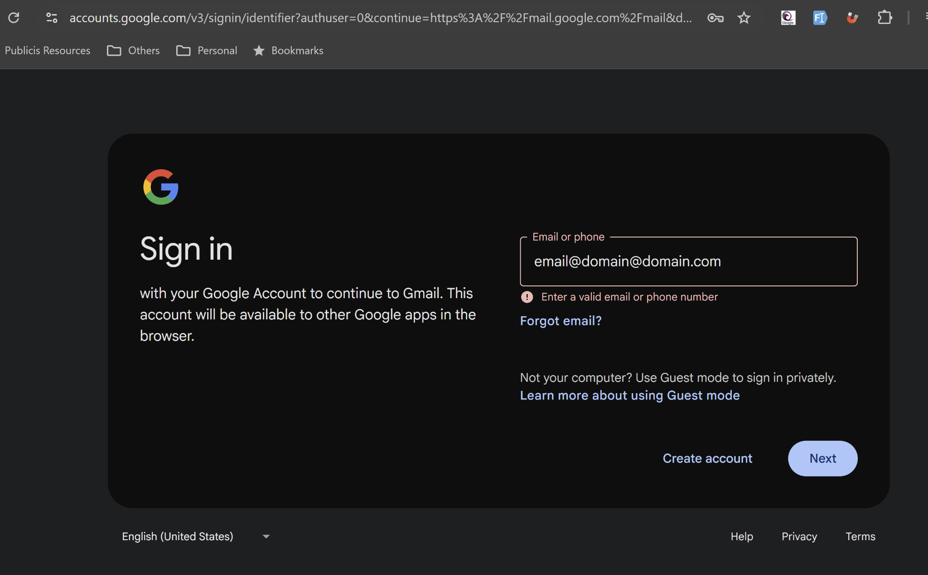

Validation point triggered

2. Use Grammarly extension to correct the mistakes in your content
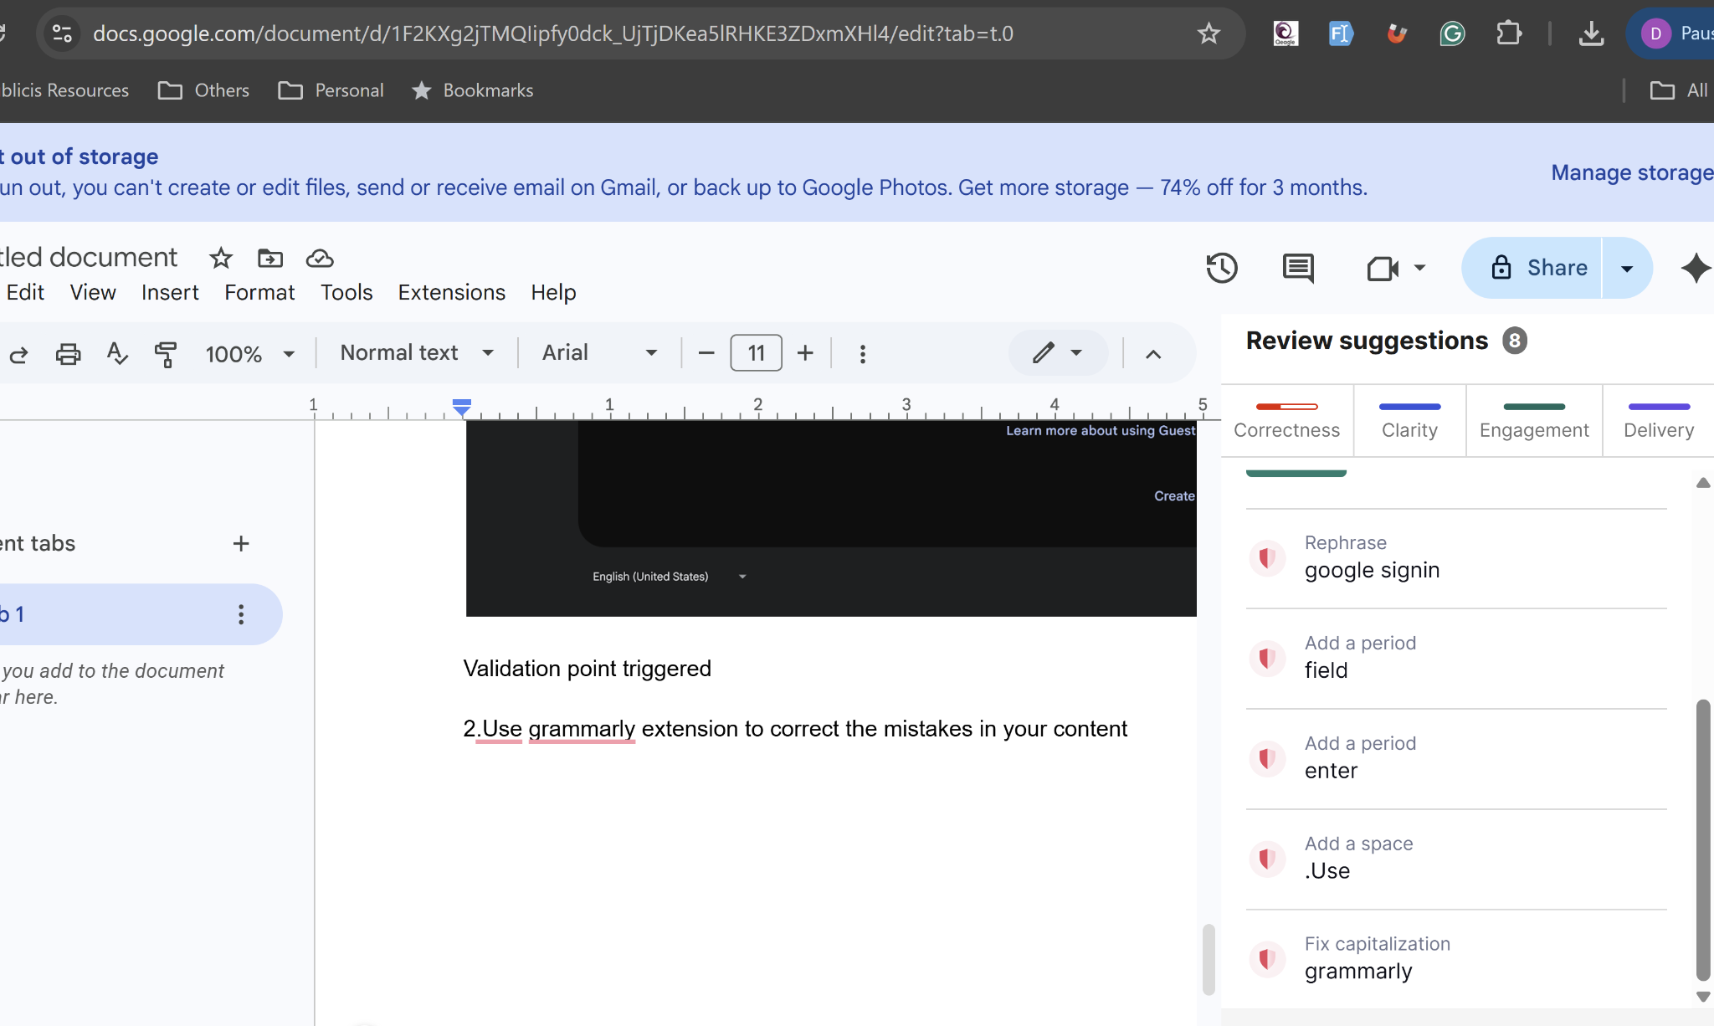
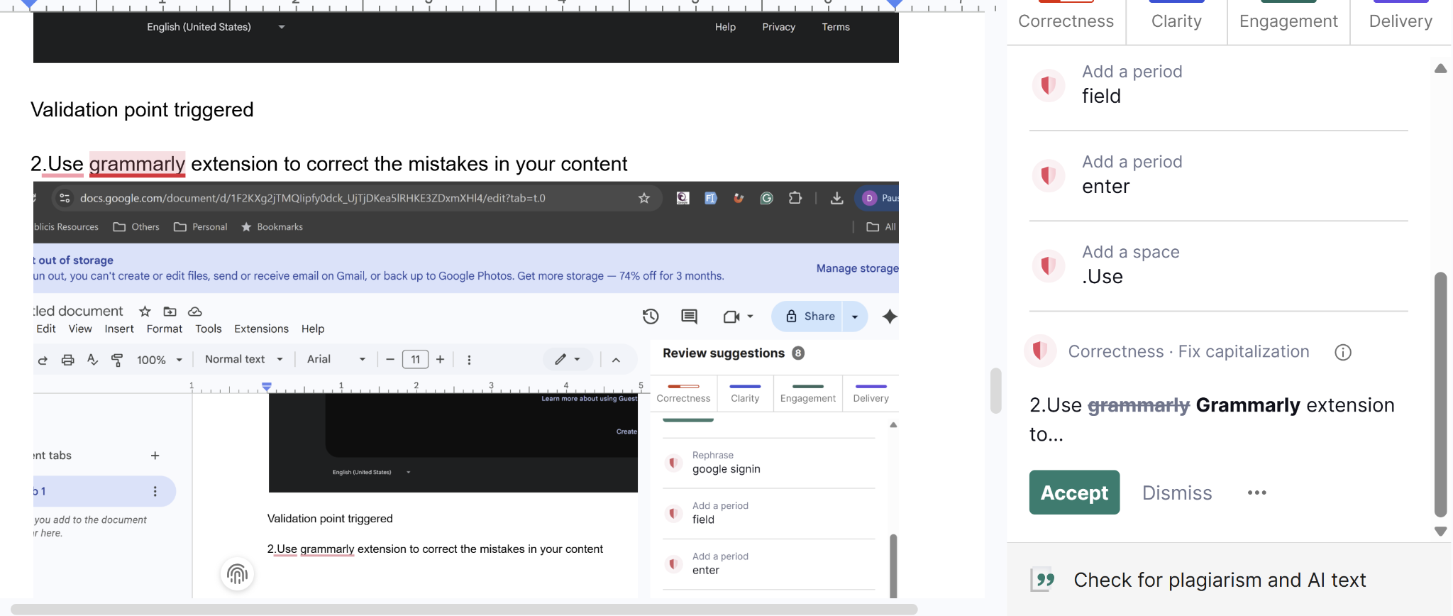
Fixed the errors using the Grammarly extension

3) Vibe Coding Generate Playwright Typescript 0r (any tool with language binding in which you are working)

Feature: Login to OpenTaps

Scenario Outline: Successful login with valid credentials
Given I open the login page
When I type "<username>" into the Username field
And I type "<password>" into the Password field
And I click the Login button
Then I should be logged in successfully

Examples:
| username | password |
| "ramesh123" | "chennai123" |
| "suresh456" | "bangalore456"|
| "kumar789" | "hyderabad789" |

Scenario Outline: Unsuccessful login with empty username
Given I open the login page
When I type "<username>" into the Username field
And I type "<password>" into the Password field
And I click the Login button
Then I should see an error message "username was empty reenter"

Examples:
| username | password |
| "" | "chennai123" |
| " " | "bangalore456"|
| "" | "hyderabad789" |

Scenario Outline: Unsuccessful login with empty password
Given I open the login page
When I type "<username>" into the Username field
And I type "<password>" into the Password field
And I click the Login button
Then I should see an error message "password was empty reenter"

Examples:
| username | password |
| "ramesh123" | "" |
| "suresh456" | " " |
| "kumar789" | "" |

import { Given, When, Then, Before, After } from '@cucumber/cucumber';
import { Browser, BrowserContext, Page, chromium } from '@playwright/test';
import { expect } from '@playwright/test';

let browser: Browser;
let context: BrowserContext;
let page: Page;

Before(async function() {
browser = await chromium.launch();
context = await browser.createContext();
page = await context.newPage();
});

After(async function() {
await context.close();
await browser.close();
});

Given('I navigate to the login page', async function() {
await page.goto('http://leaftaps.com/opentaps/control/login;jsessionid=353625802E74A1741855009B69344E2E.jvm1');
await page.waitForLoadState('networkidle');
});

When('I enter {string} into the Username field', async function(username: string) {
await page.fill('#username', username);
});

When('I enter {string} into the Password field', async function(password: string) {
await page.fill('#password', password);
});

When('I click the Login button', async function() {
await page.click('input:has-text("Login")');
await page.waitForLoadState('networkidle');
});

Then('I should see an error message for empty username and password', async function() {
const errorDiv = await page.locator('#errorDiv');
await expect(errorDiv).toBeVisible();
const errorMessages = await page.locator('#errorDiv p');
const messages = await errorMessages.allTextContents();
expect(messages).toContain('username was empty reenter');
expect(messages).toContain('password was empty reenter');
});

Then('I should be logged in successfully', async function() {
// Assuming a successful login redirects to a different page
const url = await page.url();
expect(url).not.toContain('login');
});
Code generated playwright with type script

