MOBILE INVENTORY MANAGEMENT SYSTEM

Introduction Screens

**Splash Screen**: this screen serves as the initial point of contact for users. It showcases the application’s logo and sets the tone for user’s interaction with the inventory management system.



Figure 1 Splash Screen

**On-boarding Screen**: The on-boarding screens provide a brief overview of the application’s core functionalities, guiding users through critical functions including barcode scanning, stock monitoring, and item searching.

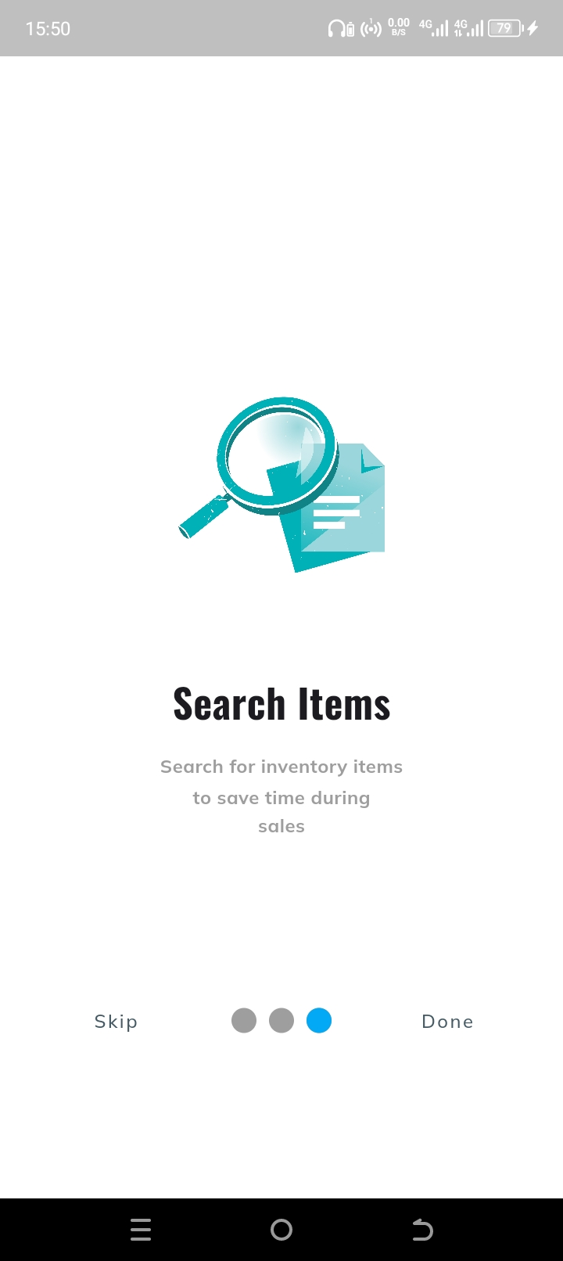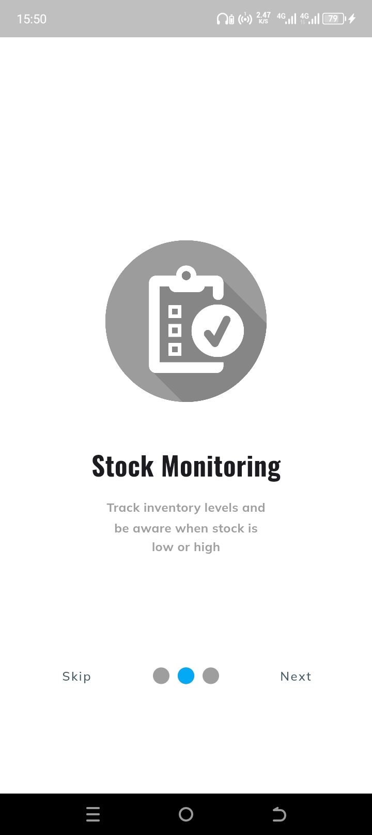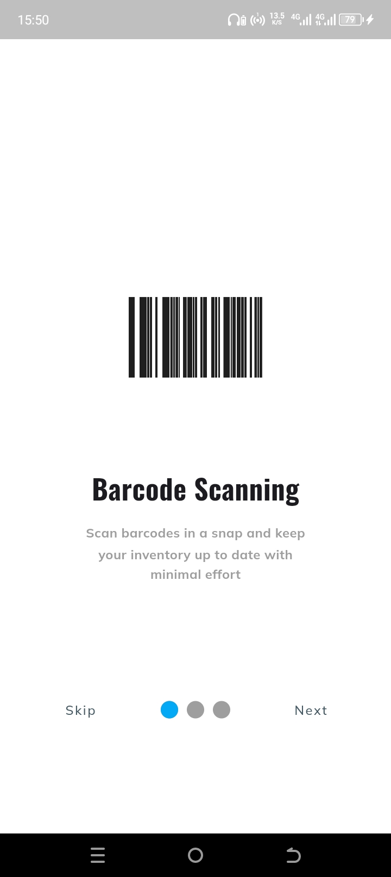

Figures 2 - 4 On-boarding Screens

Login/Register Screen

The login/register screen allows users to access the Inventory Management System, which includes crucial account management functions. Users are given the choice of logging in with their existing credentials or creating a new account if they are new users.



Figure 5 Register screen Figure 6 Login Screen

Home Screen & Drawer  
The home screen is the Inventory Management System's major hub, providing users with an overview of all inventory items as well as quick access to key features via a simple drawer menu.

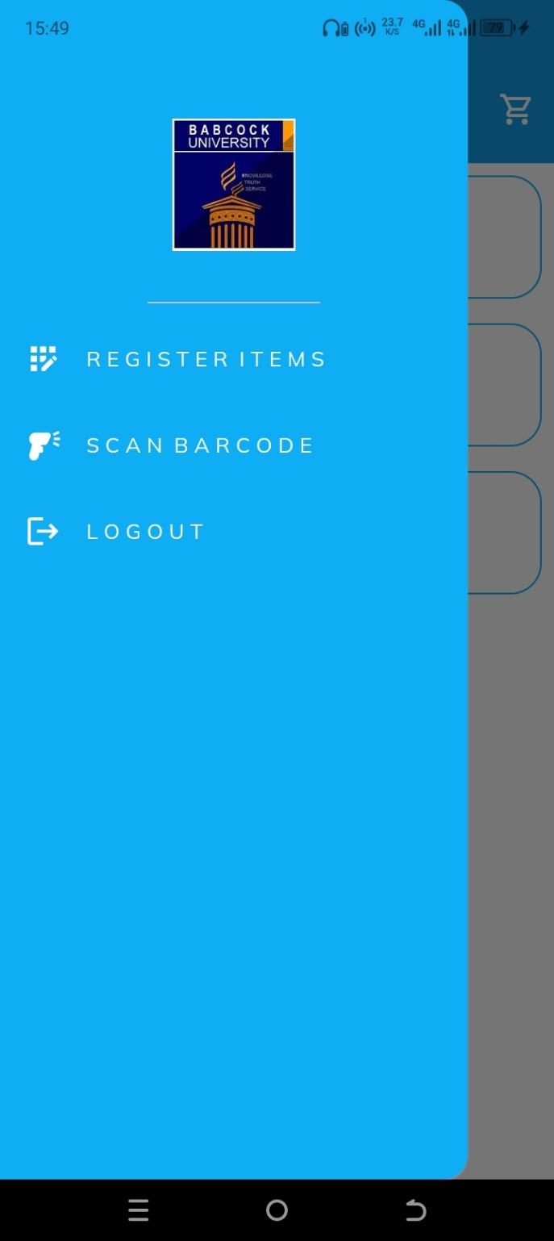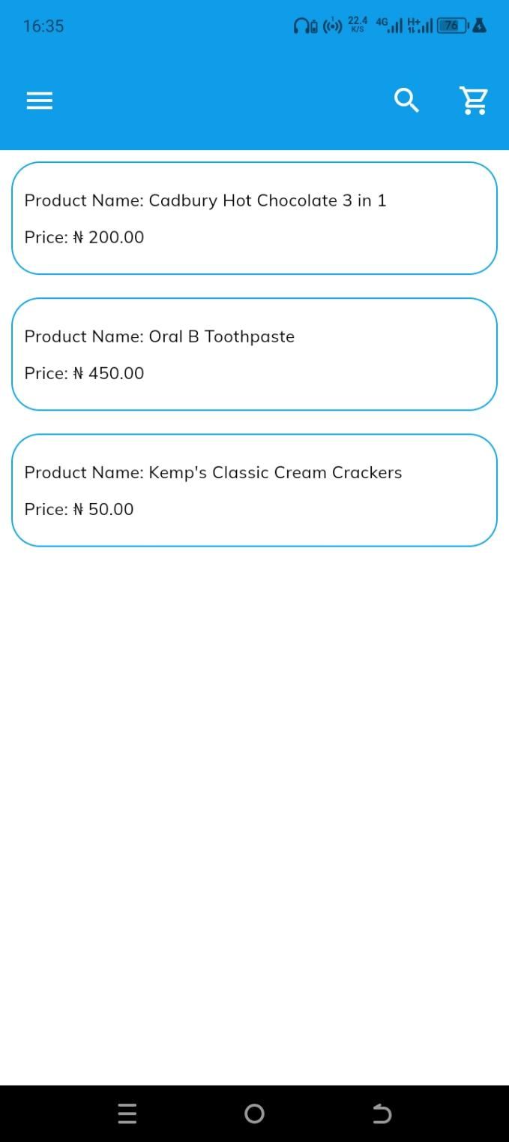

Figure 7 Home screen Figure 8 Drawer Screen

Barcode scanner

The barcode scanning page is a critical component of the Inventory Management System, intended to streamline the process of adding new items to the inventory. It uses the device's camera to instantly capture barcode information from physical objects.



Figure 9 Barcode Scanning

Product Screens

**Product Registration:**

The product registration page provides a simple interface for adding new items to the inventory, supporting both barcode scanning and manual input techniques.

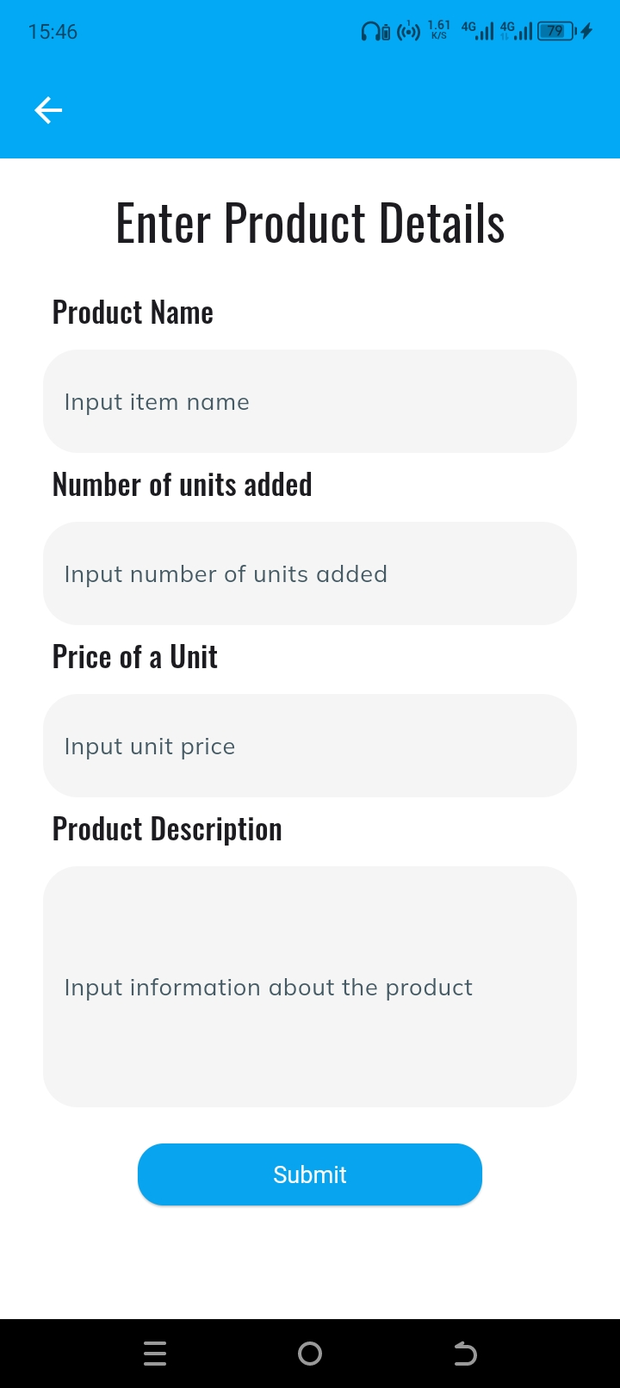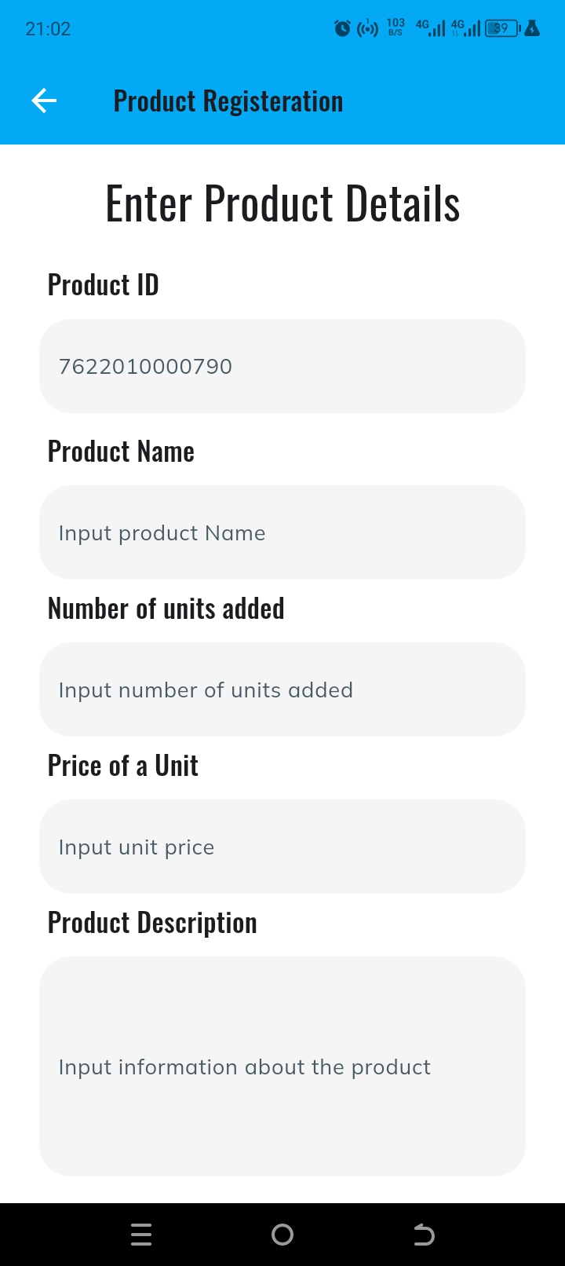

Figure 10 Barcode Registration Scree Figure 11 Manual Registration Screen

**Product Details Screen:**

This page displays product information and allows users to edit product information or delete the item from the database completely. Users also add items to cart within this screen.

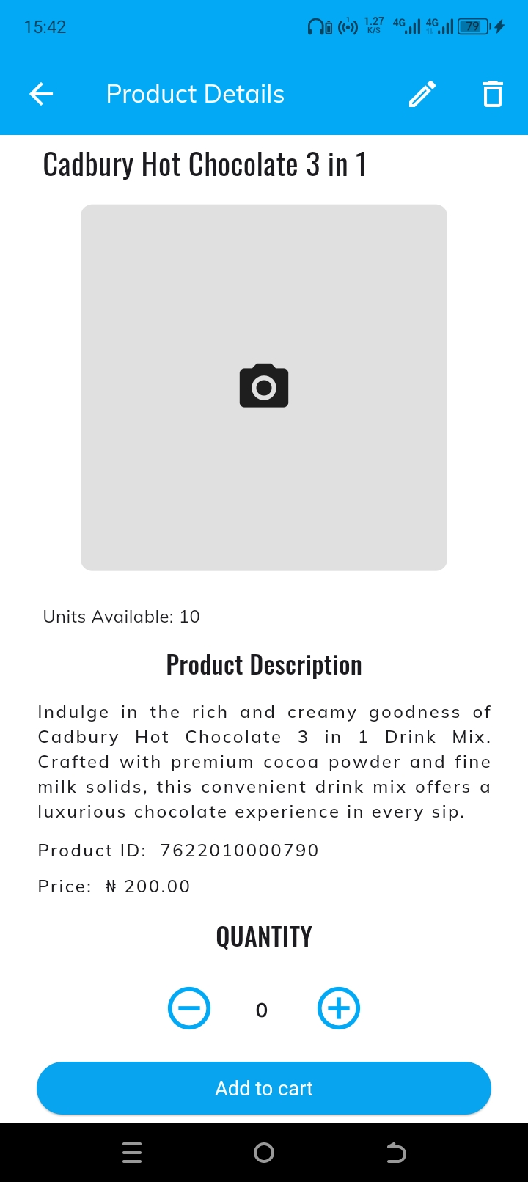

Figure 12 Product Details Screen

Cart Screen

The cart screen provides consumers with a concentrated view of the goods in their shopping cart, as well as a handy interface for evaluating and managing selected products prior to checkout.

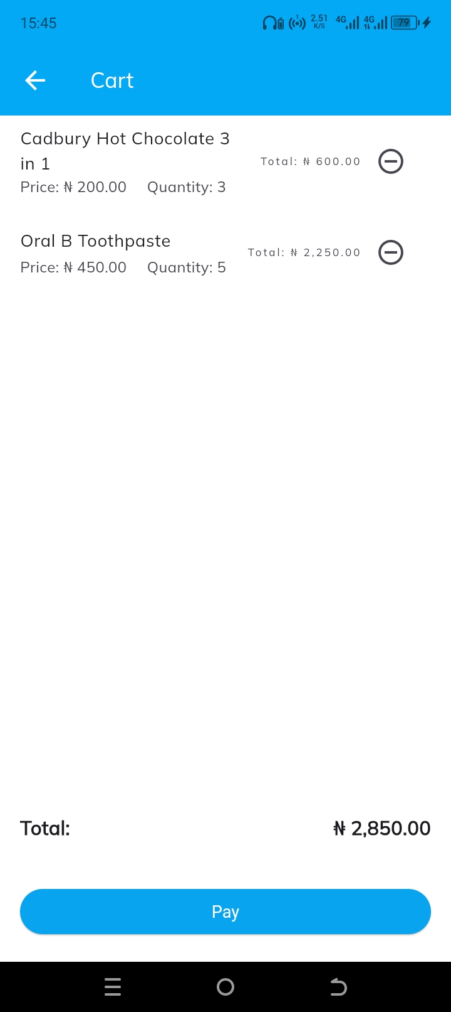

Figure 4.13 Cart Screen