Temporal RAG System - Evaluation Plots

Recency Queries - Accuracy (Excluding IDK)

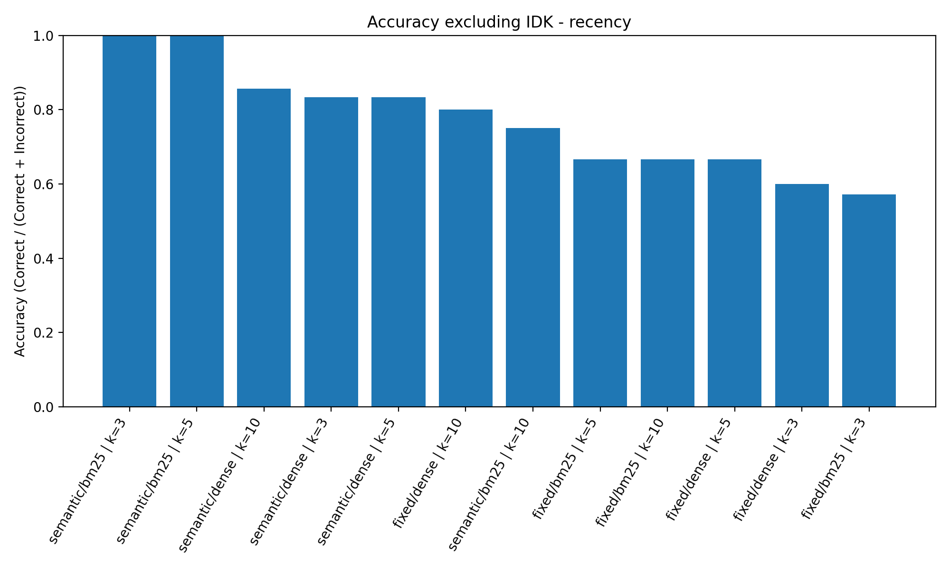

Recency Queries - Accuracy (Including IDK)

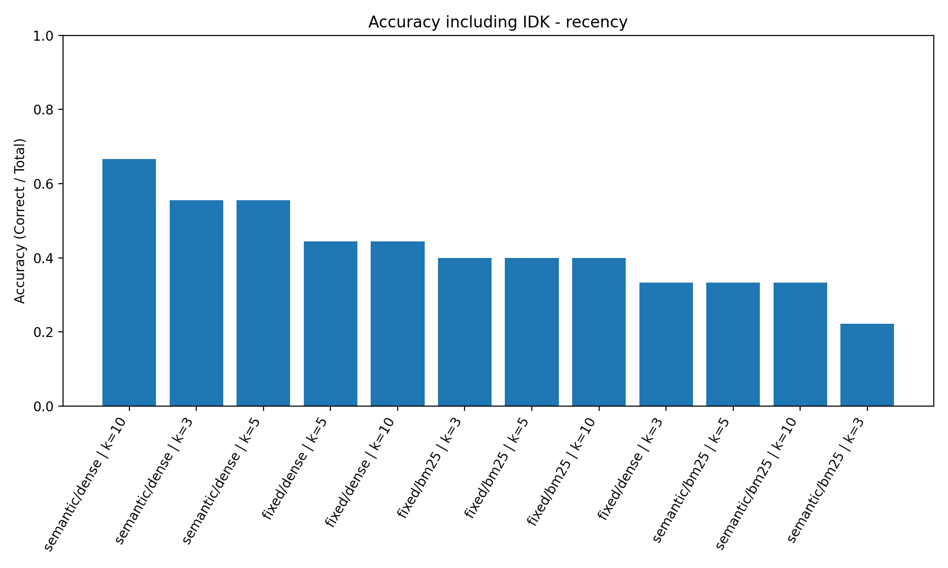

Evolution Queries - Accuracy (Excluding IDK)

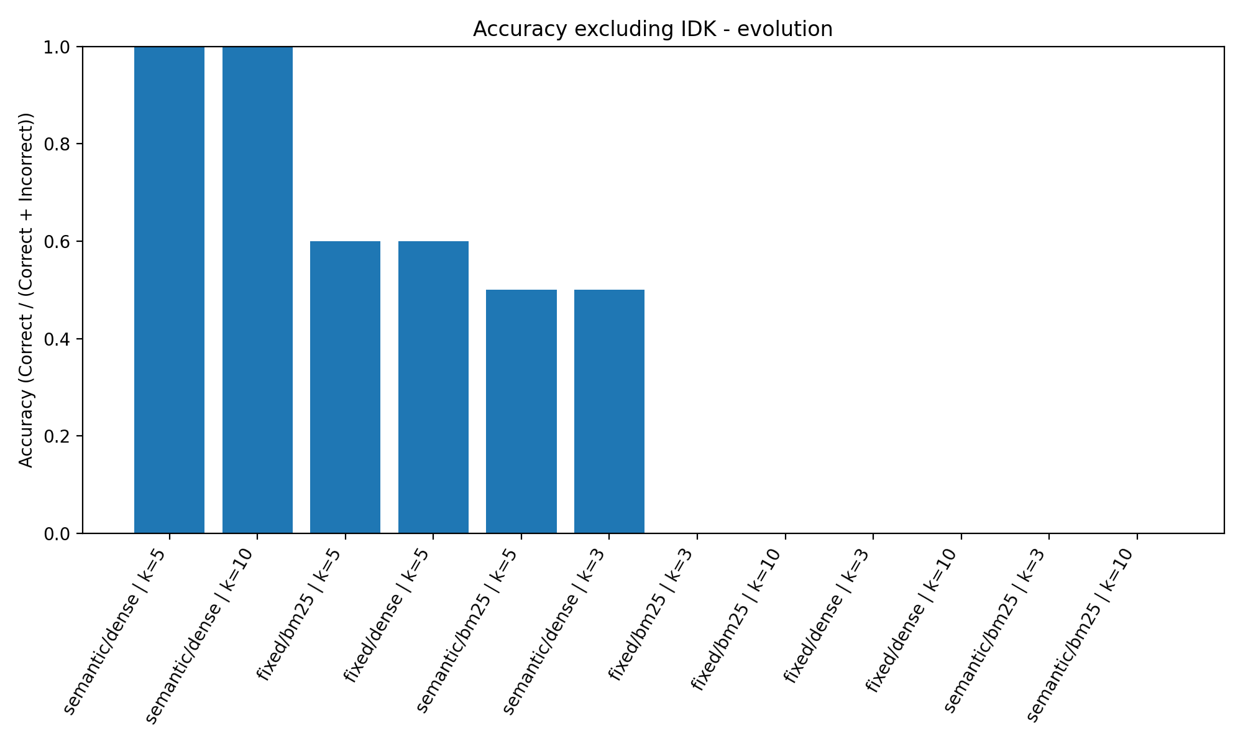

Evolution Queries - Accuracy (Including IDK)

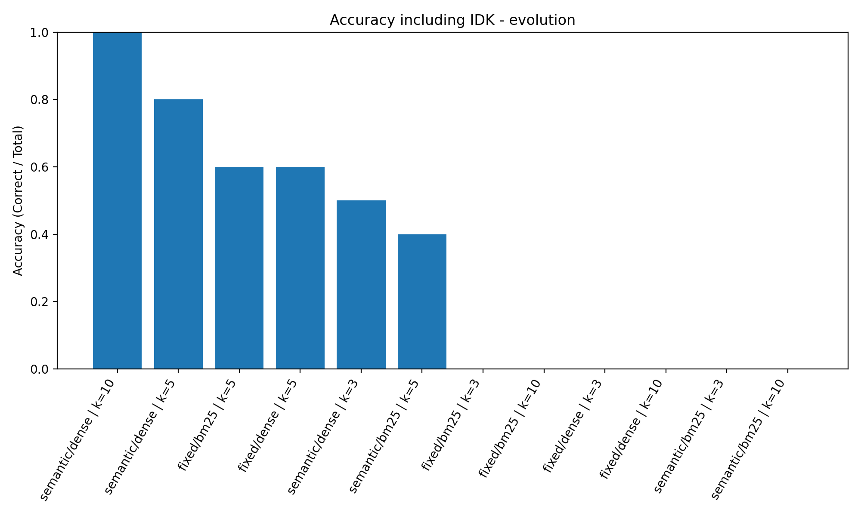

Point-in-Time (Topic) - Accuracy (Excluding IDK)

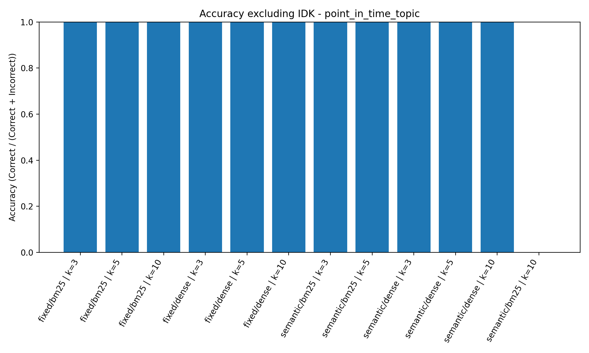

Point-in-Time (Topic) - Accuracy (Including IDK)

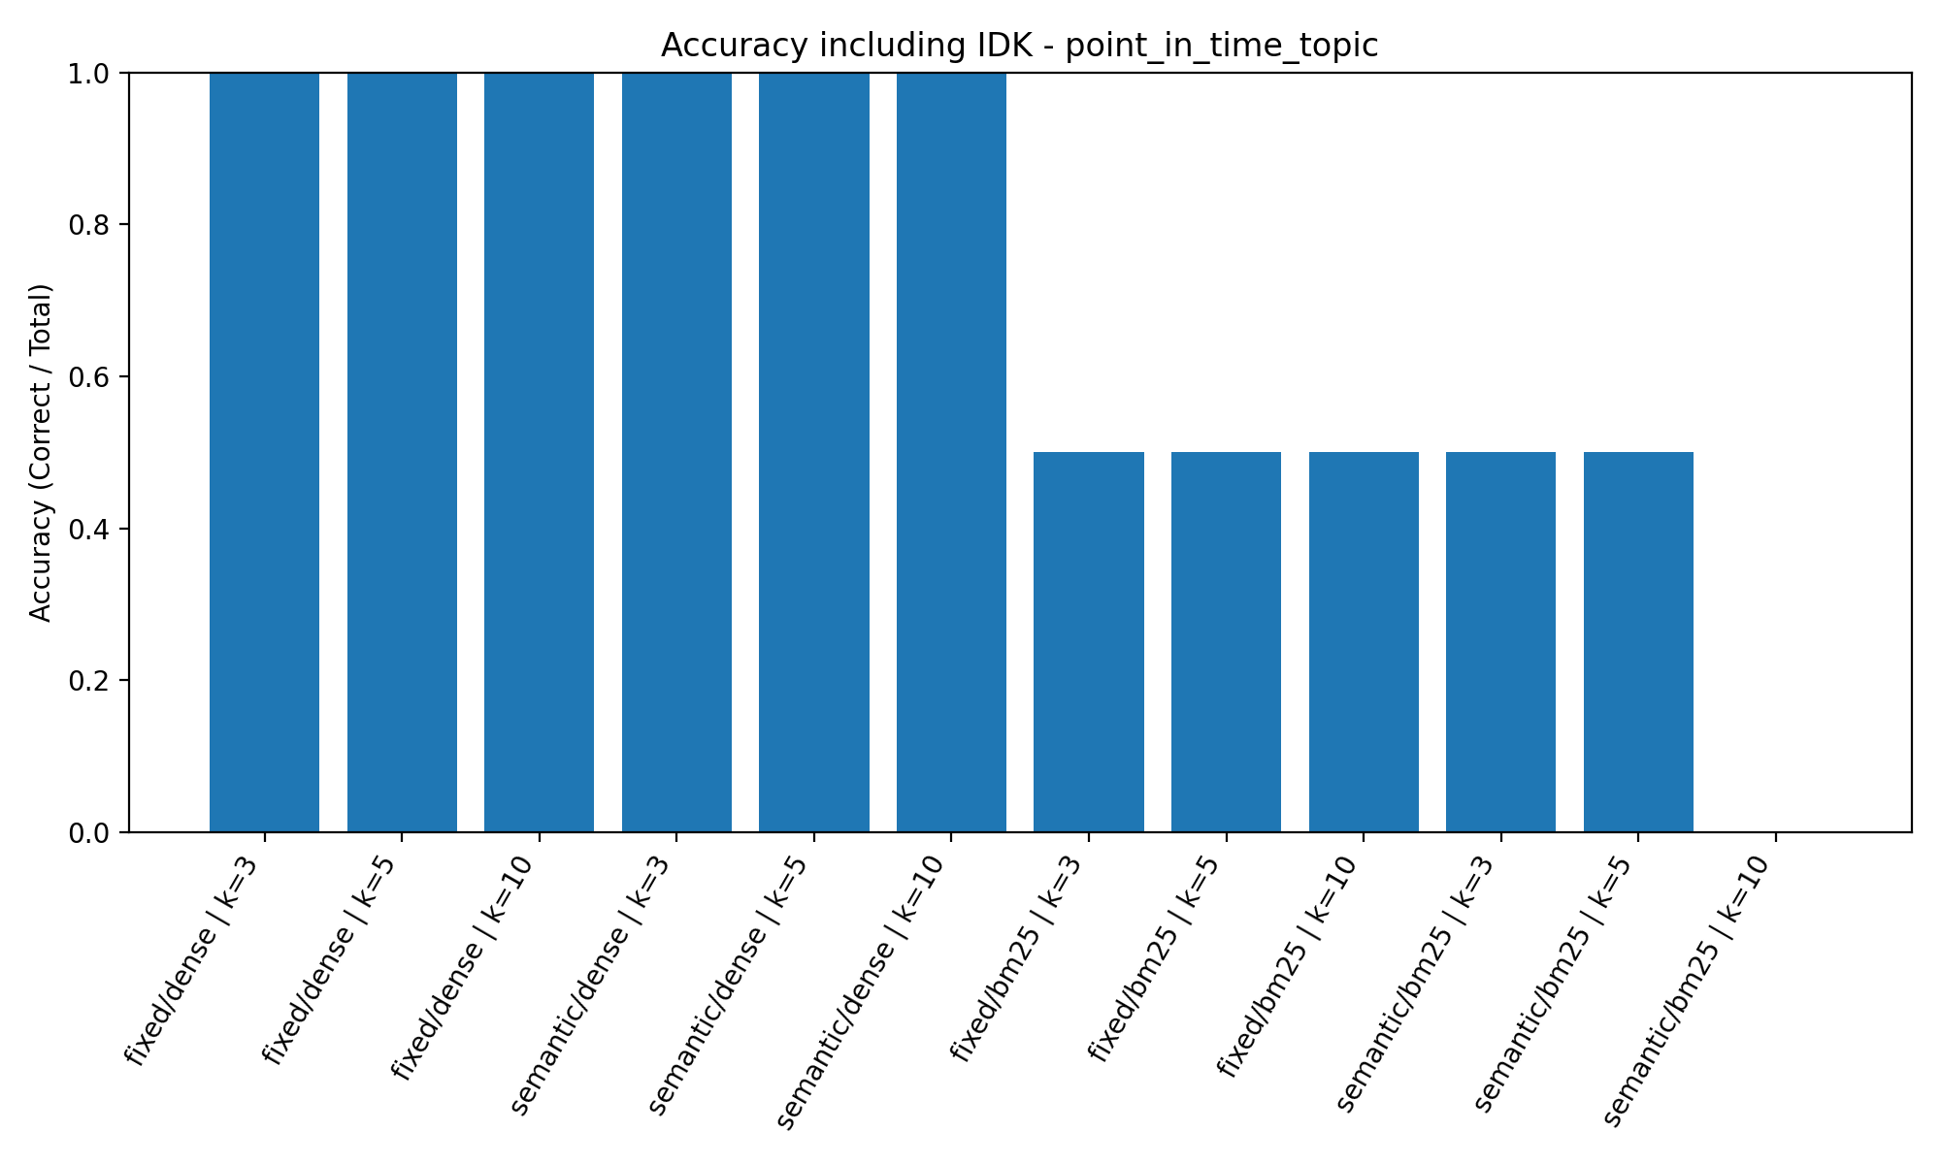

Point-in-Time (Numeric) - Accuracy (Excluding IDK)

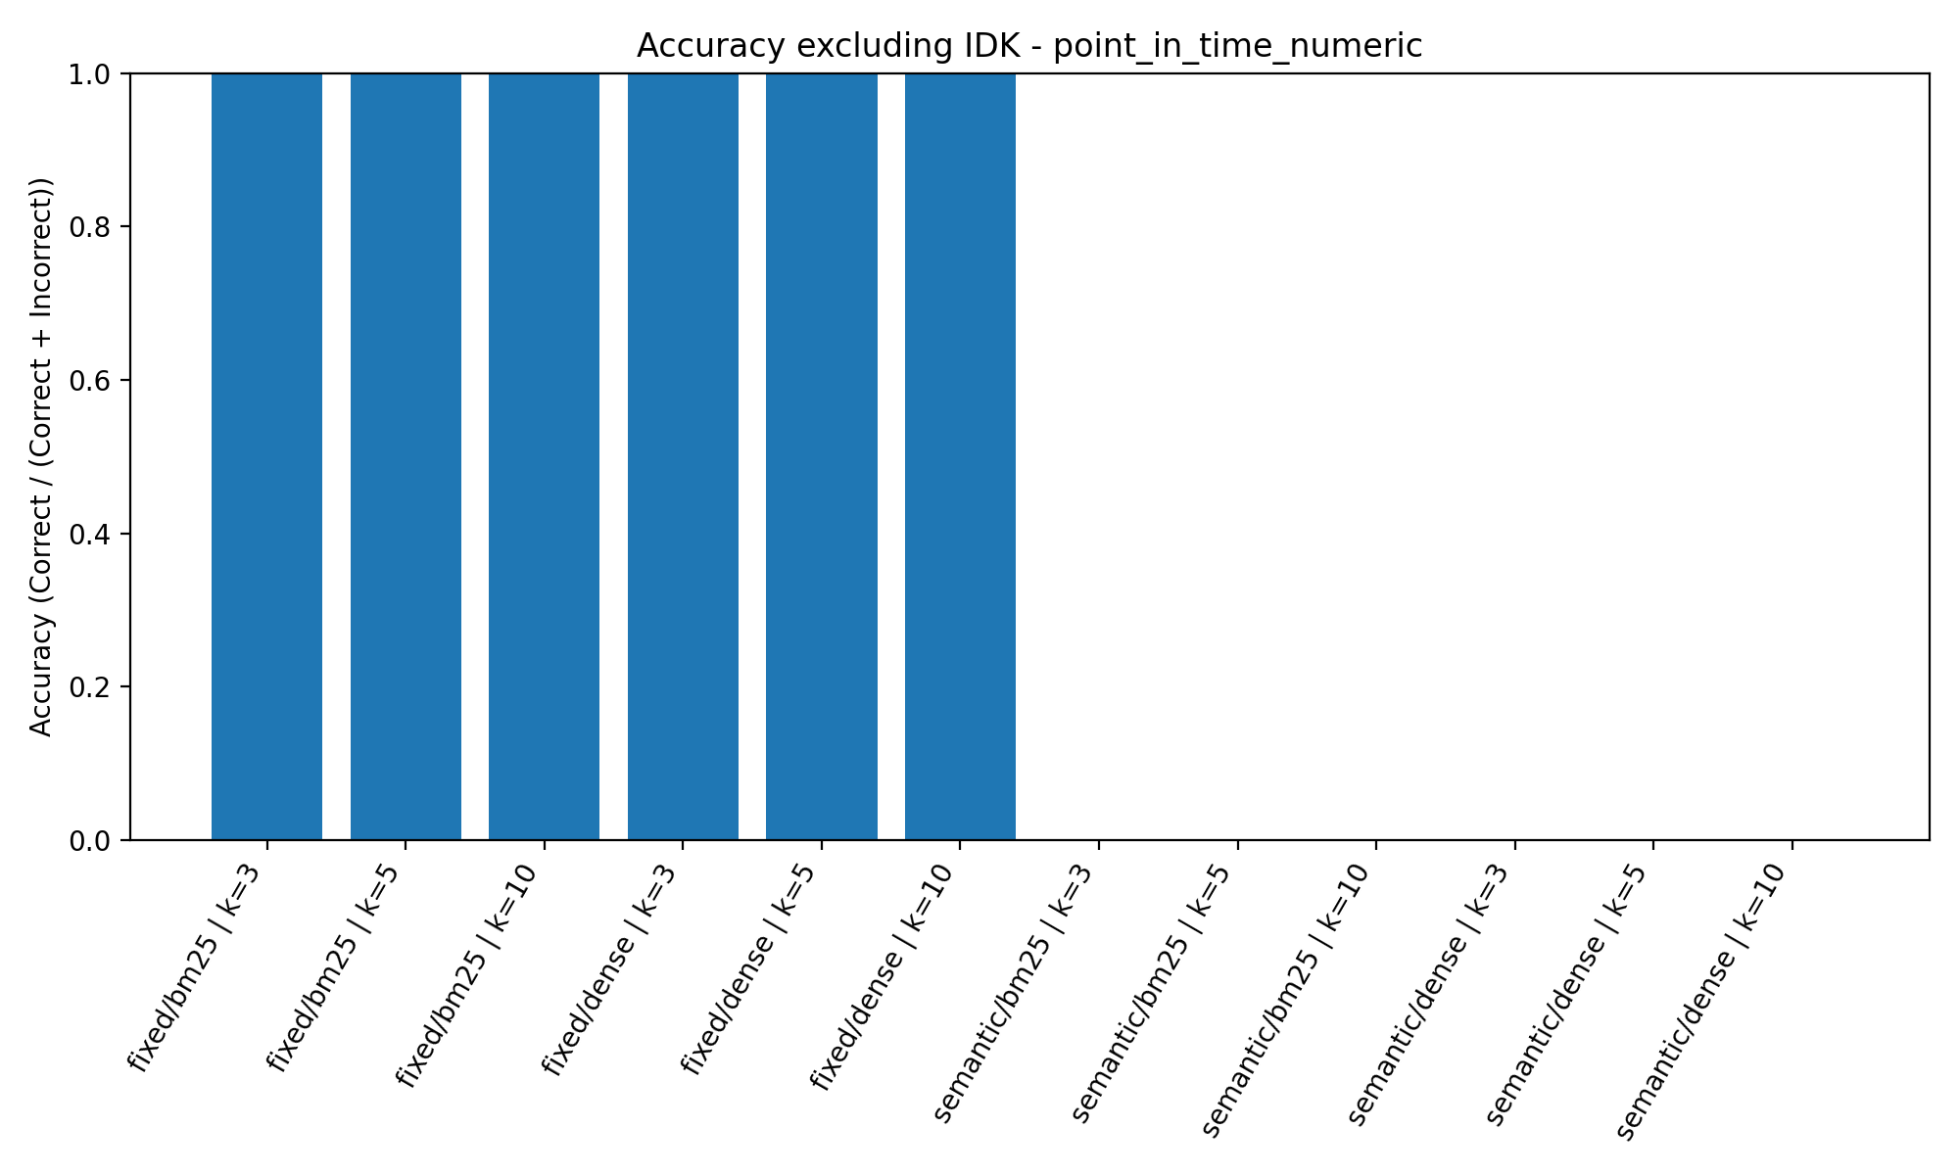

Point-in-Time (Numeric) - Accuracy (Including IDK)

