Demand Planning S&OP Workflow for ketteQ
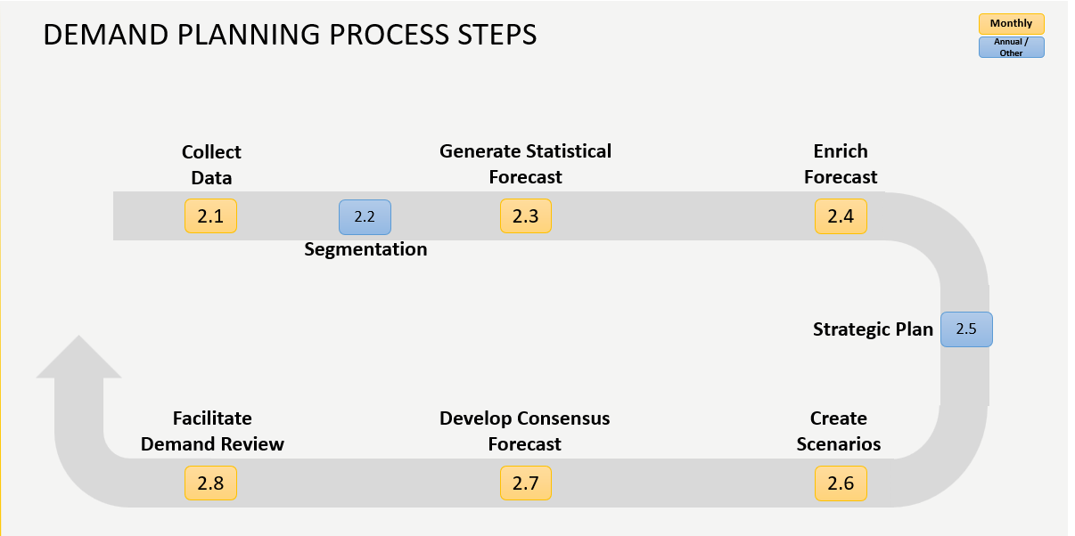
Level 3 Process Step | Level 4 linked activities | Space / Tile
2.1 Collect Data | 2.1.0 General navigation (scenarios/workspaces/tiles)  2.1.1 Validate historical Sales  2.1.2 Map OPN history (i.e. PIPO, transfers)  2.1.3 Load external forecasts - Sales forecast from SalesForce.com, Customer Forecasts from portal, Financial Budget and quarterly updates  2.1.4 Add new OPN/Customer combinations  2.1.5 Generate Monthly Hot Lists  2.1.6 Review Master data gaps | KQ  Incorta / Demand  Demand Actuals  Import  Demand Actuals  Incorta  Incorta
2.2 Segmentation | 2.2.1 Create Segments  2.2.2 Review segmentation and adjust revenue and/or CoV or revenue breakpoints | ABC
2.3 Generate (Review) Statistical Forecast | 2.3.1 Review outliers/alerts  2.3.2 Adjust history  2.3.3 Adjust/tune Stat models | Alerts  Demand Actuals  Stat Forecast
2.4 Enrich Forecast | 2.4.1 Review Forecast Value Add  2.4.2 Adjust forecast (internal & external inputs) | Metrics  Demand Plan
2.5 Generate Strategic Plan | 2.5.1 Create a Strategic Plan Scenario  2.5.2 Load long range financial forecasts (if applicable)  2.5.3 Promote LRP scenario | Demand Plan
2.6 Create Scenarios | 2.6.1 Create ad hoc scenarios (if applicable)  2.6.2 Promote ad hoc scenarios (if applicable)  2.6.3 Communicate scenario (if applicable) | Demand Plan
2.7 Develop Consensus Forecast | 2.7.1 Facilitate consensus calls: Strategic Accounts, APAC, EMEA, AMER-IND, AMER-MED  2.7.2 Accuracy & Bias Review  2.7.2 Push final forecast to S&OP Consensus  2.7.3 Load final S&OP forecast to Sales Demand Center | Incorta  Incorta  Demand Plan  Incorta
2.8 Facilitate Demand Review | 2.8.1 Facilitate Demand Review  2.8.3 Load weekly S&OE forecast pulse to Sales Demand Center | Incorta

