**Set up AWS S3 temporary drive to store and load custom trained models**

1. **For a windows machine**

**Step-1**

1. Go to \ixolerator-dev\connectors\aws\s3

Ensure that the following 2 files are present in the s3 folder

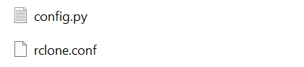

1. Open \ixolerator-dev\connectors\aws\src\s3_mount.py file in editor

Replace line 47 with

cmd = config['installlation_location'] + 'rclone mount ' + config['bucket_name'] + ':' + config['bucket_name'] + '/ ' + config['drive_name']+ ': --vfs-cache-mode full”

**Step -2**

1. Open Windows PowerShell and run as administrator

Run the following 2 steps on the PowerShell

1. Set-ExecutionPolicy Bypass -Scope Process -Force; iex ((New-Object System.Net.WebClient).DownloadString('https://chocolatey.org/install.ps1'))
2. choco install winfsp -y
3. Ensure that in your C: drive the following folder **“rclone1”** has been created

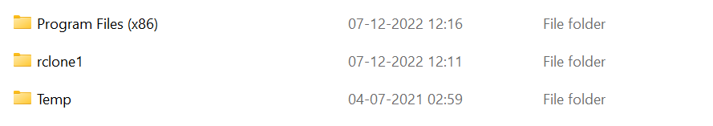

**Step-3**

1. Go to C:\Users\username\.config\rclone *for ex "C:\Users\prakhar\.config\rclone".* You will notice that this folder is empty for now.
2. Copy manually “rclone.conf” file from \ixolerator-dev\connectors\aws\s3 folder to C:\Users\username\.config\rclone

Folder

**Step-4**

1. Finally run the “s3mount.py” file from your console (pycharm,spyder etc) or from the command prompt by writing the following command

python "\ixolerator-dev\connectors\aws\src\s3_mount.py"

1. This will create a temp drive on your PC called rfm data bucket

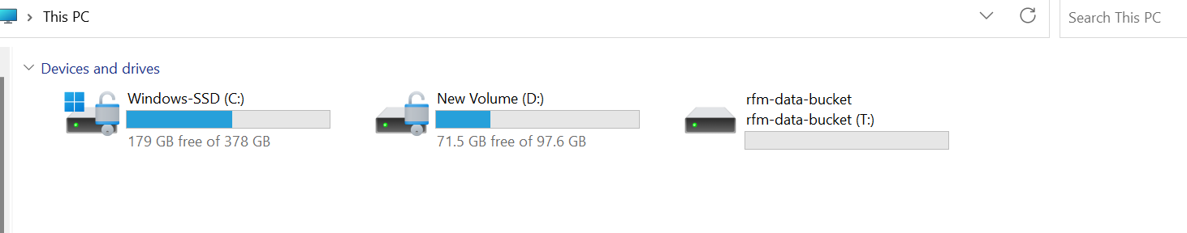

1. In this shared drive you can store and load your model files and use them in modules. 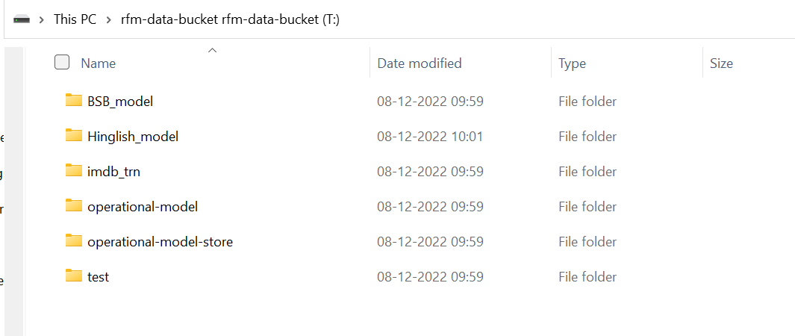

**Notes->**

1. Ensure that the command python "\ixolerator-dev\connectors\aws\src\s3_mount.py" is always running in the background while you are using this aws s3 drive for your purpose.
2. Once you are completed with your operation close the command and the drive will no longer be visible on your system.
3. To again use the rfm bucket, **just run Step 4.a**
4. **For a linux machine**

To run on a linux machine,

1. install s3fs module on your system
2. run dev\connectors\aws\src\S3MountLinux.py code file