Lab assignment4:Disk Scheduling Algorithms Report
- Student detail
- Name :tammna
- Course:BSC HONS .( Data science)
- Subject:operating system
- Course code:ETCCOS204
This report explains FCFS, SSTF, SCAN and C-SCAN disk scheduling algorithms.
Algorithms Implemented
- FCFS - First Come First Serve
- SSTF - Shortest Seek Time First
- SCAN - Elevator Algorithm
- C-SCAN - Circular SCAN
Python Code:
# Disk Scheduling Algorithms (Beginner Friendly)
# FCFS Algorithm def fcfs(requests, head):
seek_time = 0
print("\nFCFS Order:", end=" ") for r in requests: print(r, end=" ") seek_time += abs(head - r) head = r print("\nTotal Seek Time:", seek_time)
# SSTF Algorithm def sstf(requests, head): seek_time = 0 req = requests.copy() print("\nSSTF Order:", end=" ")
while req:
nearest = min(req, key=lambda x: abs(x - head)) print(nearest, end=" ") seek_time += abs(head - nearest) head = nearest req.remove(nearest) print("\nTotal Seek Time:", seek_time)
# SCAN Algorithm def scan(requests, head, disk_size):
seek_time = 0
left = [r for r in requests if r < head] right = [r for r in requests if r >= head]
left.sort(reverse=True) right.sort() print("\nSCAN Order:", end=" ")
for r in right:
print(r, end=" ") seek_time += abs(head - r) head = r
# go to end seek_time += abs(head - (disk_size - 1)) head = disk_size - 1
for r in left:
print(r, end=" ") seek_time += abs(head - r) head = r
print("\nTotal Seek Time:", seek_time)
# C-SCAN Algorithm
def cscan(requests, head, disk_size):
seek_time = 0 left = [r for r in requests if r < head] right = [r for r in requests if r >= head]
left.sort() right.sort() print("\nC-SCAN Order:", end=" ")
for r in right:
print(r, end=" ") seek_time += abs(head - r) head = r
# jump to start seek_time += abs(head - (disk_size - 1)) head = 0 seek_time += disk_size - 1
for r in left:
print(r, end=" ") seek_time += abs(head - r) head = r print("\nTotal Seek Time:", seek_time)
# MAIN PROGRAM requests = list(map(int, input("Enter disk requests (space separated): ").split())) head = int(input("Enter initial head position: ")) disk_size = int(input("Enter disk size: "))
fcfs(requests, head) sstf(requests, head) scan(requests, head, disk_size) cscan(requests, head, disk)
output:
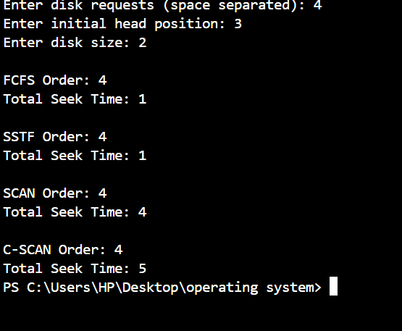
- Conclusion: SSTF usually gives better performance but SCAN and C-SCAN provide fairness.

