**TAMOJIT DAS A/7/C1**

**ASSIGNMENT 10**

Q1.

Border_Layout.java

import javax.swing.JButton;

import javax.swing.JFrame;

import java.awt.BorderLayout;

import javax.swing.JPanel;

class Border_Layout{

public static void main(String[] args) {

JFrame frame=new JFrame();

JPanel panel=new JPanel();

JButton btn1=new JButton("Button 1");

JButton btn2=new JButton("Button 2");

JButton btn3=new JButton("Button 3");

JButton btn4=new JButton("Button 4");

JButton btn5=new JButton("Button 5");

JButton btn6=new JButton("Button 6");

panel.add(btn1,BorderLayout.WEST);

panel.add(btn2,BorderLayout.CENTER);

panel.add(btn3,BorderLayout.EAST);

panel.add(btn4,BorderLayout.WEST);

panel.add(btn5,BorderLayout.CENTER);

panel.add(btn6,BorderLayout.EAST);

frame.add(panel);

frame.setTitle("Border_Layout");

frame.setSize(800, 300);

frame.setVisible(true);

frame.setDefaultCloseOperation(JFrame.EXIT_ON_CLOSE);

}

}

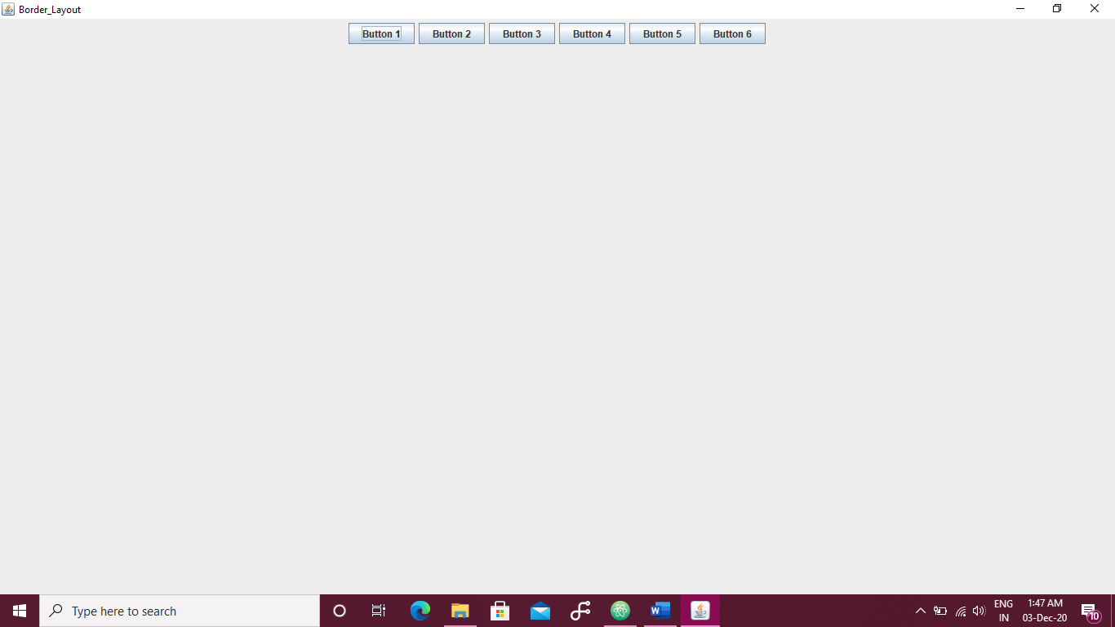

Flow_Layout.java

import javax.swing.JFrame;

import javax.swing.JPanel;

import javax.swing.JButton;

import java.awt.FlowLayout;

class Flow_Layout{

public static void main(String[] args) {

JFrame frame=new JFrame();

JPanel panel=new JPanel();

JButton btn1=new JButton("Button 1");

JButton btn2=new JButton("Button 2");

JButton btn3=new JButton("Button 3");

JButton btn4=new JButton("Button 4");

JButton btn5=new JButton("Button 5");

JButton btn6=new JButton("Button 6");

panel.setLayout(new FlowLayout(FlowLayout.CENTER, 50, 50));

panel.add(btn1);

panel.add(btn2);

panel.add(btn3);

panel.add(btn4);

panel.add(btn5);

panel.add(btn6);

frame.add(panel);

frame.setTitle("Border_Layout");

frame.setSize(800, 300);

frame.setVisible(true);

frame.setDefaultCloseOperation(JFrame.EXIT_ON_CLOSE);

}

}

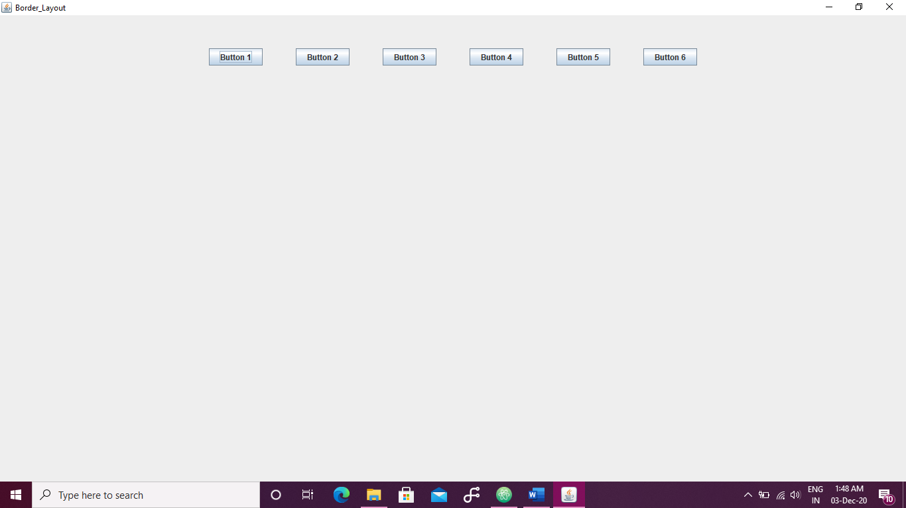

Grid_Layout.java

import javax.swing.JFrame;

import javax.swing.JPanel;

import javax.swing.JButton;

import java.awt.GridLayout;

class Grid_Layout{

public static void main(String[] args) {

JFrame frame=new JFrame();

JPanel panel=new JPanel();

JButton btn1=new JButton("Button 1");

JButton btn2=new JButton("Button 2");

JButton btn3=new JButton("Button 3");

JButton btn4=new JButton("Button 4");

JButton btn5=new JButton("Button 5");

JButton btn6=new JButton("Button 6");

panel.add(btn1);

panel.add(btn2);

panel.add(btn3);

panel.add(btn4);

panel.add(btn5);

panel.add(btn6);

panel.setLayout(new GridLayout(3, 2, 75, 75));

frame.add(panel);

frame.setTitle("Grid Layout Example");

frame.setSize(800, 300);

frame.setVisible(true);

frame.setDefaultCloseOperation(JFrame.EXIT_ON_CLOSE);

}

}

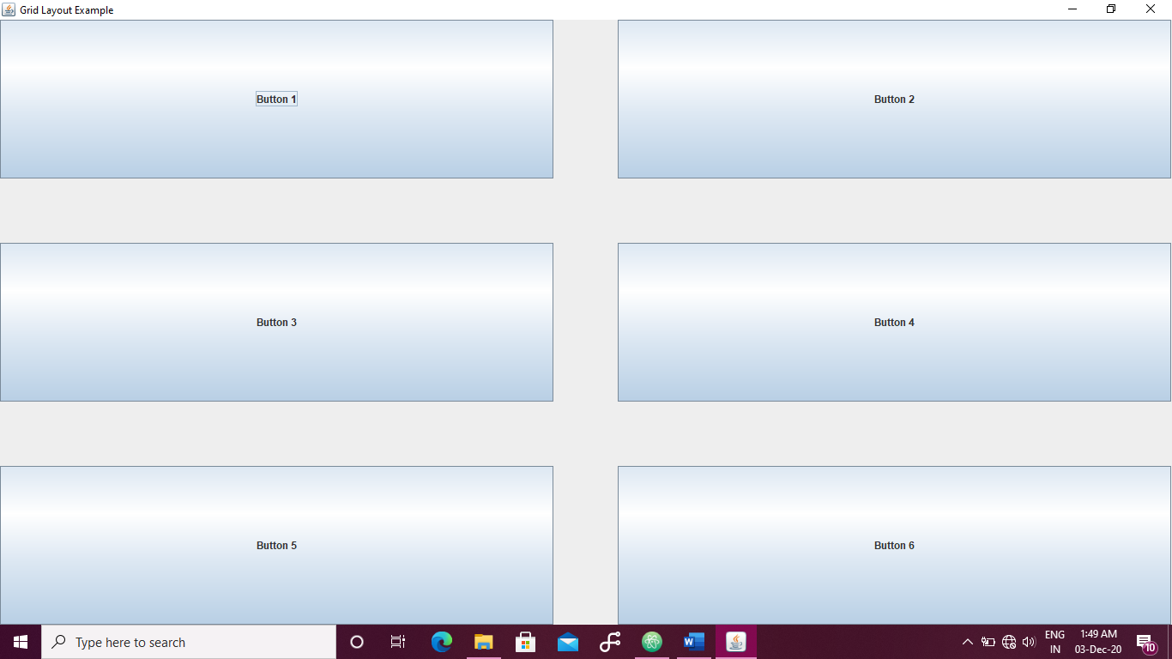

Q2.

import javax.swing.JFrame;

import javax.swing.JPanel;

import javax.swing.JButton;

import javax.swing.JLabel;

import java.awt.GridLayout;

import java.awt.event.ActionEvent;

import java.awt.event.ActionListener;

class Q2{

static JFrame frame=new JFrame();

static JPanel panel=new JPanel();

static JButton btn1=new JButton("Button 1");

static JButton btn2=new JButton("Button 2");

static JButton btn3=new JButton("Button 3");

static JButton btn4=new JButton("Button 4");

static JButton btn5=new JButton("Button 5");

static JButton btn6=new JButton("Button 6");

static JLabel label=new JLabel("Label");

public static void main(String[] args) {

panel.add(btn1);

panel.add(btn2);

panel.add(btn3);

panel.add(btn4);

panel.add(btn5);

panel.add(btn6);

panel.add(label);

panel.setLayout(new GridLayout(3, 2, 75, 75));

frame.add(panel);

frame.setTitle("Grid Layout Example");

frame.setSize(800, 300);

frame.setVisible(true);

frame.setDefaultCloseOperation(JFrame.EXIT_ON_CLOSE);

btn1.addActionListener(new ActionListener(){

@Override

public void actionPerformed(ActionEvent e) {

Click();

}

});

btn2.addActionListener(new ActionListener(){

@Override

public void actionPerformed(ActionEvent e) {

Click();

}

});

btn3.addActionListener(new ActionListener(){

@Override

public void actionPerformed(ActionEvent e) {

Click();

}

});

btn4.addActionListener(new ActionListener(){

@Override

public void actionPerformed(ActionEvent e) {

Click();

}

});

btn5.addActionListener(new ActionListener(){

@Override

public void actionPerformed(ActionEvent e) {

Click();

}

});

btn6.addActionListener(new ActionListener(){

@Override

public void actionPerformed(ActionEvent e) {

Click();

}

});

}

static void Click(){

label.setText("Clicked");

}

}

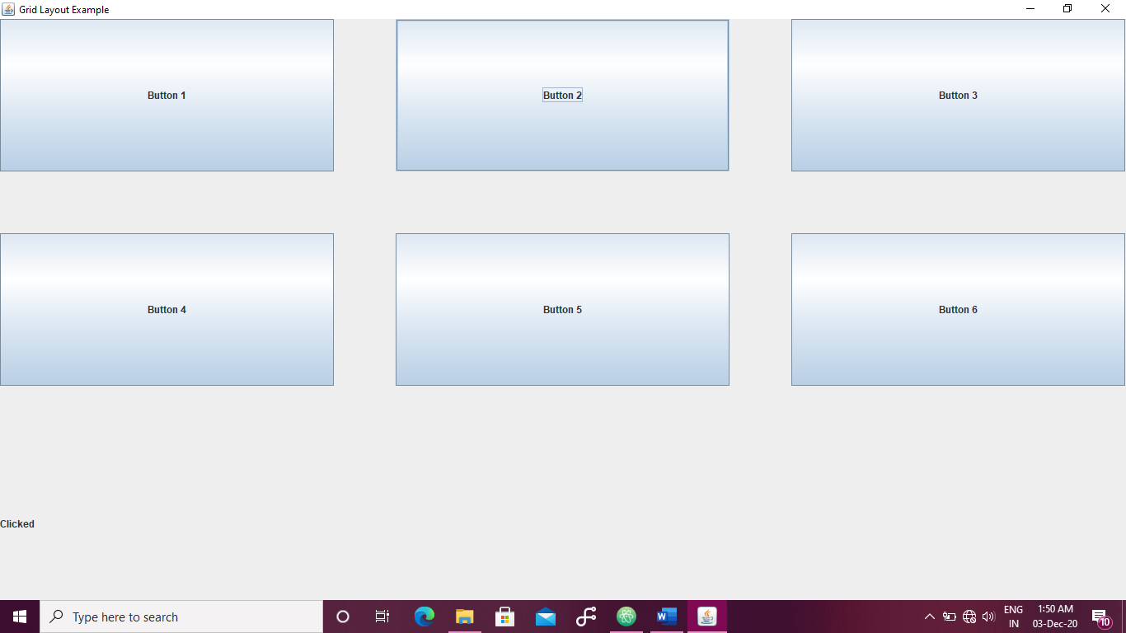

Q3.

import javax.swing.JFrame;

import javax.swing.JPanel;

import java.awt.Color;

import java.awt.Graphics;

import java.awt.event.MouseMotionListener;

import java.awt.event.MouseEvent;

class Q3{

public static void main(String[] args) {

JFrame frame=new JFrame();

JPanel panel=new JPanel();

panel.setBackground(Color.lightGray);

frame.add(panel);

frame.setTitle("Grid Layout Example");

frame.setSize(800, 300);

frame.setResizable(false);

frame.setVisible(true);

frame.setDefaultCloseOperation(JFrame.EXIT_ON_CLOSE);

panel.addMouseMotionListener(new MouseMotionListener(){

@Override

public void mouseMoved(MouseEvent e) {

}

@Override

public void mouseDragged(MouseEvent e) {

Graphics G=frame.getGraphics();

G.setColor(Color.red);

G.fillRect(e.getX(), e.getY(), 2, 2);

}

});

}

}

