**TAMOJIT DAS A/7/C1**

**ASSIGNMENT 9**

Q1 & Q2

**Accounts.java**

package Banking;

public abstract class Accounts{

public int cust_id;

public String cust_name;

public double balance;

public Accounts(){

this.cust_id=0;

this.cust_name="";

this.balance=0.0;

}

public Accounts(int a,String b,double c){

this.cust_id=a;

this.cust_name=b;

this.balance=c;

}

public abstract void Display();

}

**Savings.java**

package Banking.Savings;

import Banking.*;

public class Savings extends Accounts{

double dwl;

public Savings(int id,String name,double balance){

super(id,name,balance);

this.dwl=super.balance*0.5;

}

public Savings(int id,String name){

super(id,name,1000.0);

this.dwl=super.balance*0.5;

}

public void Display(){

String s="ID: "+this.cust_id+"\tName: "+this.cust_name+"\tBalance: "+this.balance;

s=s+"\tLimit: "+this.dwl;

System.out.println(s);

}

public void Withdraw(double amt){

if(amt<=this.dwl && amt<=this.balance){

this.balance-=amt;

System.out.println("Succesful withdraw "+amt);

}else{

System.out.println("\nLimit Exceeded\n");

}

}

public void Deposit(double amt){

this.balance+=amt;

System.out.println("Succesful deposited ${amt}");

}

}

**Current.java**

package Banking.Current;

import Banking.*;

public class Current extends Accounts{

public Current(int id,String name,double balance){

super(id,name,balance);

}

public void Display(){

String s="ID: "+this.cust_id+"\tName: "+this.cust_name+"\tBalance: "+this.balance;

System.out.println(s);

}

public void Withdraw(double amt){

if(amt<=this.balance){

this.balance-=amt;

System.out.println("Succesful withdraw "+amt);

}else{

System.out.println("\nNot enough balance\n");

}

}

public void Deposit(double amt){

if(amt>10000){

this.balance+=amt;

System.out.println("Succesful deposited ${amt}");

}else{

System.out.println("Not enough amount");

}

}

}

**Bank.java**

package Banking;

import Banking.Savings.Savings;

import Banking.Current.Current;

class Bank{

public static void main(String[] args) {

Savings S=new Savings(1,"S",20000);

Current C=new Current(2,"C",20000);

S.Display();

S.Deposit(5000);

S.Display();

S.Withdraw(2500);

S.Display();

C.Display();

C.Deposit(5000);

C.Display();

C.Withdraw(2500);

C.Display();

}

}

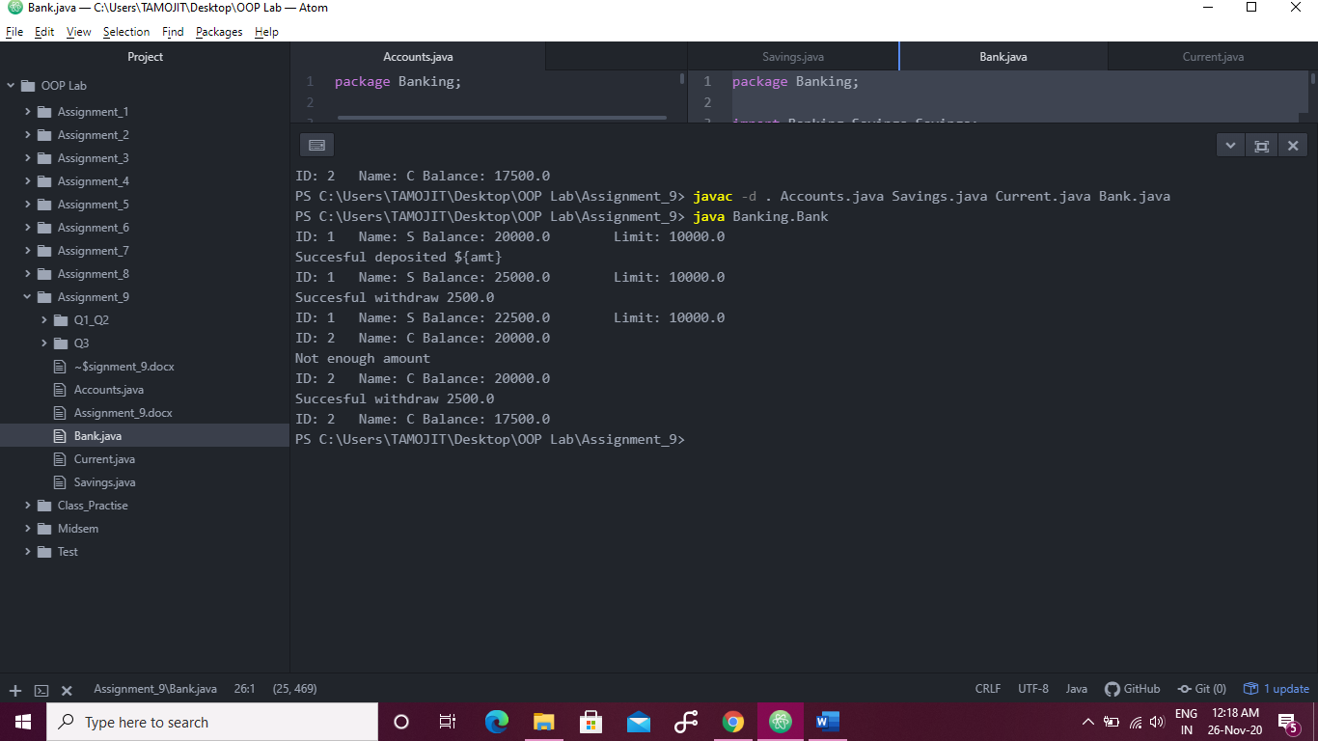

Q3.

import java.util.ArrayList;

class ListCalculator{

final static void Display(ArrayList<Integer> A1){

for(int d:A1){

System.out.println(d);

}

}

final static ArrayList<Integer> AddList(ArrayList<Integer> A1,ArrayList<Integer> A2){

ArrayList<Integer> arr=new ArrayList<Integer>();

for(int i=0;i<A1.size();i++){

arr.add(A1.get(i)+A2.get(i));

}

return arr;

}

final static boolean Check(ArrayList<Integer> A1,ArrayList<Integer> A2){

if(A1!=null && A2!=null && A1.size()==A2.size()){

return true;

}

return false;

}

public static void main(String[] args) {

ArrayList<Integer> D1=new ArrayList<Integer>();

ArrayList<Integer> D2=new ArrayList<Integer>();

D1.add(10);D1.add(11);D1.add(12);D1.add(13);

D2.add(10);D2.add(11);D2.add(12);D2.add(13);

if(Check(D1,D2)){

D2=AddList(D1,D2);

}

Display(D2);

}

}

