
Gym Management and Administration System

This Report is submitted in partial fulfilment of the requirements for the
BSc (Honours) Information Systems and Information Technology (DT249) to the
School of Computing,
College of Sciences & Health, Dublin Institute of Technology.

Author: Tomas Mikoliunas – D14123810
Supervisor: Cathy Ennis, School of Computing
Declaration
I, Tomas Mikoliunas, hereby confirm that the project I now submit for Honours Project Module, titled Gym Management and Administration System is my own work and was written by me following my research. The work is new and has not been submitted for any previous award, I further confirm that the work has not been taken from the work of others save and to the extent that such work has been identified, cited and acknowledged within the text of my proposal and presentation.
Your Name
Acknowledgement
I would like to thank my supervisor, Cathy Ennis, for her help and guidance provided during the course of the project, who provided much needed support, encouragement and understanding through the long days require to complete my project.
Table of Contents
1. How to Use This Template. i
1.1 Document Properties i
Acknowledgments i
Thesis abstract ii
Abbreviations iii
2. Literature Review (Chapter Titles are a Heading 1) 2-1
2.1 Section titles are a Heading 2 2-1
2.1.1 Subsection titles are a Heading 3 2-1
2.1.1.1 And just one more Heading 4 2-1
2.1.2 Updating Table of Contents, Figures and Tables 2-1
2.2 Heading Styles 2-1
2.3 Figures, captions & tables 2-2
2.4 Project Plan 2-4
2.5 Body Text 2-4
2.6 References 2-4
3. Learning Java 3-6
3.1 Eclipse for Java programming 3-7
3.1.1 Run HelloWorldSWT 3-7
4. System Design 4-8
4.1 System description and UML Diagrams 4-8
5. System Implementation 5-9
6. Testing 6-10
7. Conclusion 7-10
8. Appendices 8-11
Appendix A Appendix Headings are a Heading 5 8-11
Appendix B : Java code for Dijkstra’s Algorithm 8-11
Appendix C 8-12
9. Bibliography 9-12

Tables
Table 1-1 Math Symbols iii
Table 2-1 To add a caption to a table Insert > Reference > Caption 2-2
Table 3 This is a new table. 3-5

Figures
Figure 2-1 Insert caption dialogue box 2-1
Figure 2 ArgUML classes for Dijkstra code in Appendix B 2-2
Figure 3 Adding a cross-reference 2-3
Figure 4 Entering a new reference 2-4

Thesis Overview

Introduction
The following is relevant for IPR-2. It is difficult to write Chapter 1 before you have completed the project. However, for IPR-2 you should consider Chapter 1 in more aspirational light. It should reflect you current intensions and knowledge. Your goal for IPR-2 is to think through your plans and identify potential difficulties. The whole idea is to get you to think seriously about your project and express your ideas in a format that closely resembles the final deliverable. IPR-2 is not a contract; you are free to change your ideas. However, it would be nice if some material written for IPR-2 could be used in the actual project report. The next paragraph is based Kastens et al (Kim Kastens). It suggests some considerations for an introduction.
Be sure to include a hook at the beginning of the introduction. This is a statement of something sufficiently interesting to motivate your reader to read the rest of the paper, it is an important/interesting project topic. You should draw the reader in and make them want to read the rest of the report.
The next paragraphs in the introduction should cite previous work in this area. It should cite those who had the idea or ideas first, and should also cite those who have done the most recent and relevant work.
What else belongs in the introductory section(s) of your report?
- A statement of the goal of the project: why the work was undertaken.
- Sufficient background information to allow the reader to understand the context and significance of the question you are trying to address.
- Proper acknowledgement of the previous work on which you are building.
- Sufficient references that would enable a reader to validate your statements.
- Explain the scope of your work, what will and will not be included.
- A verbal "road map" or verbal "table of contents" guiding the reader to what lies ahead.
- Is it obvious where introductory material ("other peoples stuff") ends and your contribution ("your stuff") begins?
- Describe your intended software platform and/or data sets.
- Include a project plan, highlighting the potential difficulties.
- Describe some candidate use cases. Use UML notation.
- Describe some candidate classes. Use UML notation.
- Describe your current work.

How to Use This Template.
This document has been prepared for DT249 Honours students.

Document Properties
The first change you should make to this document is to edit the document properties with the details of your thesis.
File > Info >Properties
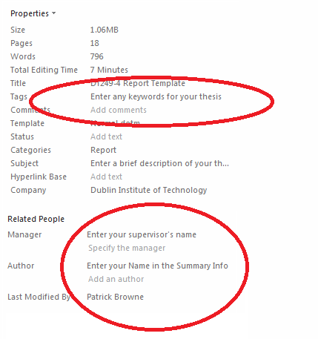

You should enter the project title, your supervisor’s name and your name in the appropriate fields. The body of the document contains several fields that will display the text from the document properties when required so that you don't have to type them
Acknowledgments
I would to thank Google for making this template.

Thesis abstract
The electronic version of the project will be uploaded to Webcourses. Three printed copies of the project manual will be delivered at the presentation. The report should not normally exceed 15,000 words (about 60-70 pages of doubled spaced 12-point Times New Roman text). Quality is obviously more important than quantity

Abbreviations
Table 1-1 Math Symbols
Symbol | Meaning
ℕ | Natural Number
∃ | There exists
∀ | For All

Literature Review
(Chapter Titles are a Heading 1)

Section titles are a Heading 2

Subsection titles are a Heading 3

And just one more Heading 4

Updating Table of Contents, Figures and Tables
When you make a change by adding or deleting a new heading, figure or table then you should update the fields in the Table of Contents, Figures, and Tables sections.
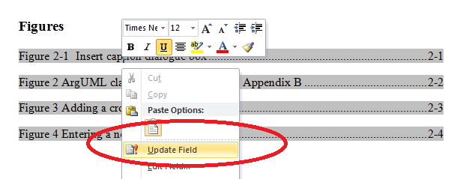

Heading Styles
All of these Heading Styles are automatically numbered and the text will automatically appear in the table of contents when the document is printed. DO NOT MANUALLY ADD NUMBERS. If you work on an individual document and the numbers do not appear or seem to be incorrect this is only because you are not viewing the document through the master document.

Figures, captions & tables
Images can be included from a variety of sources e.g. files. The images can be labelled with a number and description (References > Insert Caption).
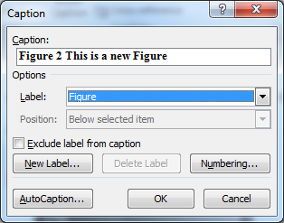
Figure 2-1 Insert caption dialogue box

Table 2-2 To add a caption to a table Insert > Reference > Caption
Table heading1 | Table heading 2 | Another table heading
Left aligned cell | Centre aligned cell | Right aligned cell

There are a set of styles for formatting text within tables.
Inserting a caption for a table will automatically add an entry in the list of tables after the table of contents. Captions are numbered automatically and are prefixed by the tables numbered in this way you can specify the numbering method used when you add the caption.
UML class diagrams can be exported from ArgoUML in the PNG file format, which can be loaded into Word with Insert -> Picture
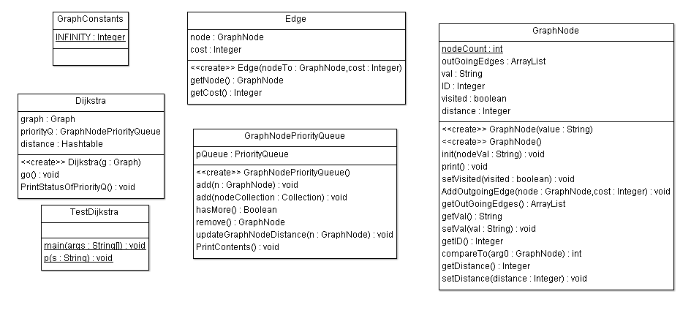
Figure 2-2 ArgoUML classes for Dijkstra code in Appendix B

We insert a caption with Reference -> Insert Caption -> Figure . There is a cross reference to Appendix B. This was placed in the caption after the caption was entered (Reference -> Cross-Reference) and the following dialog.
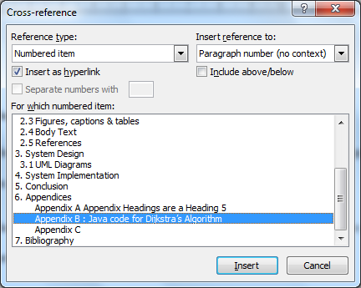
Figure 2-3 Adding a cross-reference

Project Plan
The next piece of text Figure 2-4 is a cross reference to the project plan caption.
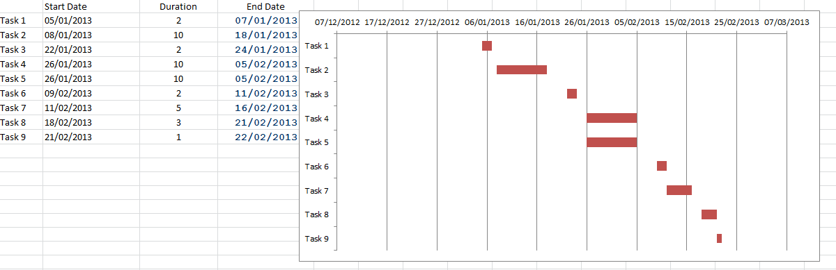
Figure 2-4 The project plan
More text here.

Body Text
The Body Text style is used for your body text. The text is double spaced with a 0.75cm indentation at the start of a left-justified paragraph.
There is an 12 point space between paragraphs so you do not have to put in a blank line between paragraphs.
Cambria Math is a useful font for mathematical symbols and Greek letters such as: ∀,∃,Σ,Υ,Φ,≠,⊇.

References
There is a separate style for references. This produces a left justified paragraph with no indent at 1½ line spacing with a 9 point gap before and after the paragraph. (just like this paragraph). Gries and Schneider (David Gries, 1993) wrote a good book on logic for computer scientists. There is a web site to accomany the book (Schneider). To enter a new reference select Reference -> Manage Sources which brings up this dialog
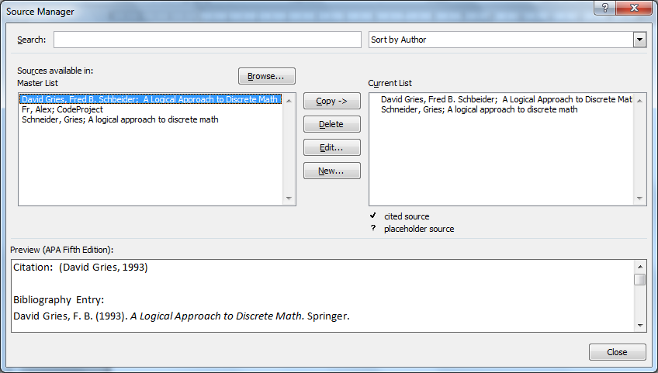
Figure 2-5 Entering a new reference

Learning Java
Copy the Java programs from student distrib to your working directory or folder.
The file-path for javac and java in A117 are.
"C:\Program Files (x86)\Java\jdk1.7.0_04\bin\javac.exe"
"C:\Program Files (x86)\Java\jre7\bin\java.exe"
Read the lectures and study the programs and their output.
http://www.comp.dit.ie/pbrowne/Information%20Systems%20Research%20Practice/IntroProg-1.PPT
http://www.comp.dit.ie/pbrowne/Information%20Systems%20Research%20Practice/IntroProg-2.PPT

Eclipse for Java programming
The next two tutorials are from the Welcome Page of Eclipse. Before starting Eclipse you should make a folder called workspace on your student drive (U:). If you are using your own machine then you can accept the default offered by Eclipse. Start Eclipse (Juno) in Lab A117 or on your laptop.
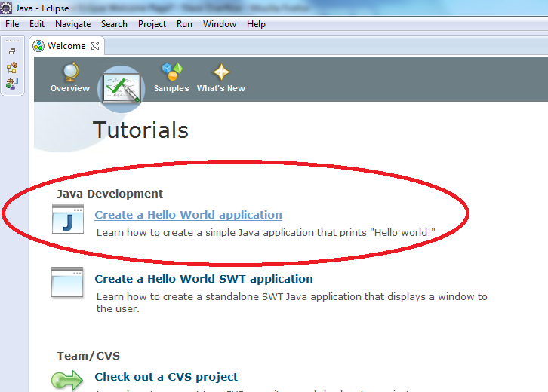
Figure 6 Eclipse (Juno) Welcome page
Start the Create Hello World Application and follow the instructions as shown in Figure 6. When you create a new project you will be prompted for a workspace. If working on your own machine accept the default, in A117 you should use the u:\workspce folder created earlier.

Run HelloWorldSWT
The Standard Widget Toolkit (SWT) is an open source widget toolkit for Java designed to provide efficient, portable access to the user-interface facilities of the operating systems on which it is implemented. Run the tutorial as instructed on the Eclipse Welcome Page. For information on SWT see: http://www.eclipse.org/swt/

Getting data from PostgreSQL.
Note without further modification this program cannot be run in the labs. It is intended to be run from your laptop. The Postgres JDBC Drivers should be downloaded to: C:\Program Files (x86)\PostgreSQL\pgJDBC. You may have done this when you installed Postgres or it can be done with the StackBuilder.
Then add the JDBC drivers to your classpath. This is done in Eclipse as follows: go to Project->Properties->Java Build Path->Libraries->Add External Jar and load the driver from the path above. Add the code Version.java, set the connection to be loacalhost, and run the program.

System Design

System description and UML Diagrams
A typical project would have some use case diagrams and some class diagrams. Tables are useful for summaries. This is a new table Reference -> Insert Caption -> Table:
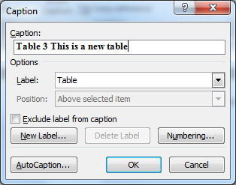
Table 3 This is a new table.
UML class | System Implementation
Date | Java Data class

System Implementation
Start typing here

Testing
Testing description. Junit (Petar Tahchiev Felipe Leme, 2007) was used for testing the Java code. Run the JUnit Tutorial at:
http://www.laliluna.de/articles/posts/eclipse-junit-testing-tutorial.html

Conclusion
Start typing here

Appendices

Appendix Headings are a Heading 5
Appendix headings are automatically prefixed with "Appendix #"

: Java code for Dijkstra’s Algorithm
This code was written by Vladimir Sutskever (Sutskever). It best to use monospaced font for source code (e.g. Courier New ).
public class Dijkstra {
private Graph graph;
//priority queue stores all of the nodes, reachable from the start node
//The queue is sorted by the node.distance
private GraphNodePriorityQueue priorityQ = new GraphNodePriorityQueue();
private Hashtable <GraphNode,Integer> distance =
new Hashtable<GraphNode, Integer>();

//1. Get the list of all nodes in the graph
//2. Initialize distance vector to infinity
//3. Edge Cost function
public Dijkstra (Graph g){
this.graph = g;
this.graph.getStartNode().setDistance(0);
this.priorityQ.add(this.graph.getAllNodes());
}
// Actual algorithm
public void go(){
while (this.priorityQ.hasMore()){
GraphNode n = this.priorityQ.remove();
n.print();
for (Edge e: n.getOutGoingEdges()){
GraphNode adjNode = e.getNode();
Integer newPossiblePathCost = e.getCost()+n.getDistance();
if (newPossiblePathCost < adjNode.getDistance()){
adjNode.setDistance(newPossiblePathCost);
this.priorityQ.updateGraphNodeDistance(adjNode);
System.out.println("current node "+ (e.getNode()).getVal());
this.priorityQ.PrintContents();
}
}
}
}

Bibliography
Choose your reference style.
ArgoUML. (n.d.). Retrieved from ArgoUML: http://argouml.tigris.org/
David Gries, F. B. (1993). A Logical Approach to Discrete Math. Springer.
Petar Tahchiev Felipe Leme, V. M. (2007). JUnit in Action, Second Edition. Manning Publications ISBN-10: 1935182021.
Schneider, G. (n.d.). A logical approach to discrete math. Retrieved 02 04, 2013, from http://www.cs.cornell.edu/gries/logic/LogicalApproach.html
Sutskever, V. (n.d.). Dijkstra Shortest Path. Retrieved 2013, from http://www.cs.nyu.edu/~vs667/development/~DijkstraAlgorithm/
The R Project for Statistical Computing. (n.d.). Retrieved 2013, from http://www.r-project.org/

