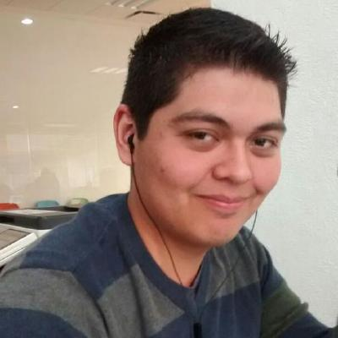MARCO CARRIZALES

B. S. Information and Communication Technologies

Tampico, Tamaulipas, Mexico

+52 (833) 346-2417

Portfolio: www.jejesauriovolador.com

Email: marco_carrizales@msn.com

About me

I’m an engineering student in Information and Communication Technologies at the Monterrey Institute of Technology and Higher Education. Among my interests are developing Android apps and games. I have launched some apps to the Playstore. I am also interested in web development. I’m currently getting my Front-End certificate by Free Code Camp.

On my free time I like to translate open source projects (also proprietary projects). With my team, we won the first place at the startup weekend 2016 at Oklahoma State University with the project Certaclear.

Objectives

My goal as a developer is to keep learning useful skills that can help push my career forward so I can keep crafting high quality code.

Education

B. S. Information and Communication Technologies by Monterrey Institute of Technology and Higher Education (2013-2018)

Study abroad program in Computer Science at Oklahoma State University (2016)

Getting my Full Stack Developer Certificate by Free Code Camp (2017-2018)

High School at the Monterrey Institute of Technology and Higher Education (2010-2013)

Skills

Java

PHP

Knowledge of HTML, CSS y Javascript

English as a second languaje

Experience

Semana i VMenu (Web App, 2015)

Cuidado a tu alcance (Web App, 2016)

Quotes on design (Android App, 2016)

El violín más pequeño (Android App, 2016)

Certaclear (Web App, 2017)

Don Gelatino (Android Game, 2017)

Proyecto de movilidad (Web App, 2017)

Sistema de aprendizaje (Web App, 2017)

Certifications

TOEFL ITP [593] (2016)

CCNA Exploration: Network Fundamentals (2016)

CCNA Routing and Switching: Routing and Switching Essentials (2016)