**<<BMOS>>**

**Bird Meal Order System**

–HoChiMinh, August 2022 –

**Group 5 – Bird meal order system**

* Phạm Võ Minh Tâm
* Nguyễn Tấn Đạt
* Lê Chí Phát
* Phan Văn Cường
* Nguyễn Đoàn Anh Duy

**I. Overview**

**1. Code Packages**

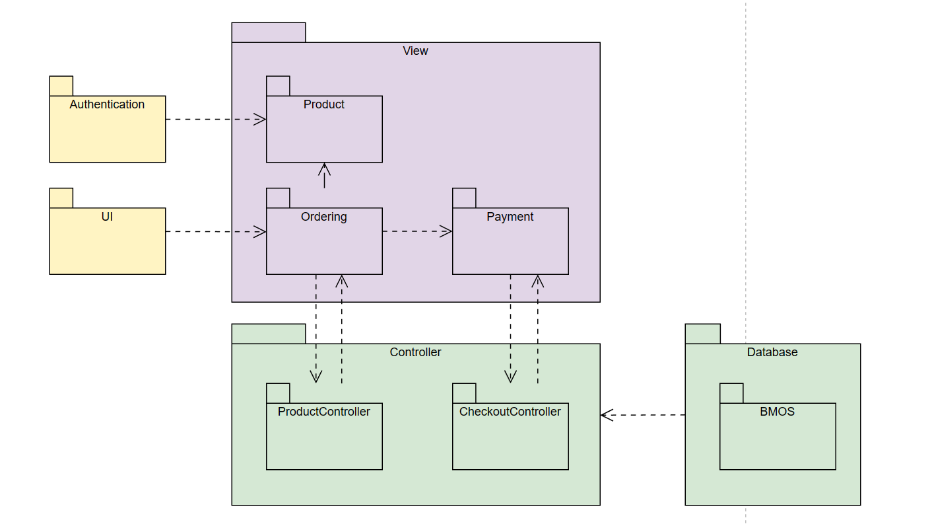

***Package descriptions***

|  |  |  |
| --- | --- | --- |
| **No** | **Package** | **Description** |
| *01* | *Authentication* | *<Login & Logout>* |
| *02* | *UI* | *<Layout website>* |
| *03* | *Product* | *<Display listproduct to buy>* |
| *04* | *Order* | *<Display orderbiew contain controller and view to handle order task>* |
| *05* | *Payment* | *<this package contain controller and view to handle payment task>* |
| *06* | *ProductController* | *<this package contain method to handle action to product item>* |
| *07* | *CheckoutController* | *<this package contain method to handle checkout action>* |
| *08* | *BMOS* | *<This package contain database to store data in the system.>* |

**2. Database Design**

**a. Database Schema**

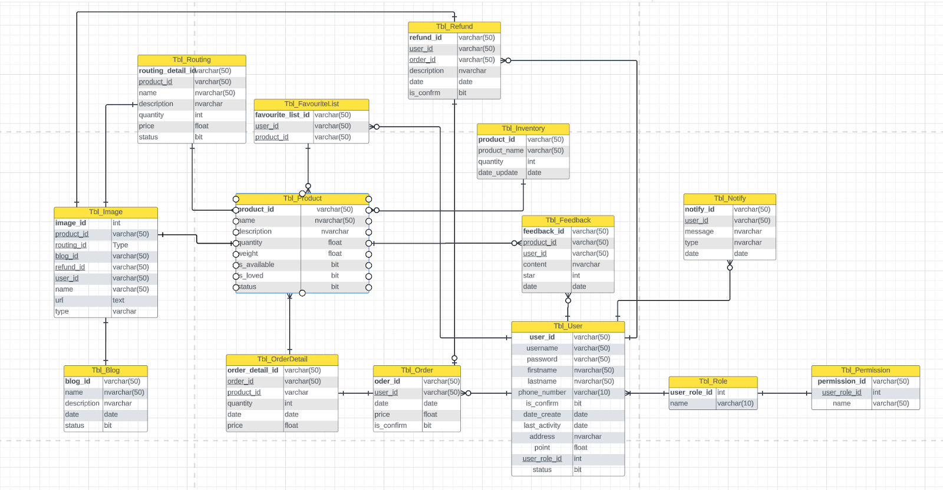

*[***b. Table Description**

|  |  |  |
| --- | --- | --- |
| **No** | **Table** | **Description** |
| *01* | *<Tbl_User>* | *This table contain user data to handle with the system* |
| *02* | *<Tbl_role>* | *this table use to authentication* |
| *03* | *<Tbl Permission>* | *this table use to authorization* |
| *04* | *<Tbl_Notify>* | *this table use to store notification to user* |
| *05* | *<Tbl_Feedback>* | *this table use to store feedback in product* |
| *06* | *<Tbl_Refund>* | *this table use to store refund offer* |
| *07* | *<tbl_Order>* | *this table use to store order in the system* |
| *08* | *<tbl_Order_detail>* | *this table use to store order detail* |
| *09* | *<tbl_product>* | *this table use to store product  information in the system* |
| *10* | *<tbl_routing>* | *this table use to store routing information* |
| *11* | *<tbl_image>* | *this table use to store image url link store in firebase storage* |
| *12* | *<tbl blog>* | *this table use to store blog in the system.* |
| *13* | *<tbl_favourite_list>* | *this table use to store favorite product which user add to their favorite list* |

**II. Code Designs**

**1. <Search>**

**b. Class Diagram**

*[Provide the description for each class and the methods in each class, following the table format as below]*

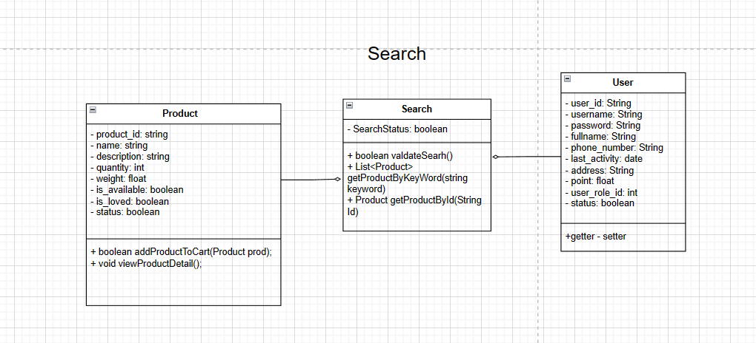

**2. <Checkout>**

**b. Class Diagram**

*[Provide the description for each class and the methods in each class, following the table format as below]*

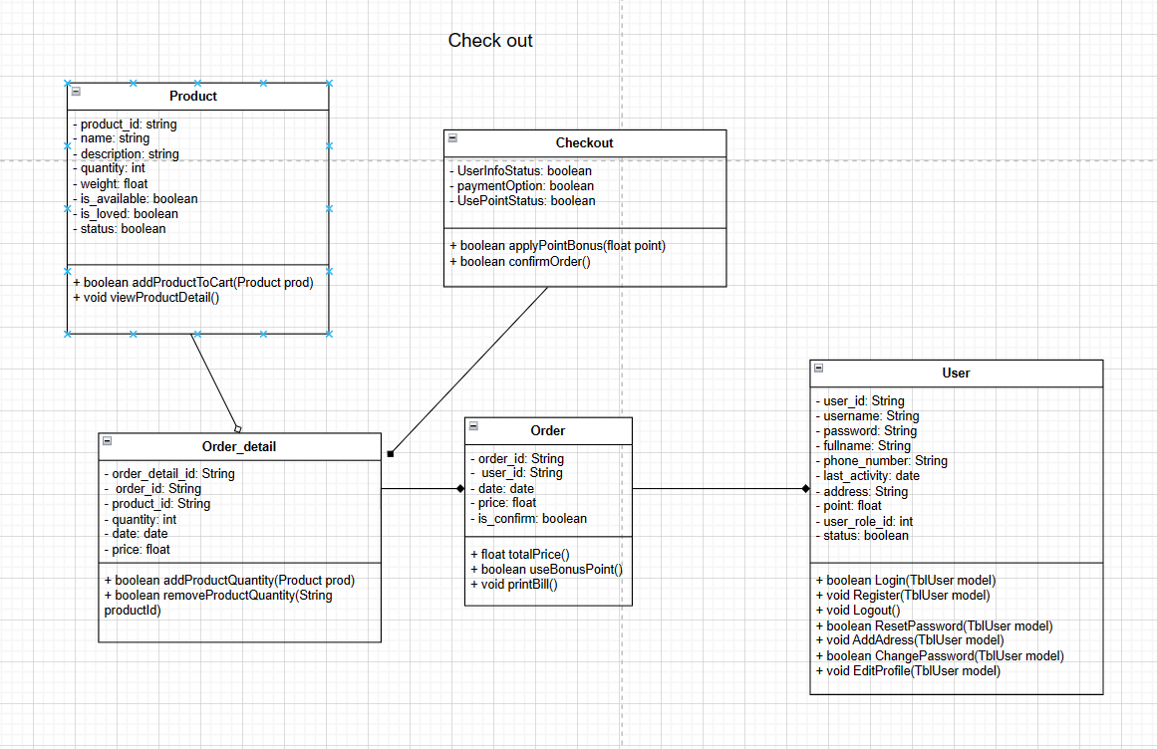

**2. <Forgot password>**

**b. Class Diagram**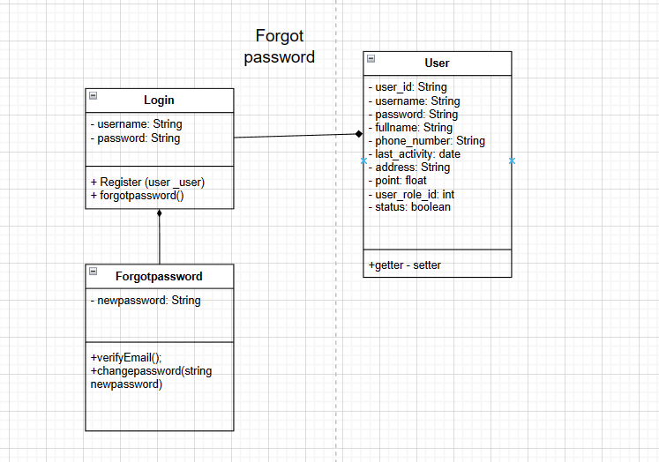

**2. <Refund>**

