Comparision of total number of accidents of OHIO state with national average

As time goes on, cars have been one of the most necessary aspects of people’s lives in United States. Today, there are about 263.6 million cars driven daily on U.S. highways, freeways, and country roads. With the number of cars increasing each year, the quantity of car accidents also increases. In 2015, According to the National Highway Traffic Safety Administration (NHTSA), 35,092 people died in fatal motor vehicle accidents, which is a 7.2% increase from 32,744 fatal accidents in 2014. The factors leading these fatal motor vehicle accidents are among many: weather, road condition, speeding, alcohol, types of intersection, etc. All of them are pivotal reasons for these fatal accidents.

Since we are college students, the drinking age of alcohol is a very important issue for us. Thus, we decided to explore the relationship between alcohol-related and non-alcohol-related fatal car accidents. First, we tried to make a plot, *Figure 1*, which can directly tell us about the alcohol-related accidents’ proportion in each U.S. state. Since we want to know the state’s alcohol-related accidents’ proportion level, we used 2015’s data (the most recent year available) to get a quick overview of these numbers. For *Figure 1*, we gathered all alcohol-related accidents and the population for each state, and then figured out the proportion between them. After that, we ranked each state to get this mosaic-type plot, which directly shows us a ranking of each state’s alcohol-related accidents density, adjusted for population (51 being the highest, 1 being the lowest; District of Columbia included). Alaska and Hawaii aren’t on the map but they are still ranked as 29 and 7, respectively. Since we live in Ohio, and Ohio is close to the middle of the range, at rank 22, of alcohol-related accident density, we decided to use Ohio’s data to compare/contrast with the United States’ data, or the “national average”, if you will.

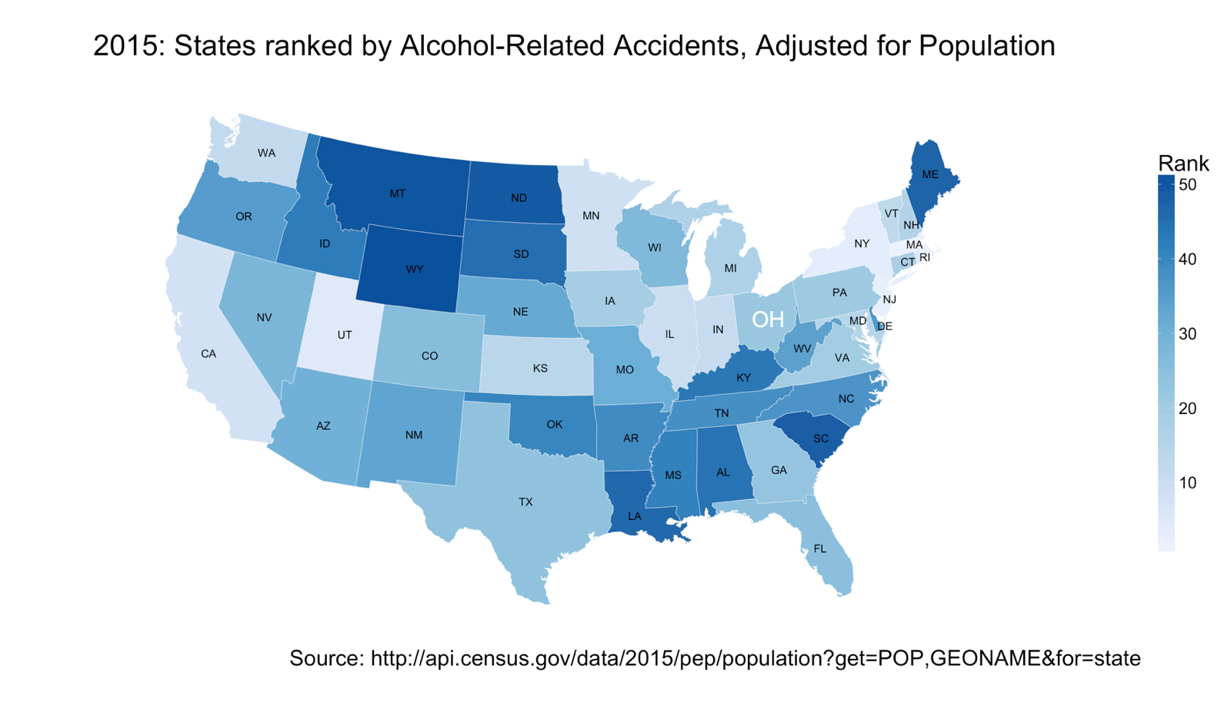

**Figure 1**

Once we chose Ohio as our target state for investigation, seeing as how it lied in the middle of the ranks, we started to notice the relationship between Ohio’s alcohol-related accidents density and the United States’ alcohol-related accidents density. We chose to look at the past 20 years of data (1994 to 2014) for our comparison, since it provided us with stronger evidence due to its large lapse of time. Since there is a significant difference between the U.S.’s population and Ohio’s population, we adjusted the proportions of Figure 2 and Figure 3. In Figure 2 below, we see an overall negative trend from 1994 to 2014, but the most interesting part is that they have a very similar and strong negative trend from 2005 to 2009.

After noticing these similar negative trends, we asked ourselves, “What caused this significant decrease for both Ohio and the whole U.S. from 2005 to 2009?” We found the simple answer is that the negative trends were due to a simultaneous large increase in population and large decrease in the number of alcohol-related accidents. From 2005 to 2009, in the U.S., there was an increase in population of 11,253,399 people and a decrease of 13,595 alcohol-related accidents. In Ohio, there was a similar proportional decrease with an increase in population of 67,383 people and a decrease of 514 alcohol-related accidents. These proportional shifts were noticeably different than the shifts experienced in other timeframes in Figure 2, for example, from 2001 to 2005, or even from 1994 to 2005 there isn’t an easily noticeable change. After discovering this, we wanted to investigate if this was an actual decrease in the proportion of alcohol-related accidents over total accidents compared to the population or if there was just a decrease in total accidents compared to the population for these years.

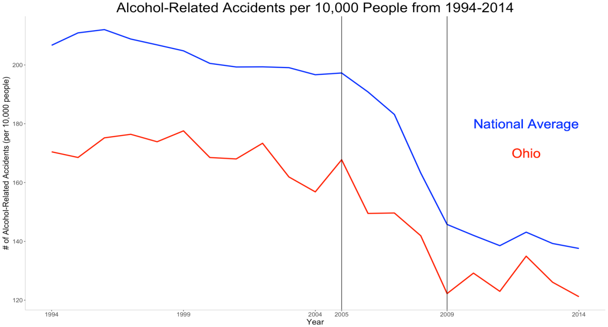

**Figure 2**

To investigate this question we looked at the Blood Alcohol Content (BAC) index of the accidents from 1994 to 2014. BAC is the most important indicator for testing if drivers are intoxicated since it is used at a threshold for the legal limit at 0.08 BAC, anything over this threshold is considered “drunk-driving”. In Figure 3, we see a proportional comparison of Ohio’s total accidents to the U.S.’s total accidents. We have non-alcoholic-related accidents (BAC = 0), alcohol-related accidents at less than the legal limit (0 < BAC < 0.08), and alcohol-related accidents at higher than legal limit (BAC > 0.08). In Figure 3, we see a relatively flat trend for the U.S. data while Ohio’s data has jumps in a few specific years, but is also relatively flat, meaning that the proportion of alcohol-related/total accidents doesn’t change significantly over the years.

After discovering no significant proportional changes of alcohol-related/total accidents from 2005 to 2009, we can conclude that the largely negative trend in Figure 2 is due to a decrease in total accidents compared to the population. We do see big shifts of alcohol-related accidents in timeframes such as from 1999 to 2001 or from 2011 to 2013, but they readjust themselves to hover around the 35% mark. Since the proportions have a fairly flat trend hovering around 35%, we can conclude that the negative trends in Figure 2 were due to a large decrease in total fatal accidents compared to the increase in the population from 1994-2014; not a decrease in alcohol-related fatal accidents’ proportion.

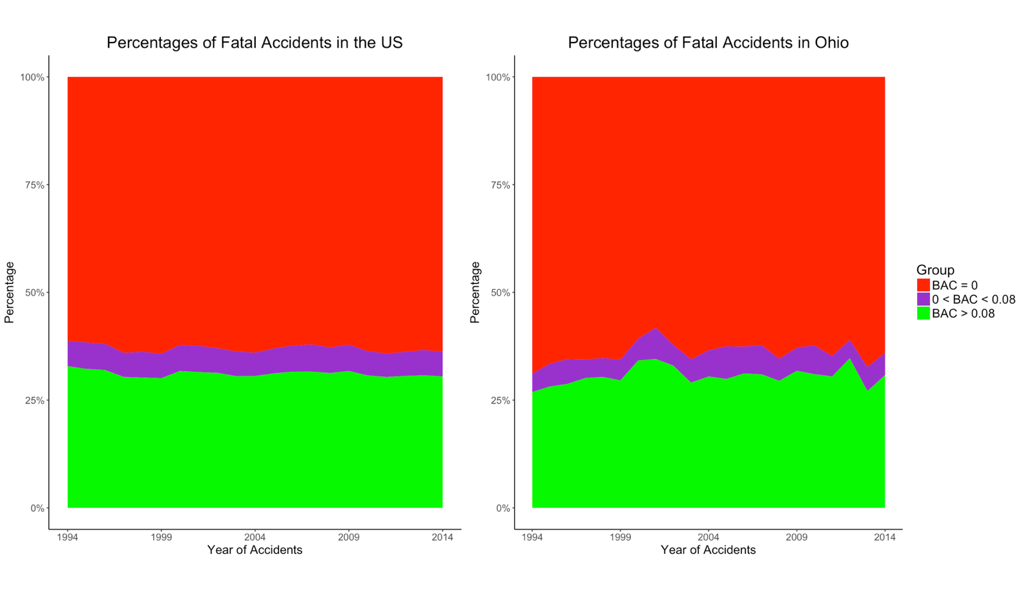

**Figure 3**

Totalling all of this up, we can conclude the following: Maine is the worst and Utah is the best when it comes to alcohol-related fatal accidents’ density in the population; there was a decrease in the total number of fatal accidents, therefore a decrease in density when compared to the increasing population from 1994 to 2014; and Ohio follows very closely with the entire U.S. in terms of alcohol-related vs non-alcohol-related fatal accidents.

Sources

Fatal Accident Data

* <https://www.nhtsa.gov/research-data/fatality-analysis-reporting-system-fars>

Population Data

* 2015
  + [http://api.census.gov/data/2015/pep/population?get=POP,GEONAME&for=state:*](http://api.census.gov/data/2015/pep/population?get=POP,GEONAME&for=state:*)
  + "Auto Crashes." III. N.p., n.d. Web. 07 June 2017.
* 1994-2014
  + http://www.randstatestats.org/us/stats/historical-population-estimates-(states-only).html?dbc=cmFuZF91c2E