**TRENDS OF COMMODITIES/INDEX DURING 2000-2016**

**Date Collection**

I collected the data from investing.com (weekly data from 2000-2016 for Gold, Crude Oil, Dollar Index and SNP 500). To access the data , I downloaded the data and saved it in my computer in html format and then read the data,which had a HTML format. Then I scraped only the table that was needed and then clean the data in R. Finally, the data was ready for analysis.

For this project, I wanted to see the trends for these commodites and the index, before the recession, during recession and after recession.

**Recession**

Recession occurs when there is a decline in real GDP for two consecutive quarters. In fact, the economy is in an official recession after six months of falling national income. During recession the inflation stayes below the forcasted rate, the unemployment rate grows, the consumer confidence declines,the houses become cheaper and so on. Recession is often confused with depression. A [depression](http://www.investopedia.com/terms/d/depression.asp) is a severe economic catastrophe in which [real gross domestic product](http://www.investopedia.com/terms/r/realgdp.asp) (GDP) falls by at least 10%. A depression is much more severe than a recession and the effects of a depression can last for years.

The latest recession in the United States was from December 2007 to june 2009. It lasted for a year and half years. During this period, the unemployment rate was 10% and the GDP declined by more than 5%. It is also known as the great recession.  
  
 In the following graphs, the line graph represents the price of the commodity during that period and the vertical line represents the start and the end of the recession period. The commodity I wish to observe were as follows:

1. **Gold**

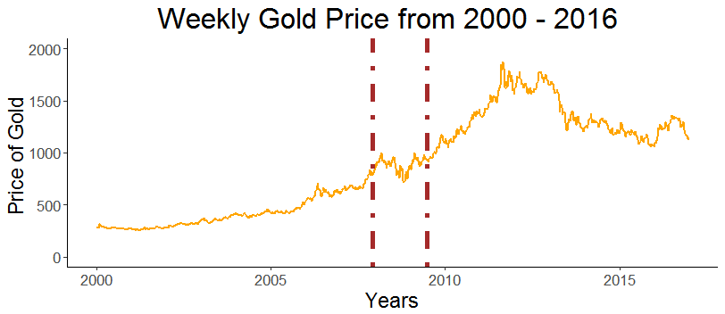

Gold had its days from the year 2000 to 2012, as gold is known to be hedging metal.Also, gold really performed well during the recession period, and right after the recession period as well. But, we notice that as soon that the consmer confidence went up, gold started to fall and in the verge of declining as the index and bond market is outperforming.

1. **Crude**

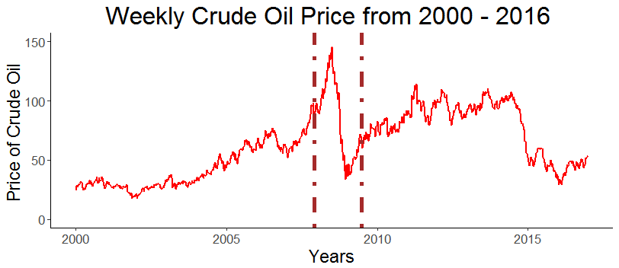

Looking at the crude oil, it took a drastic increase during the start, but then dropped more after it. After the recession, the crude started to go up a bit, but it is dropping now with more supply than demand. The US Shale is producing more and more oil whereas the OPEC countries are not making deeper cuts, which has caused the oil supply to grow and depress its costs recently.

1. **Dollar Index**

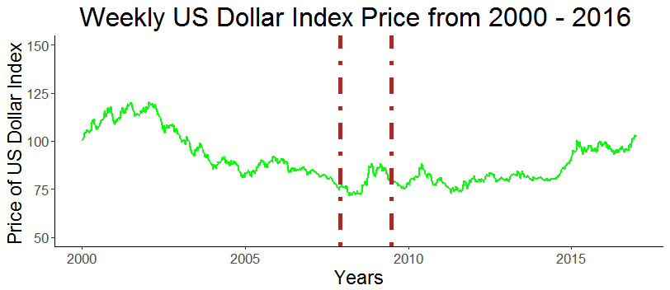

From this line chart, we can visualize that the dollar index was decreasing from 2002, which showed that the economy on the whole was not doing great and after the trend has established we saw the recession. But, during recession, we see that the dollar went up and then it stabilizes and when the consumer confidence went up aroung 2015, the dollar started to rise again, showing strength that the economy was getting better and the GDP starts to increase and the unemployment rate starts to decrease.

1. **SNP 500**

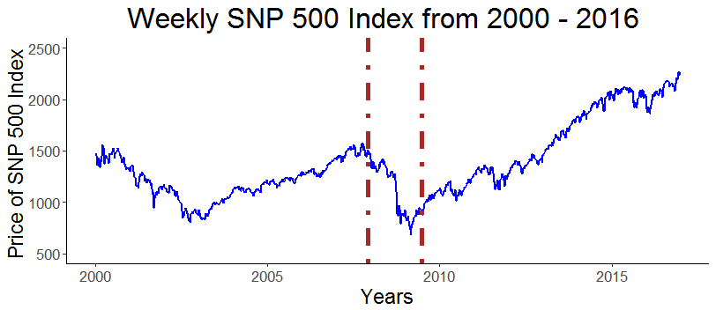

The index seems to have a very negative effect during the recession period. Right before the recession and after the recession the index tends to perform well whereas during the recession period the index seems to be doing very poorly, which can be explained by this graph.

**Conclusion**

The conclusion that we get from these 4 plots is we shouldn’t hold any stocks or bonds during recession, but it is good to hold gold until the consumer confidence is built up. Also buying an index after the recession is profitable than any other commodities. While recession seemed to have very drastic effect for the crude oil, we would be unsure to buy of short the crude oil with just the trend analysis, and further analysis is required.

Additionally, in my shiny application, we can view the correlation between any of these commodites and index.