HARDWARE SUPPLY POS
Cloud Point-of-Sale & Inventory Platform

Cashier Quick Guide
Point-of-Sale Quick Reference

Version | 1.0
Audience | Cashiers / Sales Clerks
Classification | Customer Documentation
Release date | Version 1.0 – General Availability

Table of Contents

If the contents above appear empty, right-click and choose “Update Field”.

1. Login
Purpose. Sign in to start your shift.
- Open Hardware Supply POS in your browser.
- Enter your username and password.
- Click Sign In.
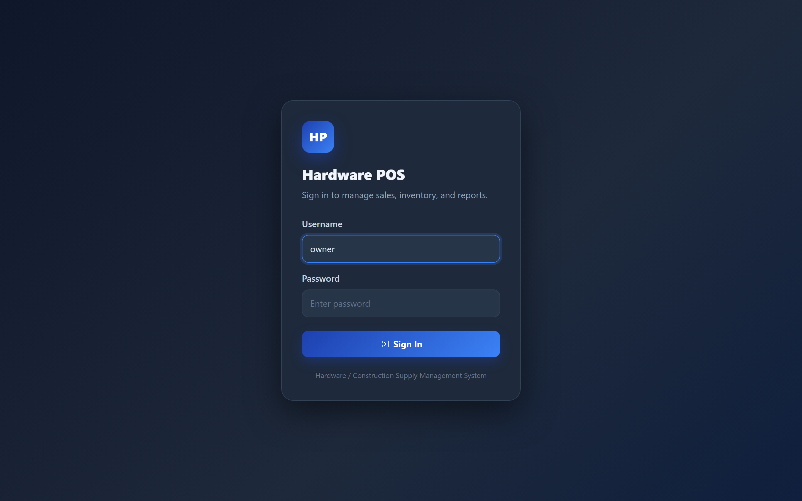
Figure 1: Login screen — enter your username and password.
Expected result. You are signed in and ready to select your branch.
Note: Use your own account. Never share your password.

2. Select Branch
Purpose. Choose the branch you are working in.
- After signing in, find the branch selector at the top of the screen.
- Choose your branch from the list.
- The system now uses that branch’s stock and prices.
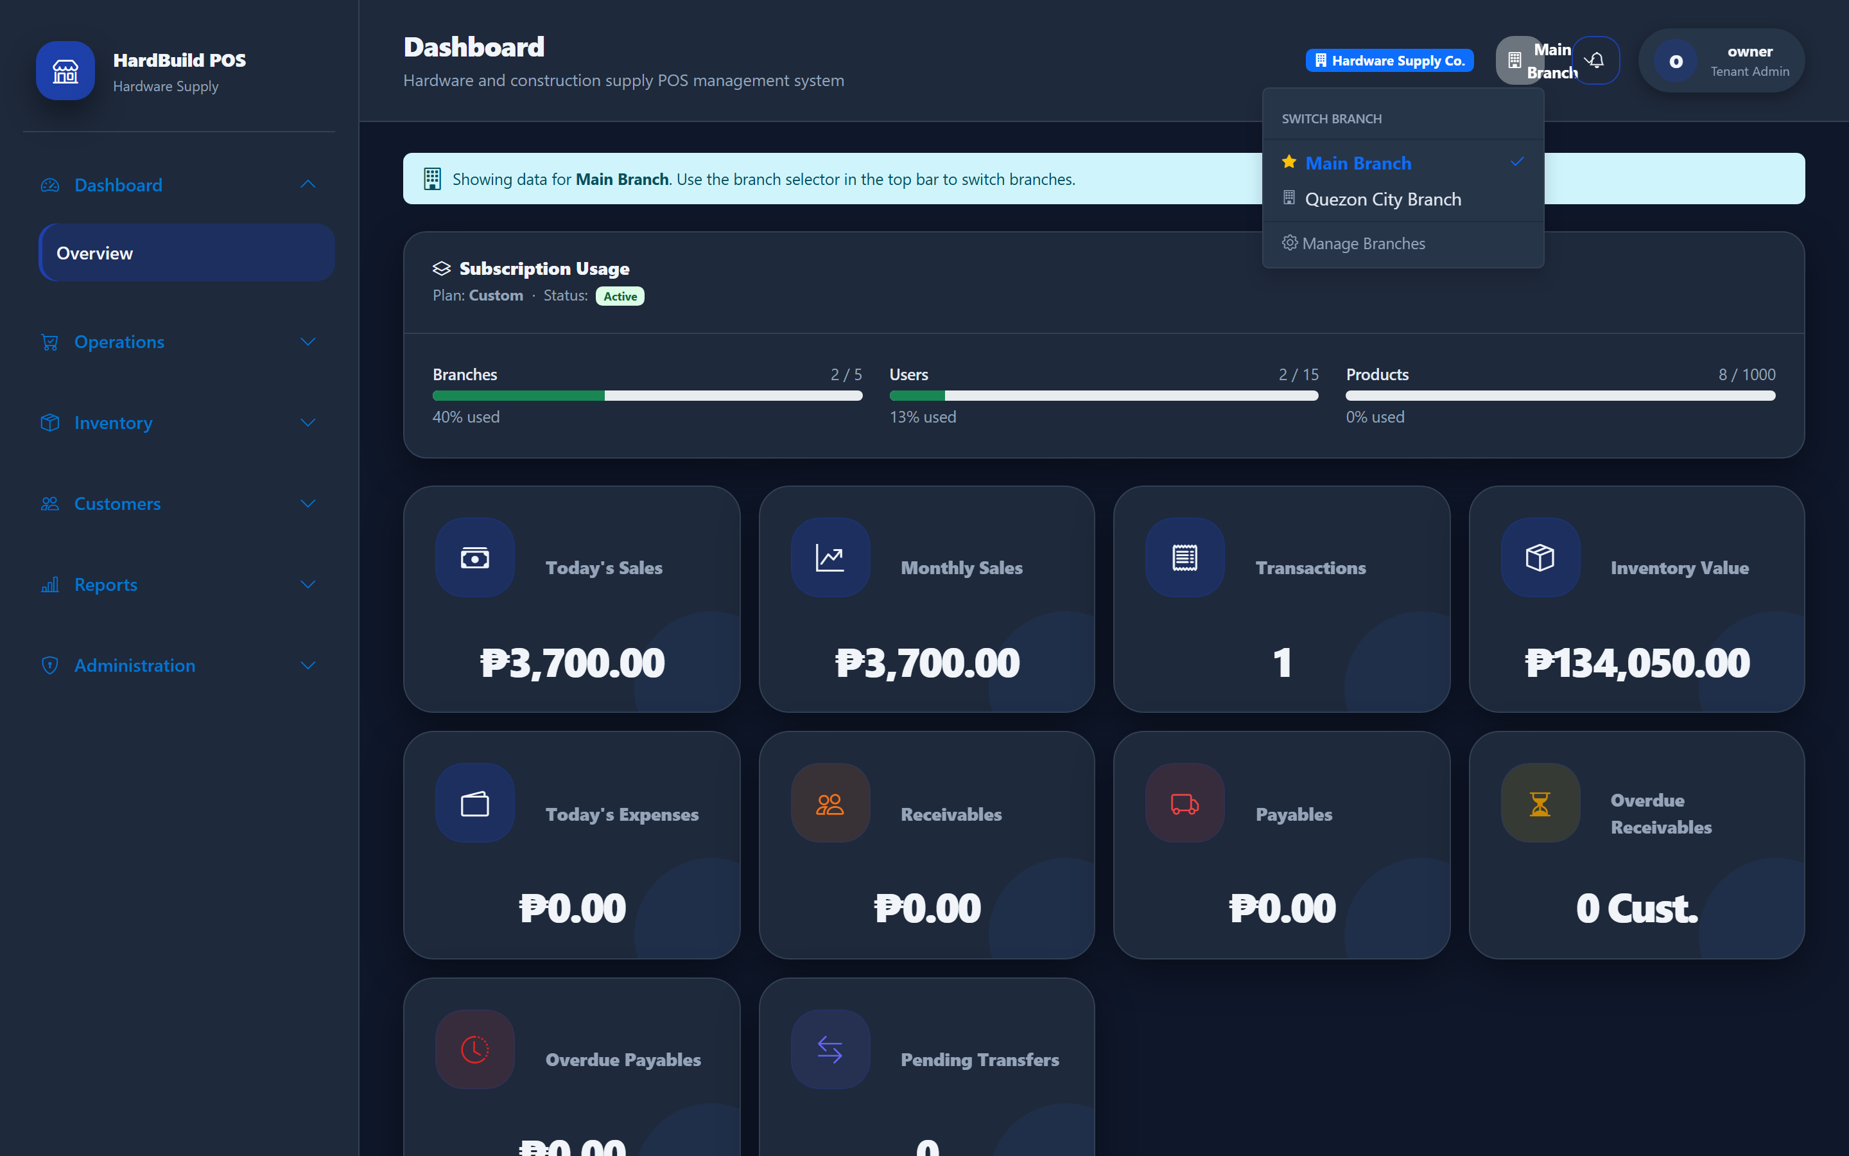
Figure 2: Branch selector — choose the location you are working in.
Expected result. Your sales and stock will apply to the selected branch.

3. Create Sale
Purpose. Ring up items for a customer.
- Open Operations → POS.
- Search for an item by name, code, or barcode.
- Click the add (+) button to put it in the order; repeat for each item.
- Adjust quantities in the Order Summary as needed.
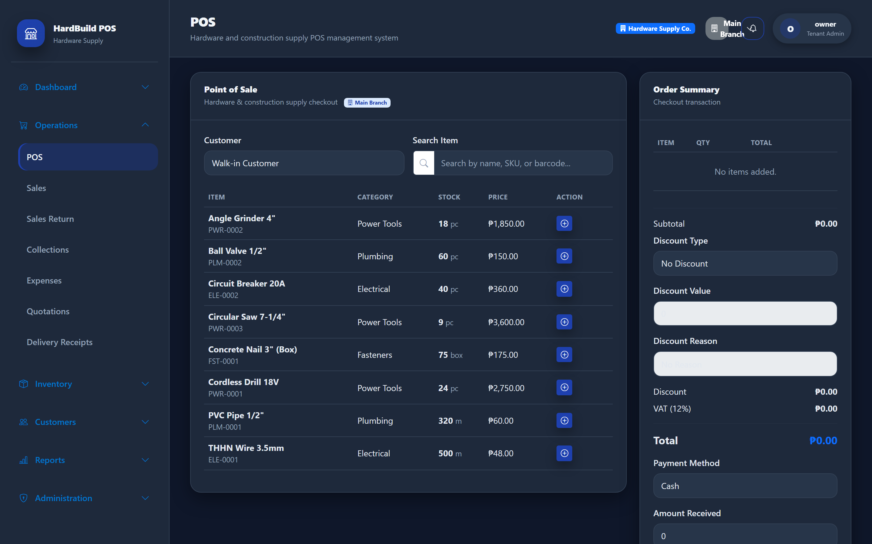
Figure 3: POS screen — search items and build the order.
Expected result. All items appear in the Order Summary with a running total.

4. Add Customer
Purpose. Attach a customer to the sale (optional).
- In the Customer box on the POS, choose a registered customer, or leave it as Walk-in.
- For a credit sale, you must select a registered customer.

Figure 4: Customer selection on the POS — Walk-in or a registered customer.
Expected result. The chosen customer is linked to the sale and the receipt.

5. Receive Payment
Purpose. Take the customer’s payment and give change.
- Confirm the total in the Order Summary.
- Apply a discount only if you are authorized to.
- Choose the payment method (for example Cash).
- Enter the Amount Received — the system calculates the change.
- Complete the sale.

Figure 5: Payment area — method, amount received, and change.
Expected result. The sale is saved, stock is reduced, and a receipt is ready to print.
Warning: Count the cash and the change carefully before finishing the sale.

6. Print Receipt
Purpose. Give the customer their receipt.
- After completing the sale, the receipt is shown on screen.
- Click Print Receipt.
- Hand the printed receipt to the customer.
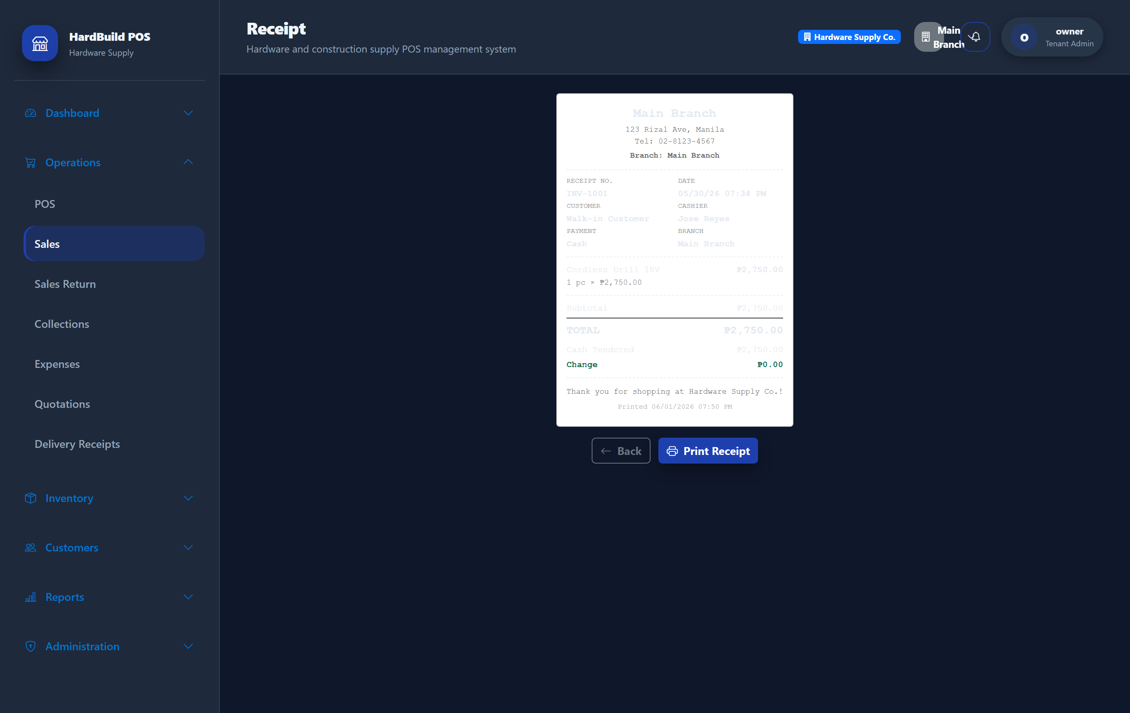
Figure 6: Receipt screen — review and print the customer’s receipt.
Expected result. The customer receives a printed receipt with your store’s details.

7. View Sale History
Purpose. Look up sales you have processed.
- Open Operations → Sales.
- Use search and date filters to find a sale.
- Open a sale to view details or reprint its receipt.
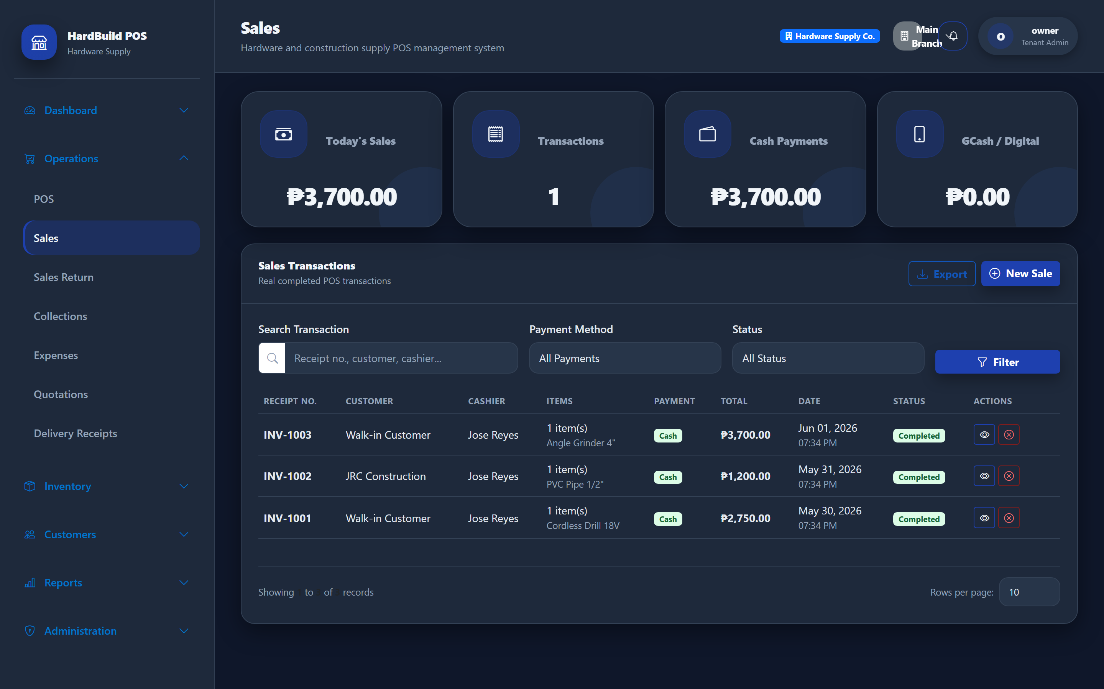
Figure 7: Sales history — find and review past sales.
Expected result. You can locate any past sale and reprint its receipt.

8. Logout
Purpose. Protect the till when you step away or end your shift.
- Click your name in the top-right corner.
- Choose Logout.
- Confirm you are returned to the sign-in screen.
Warning: Always log out at the end of your shift so no one can sell under your account.

9. Common Errors
Purpose. Quick fixes for everyday problems.
- “Item out of stock” — the item has no stock at your branch. Ask a supervisor to transfer or receive stock.
- Cannot find an item — try the code or barcode instead of the name; check spelling.
- Wrong branch — use the branch selector at the top to switch to your correct branch.
- Cannot apply a discount — you may not be authorized. Ask a supervisor.
- Locked out after wrong passwords — wait a few minutes, then sign in again.

10. Quick Tips
Purpose. Be faster and more accurate at the till.
- Scan or type the barcode to add items instantly.
- Confirm the customer’s name for credit sales before completing.
- Re-read the total and change amount out loud to the customer.
- Reprint a receipt any time from Sales history.
- Log out whenever you leave the counter.
Tip: Keep the Order Summary visible while ringing up — it shows the live total, discount, VAT, and change.

