HARDWARE SUPPLY POS
Cloud Point-of-Sale & Inventory Platform

SuperAdmin Manual
Platform Administration & Operations Guide

Version | 1.0
Audience | System Owner / Platform Operator
Classification | Internal – Confidential
Release date | Version 1.0 – General Availability

Table of Contents

If the contents above appear empty, right-click and choose “Update Field”.

1. Introduction
Purpose. This manual is the operational reference for the System Owner who administers the Hardware Supply POS platform. It explains how the multi-tenant Software-as-a-Service (SaaS) system is structured and how to provision, operate, and support customer tenants.
Hardware Supply POS is a cloud point-of-sale and inventory platform for hardware and construction-supply businesses. A single deployment serves many independent customers (“tenants”), each with isolated data, users, branches, products, and reports.
Warning: This document is for internal use by the platform owner and authorized operators only. It contains administrative procedures that must never be shared with end customers.

- SuperAdmin sign-in URL: /Account/Login
- SuperAdmin console: SaaS Management menu (Dashboard, Tenants, Subscription Plans, Global Audit Trail)
- Default platform account: superadmin (rotate the password before go-live).

2. System Architecture
Purpose. Understand how platform data and tenant operational data are separated so you can provision and troubleshoot tenants safely.

Two database layers
- Shared platform database — stores identity (users, roles, permissions), tenant metadata, subscription plans, and the global audit trail. All tenants that run in Shared mode also keep their operational data here, isolated by a TenantId column.
- Dedicated tenant database — an optional, per-tenant operational database (its own catalog on the SQL Server) used by larger customers. It holds that tenant’s products, inventory, sales, suppliers, customers, and related records.

Runtime routing
On each request the platform resolves the signed-in user’s tenant, then decides whether to read and write operational data in the shared database or in that tenant’s dedicated database. The decision is driven by the tenant’s database flags (described in the Routing and Provisioning chapters).
Note: Identity and tenant metadata always live in the shared database, even for tenants that use a dedicated operational database. This keeps sign-in and platform administration consistent for every tenant.

3. SaaS Overview
Purpose. Get a platform-wide picture of tenants, branches, users, and product usage from a single screen.
- Sign in with the SuperAdmin account.
- You arrive on the SuperAdmin Dashboard automatically.
- Review the KPI cards (Total Tenants, Active Branches, Active Users, Total Products).
- Use the Tenant Overview table to see each tenant’s plan, status, and usage against its limits.
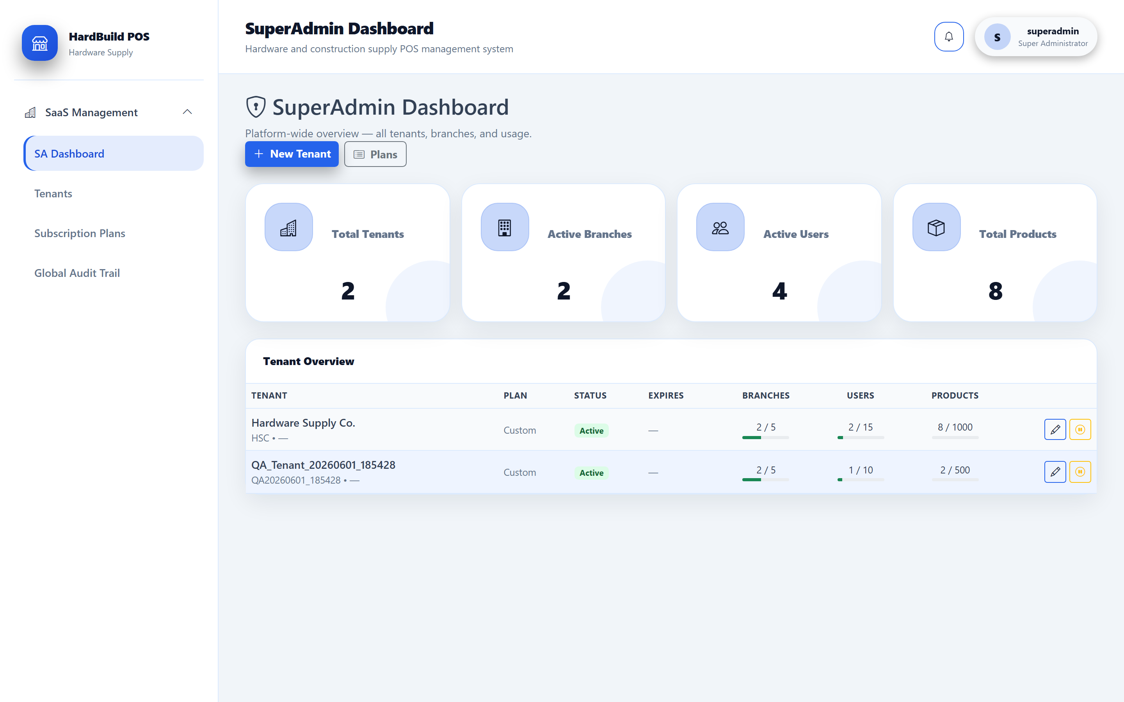
Figure 1: SuperAdmin Dashboard — platform-wide tenant, branch, user, and product overview.
Expected result. The dashboard shows live totals and a per-tenant usage table with quick links to manage or view each tenant.

4. Tenant Management
Purpose. Find, review, and manage every customer tenant on the platform.
- Open SaaS Management → Tenants.
- Use the list to review each tenant’s name, code, plan, status, and usage.
- Select a tenant row to open its details, or use New Tenant to onboard a customer.
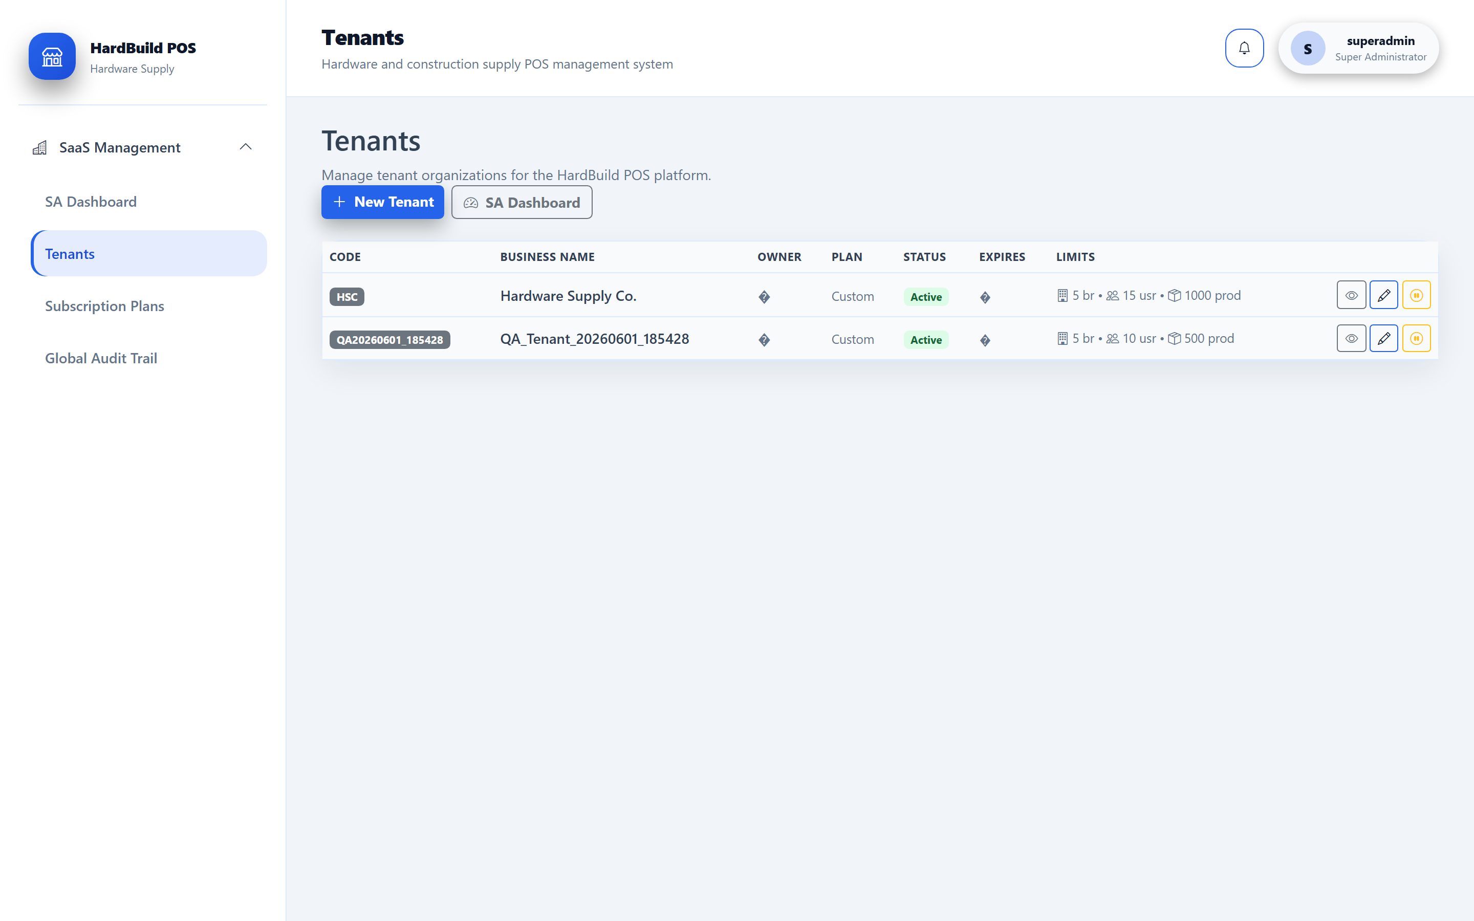
Figure 2: Tenants list — all customer tenants with plan, status, and usage limits.
Note: A tenant can be Active, Suspended, or otherwise restricted. Suspended tenants cannot sign in; their data is retained.

5. Subscription Plans
Purpose. Define the commercial tiers (limits on branches, users, and products) that tenants are assigned to.
- Open SaaS Management → Subscription Plans.
- Review existing plans and their limits.
- Create or edit a plan to set maximum branches, users, and products.
- Assign the plan to a tenant from the tenant’s record.
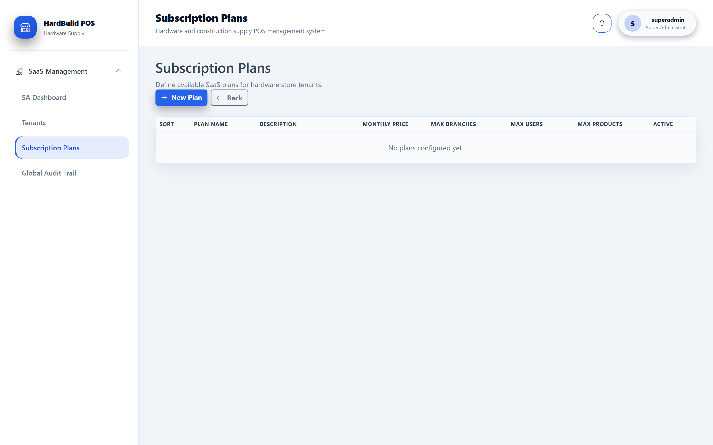
Figure 3: Subscription Plans — commercial tiers and their resource limits.
Expected result. Each tenant’s usage is measured against the limits of its assigned plan, shown on the dashboard and tenant list.

6. Tenant Creation
Purpose. Onboard a new customer by creating a tenant and its first administrator.
- Open SaaS Management → Tenants and click New Tenant.
- Enter the business name and a short unique tenant code.
- Choose the subscription plan and set the limits (branches, users, products).
- Provide the first Tenant Administrator’s name, username, and email.
- Save. The tenant starts in Shared database mode by default.
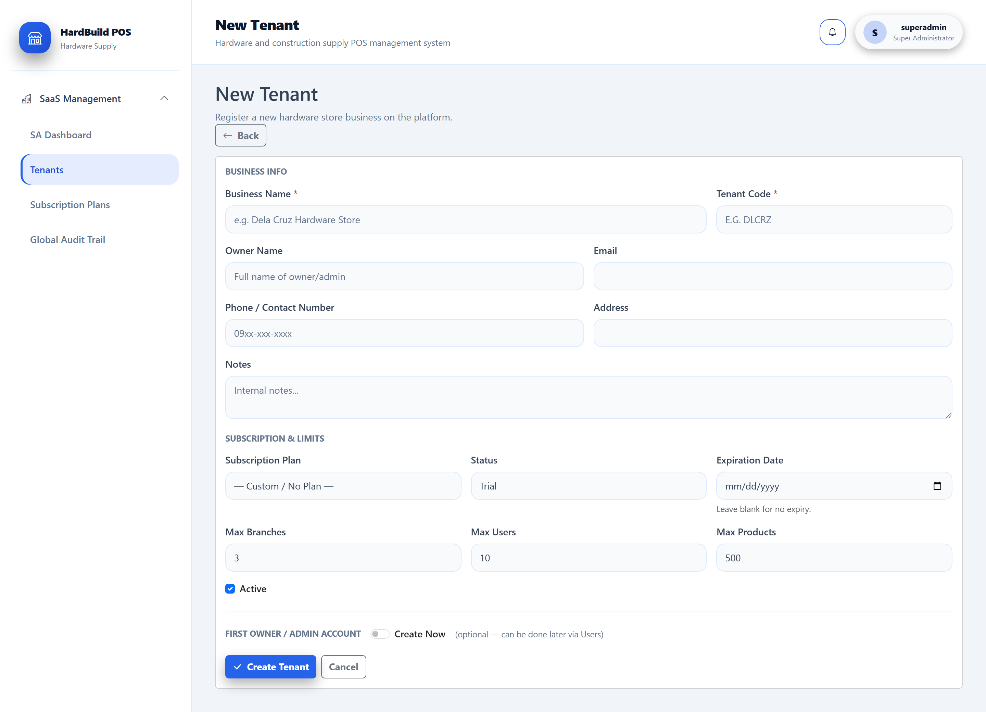
Figure 4: Create Tenant — business details, plan, limits, and the first administrator account.
Tip: Use a short, stable tenant code (for example HSC). It is used internally and should not be changed after go-live.

Expected result. A new Active tenant appears in the list with one Tenant Administrator who can sign in immediately.

7. Tenant Administration
Purpose. Manage an individual tenant: review usage, manage its users, suspend or reactivate it, and reset administrator passwords.
- Open Tenants and select the tenant to open its Details page.
- Review usage, plan, and the tenant’s users.
- Use Suspend to block access (data is retained) or Reactivate to restore it.
- Use Reset Password to issue a new password to a tenant user when required.
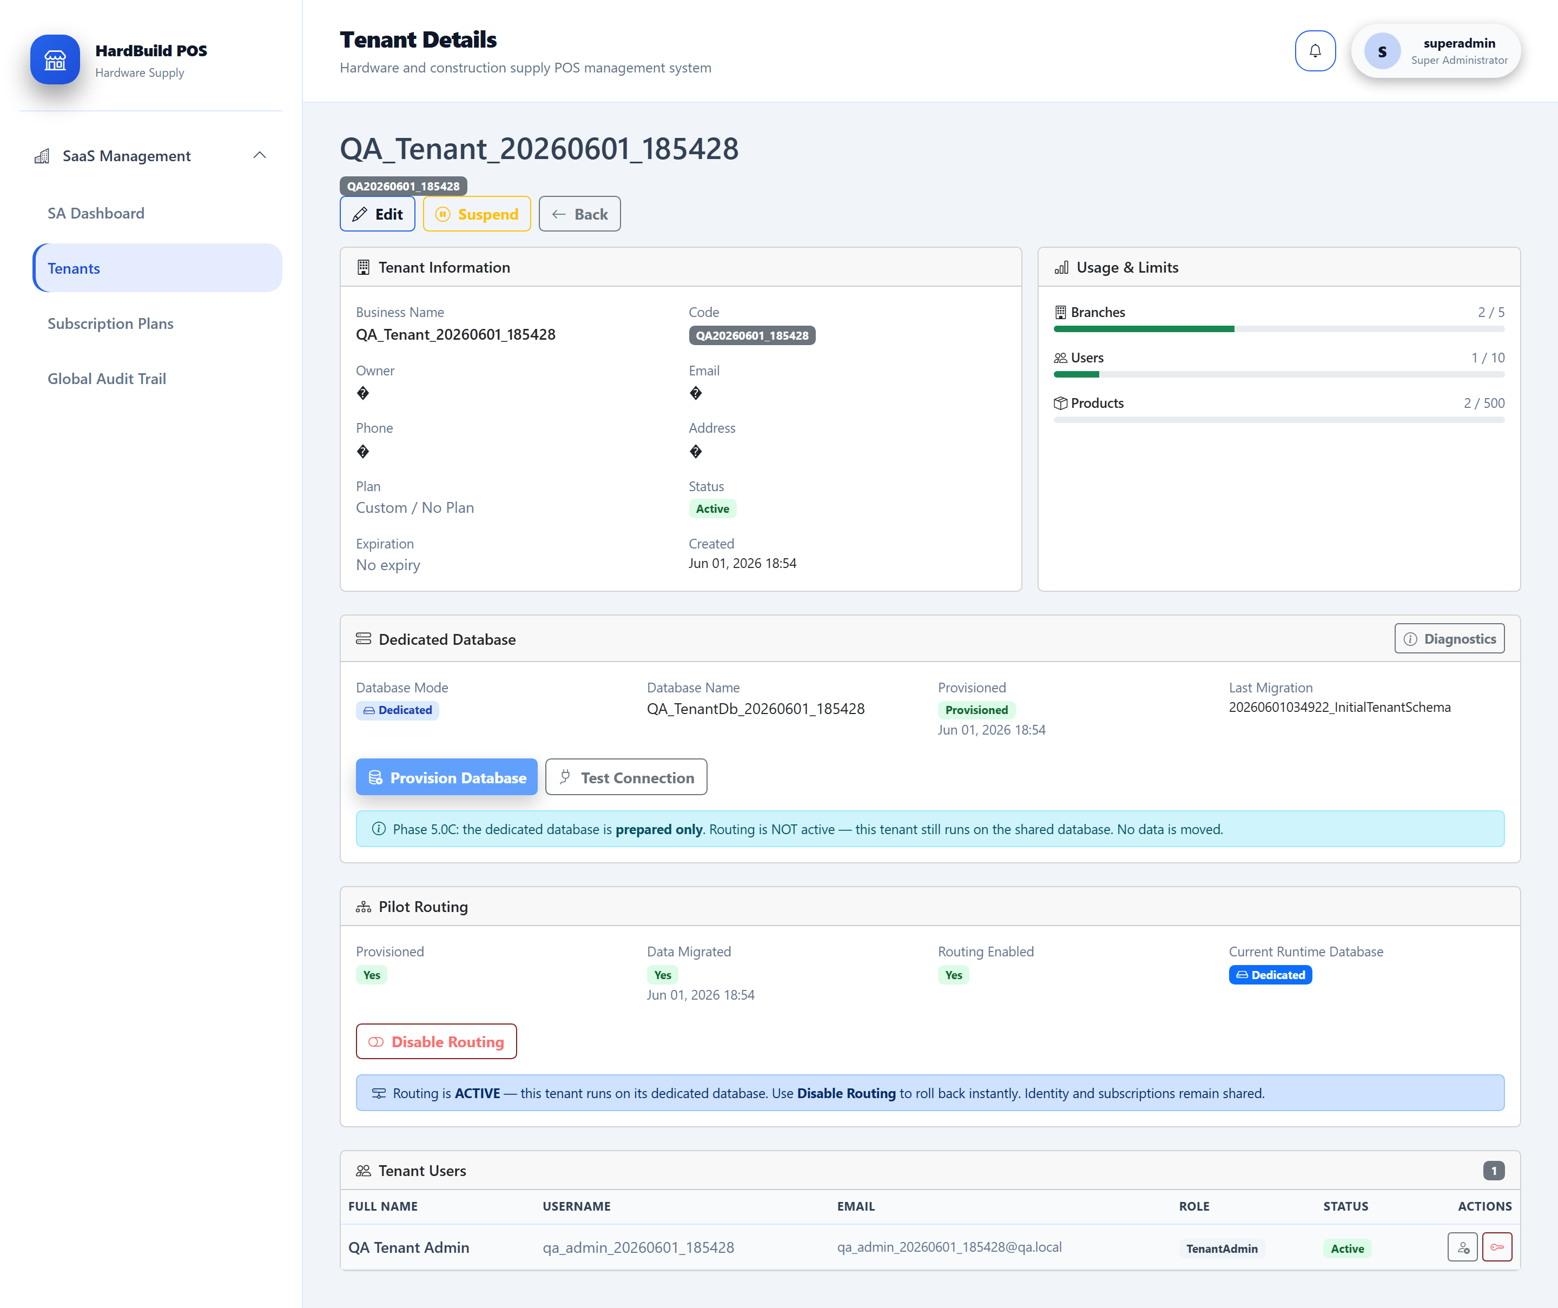
Figure 5: Tenant Details — usage, users, status controls, and the dedicated-database panel.
Warning: Suspending a tenant immediately prevents all of that tenant’s users from signing in. Confirm with the account owner before suspending a live customer.

8. User Administration
Purpose. Manage platform and tenant user accounts, including activation state and roles.
- Open the Users area.
- Locate a user by name, username, or tenant.
- Activate or deactivate accounts and confirm role assignments.
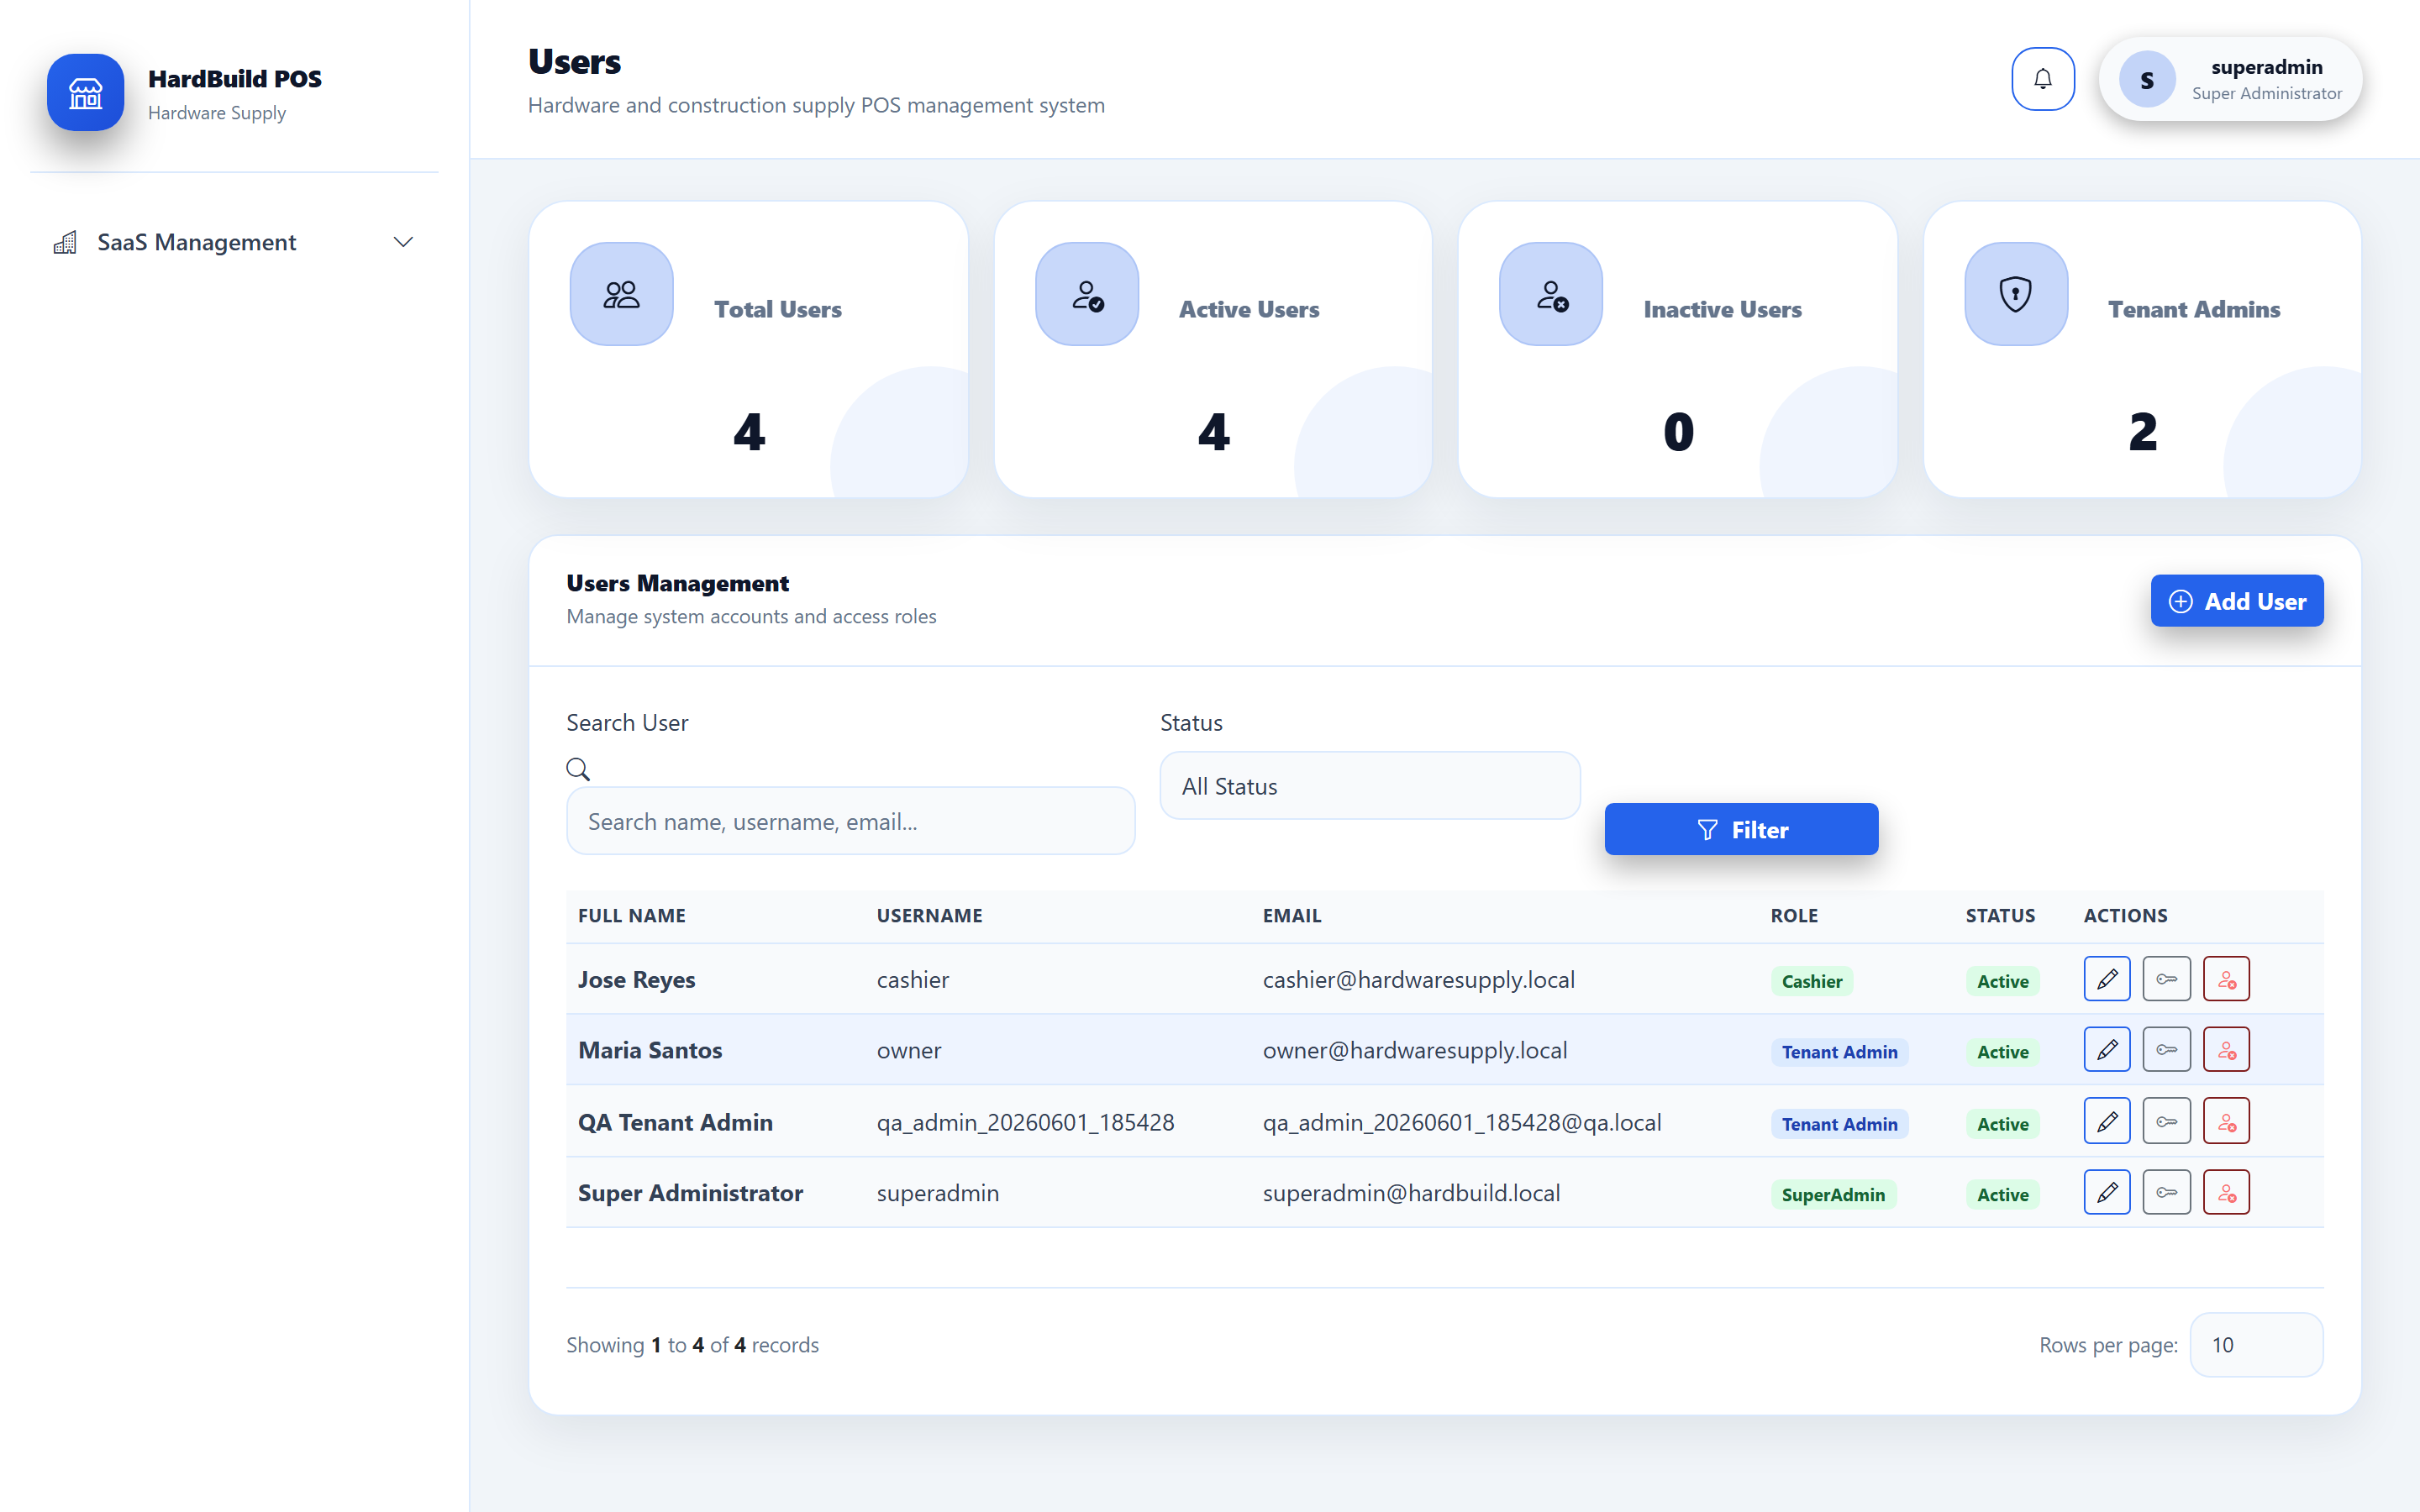
Figure 6: User administration — accounts, roles, and activation state.
Note: Deactivated users keep their history but cannot sign in. Prefer deactivation over deletion to preserve the audit trail.

9. Permissions
Purpose. Control what each role can see and do through module-level permissions.
- Open the Roles / Role Permissions area.
- Select a role (for example TenantAdmin, BranchManager, Cashier).
- Grant or revoke access per module (POS, Inventory, Reports, and so on).
- Save. Changes apply the next time affected users load a page.
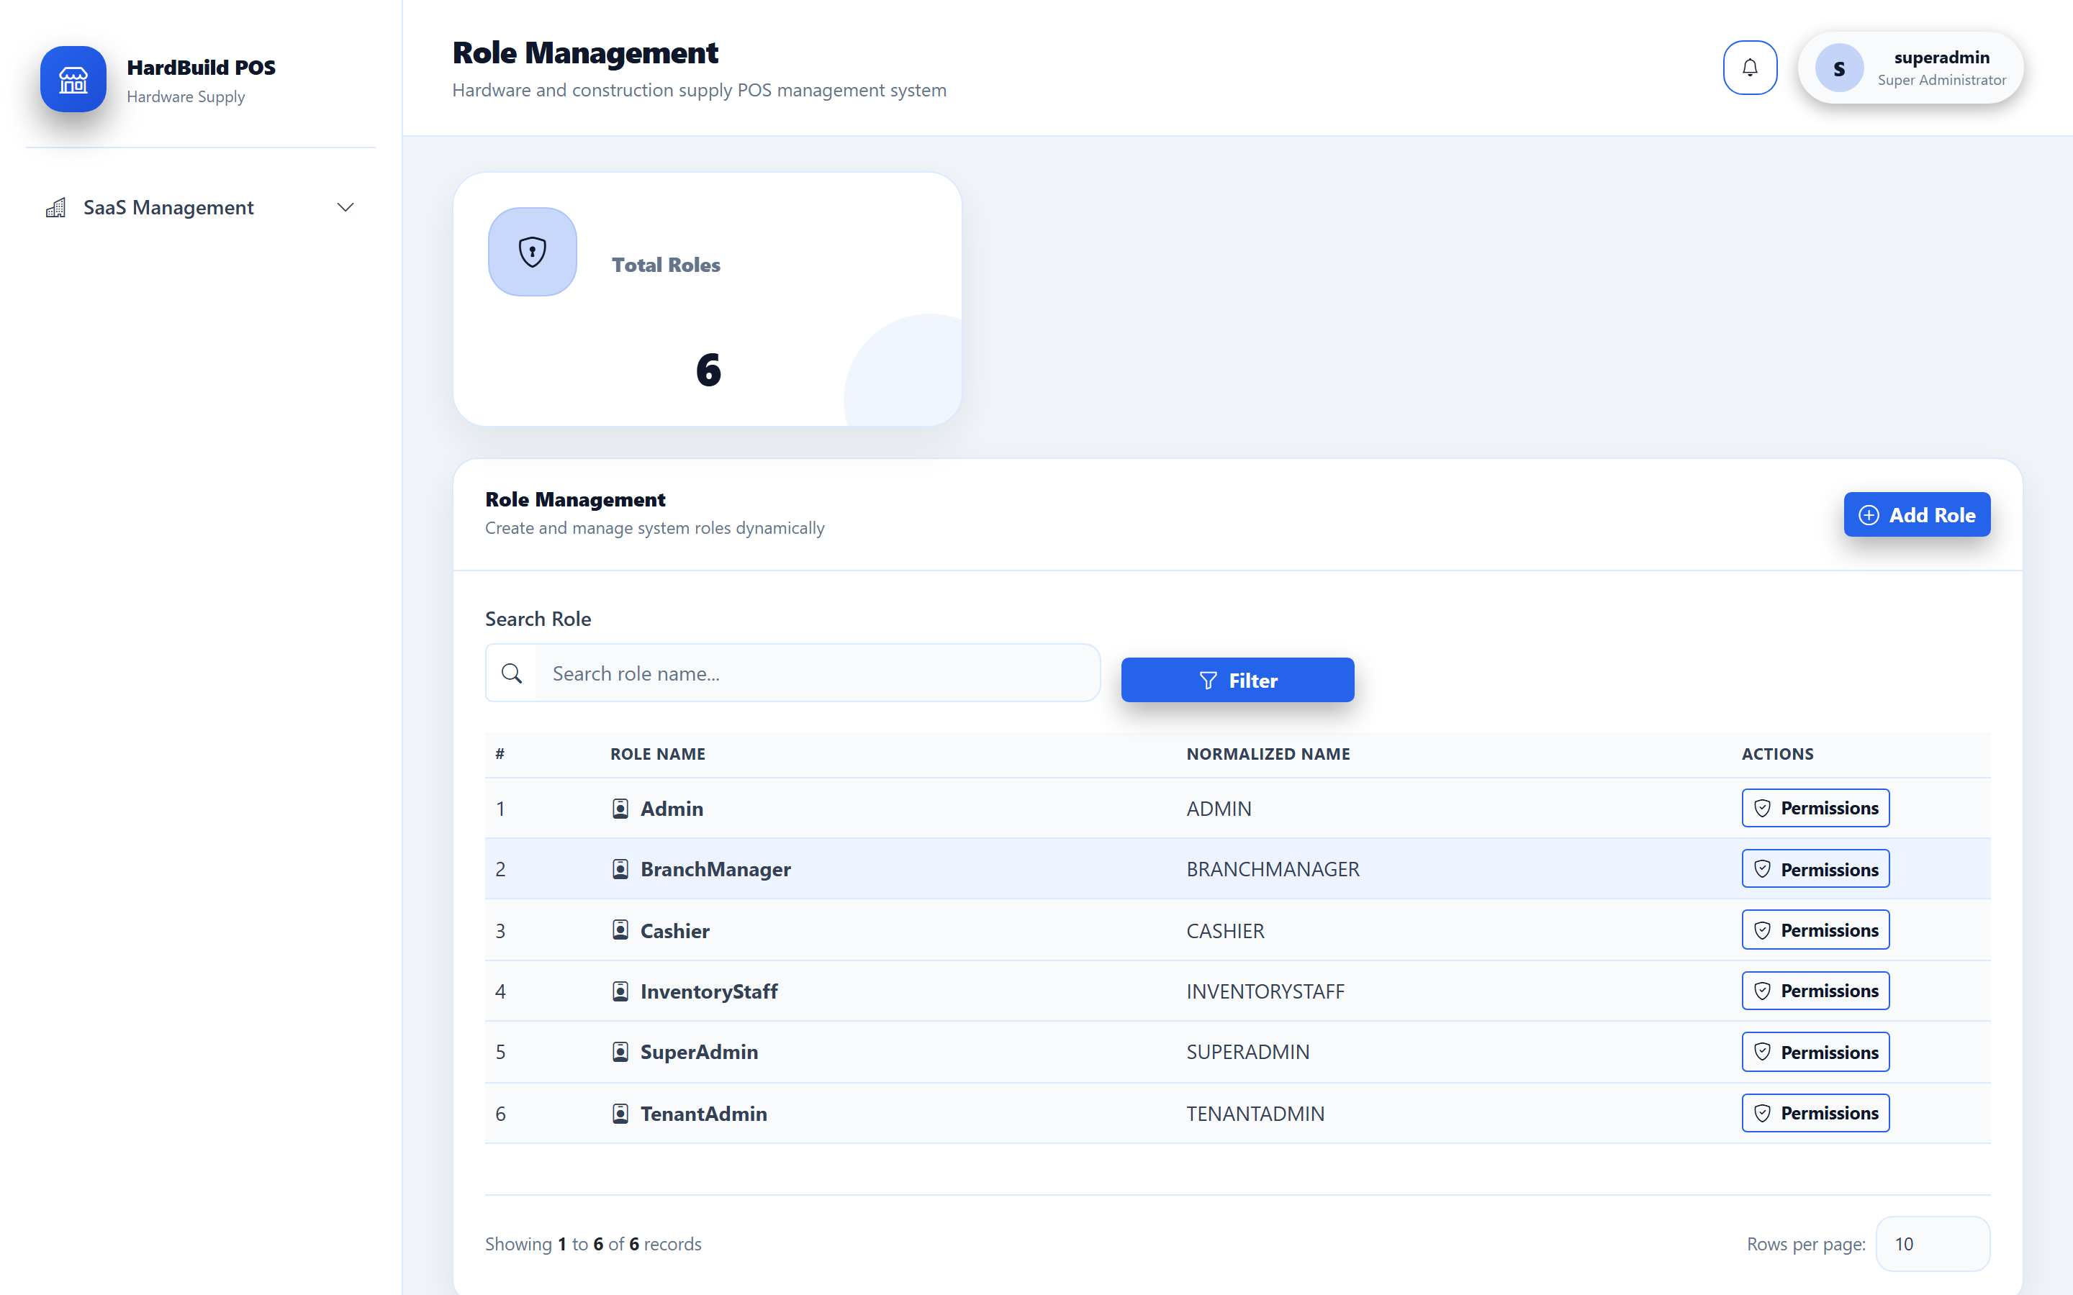
Figure 7: Roles and module permissions — access control per role.
Warning: The Cashier role is intentionally limited. Grant only the modules a cashier needs (POS, Sales) to keep least-privilege access.

10. Dedicated Database Provisioning
Purpose. Create a dedicated operational database for a tenant that has outgrown shared mode.
- Open the tenant’s Details page and locate the dedicated-database panel.
- Switch the tenant’s database mode to Dedicated.
- Click Provision. The platform creates the tenant’s database, applies the operational schema (migrations), and seeds minimal required data.
- Click Test Connection to confirm the new database is reachable.

Figure 8: Dedicated-database panel — provisioning, connection test, migration, and routing controls.
Note: Provisioning only creates and prepares the database. It does NOT move existing data or send traffic to it yet — those are separate, deliberate steps (Migration and Routing).

Warning: Provisioning is a one-time setup per tenant. If a dedicated database already exists for the tenant, the platform will not overwrite it.

11. Database Migration
Purpose. Copy the tenant’s existing operational data from the shared database into its newly provisioned dedicated database.
- Confirm the tenant is provisioned and the connection test passes.
- On the tenant’s Details page, click Migrate Data.
- Wait for the migration to complete and review the reported row counts.
- Open Database Diagnostics to verify record counts match expectations.
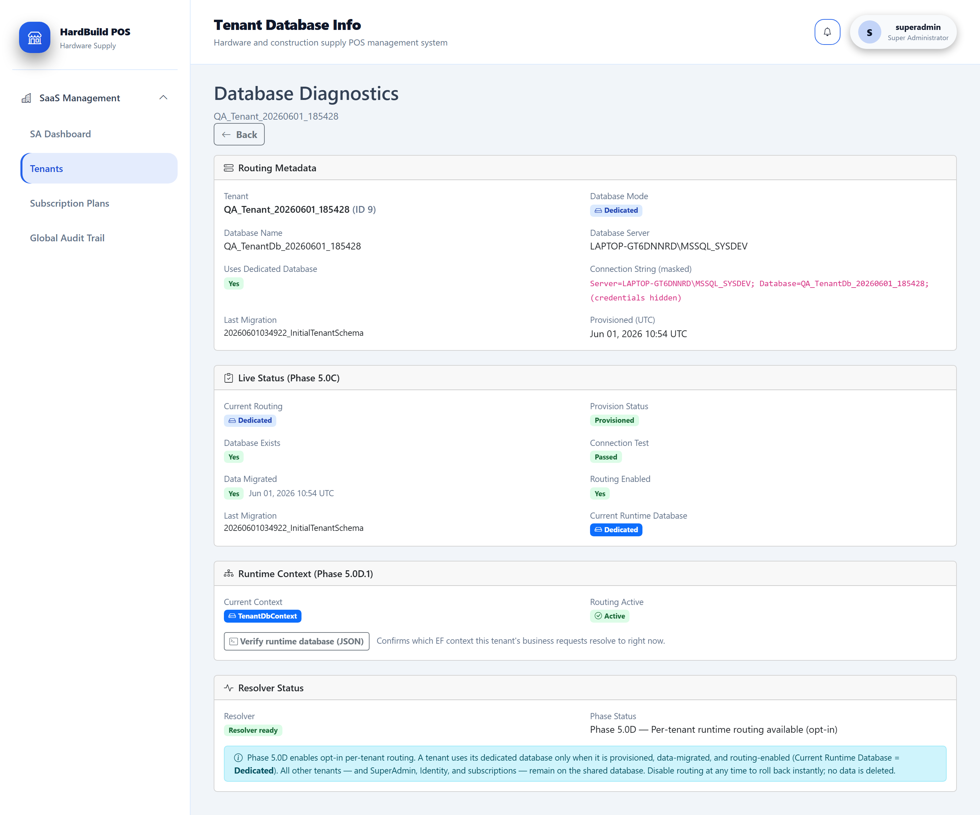
Figure 9: Database Diagnostics — used to confirm migrated record counts and database health.
Warning: Run migration during a quiet period. Avoid letting the tenant create new sales while data is being copied to prevent split records.

12. Routing Enable / Disable
Purpose. Switch a tenant’s live operational traffic to (or away from) its dedicated database.
- Confirm provisioning and migration are complete and verified.
- On the tenant’s Details page, click Enable Routing.
- Ask the tenant to sign in and confirm their data is present and correct.
- To revert, click Disable Routing (see Rollback Procedure).

Figure 10: Routing controls — enable or disable dedicated-database routing for the tenant.
Note: Routing only takes effect when every required flag is satisfied: mode is Dedicated, the database is provisioned, data is migrated, routing is enabled, and a connection string is resolved.

13. Rollback Procedure
Purpose. Safely return a tenant to the shared database if an issue is found after routing is enabled.
- Open the tenant’s Details page.
- Click Disable Routing. The tenant immediately resumes using the shared database.
- Confirm the tenant can sign in and see their pre-migration data.
- Investigate the dedicated database issue before attempting routing again.
Warning: Rollback is non-destructive: disabling routing reverts the tenant to the shared database and the dedicated database is retained. Data created in the dedicated database while routed will not appear in the shared database after rollback — reconcile before re-enabling.

Tip: Because rollback is instant and safe, prefer enabling routing early in the day so you have a full business day to validate and, if needed, roll back.

14. Diagnostics Page
Purpose. Inspect a tenant’s database mode, routing state, connectivity, and record counts in one place.
- Open the tenant’s Details page and click Database Info / Diagnostics.
- Review the active mode, routing flags, and connection status.
- Compare record counts against the shared database after a migration.

Figure 11: Database Diagnostics — mode, routing flags, connectivity, and record counts.
Note: Connection strings shown here are masked: only the server and database name are displayed and credentials are never exposed.

15. Audit Monitoring
Purpose. Review who did what across the platform for security and support.
- Open SaaS Management → Global Audit Trail.
- Filter by user, action, module, or date range.
- Open an entry to see the details of the recorded change.
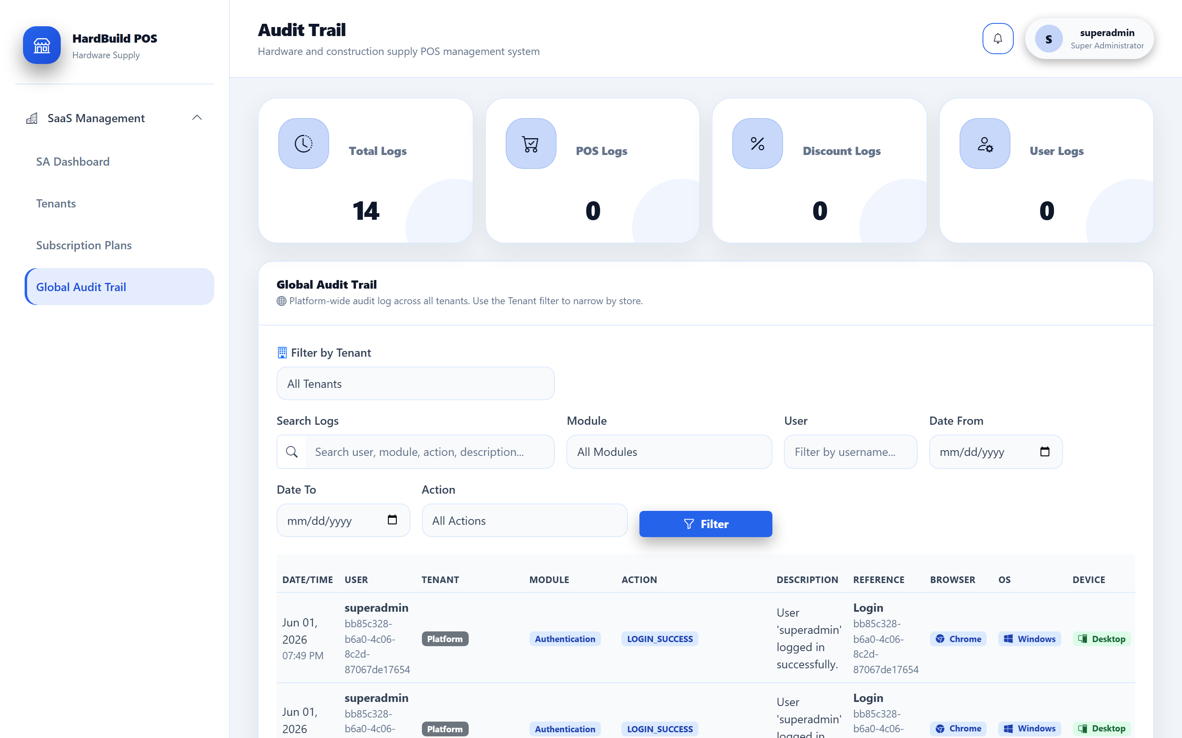
Figure 12: Global Audit Trail — platform-wide record of user actions.
Tip: Use the audit trail first when investigating a support ticket — it usually shows exactly which action and user caused the reported state.

16. Backup Procedures
Purpose. Protect both platform and tenant data, plus uploaded files, with regular backups.
- Shared platform database — back up on a fixed schedule; it contains identity, tenant metadata, plans, audit, and all Shared-mode tenant data.
- Each dedicated tenant database — back up on the same schedule; one catalog per dedicated tenant.
- Uploaded files — back up the logos folder under wwwroot/uploads/logos/ (tenant logos are stored on the filesystem, not in the database).
- Schedule full backups of the shared database and every dedicated database.
- Include the wwwroot/uploads/logos/ directory in the file backup job.
- Store backups off the application server and verify them regularly.
Note: Refer to the internal Backup and Restore Guide for SQL Server commands and retention recommendations.

17. Restore Procedures
Purpose. Recover platform or tenant data after loss or corruption.
- Identify the affected scope (shared database, a single dedicated database, or uploaded files).
- Restore the most recent verified backup for that scope.
- Restore the matching logos folder if files were affected.
- Run Database Diagnostics for affected tenants to confirm record counts and connectivity.
Warning: Restoring the shared database affects every Shared-mode tenant. Schedule a maintenance window and notify customers before a platform-wide restore.

18. QA Runner Usage
Purpose. Validate the tenant lifecycle (provision → migrate → route → operate) automatically before and after releases.
- Stop the running web application.
- From the project folder run the end-to-end QA runner with the appropriate flag (for example: dotnet run -- --qa-phase50d2).
- Watch the console for the pass/fail summary and review created QA_ records.
- Use the runner’s cleanup option to remove QA_ test data when finished.
Note: QA runners are Development-only utilities. They never start the web server and they tag all test data with a QA_ prefix so it is easy to identify and remove.

Warning: Never run QA runners against a production database.

19. Troubleshooting
Purpose. Resolve the most common operational issues quickly.
- Tenant cannot sign in — confirm the tenant is Active (not Suspended) and the user account is active.
- Routing has no effect — verify all flags: Dedicated mode, Provisioned, Data migrated, Routing enabled, and a resolvable connection string.
- Migration row counts look wrong — re-run Database Diagnostics; ensure no new sales were created mid-migration.
- Logo not displaying — confirm the file exists under wwwroot/uploads/logos/ and is within the 2 MB size limit.
- Page returns Not Found — navigate using the in-app menus; deep links require an explicit page action.
Tip: Start every investigation with the Global Audit Trail and the tenant’s Database Diagnostics page — together they explain most reported issues.

20. Go-Live Checklist
Purpose. Confirm the platform is ready before onboarding the first paying customer.
- Default superadmin password has been rotated to a strong, unique value.
- Subscription plans are defined and assigned correctly.
- Backups are scheduled and a test restore has been verified.
- HTTPS, security headers, and rate limiting are confirmed active.
- QA runner passes end-to-end on a staging environment.
- Pilot tenant has been provisioned, migrated, routed, and validated.
- Rollback (Disable Routing) has been rehearsed and confirmed instant.
- Operations team has access to this manual and the internal release guides.
Warning: Do not skip rotating the default superadmin password. This is a mandatory pre-go-live security action.

