HARDWARE SUPPLY POS
Cloud Point-of-Sale & Inventory Platform

Tenant Admin Manual
Store Owner & Administrator Guide

Version | 1.0
Audience | Store Owner / Tenant Administrator
Classification | Customer Documentation
Release date | Version 1.0 – General Availability

Table of Contents

If the contents above appear empty, right-click and choose “Update Field”.

1. Introduction
Purpose. This guide helps the store owner or administrator set up and run their Hardware Supply POS account: configuring the business, managing branches and staff, maintaining products and inventory, selling, and reading reports.
Hardware Supply POS is an online point-of-sale and inventory system built for hardware and construction-supply stores. Your data is private to your business.
Tip: Work through this manual in order the first time. Setting up Settings, Branches, Categories, Units, and Products first makes selling and reporting accurate from day one.

2. Login
Purpose. Sign in securely to your account.
- Open your store’s Hardware Supply POS web address.
- Enter your username and password.
- Click Sign In.
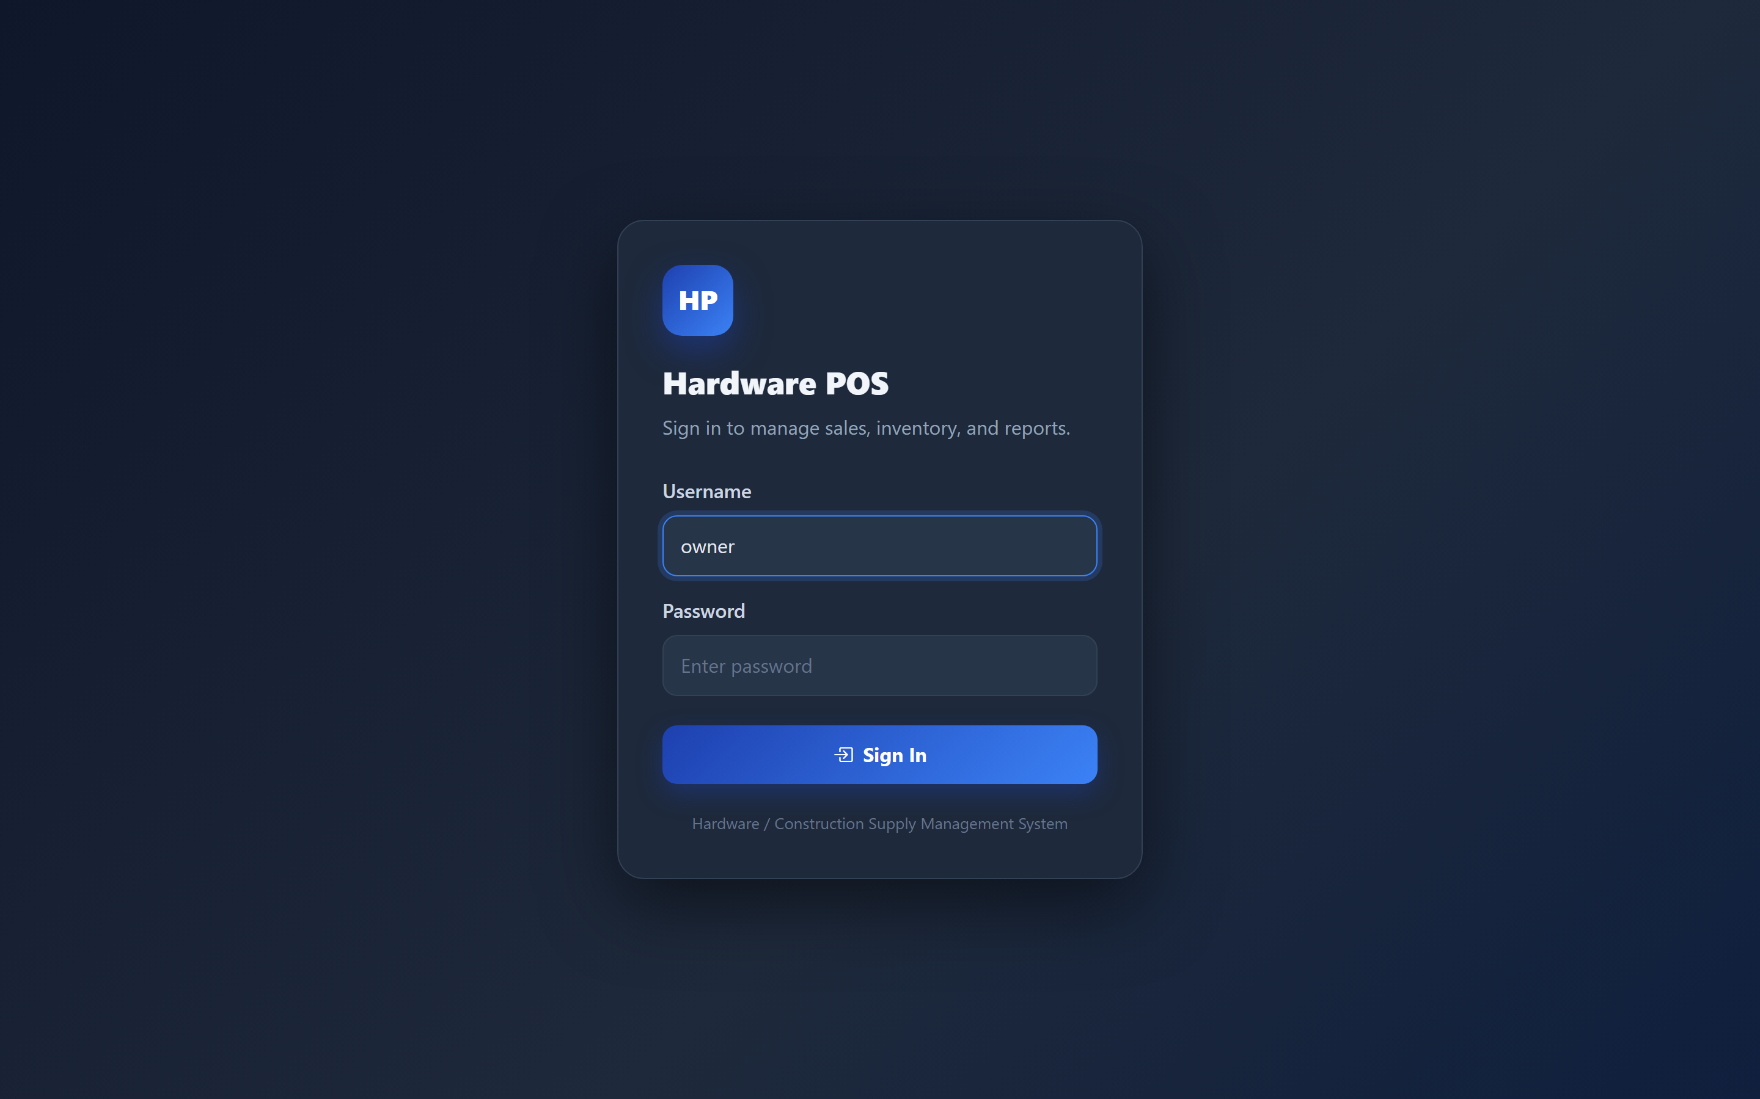
Figure 1: Login screen — sign in with your username and password.
Expected result. You are signed in and taken to your Dashboard.
Note: If you mistype your password several times the account is temporarily locked for security. Wait a few minutes and try again, or ask your administrator to reset it.

3. Dashboard
Purpose. See the health of your business at a glance.
- Sign in to land on the Dashboard.
- Review the summary cards and charts (sales, stock alerts, and key figures).
- Use the left menu to open any module.
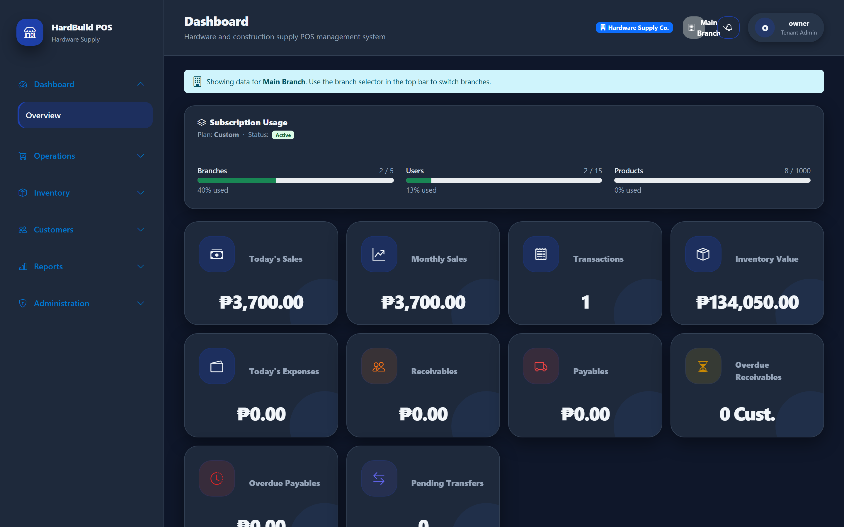
Figure 2: Tenant Dashboard — sales, inventory, and business KPIs.
Expected result. You see live totals for your selected branch and quick access to every module.

4. Settings
Purpose. Configure how the system behaves for your business.
- Open Administration → Settings.
- Set your currency, tax mode and VAT percentage, and receipt options.
- Save your changes.
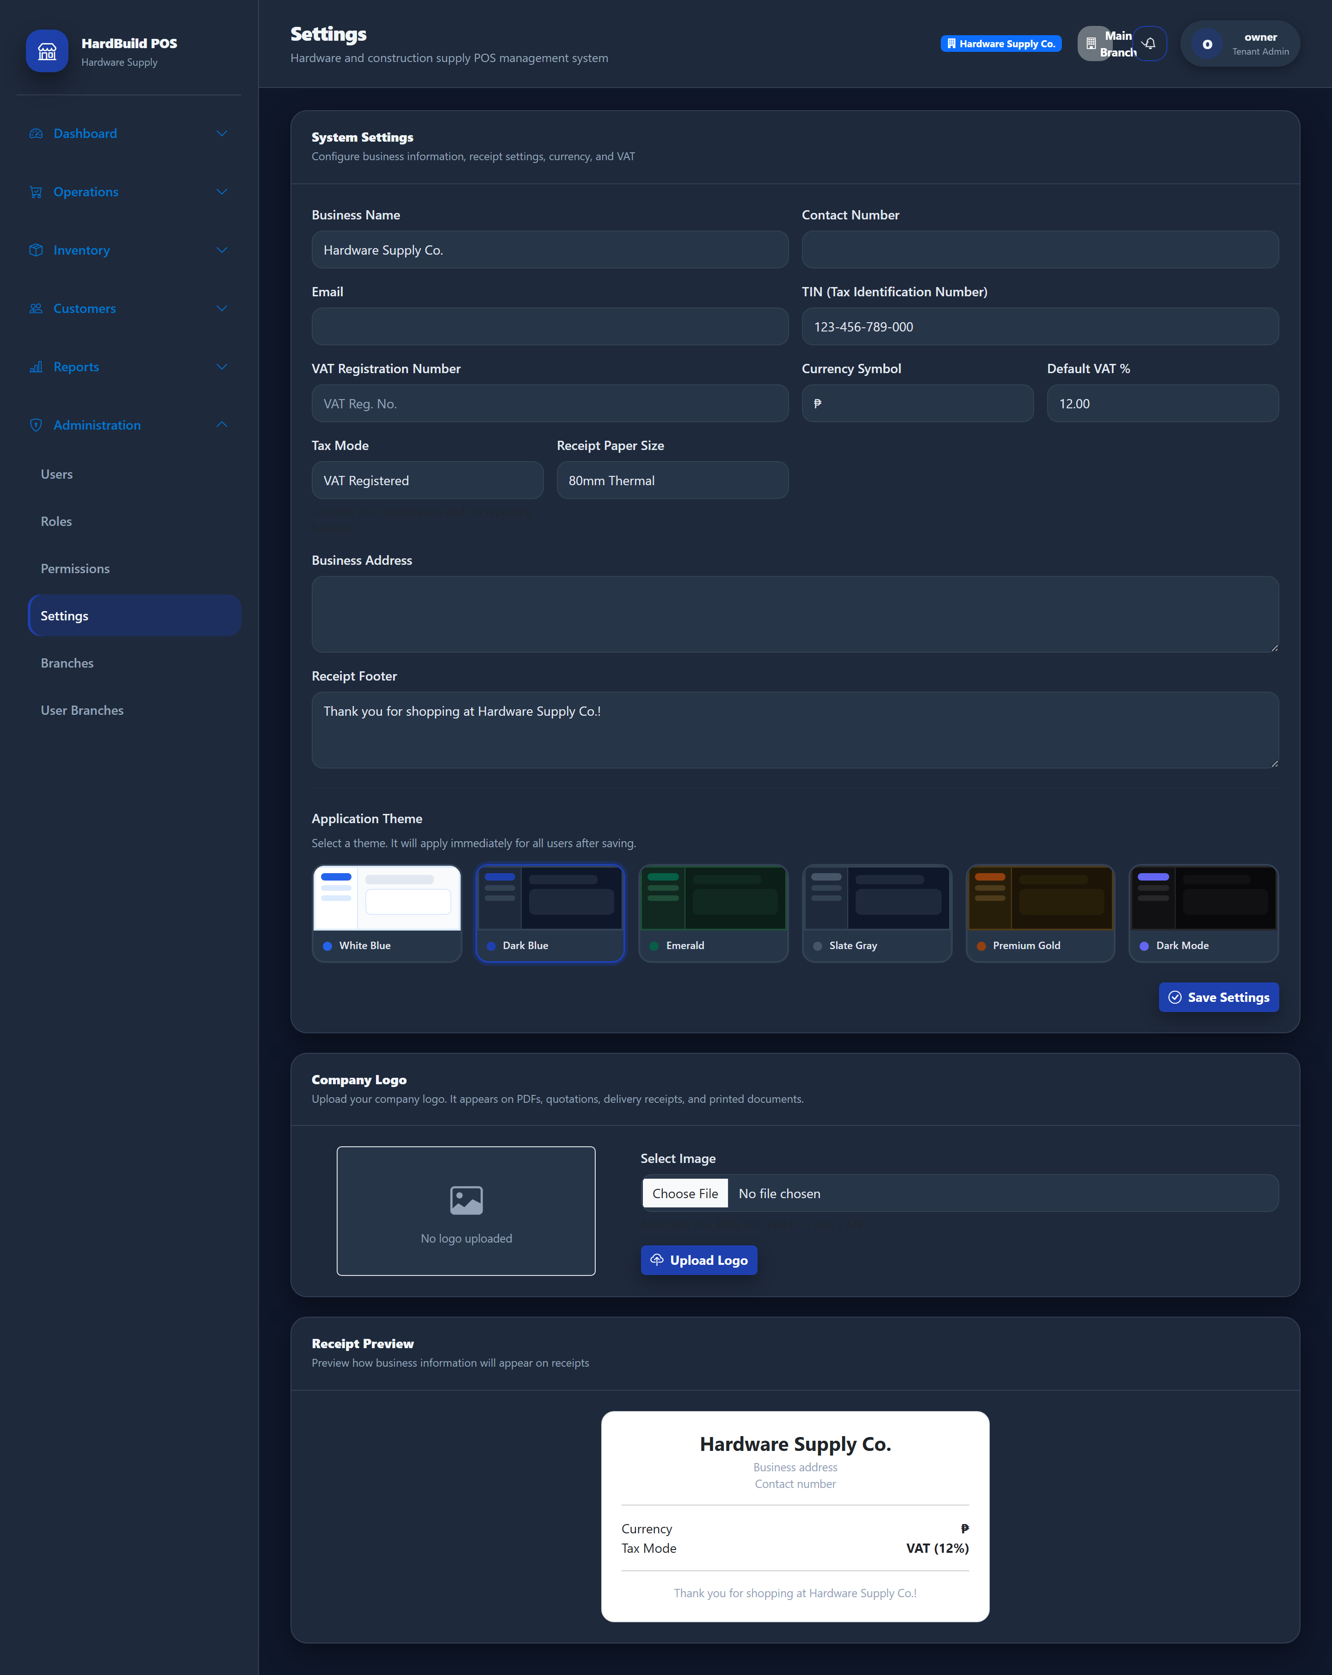
Figure 3: Settings — business profile, tax, currency, and receipt options.
Expected result. Your preferences apply across POS, receipts, and reports.
Note: The VAT percentage you set here is used to calculate tax on the POS and on receipts.

5. Business Profile
Purpose. Record your business identity for receipts and reports.
- Open Administration → Settings.
- Enter your business name, tax identification number (TIN), and contact details.
- Enter the receipt footer message customers will see.
- Save.

Figure 4: Business Profile — business name, TIN, and receipt footer.
Expected result. Your business details appear on printed receipts and documents.

6. Logo Upload
Purpose. Add your store logo to brand the system and receipts.
- Open Administration → Settings.
- Use the logo upload control to select an image from your computer.
- Save. The logo is stored securely for your business only.

Figure 5: Logo upload — brand the system with your store logo.
Expected result. Your logo appears in the application and on documents.
Warning: Logo files must be 2 MB or smaller. Use a PNG or JPG for best results.

7. Branch Management
Purpose. Set up and maintain your store branches.
- Open Inventory → (Branches) or the Branches menu.
- Add each branch with its name, code, address, and contact.
- Mark your primary location as the Main Branch.
- Keep inactive branches deactivated rather than deleting them.
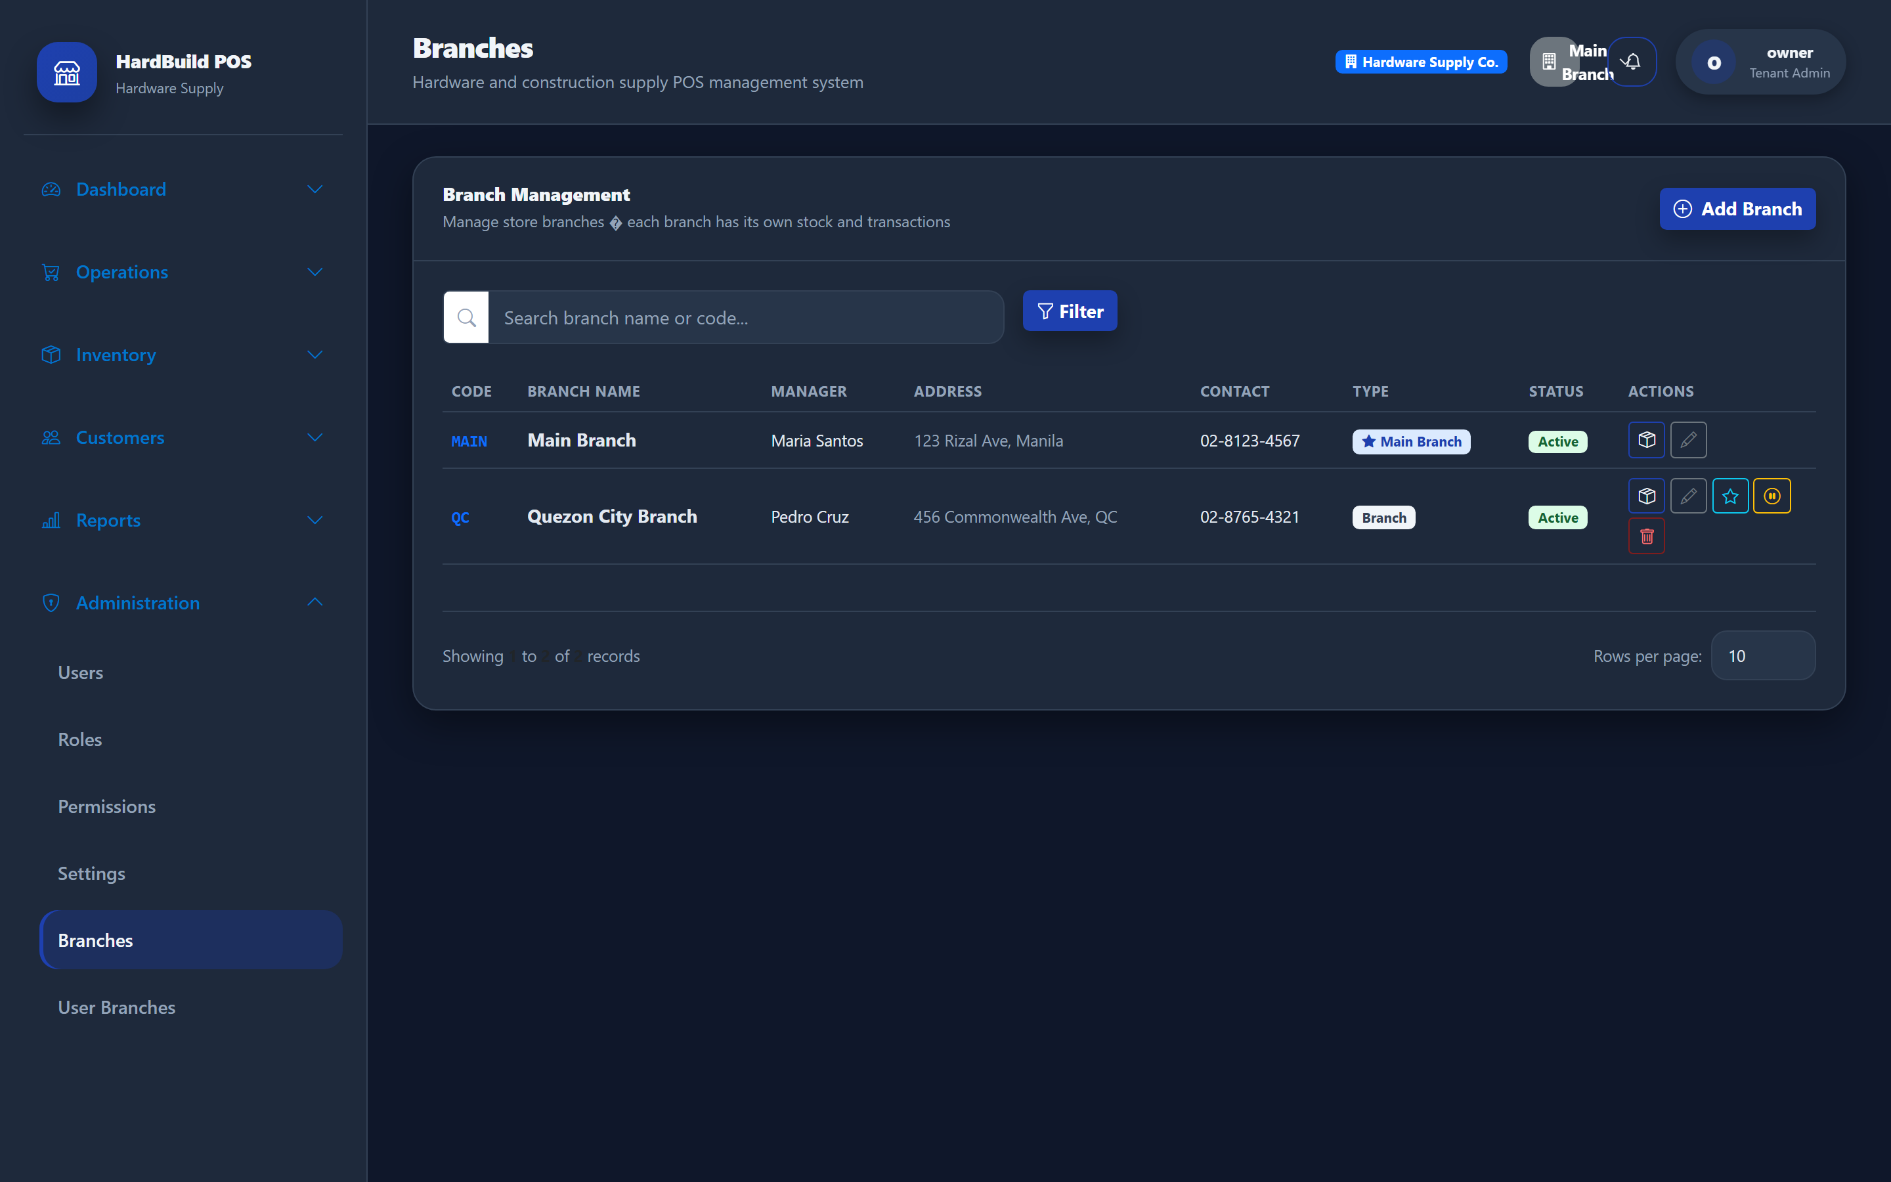
Figure 6: Branches — manage all store locations.
Expected result. Each branch can hold its own stock and process its own sales.

8. User Management
Purpose. Create staff accounts and assign them to branches.
- Open Administration → User Branches (user assignments).
- Assign each staff member to the branch(es) they work in.
- Confirm each user has the correct role (for example Cashier or Branch Manager).
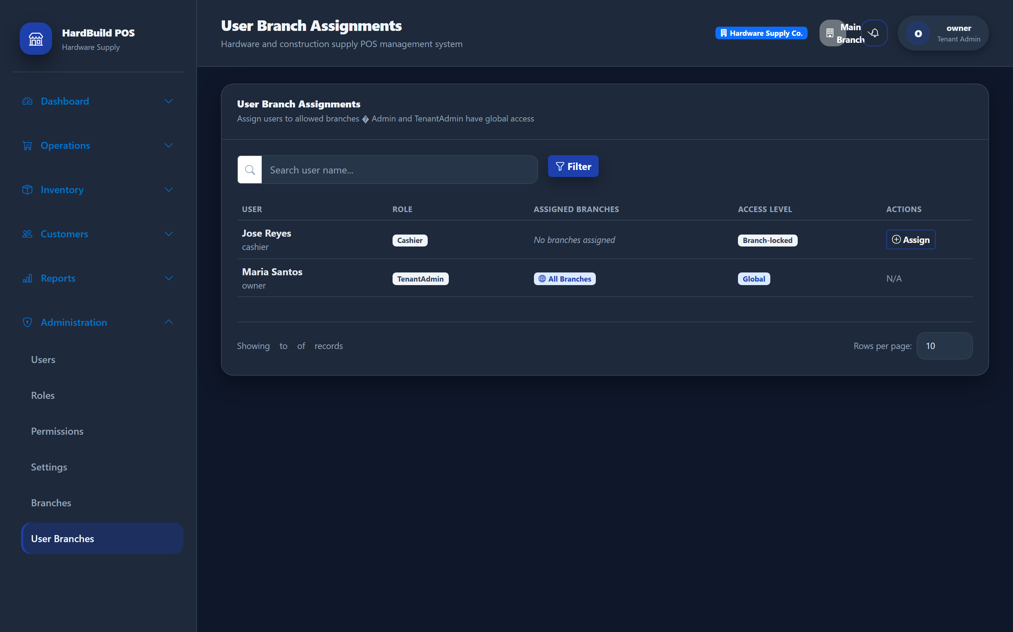
Figure 7: User–branch assignments — control which staff work in which branch.
Expected result. Staff only see and act on the branches assigned to them.
Tip: Give each employee their own account. Shared logins make the audit trail and cashier reports unreliable.

9. Categories
Purpose. Group products for easier management and reporting.
- Open Inventory → Categories.
- Add categories such as Power Tools, Plumbing, Electrical, and Fasteners.
- Save.
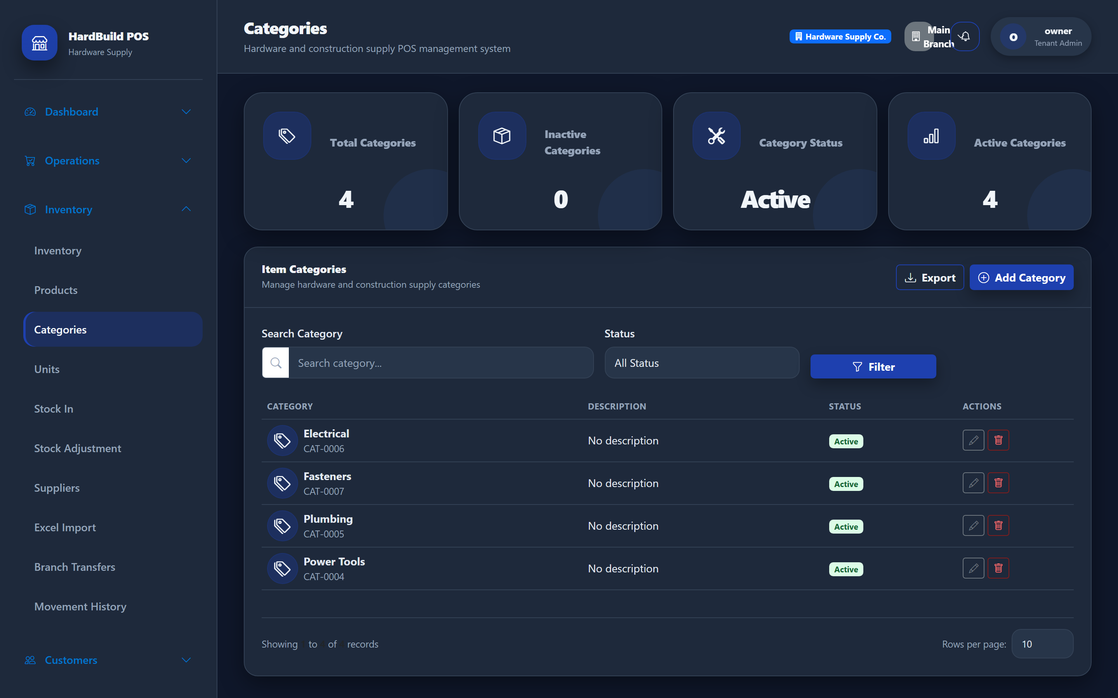
Figure 8: Categories — group products for filtering and reporting.
Expected result. Categories appear in product filters and inventory reports.

10. Units
Purpose. Define the units you sell products in.
- Open Inventory → Units.
- Add units such as Piece, Box, and Meter with short names.
- Save.
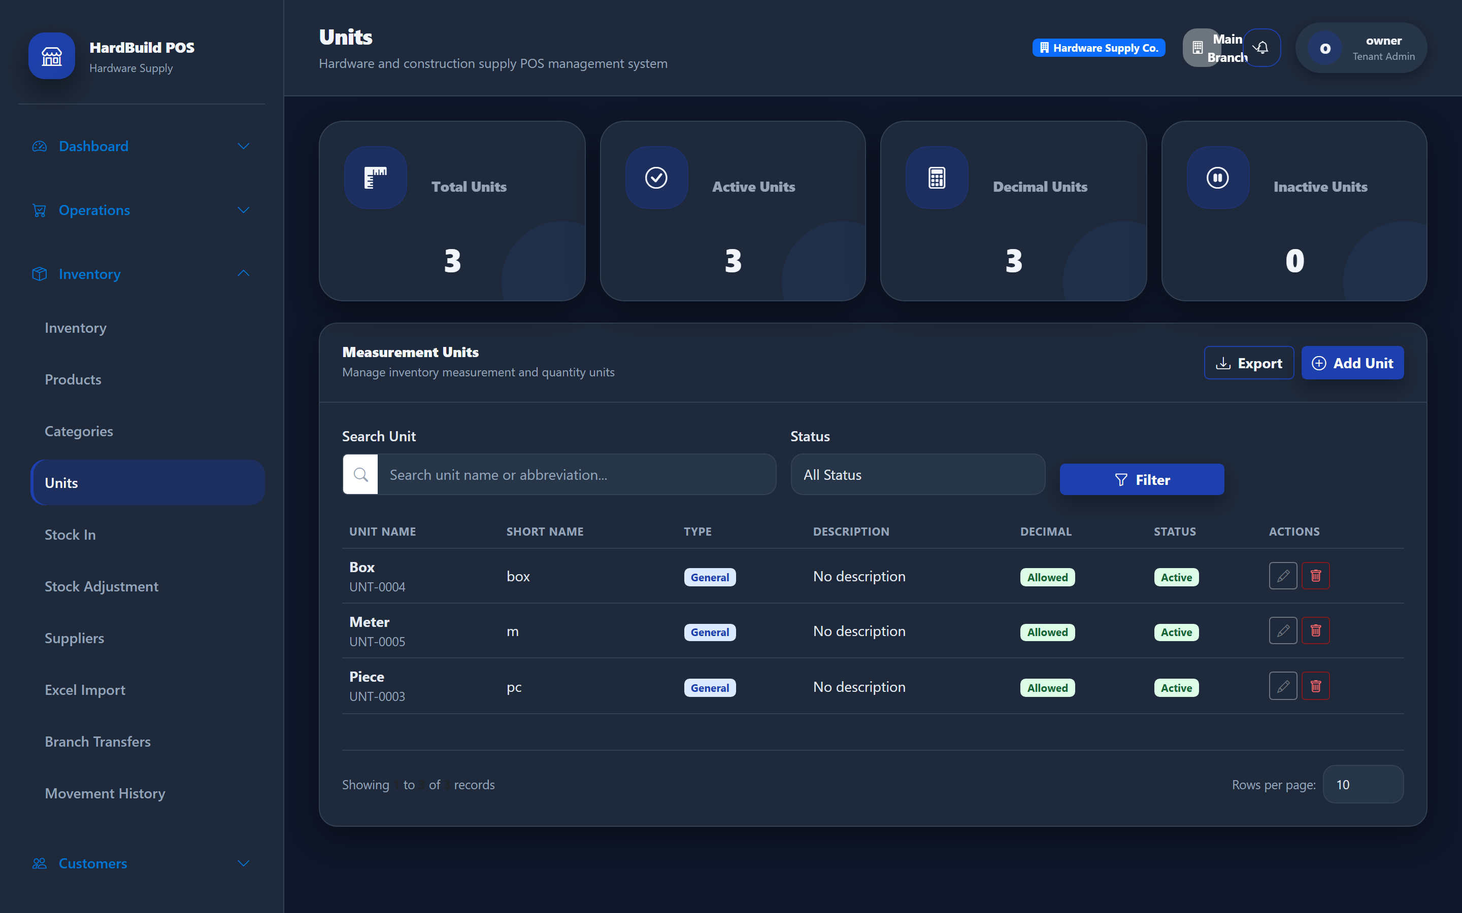
Figure 9: Units of measure — piece, box, meter, and more.
Expected result. Units are selectable when you create products and appear on receipts.

11. Products
Purpose. Maintain your product catalog — codes, prices, and stock levels.
- Open Inventory → Products.
- Click Add Product and enter the code, name, category, unit, and supplier.
- Set the cost price, selling price, and reorder level.
- Save.
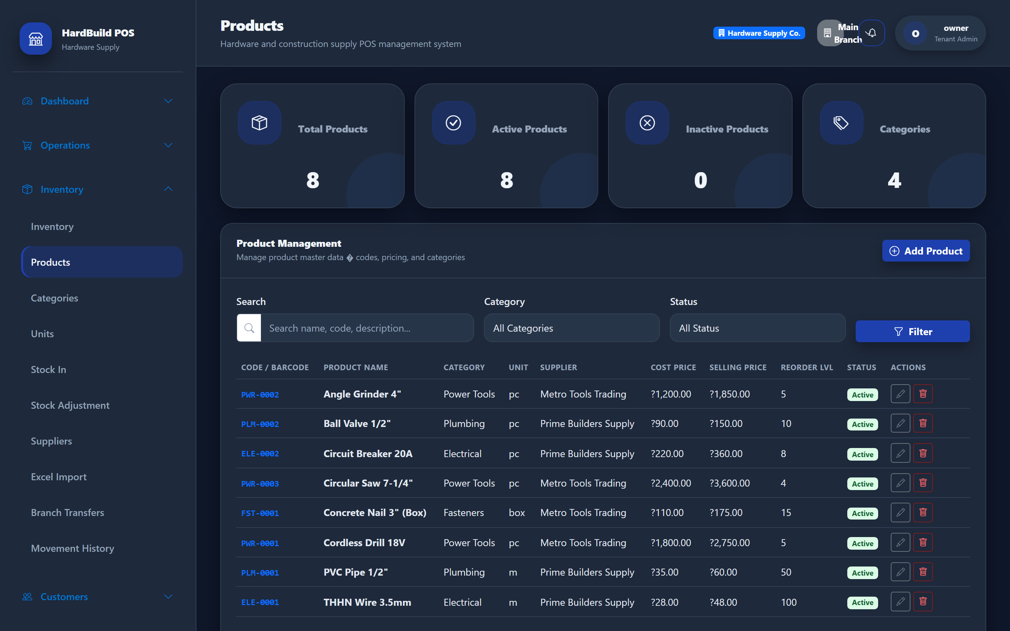
Figure 10: Products — catalog with codes, pricing, stock, and reorder levels.
Expected result. Products become available in POS and are tracked in inventory.
Tip: Set a sensible reorder level for each product so the system can warn you before you run out.

12. Inventory
Purpose. Monitor stock on hand across your branches.
- Open Inventory → Inventory.
- Review current stock levels and low-stock indicators.
- Use search and filters to find specific items.
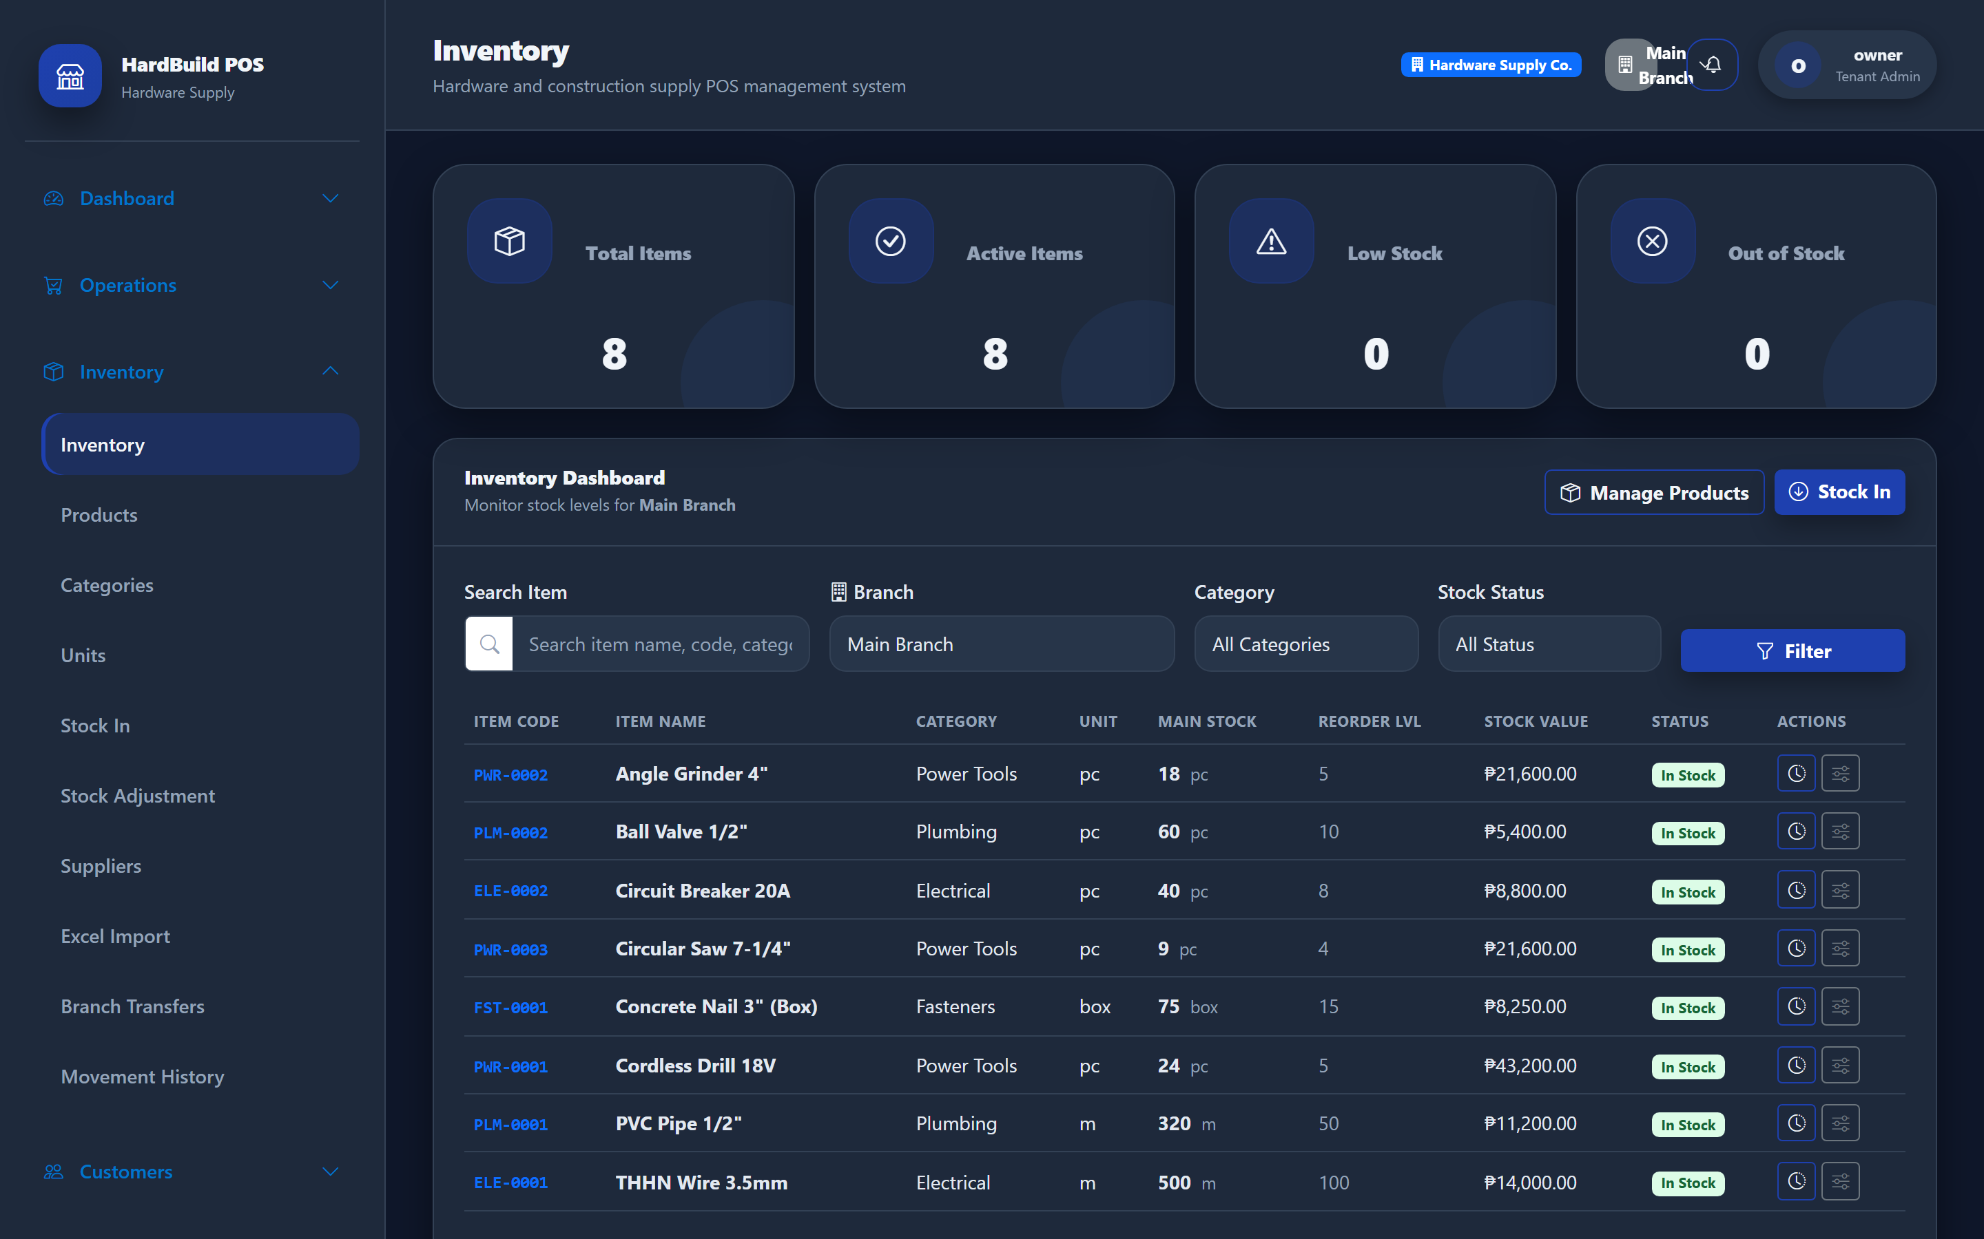
Figure 11: Inventory — stock on hand and low-stock indicators.
Expected result. You can see exactly what is in stock and what needs reordering.

13. Suppliers
Purpose. Keep records of the vendors you buy from.
- Open Inventory → Suppliers (or the Suppliers menu).
- Add each supplier’s name, contact person, and contact details.
- Save.
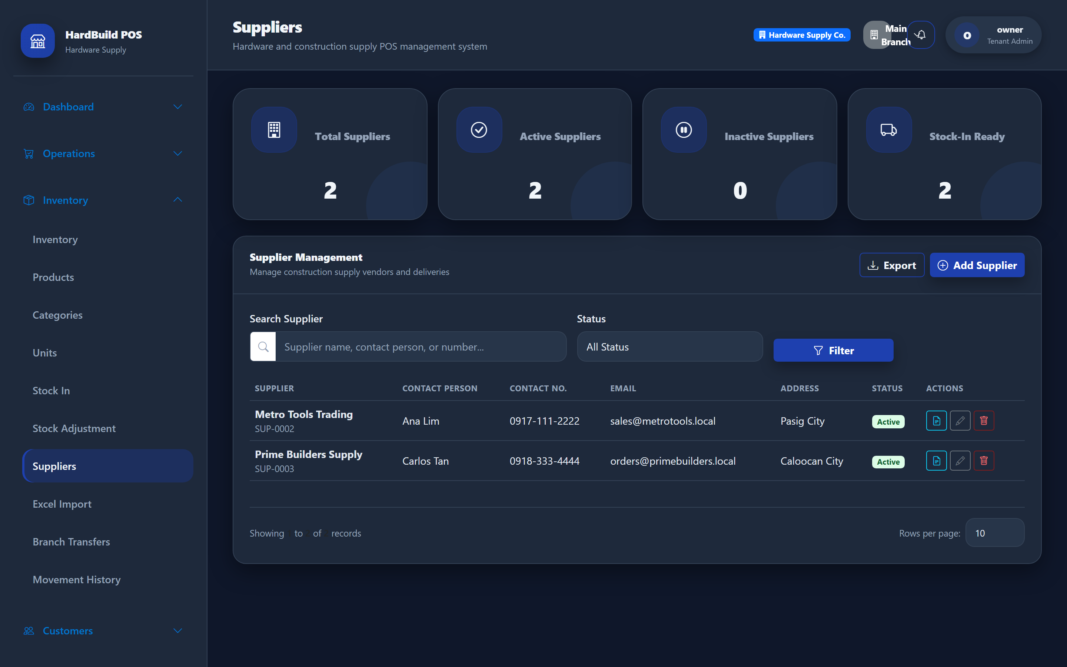
Figure 12: Suppliers — vendor records used in purchasing and payables.
Expected result. Suppliers can be linked to products, purchase orders, and payments.

14. Customers
Purpose. Maintain customer records for sales and credit.
- Open Customers → Customers.
- Add customers with their contact details and type (for example Regular or Walk-in).
- Save.
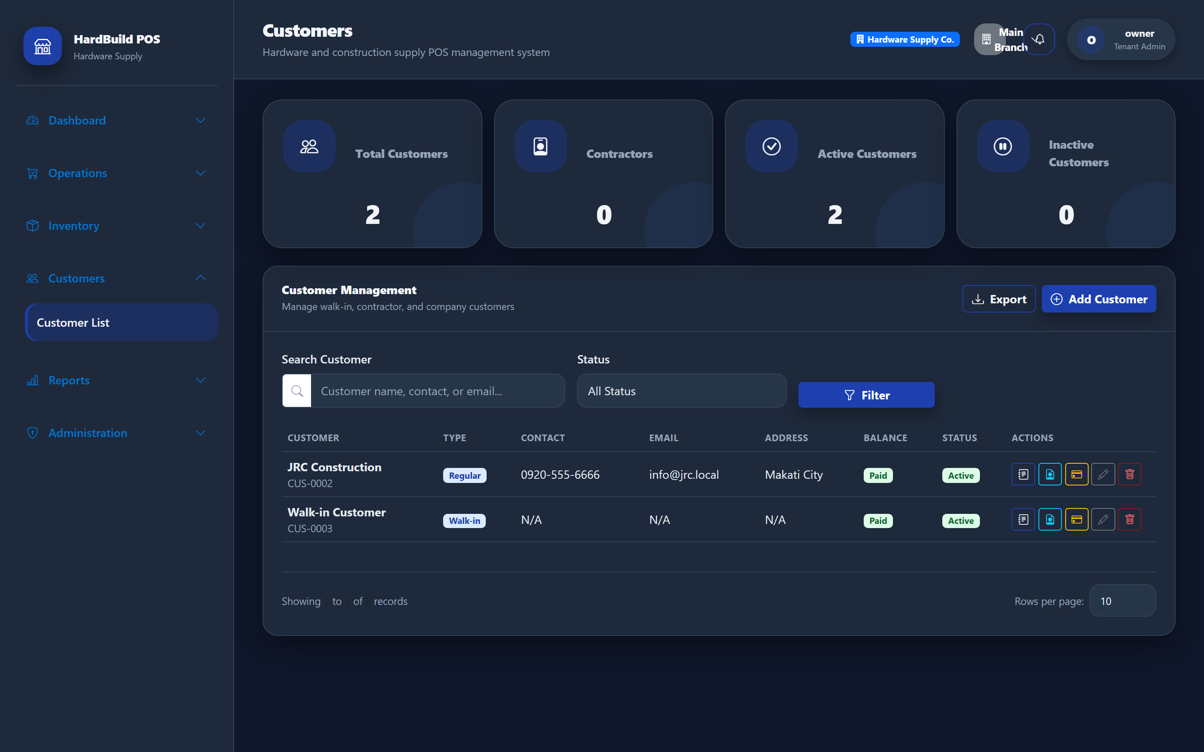
Figure 13: Customers — records used for sales, credit, and collections.
Expected result. Customers can be selected at the POS and tracked for balances.

15. Purchase Orders
Purpose. Order stock from your suppliers.
- Open Inventory → Purchase Orders.
- Create a new order, choose the supplier, and add the products and quantities.
- Save and send the order to your supplier.
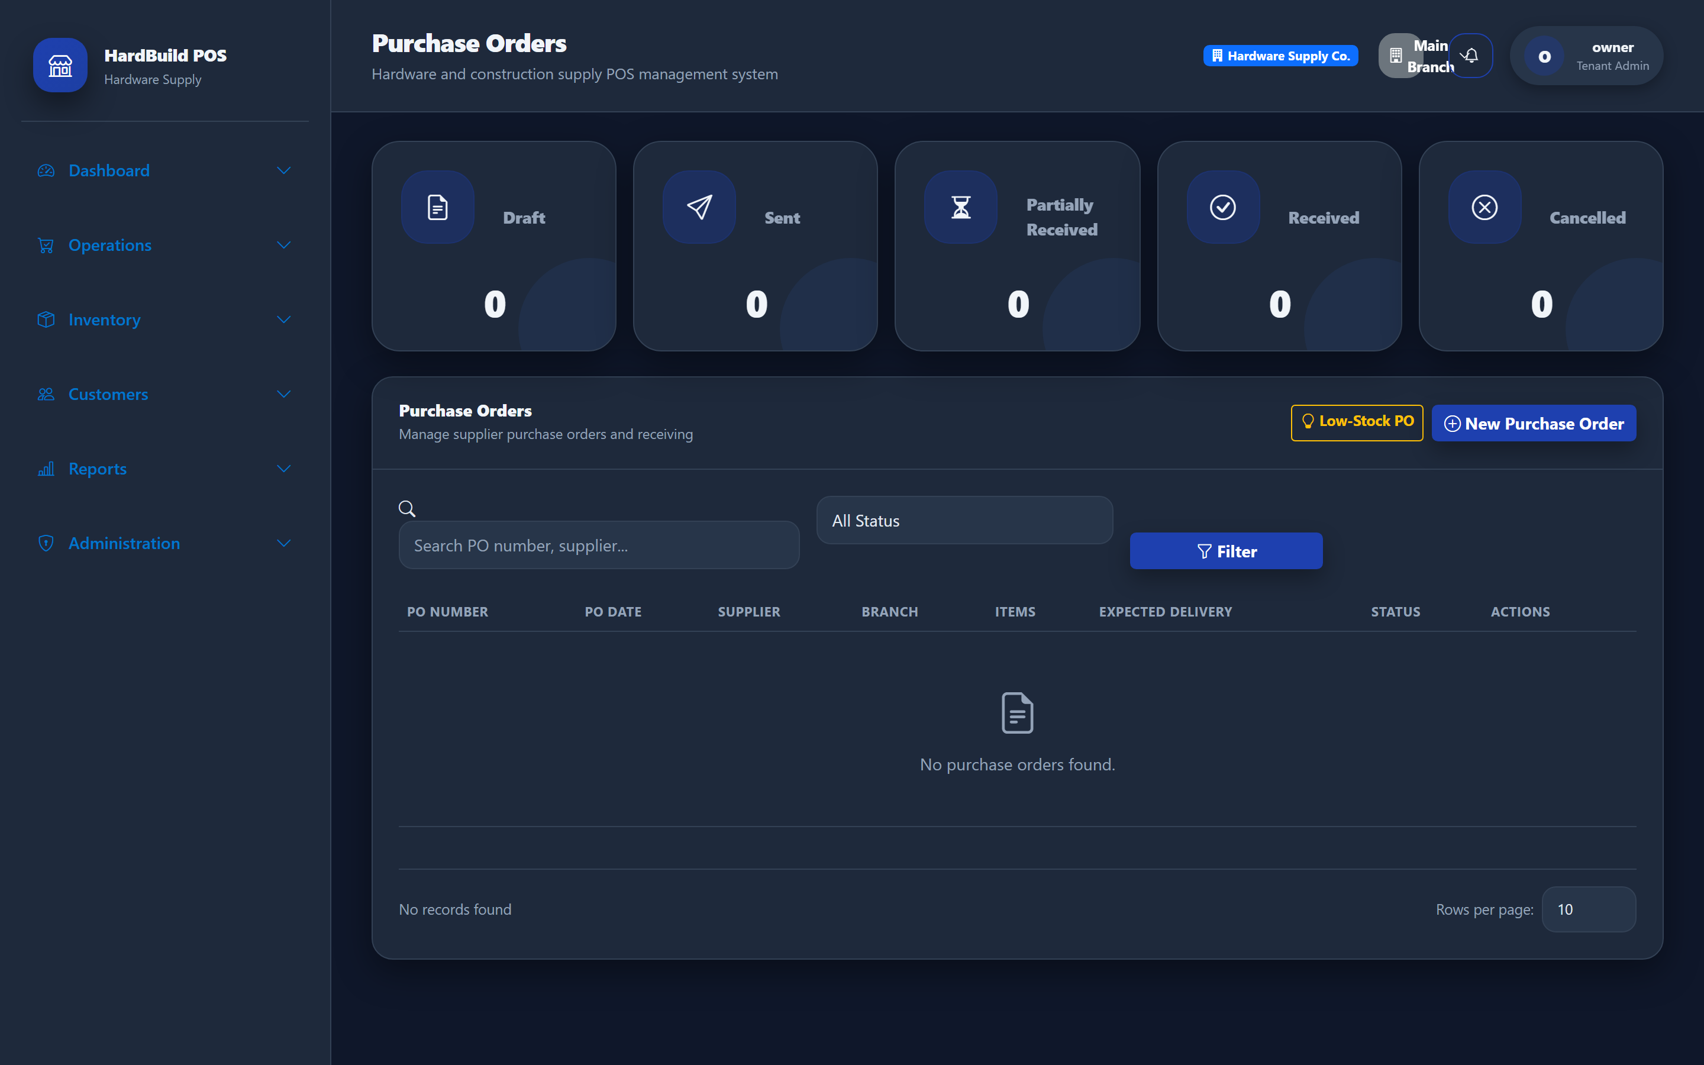
Figure 14: Purchase Orders — order stock from suppliers.
Expected result. Open purchase orders are tracked until the goods are received.

16. Receiving Inventory
Purpose. Record stock that arrives from suppliers (Stock In).
- Open Inventory → Stock In.
- Create a Stock In entry, selecting the supplier and (where applicable) the purchase order.
- Enter received quantities and costs.
- Save to increase stock at the receiving branch.
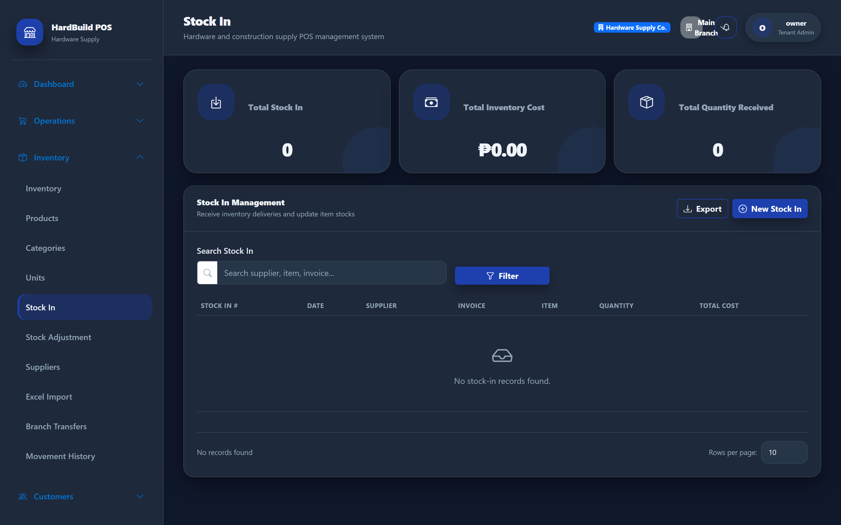
Figure 15: Stock In — record received goods and update stock.
Expected result. Stock levels increase and a payable to the supplier is recorded.

17. Stock Adjustments
Purpose. Correct stock for damage, loss, or count differences.
- Open Inventory → Stock Adjustment.
- Create an adjustment and choose the branch and items.
- Enter the corrected quantity and a reason.
- Save.
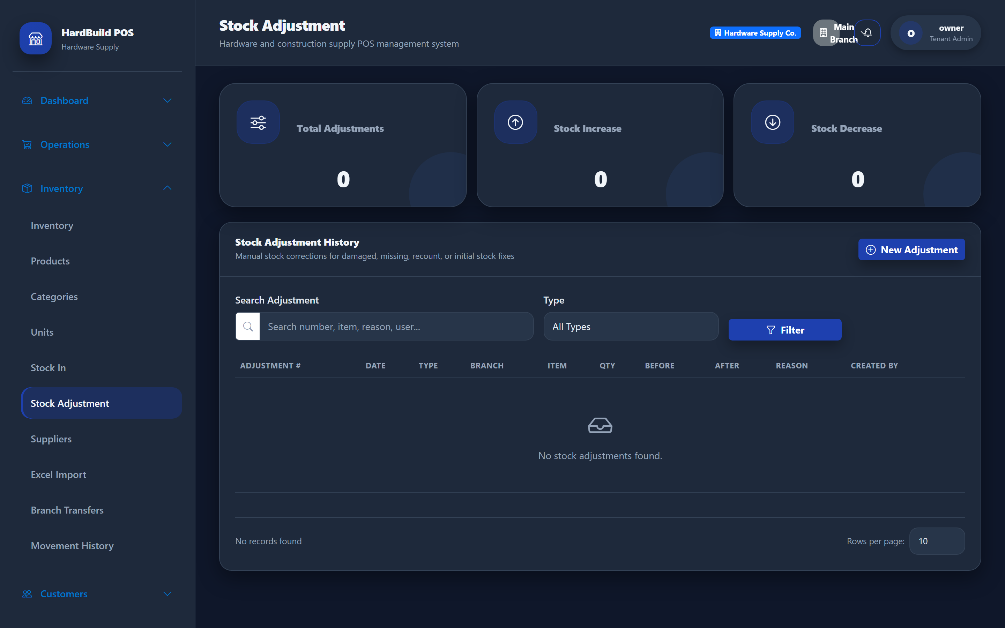
Figure 16: Stock Adjustment — correct stock with a reason for the change.
Expected result. Stock is corrected and the change is recorded for audit.
Warning: Always enter a clear reason for every adjustment. Adjustments change your stock value and are reviewed in reports.

18. Branch Transfers
Purpose. Move stock between your branches.
- Open Inventory → Branch Transfers.
- Create a transfer from the source branch to the destination branch.
- Add the items and quantities.
- Save and complete the transfer when goods arrive.
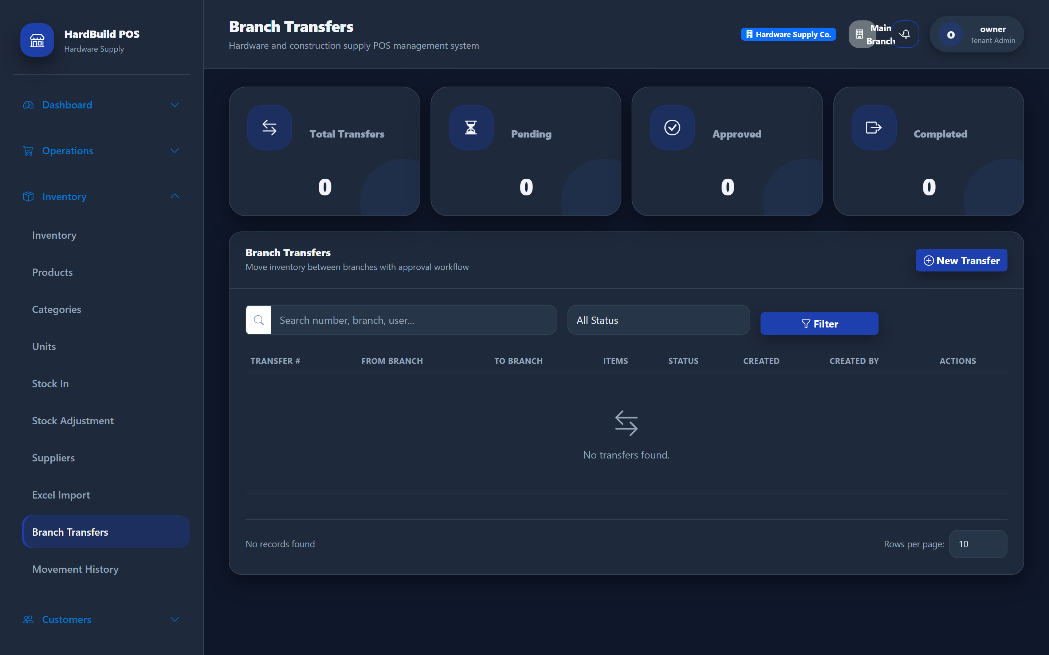
Figure 17: Branch Transfers — move stock between locations.
Expected result. Stock decreases at the source and increases at the destination branch.

19. Quotations
Purpose. Give customers a price quote before a sale.
- Open Operations → Quotations.
- Create a quotation, choose the customer, and add items and prices.
- Save and share the quotation with the customer.
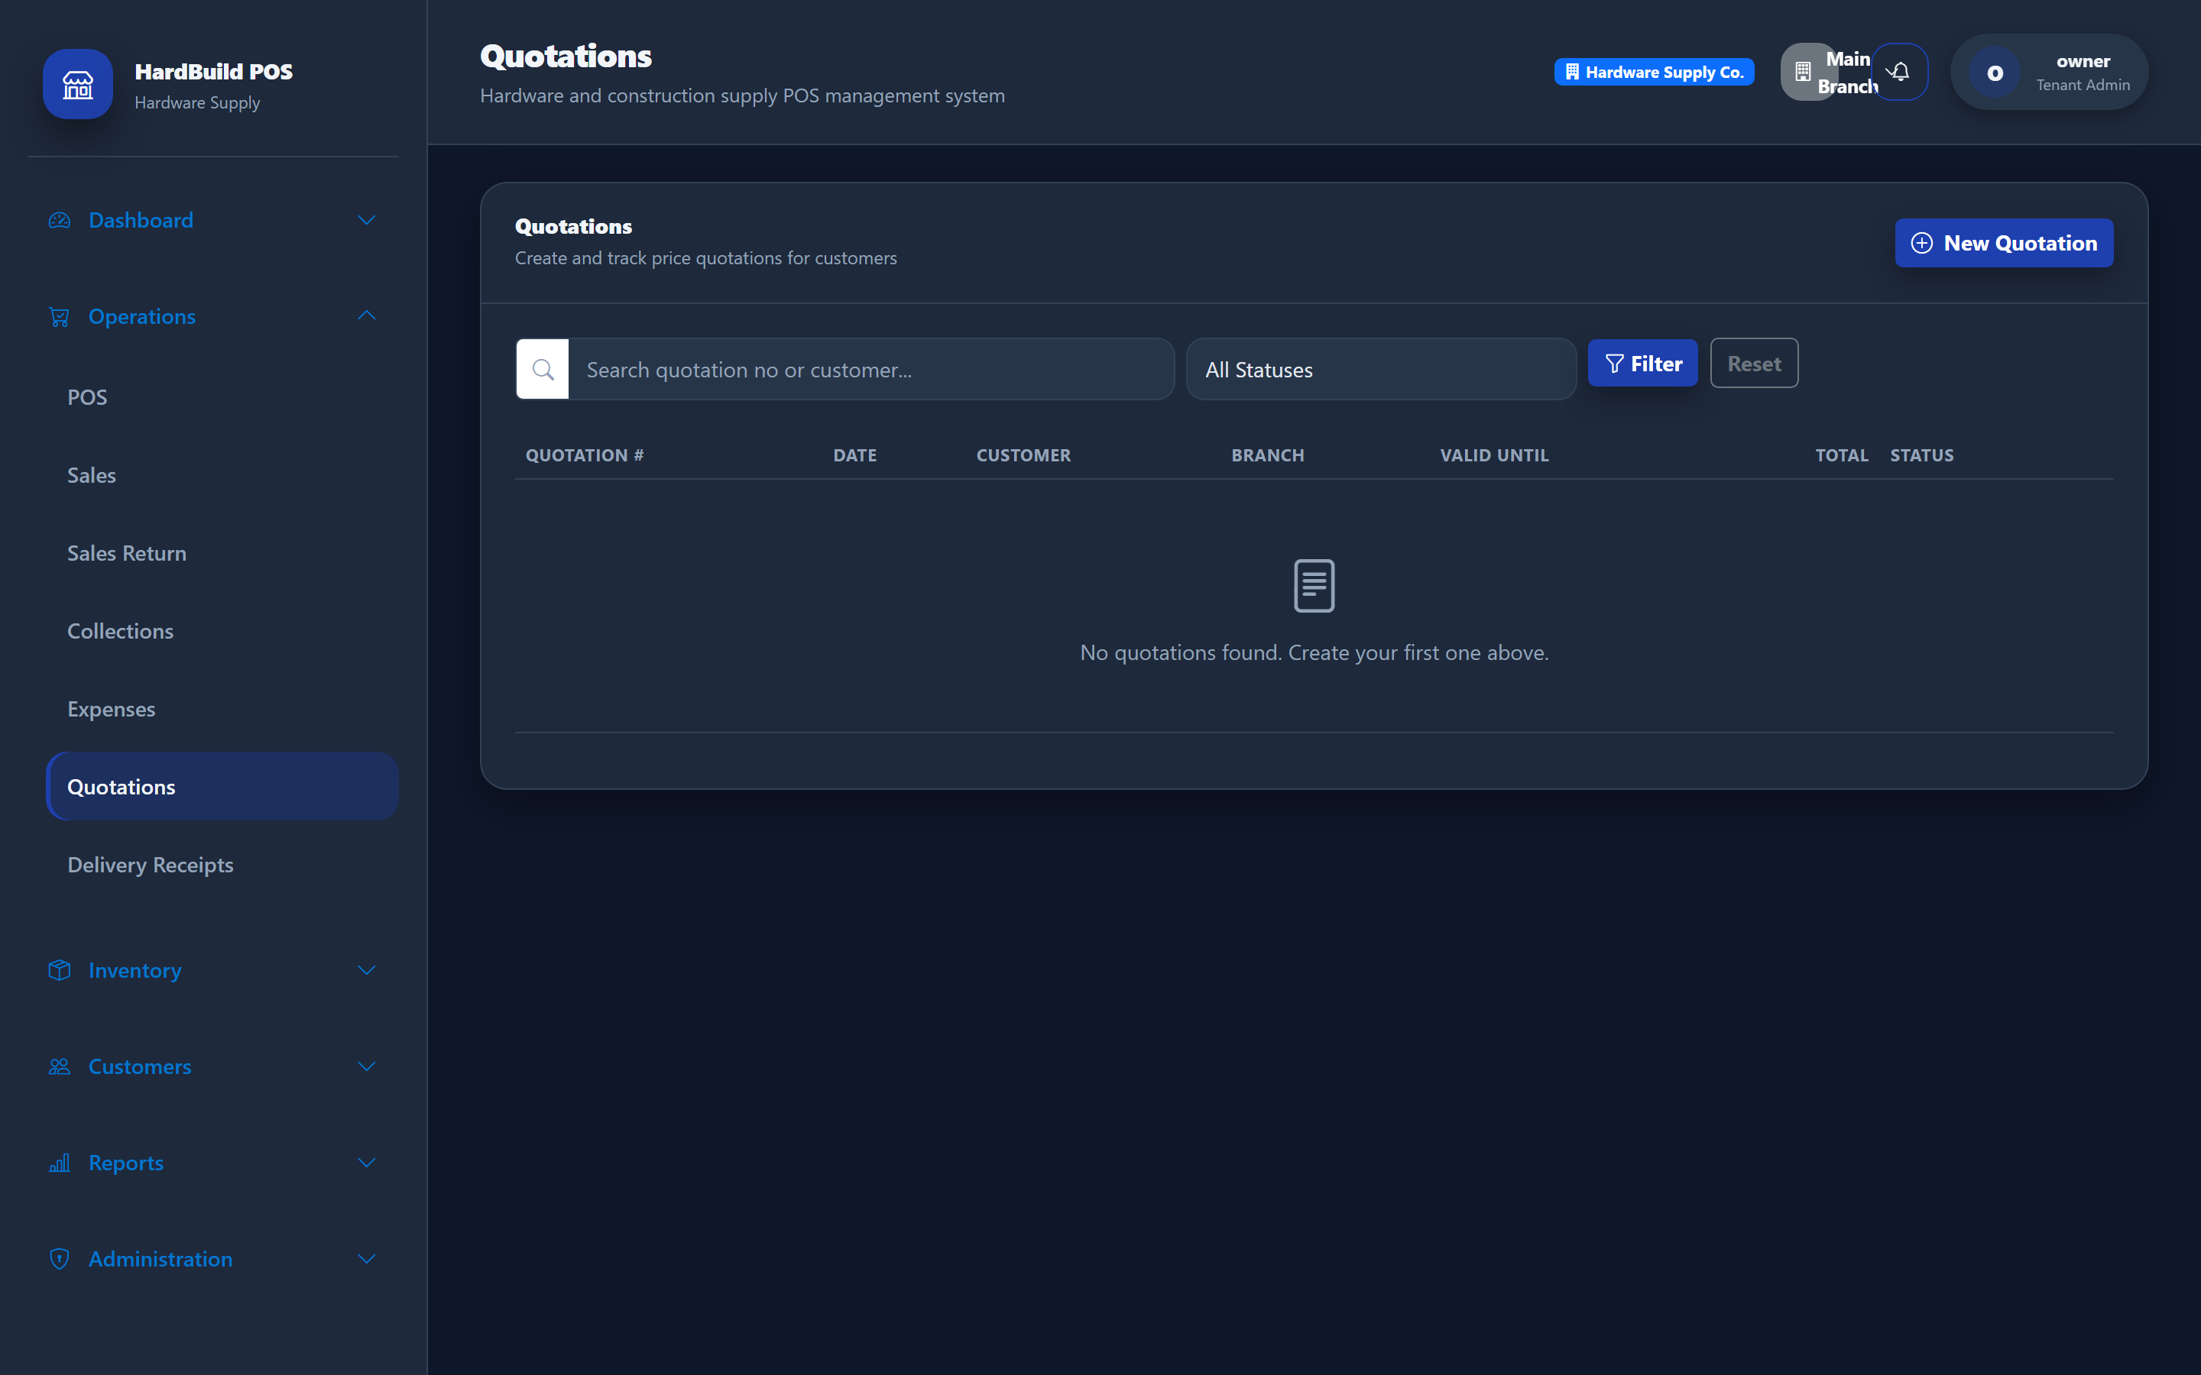
Figure 18: Quotations — prepare price quotes for customers.
Expected result. Quotations can be referenced when the customer decides to buy.

20. Delivery Receipts
Purpose. Document goods delivered to customers.
- Open Operations → Delivery Receipts.
- Create a delivery receipt for the customer and items delivered.
- Save and print for the customer to sign.
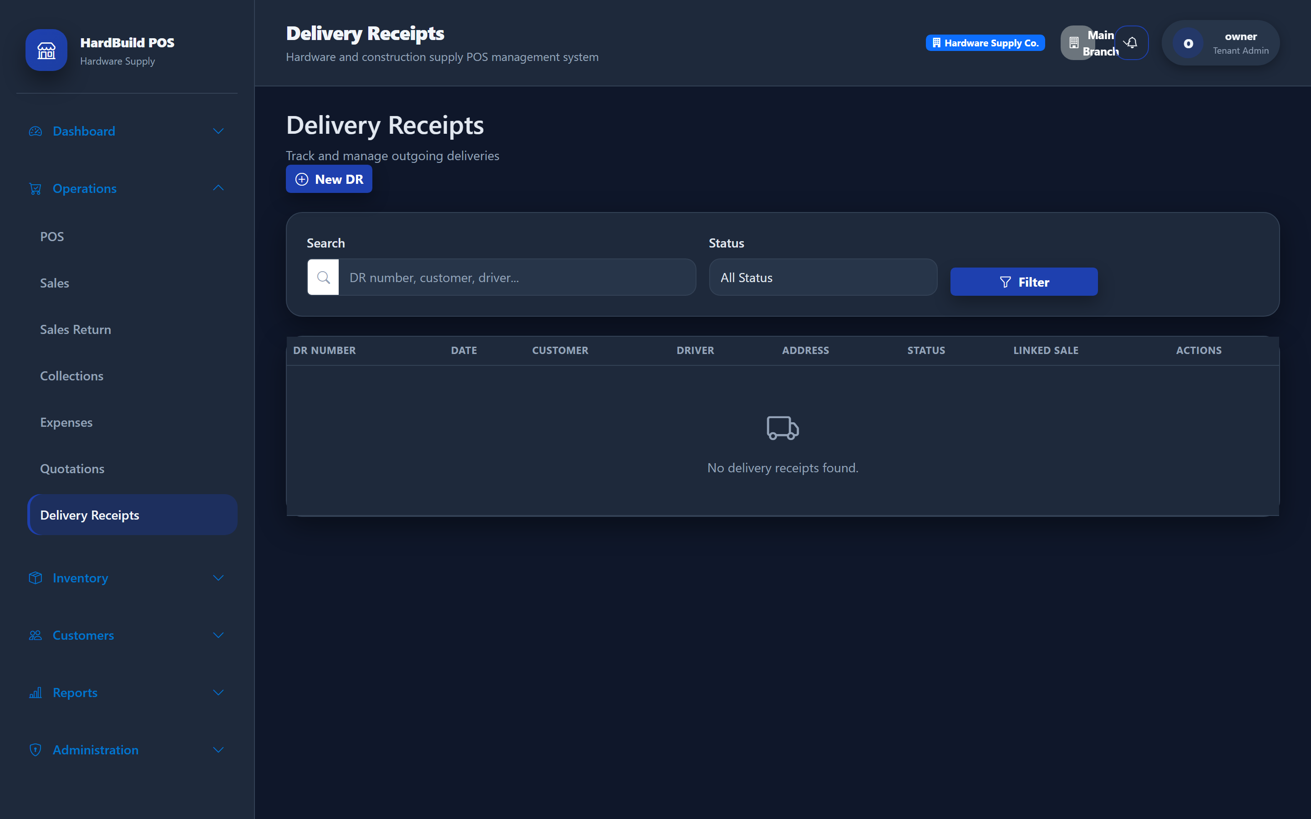
Figure 19: Delivery Receipts — record goods delivered to customers.
Expected result. You have a signed record of what was delivered and when.

21. POS Sales
Purpose. Sell products quickly at the point of sale.
- Open Operations → POS.
- Search for an item and add it to the order; adjust quantities as needed.
- Choose the customer (or Walk-in), apply any discount, and select the payment method.
- Enter the amount received and complete the sale.
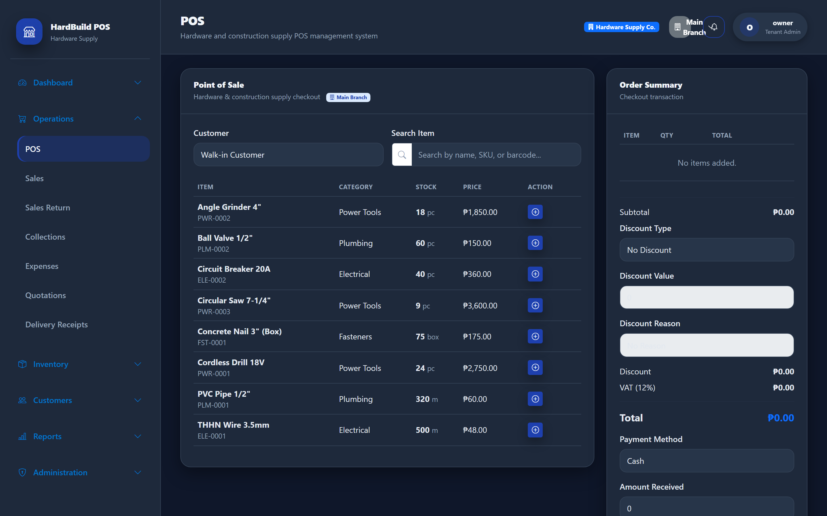
Figure 20: Point of Sale — add items, take payment, and complete a sale.
Expected result. The sale is recorded, stock is reduced, and a receipt is produced.

22. Credit Sales
Purpose. Sell on account to trusted customers.
- At the POS, select a registered customer (not Walk-in).
- Add items as usual.
- Choose the credit/charge payment option for the unpaid balance.
- Complete the sale; the balance is added to the customer’s account.

Figure 21: Credit sale — select a customer and charge the balance to their account.
Expected result. The unpaid balance is tracked against the customer for later collection.
Warning: Only extend credit to customers you trust. Monitor outstanding balances using the Aging Receivables report.

23. Customer Collections
Purpose. Receive payments against customer balances.
- Open Operations → Collections.
- Select the customer and the outstanding amount.
- Record the payment received.
- Save.
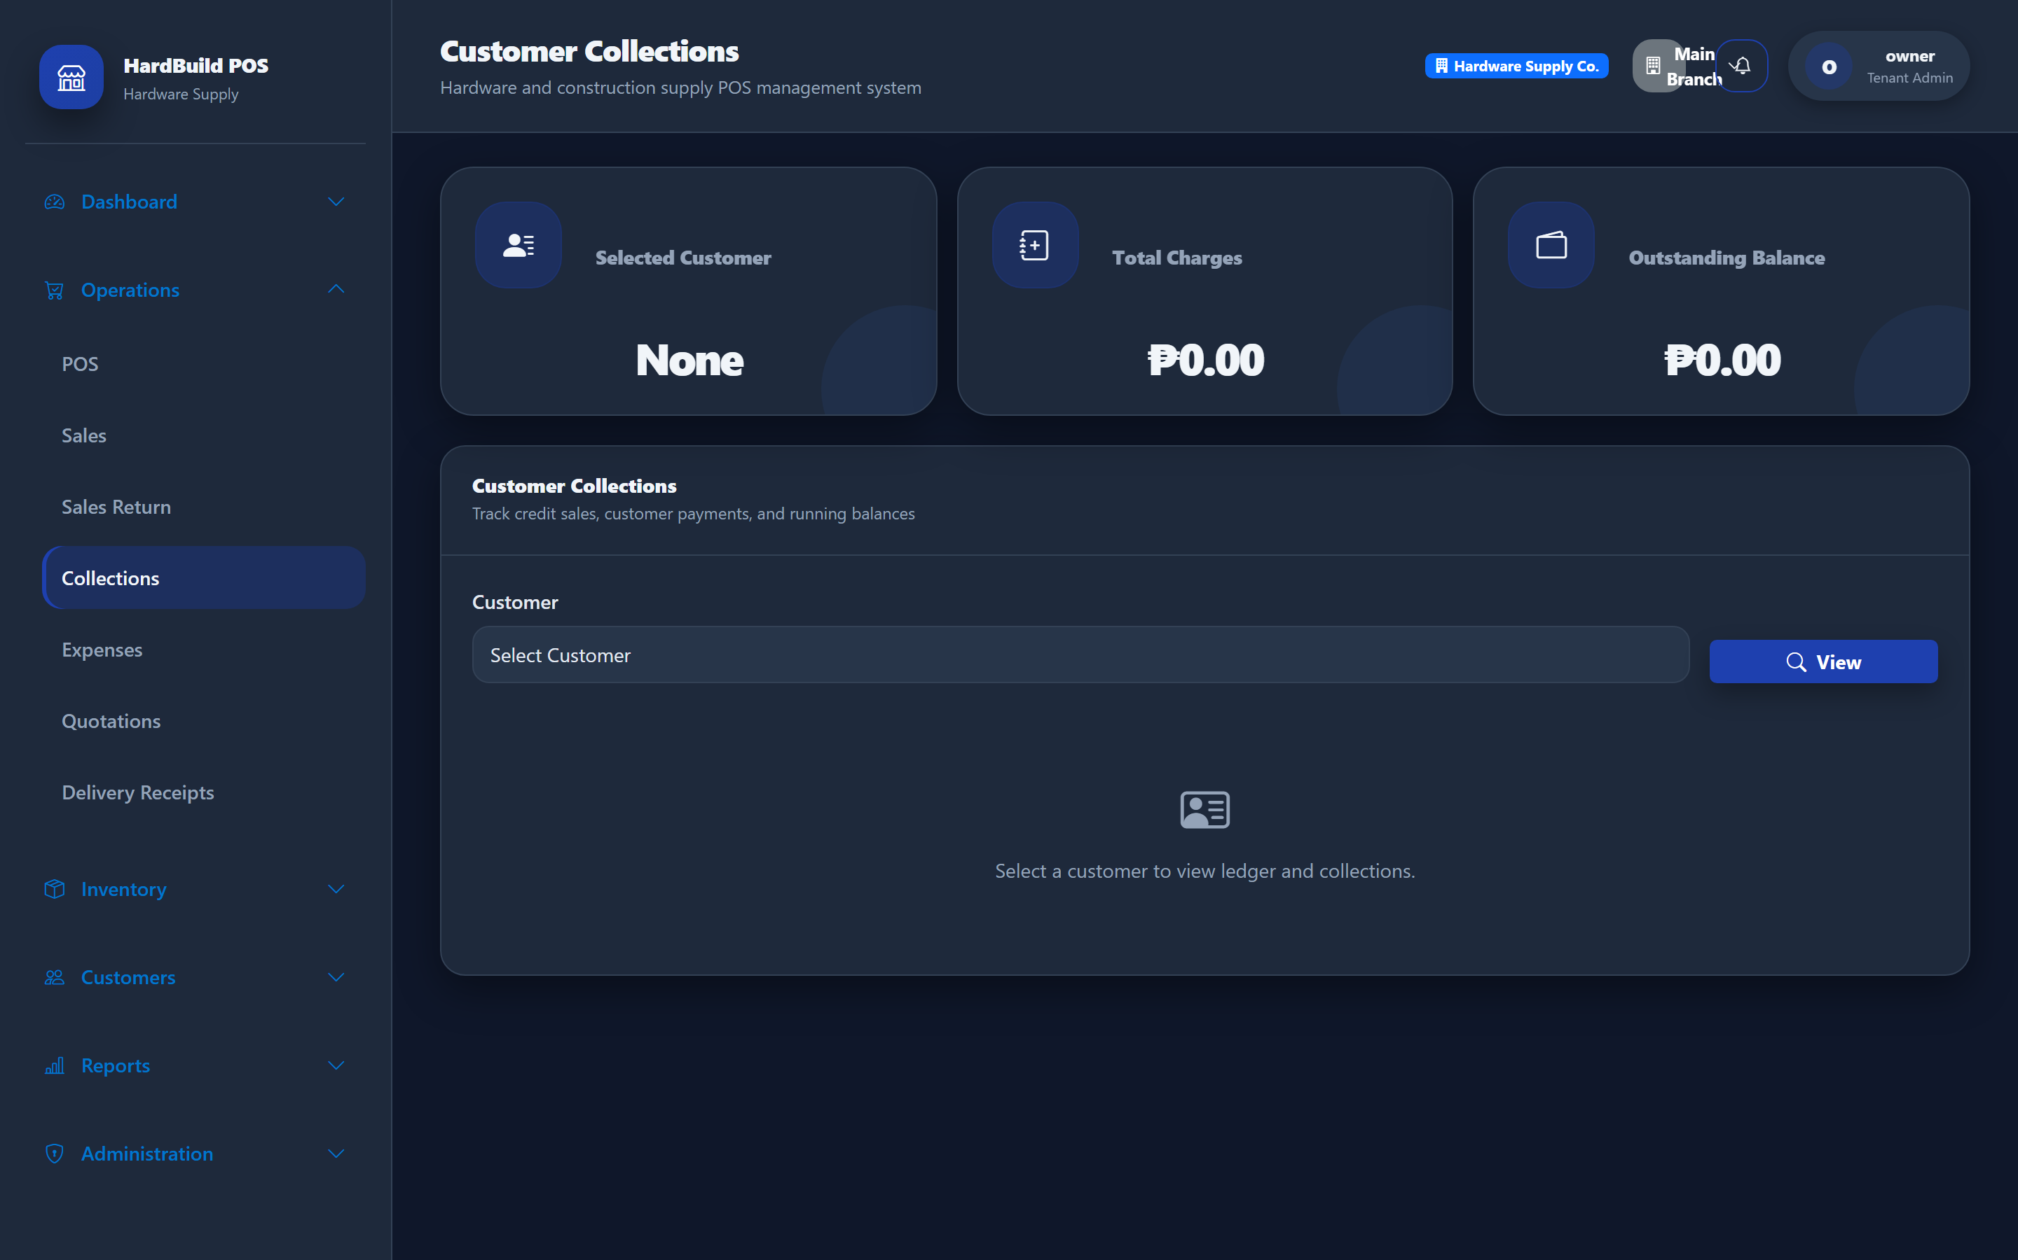
Figure 22: Collections — record payments against customer balances.
Expected result. The customer’s outstanding balance is reduced and the payment is recorded.

24. Supplier Payments
Purpose. Pay your suppliers for received goods.
- Open Reports → Supplier Payables to review what you owe per stock-in invoice.
- From a payable, open Pay and record the amount paid.
- Save to reduce the outstanding balance to that supplier.
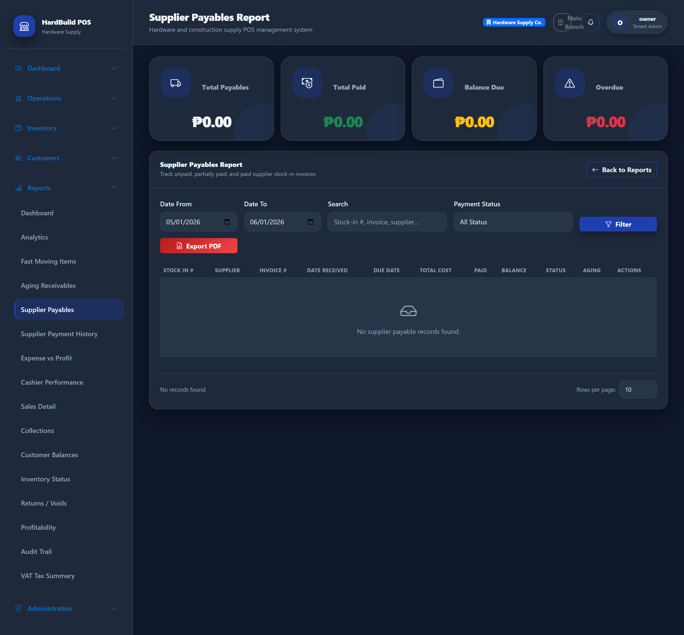
Figure 23: Supplier Payables — track and settle what you owe suppliers.
Expected result. The amount owed to the supplier is reduced and the payment is recorded.
Note: Supplier payments are made against received Stock In invoices, so receive your goods first, then pay.

25. Expenses
Purpose. Track operating costs such as utilities and rent.
- Open Operations → Expenses.
- Add an expense with its category, amount, and date.
- Save.
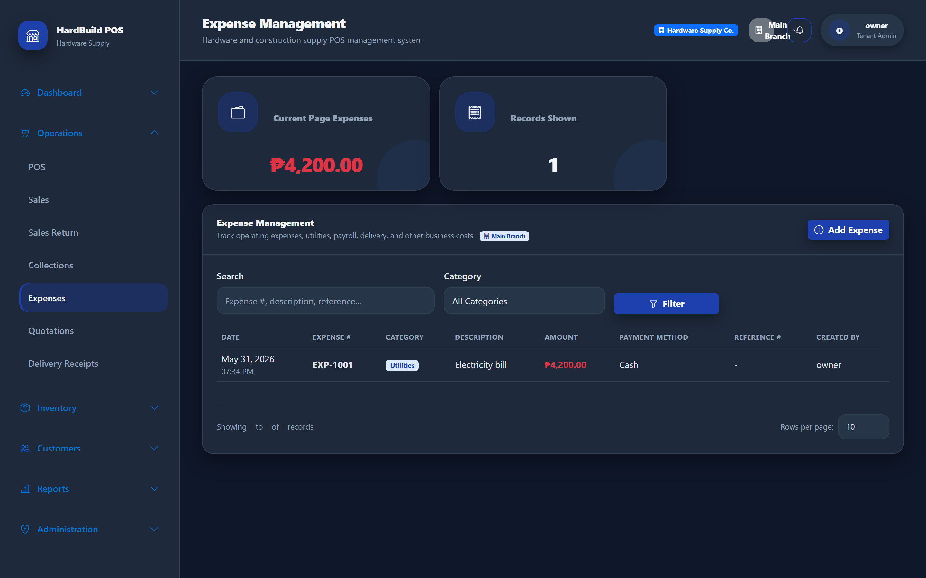
Figure 24: Expenses — record operating costs by category.
Expected result. Expenses are included in profit reporting (Expense vs Profit).

26. Reports
Purpose. Make decisions using sales, inventory, and financial reports.
- Open the Reports menu.
- Choose a report (for example Sales Detail, Profitability, or Aging Receivables).
- Set the date range and filters, then view or export.
- Use Export (PDF/Excel) to save or share a report.
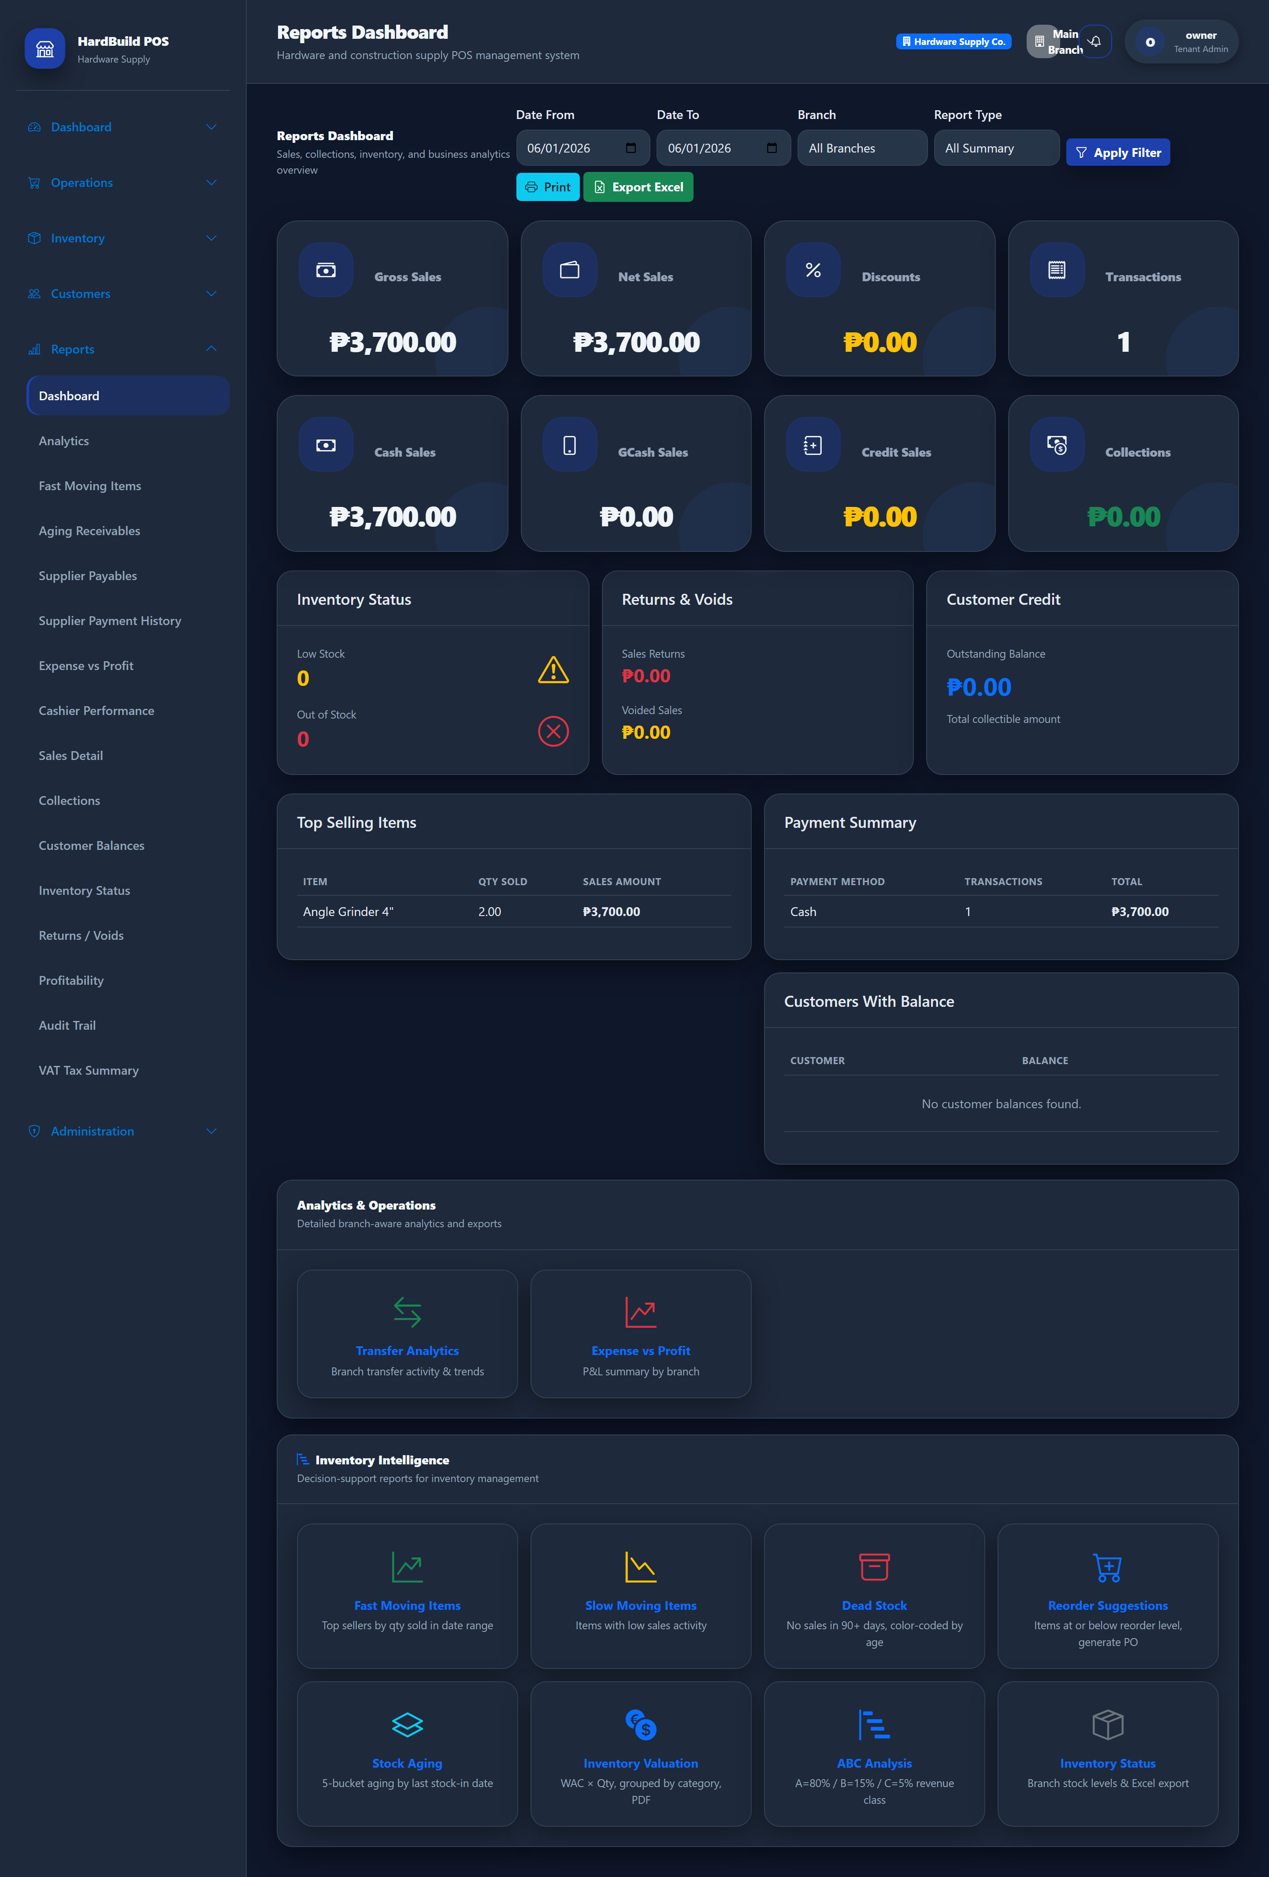
Figure 25: Reports — sales, inventory, customer, supplier, and financial reporting.
Expected result. You can analyze performance and export reports for sharing.

27. Inventory Intelligence
Purpose. Use advanced stock analytics to optimize purchasing.
- Open Reports and select an inventory-intelligence report.
- Review Fast / Slow Moving items to guide purchasing.
- Open Inventory Valuation to see the value of stock on hand.
- Use ABC analysis, dead-stock, and reorder suggestions to refine stock.
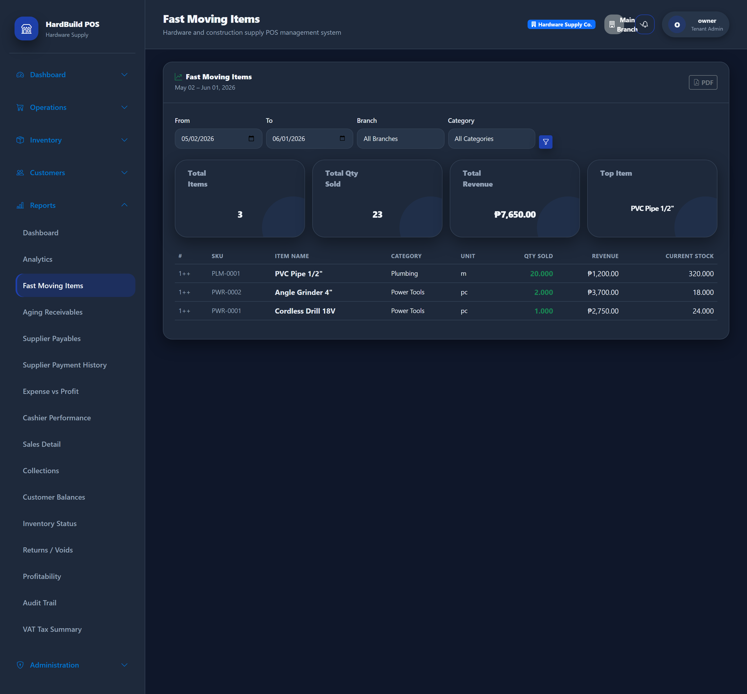
Figure 26: Fast / Slow Moving items — identify which products to reorder or discount.
Expected result. You can prioritize fast movers and act on slow or dead stock.
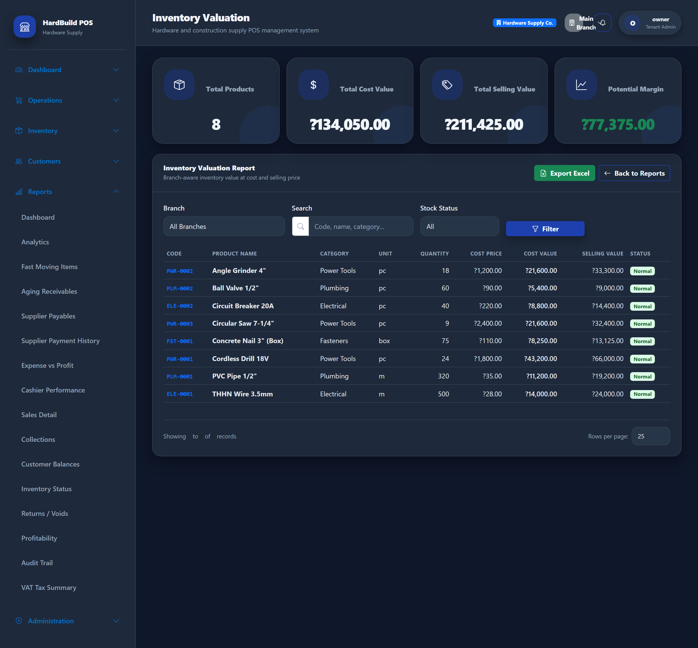
Figure 27: Inventory Valuation — the current value of stock on hand.
Tip: Review Fast/Slow Moving and Reorder Suggestions weekly to keep cash tied up in the right stock.

28. Imports
Purpose. Bring existing data into the system from spreadsheets.
- Open Inventory → Excel Import (Imports).
- Download the template, fill it with your data, and upload the file.
- Map the columns, preview the rows, and confirm the import.
- Review the result summary for any rows that need attention.
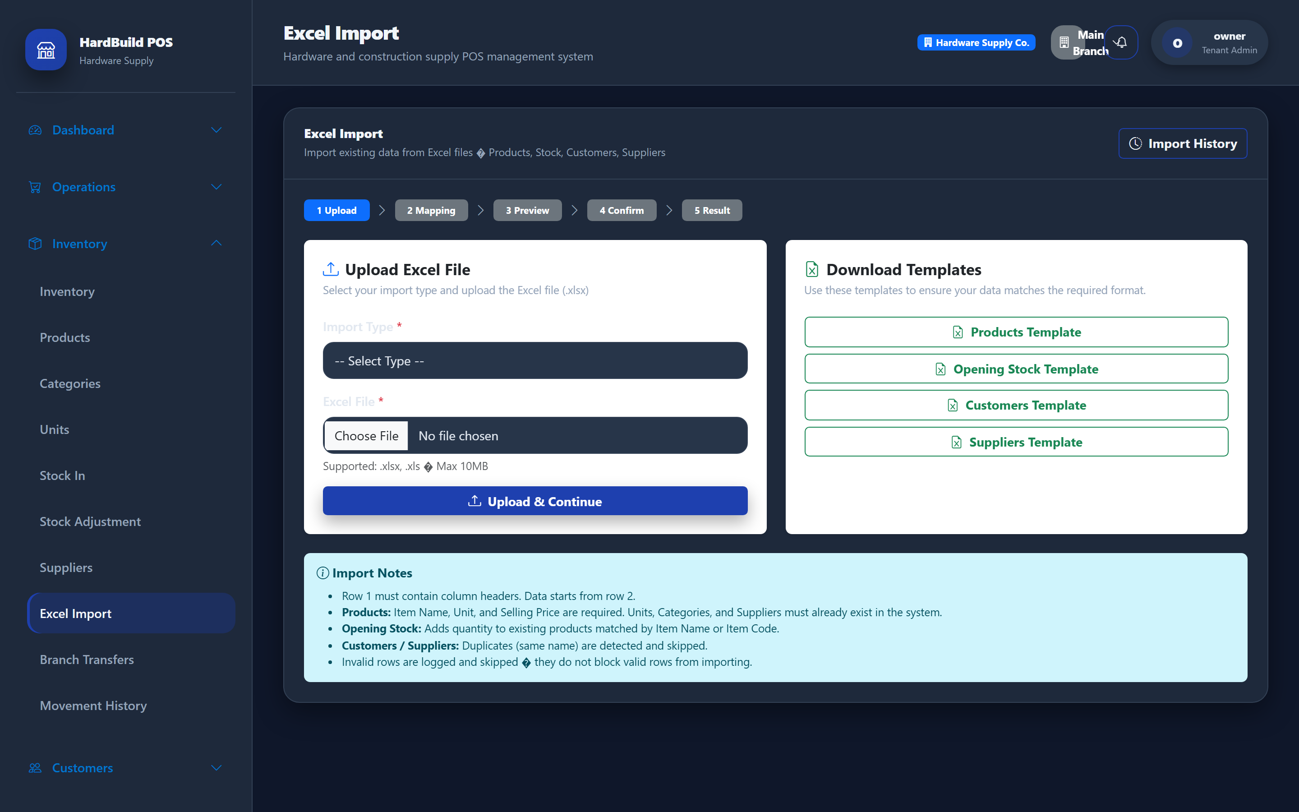
Figure 28: Imports — load products and data from Excel with column mapping and preview.
Expected result. Valid rows are imported; problem rows are reported so you can correct and re-import.
Tip: Always use the preview step to catch formatting issues before committing an import.

29. Audit Logs
Purpose. See who changed what in your account.
- Open Administration → Audit Trail.
- Filter by user, action, module, or date.
- Open an entry for details.
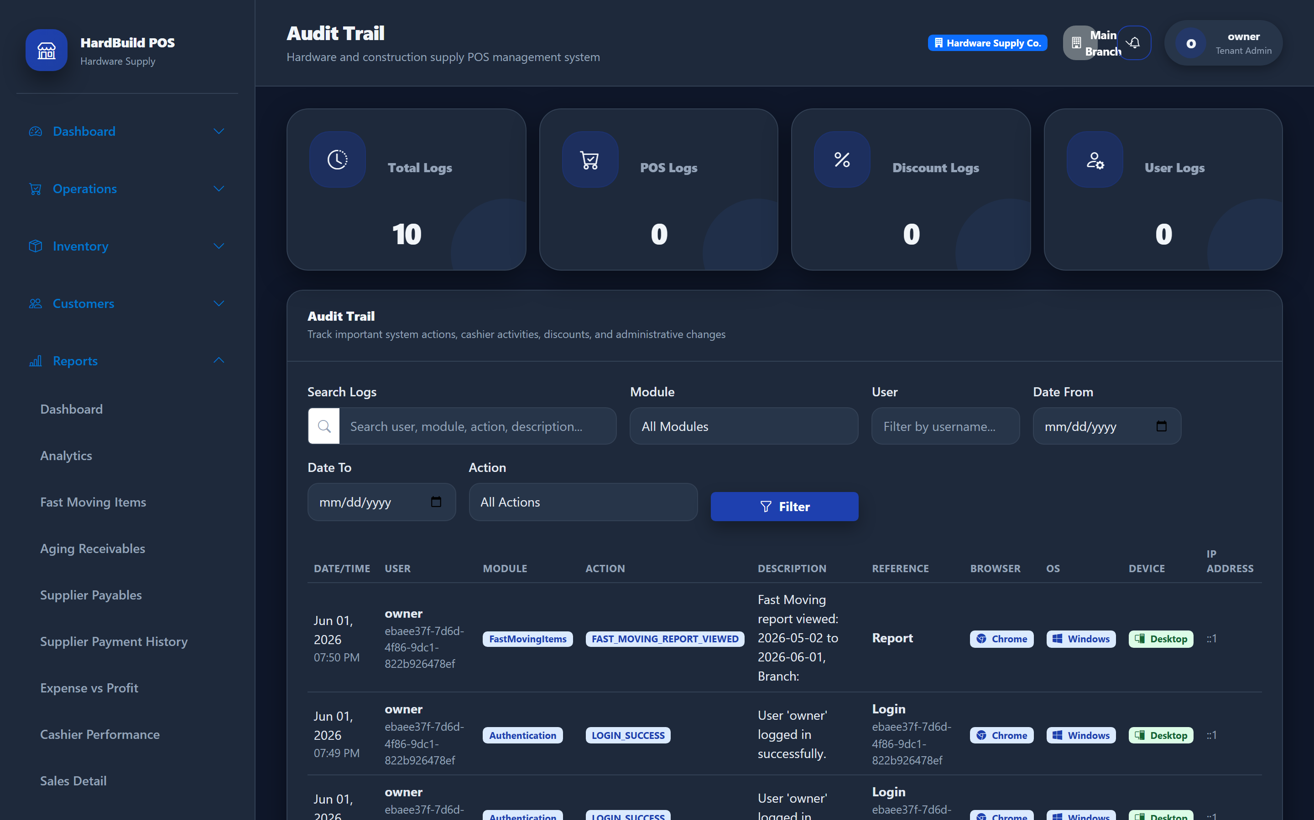
Figure 29: Audit Logs — a record of actions taken in your account.
Expected result. You can review and investigate changes made by your staff.

30. Best Practices
Purpose. Get the most from Hardware Supply POS and keep your data accurate.
- Give every employee their own account and the minimum role they need.
- Set reorder levels on products so low-stock warnings are meaningful.
- Receive stock (Stock In) promptly so inventory and payables stay accurate.
- Record expenses as they happen for reliable profit reporting.
- Reconcile customer and supplier balances regularly using the aging reports.
- Review the audit trail if numbers ever look unexpected.
Tip: A few minutes of daily housekeeping (receiving stock, recording expenses, taking collections) keeps every report trustworthy.

31. FAQ
Purpose. Answers to the questions store owners ask most often.

I forgot my password — what do I do?
Ask your administrator to reset it, or contact support. For security, accounts lock briefly after several failed attempts.

Why can a cashier not see a menu?
Menus follow roles. Cashiers see only what their role allows. Ask your administrator to adjust the role’s permissions if needed.

Why is stock different between branches?
Stock is tracked per branch. Use Branch Transfers to move stock, and Stock Adjustments to correct counts.

Can I sell on credit?
Yes. Select a registered customer at the POS and charge the balance to their account, then collect later under Collections.

How do I get my data out?
Most reports offer Export to PDF or Excel. Use these to share figures with your accountant.

