DOCUMENT TYPE: Standard Operating Procedure
TITLE: BAM-1020 Background (BKGD) Test

PREPARED BY: Pamela Atcitty 1/19/14
Tribal Air Program (Date)

REVIEWED BY:
Environmental Technician (Date)

APPROVED BY:
Environmental Department Manager (Date)

Table of Contents

- Scope of Application……………………………………………………………………………………………….1
- Summary of Method………………………………………………………………………………………….…….1
- Interferences/Comments……………………………………………………………………………………………1
- Supplies………………………………………………………………………………………………….………….2
- Procedures Setups………………………………………………………………………..……………………….2-3
- Troubleshooting…………………………………………………………………………….……………………….3

Scope of Application

The primary purpose of the test is to fine tune the Background Offset (BKGD) value in the BAM-1020 to compensate for minor variations in local site conditions, such as grounding characteristics. This results in optimum accuracy at lower concentrations typical of PM2.5 levels, and near perfect offsets when compared to FRM filter samplers. A secondary purpose of the test is to provide information about the hourly noise level and detection limit of the BAM-1020 being tested.

- Summary of Method

Install BX-302 and perform a leak check (in “off” position)

Record existing BKGD value and change to 0.0000

Turn BX-302 “on”

Allow BAM-1020 to sample for at least 72 hours

Collect data
  - Calculate and enter average of 72 hourly concentrations
  - Remove BX-302

Interferences/Comments

For best results, the zero-test should be performed during a period of fairly stable weather.

The shelter room temperature must be within the specified range and as stable as possible. The exact temperature is not important, as long as it remains fairly constant.
  - This test will require a run time of at least 72 hours; plan accordingly.
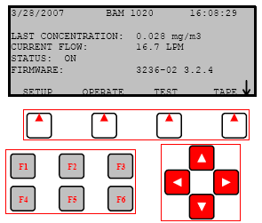
  - The BAM-1020 should be powered up for about 24 hours before starting the test, but doesn’t need to be sampling.
  - Using the BAM-1020 Keypad/Display: This main menu screen is the starting point for all functions of the BAM and can be accessed from any screen by selecting EXIT.
    - Soft keys: Four white buttons directly beneath the display changes in response to a menu option above.
    - Function keys: Used for entering password (F1,F2,F3,F4)
    - Arrow keys: Used to navigate up, down, left and right
3.6 Whenever you navigate away from the main menu screen, a prompt will ask: “Stop Sampling: yes or no?” Select “Yes” to continue with any operation. This will stop the operation of the BAM unit.

Supplies

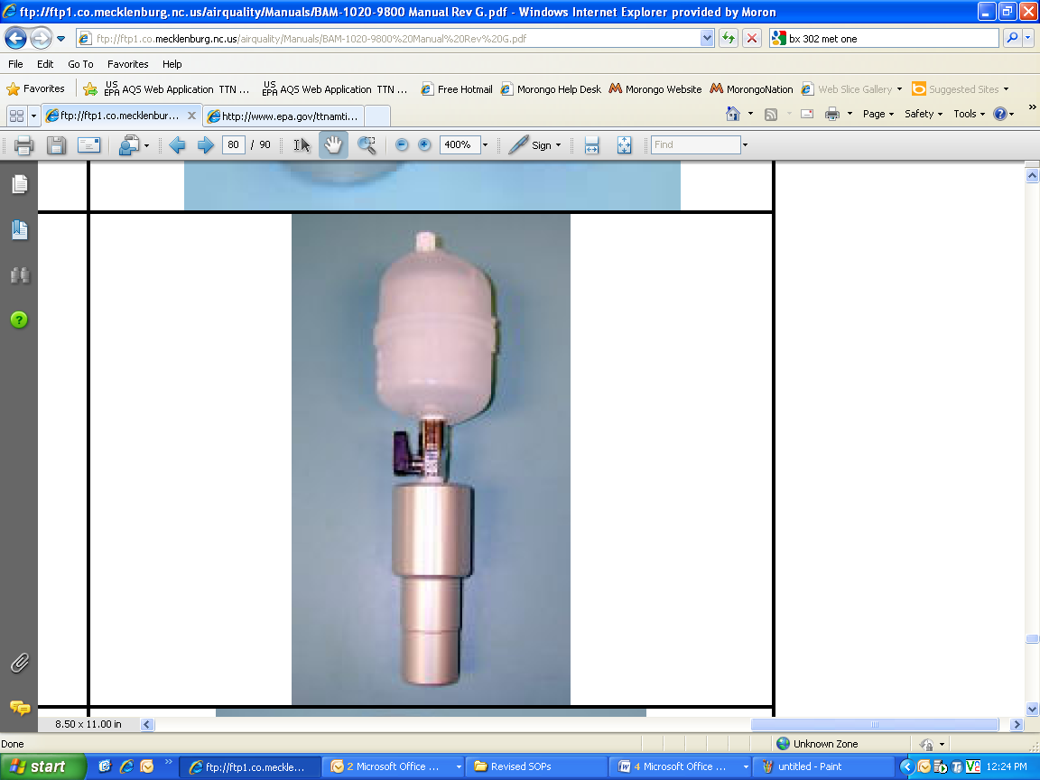
BX-302 Zero Filter Calibration Kit

Silicone lube (if needed)

BAM-1020 Fully installed and operational
BX-302 Zero Filter Calibration Kit

Laptop computer

R232 (9pin) cable
  - Microsoft Excel

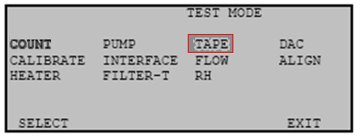
Procedure

Perform Leak Test

At the BAM’s main menu press TEST then highlight TAPE using the arrow keys, then press SELECT soft key.

The “Tape Test Mode” menu will appear, advance tape by pressing FWD soft key to advance the tape 1 “window” to a clean, unused spot.

Remove PM10 and PM2.5 inlet heads from the inlet tube.

Install the BX-302 onto the inlet tube.

Turn the valve on the BX-302 to the “OFF” position; this prevents any air from entering the inlet tube.
    - At the BAM unit, continue to the main menu screen by selecting EXIT. Select the TEST soft key, then highlight PUMP and then SELECT soft key. The Pump screen will appear, select the PUMP ON soft key and the pump will begin
    - Allow the BAM-1020 to stabilize for about 2-3 minutes. Since there is no air entering the inlet tube, the flow rate should be below 1.0 liter per minute (Lpm). If the flow rate, displayed on BAM screen, is less than 1.0 Lpm there is not a leak. Enter this number on the BKGD Test field sheet (If flow rate is greater than 1.0 Lpm see Troubleshooting below). Do not remove the BX-302.
.

Begin BKGD Test
    - Navigate to the CALIBRATE screen from the main menu by selecting the SETUP soft key then using arrow keys, scroll to the CALIBRATE screen.
    - Record the existing BKGD value from the CALIBRATE screen and enter on to the BKGD Test field sheet.
    - After recording previous BKGD value change this value to 0.0000 by using the arrow keys.
    - Select SAVE and exit back to the main menu. The BAM-1020 will begin sampling at the next hour.
    - At the shelter’s rooftop, turn the BX-302 to the “ON” position
    - Allow the BAM-1020 to sample for at least 72 hours. The unit should operate just like it would for regular monitoring, only with BX-302 zero filter installed.
  - Collect data
    - After 72 hours of operation, download the test data from the unit and import it into a spread sheet for analysis (see SOP titled: BAM-1020 DataRetrevial_v.2). The data should not contain any error flags during the test period. Data collected during the warm-up period may be discarded because the first few hours are typically noisy.
    - Using Excel, calculate the standard deviation of the data to four decimal places. This value should be less than 2.4 mg. The lower the number, the better the noise characteristics of the unit.
    - Using Excel, calculate the average of the 72 hourly BAM concentrations to four decimal places. The new BKGD value is simply the negative of this average. (For example: the average of the data sample of 0.0021 mg (2.1µg) is -0.0021.)
    - Enter the new BKGD value. From the main menu select SETUP then scrolling to the CALIBRATE menu, navigate to the BKGD field and change value using the arrow keys.
    - Compare the new BKGD value to the previous factory-set BKGD value. The field-set BKGD should typically vary from the factory value by less than 2µg. Record the test results and any BKGD changes. If the values are considerably different, check the BAM for leaks at the nozzle and verify the temperature stability of the room.
    - Remove the BX-302 zero filter and reinstall the PM10 and PM2.5 inlet heads. The unit can now be operated normally. The new BKGD value will be automatically applied to all hourly concentration data points in the unit.

Troubleshooting
- If the leak flow value is 1.0 or greater there may be another small leak in the system. If a leak is indicated, resolve it using the Troubleshooting steps in SOP titled: BAM- LeakCheck v.2

Refer to the BAM 102 Particulate Monitor Operation Manual Rev. G or M:_103/Task1_Air Monitoring/AMS_Equipment/BAM-1020-9800 Manual Rev G

