DOCUMENT TYPE: Standard Operating Procedure
TITLE: Unloading/Loading BAM 1020 Filter Tape

PREPARED BY: Pamela Atcitty 1/07/16
Tribal Air Program (Date)

REVIEWED BY:
Environmental Technician (Date)

APPROVED BY:
Environmental Department Manager (Date)

Table of Contents

- Scope of Application……………………………………………………………………………………………….1
- Summary of Method………………………………………………………………………………………….…….1
- Interferences/Comments…………………………………………………………………………………..………1-2
- Supplies………………………………………………………………………………………………….………….2
- Procedures Setups……………………………………………………………………..………………..…………2-3
- Troubleshooting…………………………………………………………………………….……………………….2

Scope of Application

Gather ambient air data, which have been linked to smog, ozone depletion, acid rain and global warming. Maintaining the equipment that records this data is a vital aspect of providing consistent, current and valid data.

Summary of Method

Placing BAM 1020 in “maintenance mode”

Removing spent filter tape

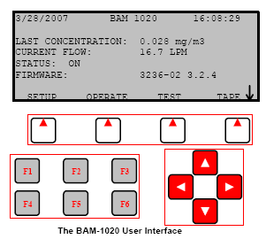
Replacing filter tape

Resetting BAM 1020

Interferences/Comments

Special care should be taken when handling unused filter tape. Clean lint-free gloves should be worn to avoid contamination or sample material. If gloves are not available, make sure hands are clean, using hand sanitizer or wipes. Gentle handling during filter tape loading will reduce filter tape breakage.
  - Using the BAM-1020 Keypad/Display: This main menu screen is the starting point for all functions of the BAM and can be accessed from any screen by selecting EXIT.
    - Soft keys: Four white buttons directly beneath the display changes in response to a menu option above.
    - Function keys: Used for entering password F1,F2,F3,F4
    - Arrow keys: Used to navigate up, down, left and right

    - Whenever you navigate away from the main menu screen, a prompt will ask: “Stop Sampling: yes or no?” Select “Yes” to continue with any operation.
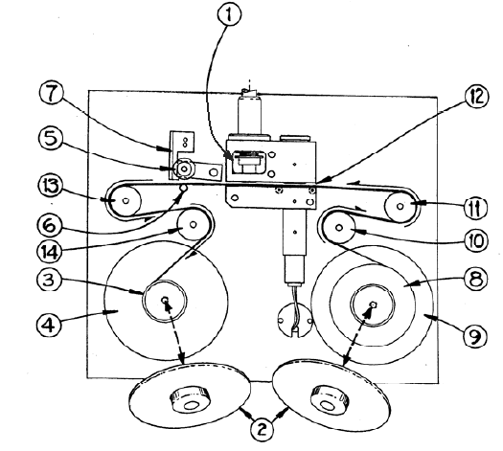

Supplies

Un-used filter tape (located in AMS in workstation desk’s top drawer)

Adhesive tape

Clean lint-free gloves/ hand sanitzer or wipes

Procedure

From BAM-1020 main screen, select TAPE soft key. A prompt will ask: “Stop Sampling: yes or no?” Select “Yes” and the select TENSION soft key to raises the nozzle up (1) away from tape.

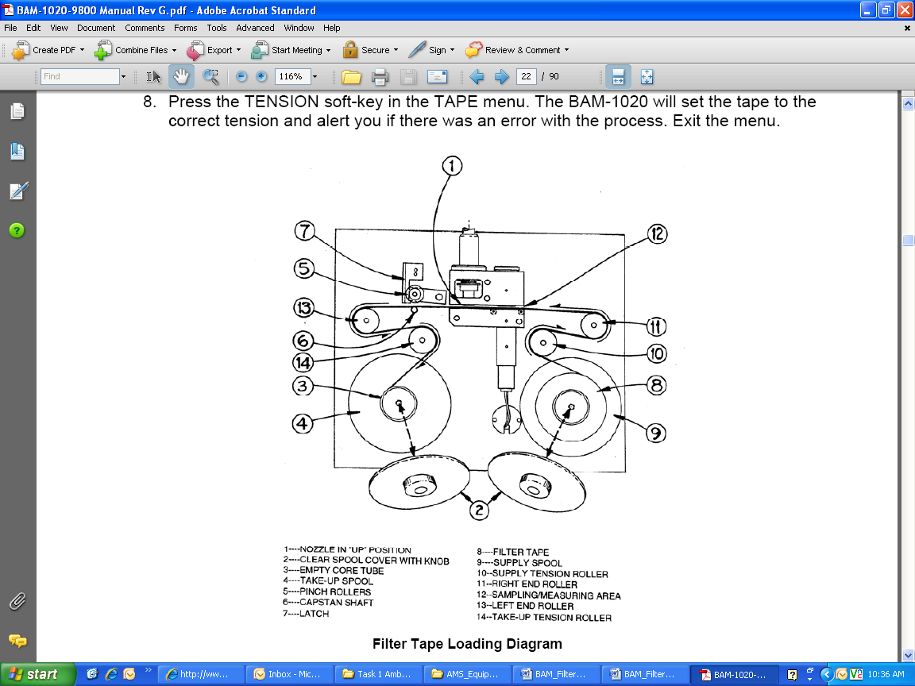
Open BAM door (by pushing in at the door’s bottom right corner) and verify that the nozzle is in the up position (1) away from tape. Inspect the sample area (12) and verify that the nozzle in not touching the tape and the tape is free from any obstruction.

Remove both of the clear plastic spool covers (2) by unscrewing the knobs. (Take note of the tightness for re-screwing knobs back on).

Lock pinch roller (5) in up position.

Lift up the pinch roller’s center rod with one hand.

With the other hand, swing the latch (7) to the right. The latch should be under the pinch roller.

Allow the pinch roller to rest on latch, away from filter tape, as shown above.

Remove spent tape from tape hub (3) wrap excess tape and place in new tape’s empty box.

REFER TO: Cleaning BAM-1020 Nozzle and Vane SOP before replacing new filter tape.

An empty core tube (3) must be installed on the hub of the take-up (left) spool (4), or filter edge tape damage will occur.

Place full roll of filter tape (8) on supply (right) spool (9), with tape feeding upward and counter clockwise.

Pass filter tape clockwise over supply tension roller (10), then counter-clockwise over right end roller (11).

Feed filter tape counter-clockwise over left end roller (13).

Thread the filter tape through sampling/measuring area (12).

Wrap it clockwise around take-up tension roller (14).

Feed the end of filter tape so that it enters the take-up spool (4) in the counter-clockwise direction. Using any available adhesive tape, attach the leading end of the filter tape to the empty core tube (3).

By hand, gently tension tape to initial point of slack removal.

Install both spool covers (2) at same torque in which they were removed. The clamping force of the covers prevents tape slippage.

Unlock pinch roller (5)

Slightly raise the pinch roller’s center rod (5) with one hand.

With the other hand, swing the latch (7) to the left.

Gently lower pinch roller onto the tape.

Close BAM door. Select EXIT to return to main menu screen.

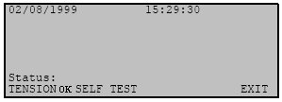

From the main menu, tension the filter tape by pressing TAPE

soft key then TENSION soft key. The BAM will set the tape

to the correct tension and when completed, “Status” will read TENSION OK.
Tape Menu Screen

After tape is tensioned select SELF TEST soft key from the

TAPE menu.

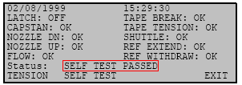
Wait for SELF TEST to run its course. The test will take a couple of minutes.

Once SELF TEST is complete, the BAM will display the results of each tested item with an OK or FAIL tag. If all items are OK, the status will read “Self Test Passed”. If any item fails, the status will show “Error Occurred” refer to Operation Manual (pg. 25-26) to assist in adjusting item.
Self Test Status Screen

Once Self Test is passed, press EXIT soft key to return to the main menu and the BAM will continue sampling at the next hour.

Troubleshooting

Refer to the BAM 102 Particulate Monitor Operation Manual located in the “PM2.5 Binder”

