DOCUMENT TYPE: Standard Operating Procedure
TITLE: BAM-1020 Inlet Tube Cleaning

PREPARED BY: Pamela Atcitty 08/02/2011
Tribal Air Program (Date)

REVIEWED BY:
Environmental Supervisor (Date)

APPROVED BY:
Environmental Department Manager (Date)

Table of Contents

- Scope of Application……………………………………………………………………………………………….1
- Summary of Method………………………………………………………………………………………….…….1
- Interferences/Comments……………………………………………………………………………………………2
- Supplies………………………………………………………………………………………………….………….2
- Procedures Setups………………………………………………………………………..………………………….2
- Troubleshooting…………………………………………………………………………….……………………….2

Scope of Application

Gather ambient air data, which have been linked to smog, ozone depletion, acid rain and global warming. Maintaining the equipment that records this data is a vital aspect of providing consistent, current and valid data.

Summary of Method

Disassemble attachments to the inlet tube

Remove inlet tube from BAM-1020

Clean inlet tube

Re-attach inlet tube to BAM-1020

Re-assemble attachments

Interferences/Comments

The best time to perform this cleaning procedure is following the BAM leak and flow check as it eliminates some of the BAM down time.

All supplies can be found in work station cabinet or desk drawer

Supplies

Kim-wipe

Cloth/rag

Cotton swab

Red plastic inlet cap

Isopropyl alcohol

Procedures

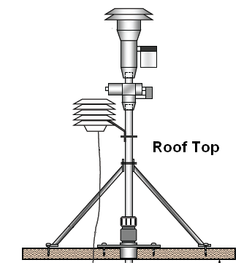
Place BAM into maintenance mode by pressing SET UP then CALIBRATE.

Remove the heater cover from over the heater/inlet tube.

Loosen the 2 set screws on the top of the BAM cabinet using the proper Allen key.

From the roof of the shelter, remove the PM10 and SCC assembly by pulling straight off.

Loosen the temperature/pressure assembly set screws then pull straight off/over the inlet tube.

Using a screwdriver, loosen the clamp holding the bipod to the inlet tube.

By hand, loosen the plastic flange just above the roof where the inlet tube meets the roof.

Inside the shelter, loosen the two set screws of the heater assembly and slide it down the tube.

Gently push the tube up far enough to clear it of the heater assembly then move the heater out of the way.

Place red plastic cap over inlet receptive area to keep any debris from entering the BAM.

From the roof of the shelter, gently pull inlet tube up and out.

Clean with cloth running inside from one end to the other (Caution: avoid using any abrasive materials).

After inlet tube is clean and dry, reassemble and re-install, reversing the above steps.

Troubleshooting
Refer to the BAM-1020 9800 Manual Rev. G in m:\_103\Task 1_Air Monitoring\AMS_Equipment folder.

