DOCUMENT TYPE: Standard Operating Procedure
TITLE: Leak Check for the BAM 1020

PREPARED BY: Pamela Atcitty 11/07/2012
Tribal Air Program (Date)

REVIEWED BY:
Environmental Technician (Date)

APPROVED BY:
Environmental Department Manager (Date)

Table of Contents

- Scope of Application……………………………………………………………………………………………….1
- Summary of Method………………………………………………………………………………………….…….1
- Interferences/Comments……………………………………………………………………………………………1
- Supplies………………………………………………………………………………………………….………….2
- Procedures Setups………………………………………………………………………..………………………….2
- Troubleshooting…………………………………………………………………………….……………………….3

Scope of Application

Quality Control (QC) is the overall system of technical activities that measures the attributes and performance of a process, item, or service against defined standards to verify that they meet the stated requirements established by the tribe. Day-to-day quality control is implemented through the use of various checks or instruments that are used for comparison.

Summary of Method

Placing BAM into ‘maintenance’ mode

Remove PM10 head

Installing leak test valve

Checking for any leaks

Reassembling BAM

Interferences/Comments

An allowance for 1.0 Lpm leak flow is due to the test conditions.

Leak checks should be performed at least monthly and whenever the filter tape is changed

Flow check should also immediately follow leak checks as to eliminate any further down time the BAM incurs.

Almost all air leaks in the BAM system occur at the nozzle where it contacts the filter tape.

  - Using the BAM-1020 Keypad/Display: This main menu screen is the starting point for all functions of the BAM and can be accessed from any screen by selecting EXIT.
    - Soft keys: Four white buttons directly beneath the display changes in response to a menu option above.
    - Function keys: Used for entering password (F1,F2,F3,F4)
    - Arrow keys: Used to navigate up, down, left and right
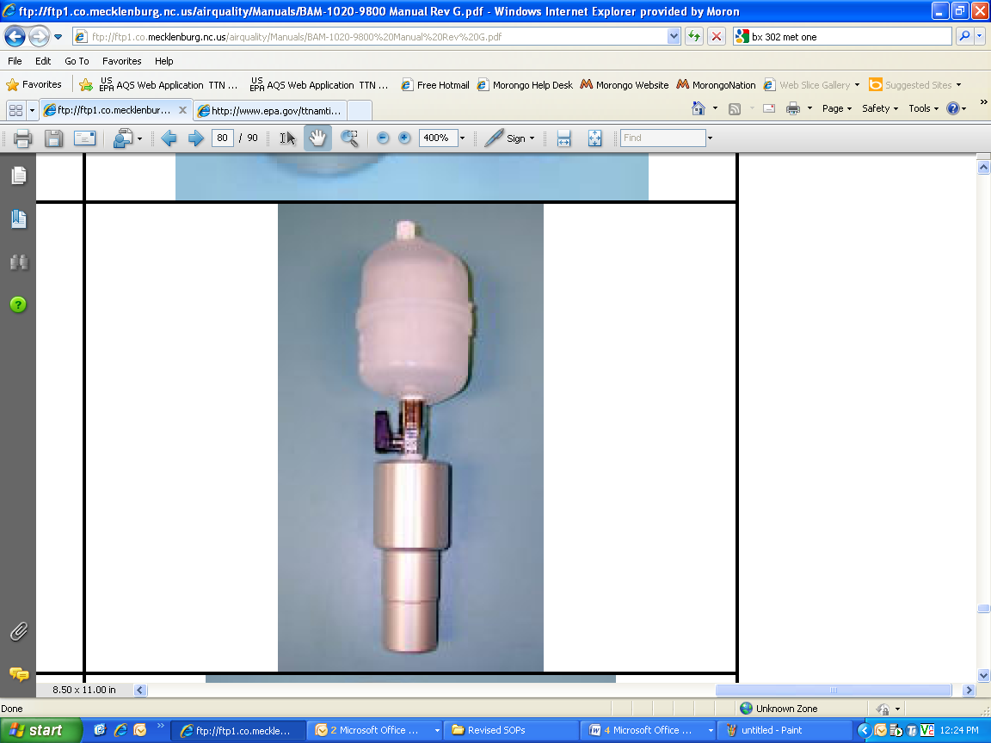
3.6 Whenever you navigate away from the main menu screen, a prompt will ask: “Stop Sampling: yes or no?” Select “Yes” to continue with any operation. This will stop the operation of the BAM unit.
BX-302 Leak Check Valve

Supplies

BX-302 (or 305) leak check valve

Silicone lube (if needed)
  - BAM-1020 Calibration Sheet (located on clipboard on west wall of shelter)

Procedure

Place BAM-1020 system into MAINTENANCE

At the BAM’s main menu press TEST then highlight TAPE using the arrow keys, then press SELECT soft key.

The “Tape Test Mode” menu will appear, advance tape by pressing FWD soft key to advance the tape 1 “window” to a clean, unused spot.

Install leak check valve (BX-302) onto PM inlet at the rooftop

Remove PM10 head from the inlet tube.

Install the BX-302 onto the inlet tube. If a PM2.5 VSCC is used, install the leak check valve on top of the VSCC, since the VSCC is a possible source of leaks and should be tested.

Turn the valve on the BX-302 to the “OFF” position; this prevents any air from entering the inlet tube.
  - Check flow rate at the BAM unit
    - At the BAM unit, continue to the main menu screen by selecting EXIT. Select the TEST soft key, then highlight PUMP and then SELECT soft key. The Pump screen will appear, select the PUMP ON soft key and the pump will begin
    - Allow the BAM-1020 to stabilize for about 2-3 minutes. Since there is no air entering the inlet tube, the flow rate should be below 1.0 liter per minute (Lpm). If the flow rate, displayed on BAM screen, is less than 1.0 Lpm there will not be a leak during normal operation, enter this number on the calibration checklist. (If flow rate is greater than 1.0 Lpm see Troubleshooting below)

Turn the BAM pump off by selecting PUMP OFF or EXIT to return to the main menu and BAM will start sampling at the next hour.

**The flow check should be performed next. REFER to the SOP titled: Flow Check on the BAM-1020.

If flow check is not performed, remove the BX-302 leak test valve, and re-install PM10 and PM2.5 inlet heads.

Troubleshooting
- If the leak flow value is 1.0 or greater there may be another small leak in the system. If a leak is indicated, resolve it using the methods below.

Refer to the BAM 102 Particulate Monitor Operation Manual Rev. G or M:_103/Task1_Air Monitoring/AMS_Equipment/BAM-1020-9800 Manual Rev G

  - Remove PM 2.5 VSCC inlet head
    - First attempt the leak check again with the PM2.5 cyclone removed (if used). If problem is still not resolved, clean the nozzle vane (Refer to Troubleshooting below or the BAM Troubleshooting guide in the BAM User Manual pg. 36)
  - Check the Zero on the Flow meter
    - Remove the pump tubing from the quick disconnect fitting on the back of the BAM.
    - From the main menu press TEST then select PUMP and turn the pump on.
    - Flow should be less than 0.2 Lpm. If the flow is greater than this value do a flow audit from manual.
    - Retry the Leak Test Procedures
  - Check all connections from the inlet adapter to the vacuum pump
    - Remove the inlet adapter and visually check for leaks and loose fittings and replace
    - Remove the inlet tube from the BAM and visually inspect. Check the two O-rings in the inlet for wear or splits.
    - Open the front door and manually lift and lower the nozzle, letting it slowly contact filter paper.
6.2.3.1 Nozzle should be free to move up and down
6.2.3.2 If Nozzle sticks, contact the factory and a BX-803 kit
6.2.4 Remove the tubing from the back of the BAM and inspect for splits or loose connections.
6.2.4.1 If the tube is split, cut out the bad portion and reinsert into the back of the BAM.
  - Clean the Nozzle
    - Refer the SOP for Cleaning BAM 1020 Nozzle and Vane
  - Internal Check
    - Tools required: Screwdriver set, pliers, and adjustable wrench
    - Remove the Inlet tube from the back of the BAM
    - Plug the inlet and check the flow. If the leak test passes, the leak is in the inlet tube assembly.
    - Remove the BAM cover by 10 Philips head screws and gently remove.
    - Disconnect the tubing at the inline filter and plug the opening. Recheck the flow. If the unit passes the leak is in the nozzle assembly. Check all fittings from the inline filter to the BAM inlet on the top of the BAM. Replace as needed.
  - Resolve the leak and perform the check again. A properly functioning BAM with a clean nozzle and vane will usually have a leave value of about 0.5 Lpm or less using this method.

