DOCUMENT TYPE: Standard Operating Procedure
TITLE: Cleaning Pump Muffler on BAM 1020

PREPARED BY: Pamela Atcitty 06/23/2011
Tribal Air Program (Date)

REVIEWED BY:
Environmental Supervisor (Date)

APPROVED BY:
Environmental Department Manager (Date)

Table of Contents

- Scope of Application……………………………………………………………………………………………….1
- Summary of Method………………………………………………………………………………………….…….1
- Interferences/Comments……………………………………………………………………………………………1
- Supplies………………………………………………………………………………………………….………….2
- Procedures Setups………………………………………………………………………..………………………….2
- Troubleshooting…………………………………………………………………………….……………………….2

Scope of Application

Gather ambient air data, which have been linked to smog, ozone depletion, acid rain and global warming. Maintaining the equipment that records this data is a vital aspect of providing consistent, current and valid data.

Summary of Method

Remove muffler

Clean muffler

Reassemble muffler

Interferences/Comments

The pump runs almost continuously and thus is hot; be sure to take proper precaution when removing the muffler.

The pump may be allowed to run while the muffler is removed.

Supplies

Adjustable wrench

Isopropyl alcohol

Cotton swabs

Teflon tape

Small cup

Procedure

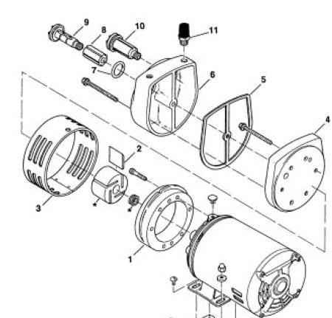
Remove the muffler by unscrewing the hex-nut counter clockwise.

After it is cool to the touch, remove the inside carbon build up with a cotton swab.

Soak the muffler in isopropyl alcohol for 15 minutes, agitating every couple of minutes.

Clean the inside again using a cotton swab.

Rinse with alcohol or water.

Let the muffler set in the sun for 15 minutes to ensure complete dryness.

Wrap muffler’s threaded end with Teflon tape to make sure threads are sealed.

Replace muffler at the same tightness as it was remove.

Troubleshooting

Contact the manufacturer at www.gastmfg.com

