QUARTERLY DATA VERIFICATION, DATA VALIDATION, BATCH EDITING
and
DATA ENTRY PROCEDURES
for
CHEROKEE NATION ENVIRONMENTAL PROGRAMS

January 2015

Overview:

Data from our air quality monitors must be submitted to the EPA on a quarterly basis within 90 days of the last day of the quarter. Data is submitted to the EPA via AQS, a repository of air quality data collected from EPA, state, local and tribal agencies. All raw data from the continuous monitors at each site is stored on two separate computers at the CNEP office. Data collected on WinAQMS dataloggers is stored using Airodis software; data collected on Agilaire (ESC) dataloggers is stored using AirVision software. Both programs are capable of creating pipe-delimited or XML files; these files are loaded into AQS. Before any of this data is submitted it must be reviewed, and any missing or invalid data appropriately flagged.

Materials needed:

- Daily Reports for each site for the period being reviewed
- Missing Data and Data Validation Forms
- Bi-weekly and multipoint audit forms for each site which were conducted during the period being reviewed
- Independent audit forms which were conducted during the period being reviewed (independent audits currently being conducted by INQUEST Environmental)
- Copies of bound record book (logbook) from each site for the period being reviewed

Data Verification Procedure

The EPA defines data verification as a process for evaluating performance and compliance of a set of data when compared to a set of standards to ascertain its completeness, correctness, and consistency using the methods and criteria defined in the project documentation. The goal of data verification is to ensure that the data reported reflects what was actually done. The procedure outlined below should be performed separately for each site being reviewed.

- Make a copy of the site logbook for the quarter being reviewed and return the logbook to the site as soon as possible. The copy should be labeled with the quarter that it represents and filed at CNEP after use.

- Collect the Daily Reports and prepare the Missing Data Report by entering the correct review period (quarter), site and AQS ID in the form. The naming convention used is sitenamemissingquarteryear.xls, e.g. Tah Missing 4th Qtr 2014.xls.

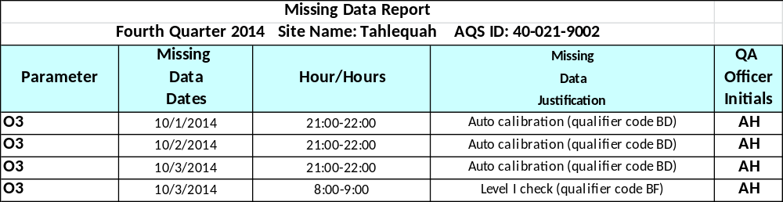

- Review all of the hourly data for missing values, repeated values and negative values.
- Missing data – any hourly value that is not reflected in the daily reports (this could be due to maintenance, audits, power failures, etc.)
- Repeated values – any hourly values that are repeated to an extent that could indicate problems with the instrument and are approaching the NAAQS.
- Negative values - Previously, the practice had been to replace the negative value with a zero, and to flag the value with the qualifier code '9'. The OAQPS monitoring group has determined that this introduces statistical bias into the computations. Effective immediately, AQS will accept negative values down to the negative of the Method Detection Limit (MDL). AQS will reject values lower than the negative of the MDL. Users are advised to replace more negative values with a null data code (e.g. 'DA').

All instruments should be put into maintenance or disable mode before performing audits or pulling the instrument, but this is not always the case. Any suspicious data is highlighted for review.

- Any values that are missing or otherwise found to be invalid are logged into the
Missing Data Report. The site logbook and audit forms can be used to determine the proper missing data justification. Parameter, date, time and reason for missing data should be recorded in the missing data reports.

5. This procedure should be performed for all parameters at a given site. When the review is complete, sort all entries by parameter and date for easy reference. A separate missing data report should be completed for each site. Digital copies of the report are maintained on one of the data acquisition computers, and hard copies are maintained in the site files.
Data Validation Procedure

Data validation follows the data verification process and uses information from the project documentation to ascertain the usability of the data in light of its measurement quality objectives and to ensure that results obtained are scientifically defensible. The procedure outlined below should be performed separately for each site being reviewed.

- Prepare the Data Validation Report by entering the correct review period (quarter), site and AQS ID in the form. The naming convention used is sitenamedatvalquarteryear.xls, e.g. Tah Data Val 4th Qtr 2014.xls.

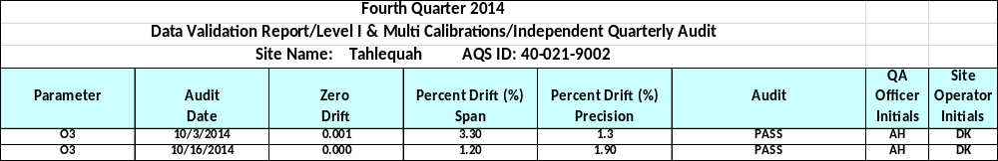

- Record on the data validation form the parameter, date, zero drift, span value percent difference, precision value percent difference, and date from each audit form for every audit performed during the quarter. Be sure to include the initials of the individual that performed the audit. Multipoint audits are highlighted in gray; independent audits are highlighted in yellow. Record on the data validation form if the span and precision values fall within the acceptance limits by indicating if the audit passed or failed.

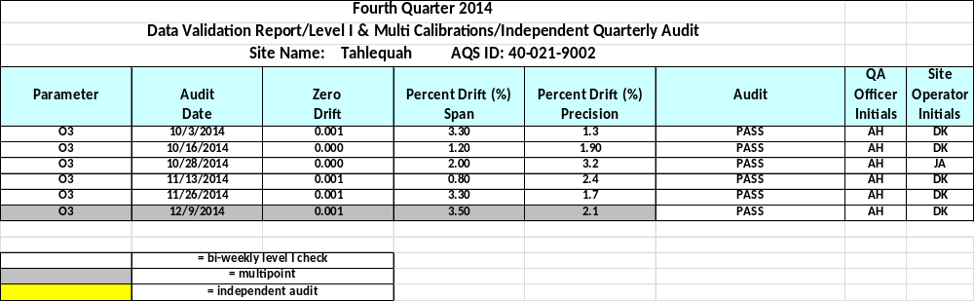

- If any audits fail, indicate this by highlighting the cell in the audit column in red.

- Sort all entries by parameter and date.

Reconciliation of Missing Data

- A span of data from a monitor is considered valid when there is a passing audit both before and after that span of time. When an audit fails, the data from that point back to the last passing audit and forward to the next passing audit must be flagged on the missing data form for that particular parameter. This requires modification of the Missing Data Report.

- Use the information on the Data Validation Report to determine when the last passing audit
was performed, then note in the missing data verification column the data which should be
removed. Once the failed audits have been noted, the files are ready to be batch edited.

Batch Editing Files – AirVision

- On the AirVision Home ribbon, click on Data Editors then Average Data Editor.

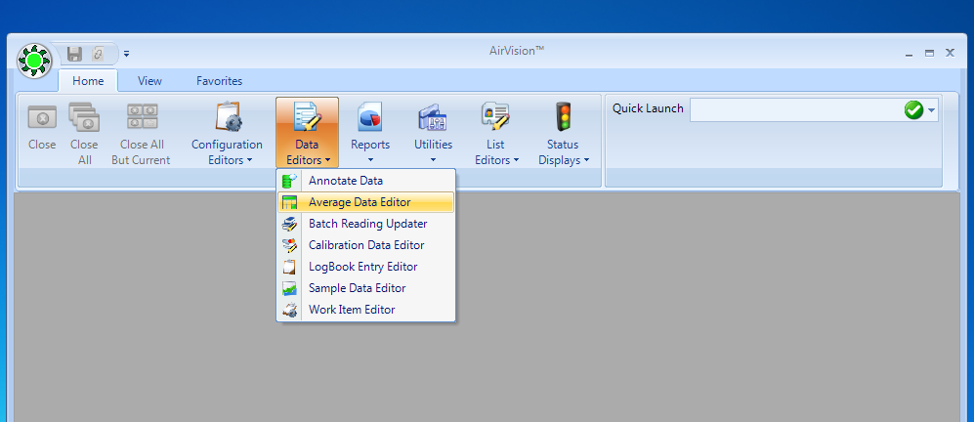

- Select the start and end date, as well as the site and parameter to be edited. Use one hour (001h) data only. Click on Retrieve Data to load the data onto the screen.

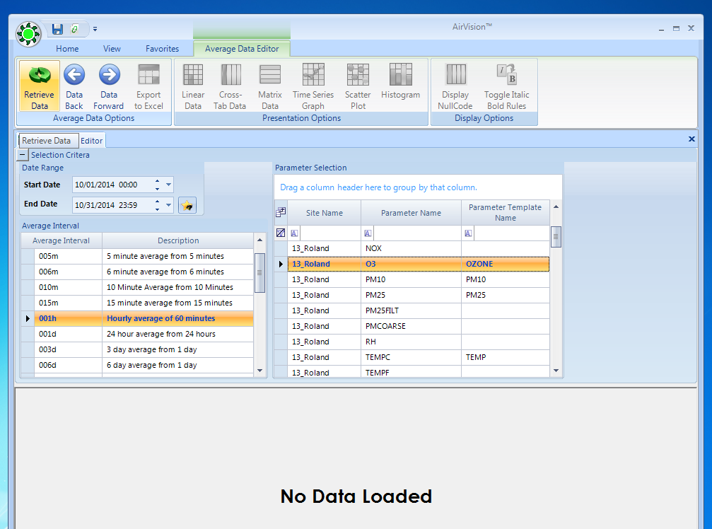

- Scroll through the data, select the hour or hours to be edited per the Missing Data Report, right click and select Batch Edit.

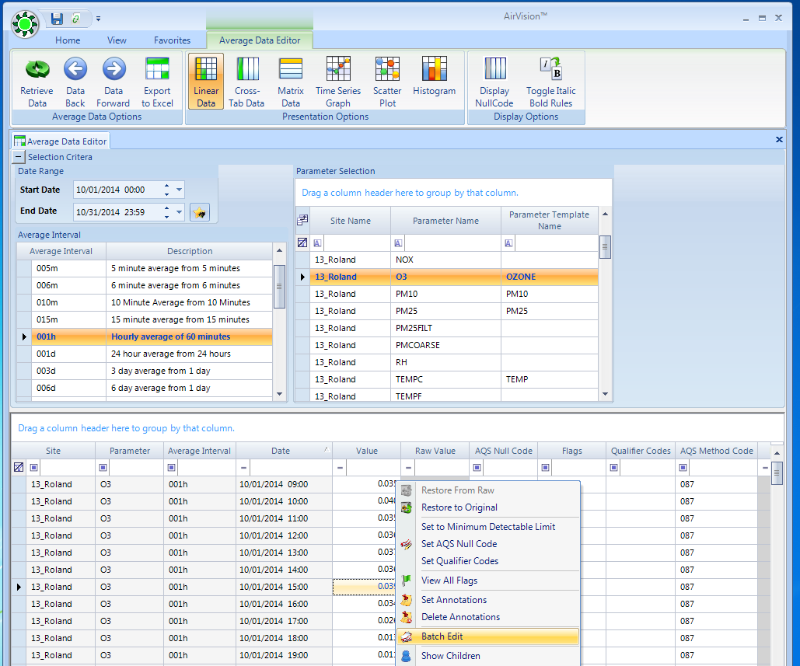

- In the batch edit window, add the appropriate null data code or select the appropriate flag. Click OK.

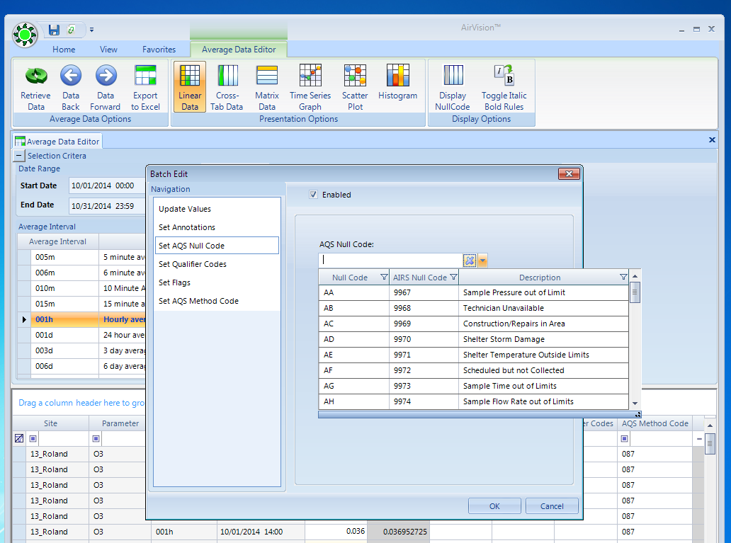

- After all changes have been made, click the Save button. Perform these steps for all site/parameter combinations that require edits.

Batch Editing Files – Airodis

1. Click the Data Manager tab. On the Data Manager Ribbon, select a station, choose a period and press display. The Airodis client will load data from the database and provide a tabular display of the selected data. From this tab, the user can invalidate, change or delete data.

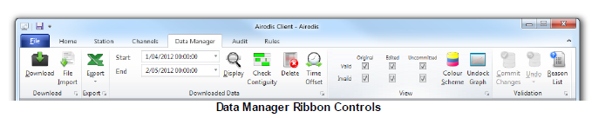

2. Validation is done in the Data Manager and is achieved through the use of the Reasons List, which is found on the right-hand side of the Data Manager tab. Scroll through the data and select the hour or hours to be edited per the Missing Data Report; the data will be highlighted in light grey. (To select multiple columns, the <CTRL><SHIFT> key combo can be used.) Select a reason and drag it onto the highlighted data.

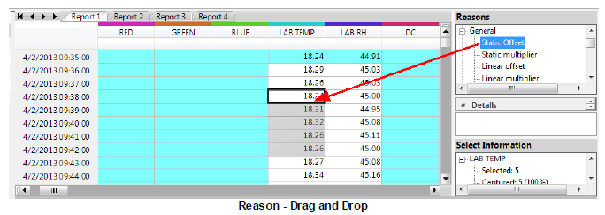

3. All changes made to the data will be logged in the Audit tab and can be discarded or undone until committed. Click the Commit Changes button in the Data Manager ribbon controls to save the changes.

Generating Pipe-delimited Data Files – AirVision

1. Select Reports, then AQS Text Report.

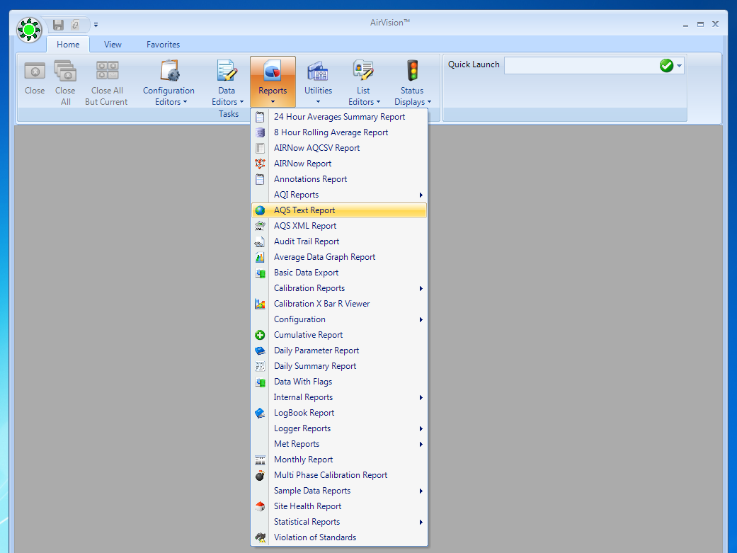

- Select the start and end date, as well as the site and parameter for the report. Use one hour (001h) data only, and select Average Data Records under the Record Type Selection. Click on Retrieve Data to load the data onto the screen.

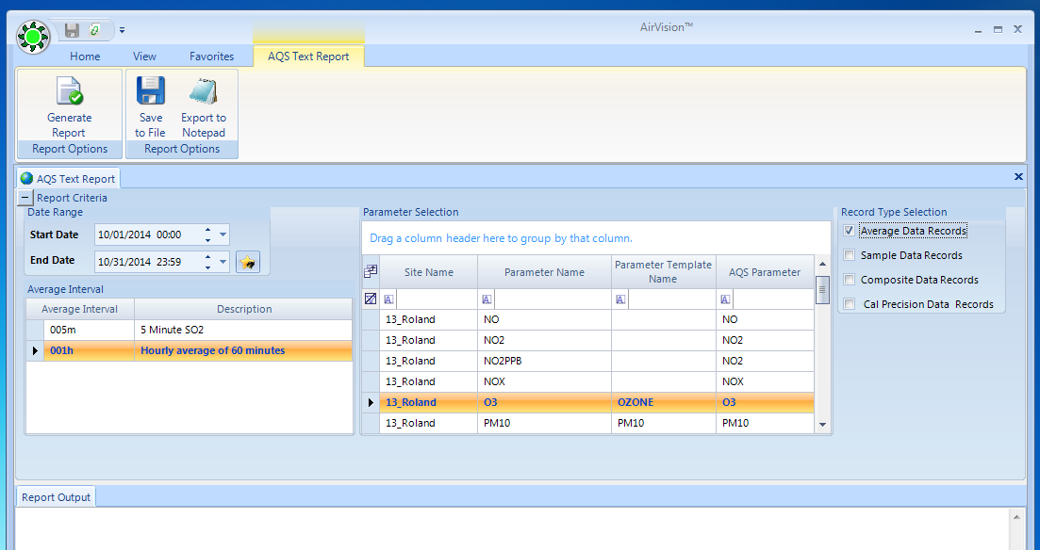

3. To export the files, select Save to File and save in the appropriate folder.

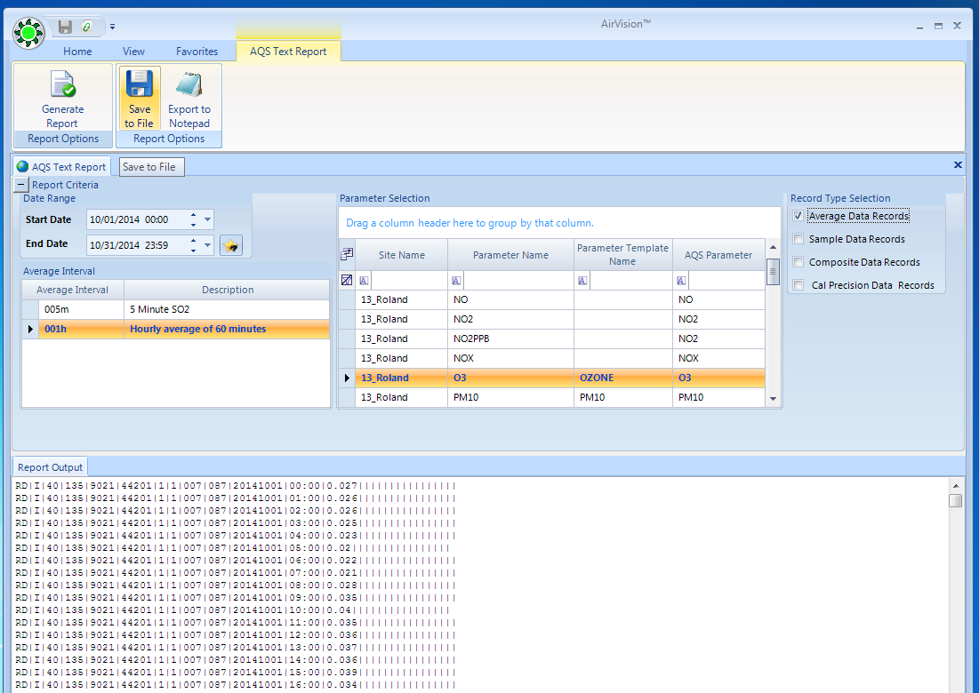

Generating Pipe-delimited Data Files – Airodis

1. In the Airodis Workspace Manager, select Report Manager.

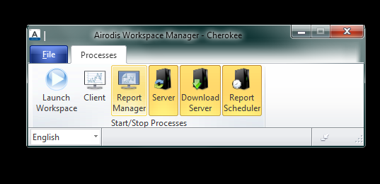

2. Select the appropriate AQS report and click Open. (Instructions on how to create reports can be found in Part XIII of the Airodis Manual.)

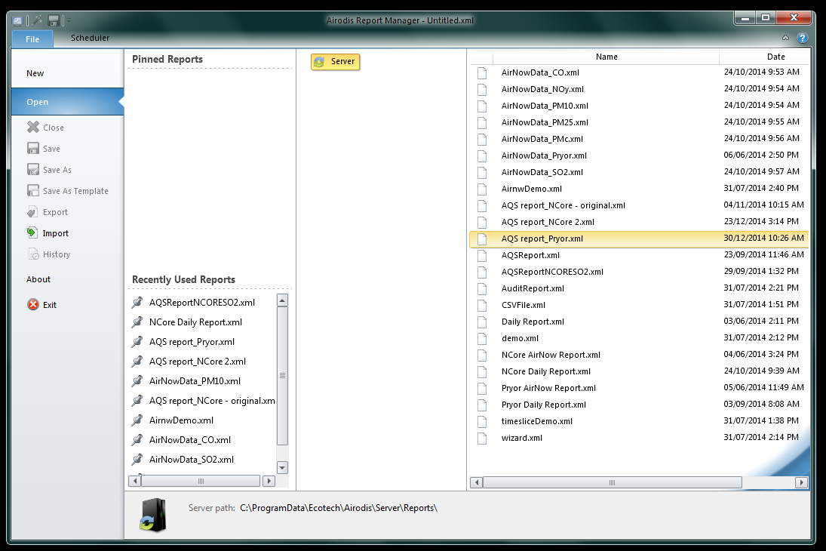

3. In the Edit tab, select the appropriate Date Range. Click Save.

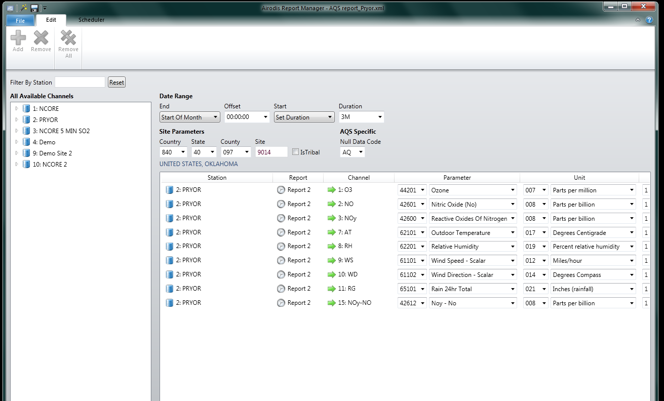

- In the Scheduler tab, select the appropriate report, right click and select Edit.

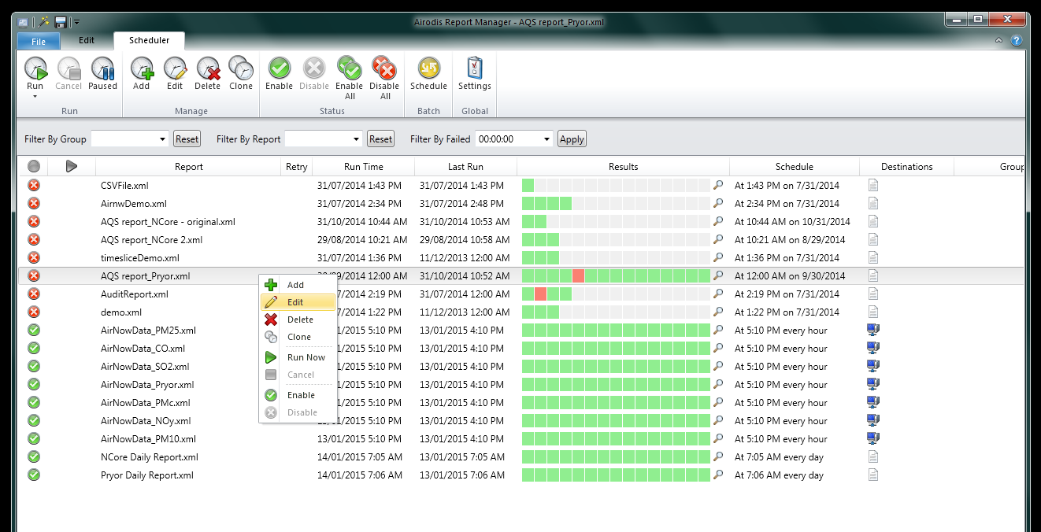

- In the Edit Schedule box, select Destinations. Click File and select AQS (Legacy) format under Filename Properties. Click Browse to select the file destination, and choose the appropriate filename. Click OK.

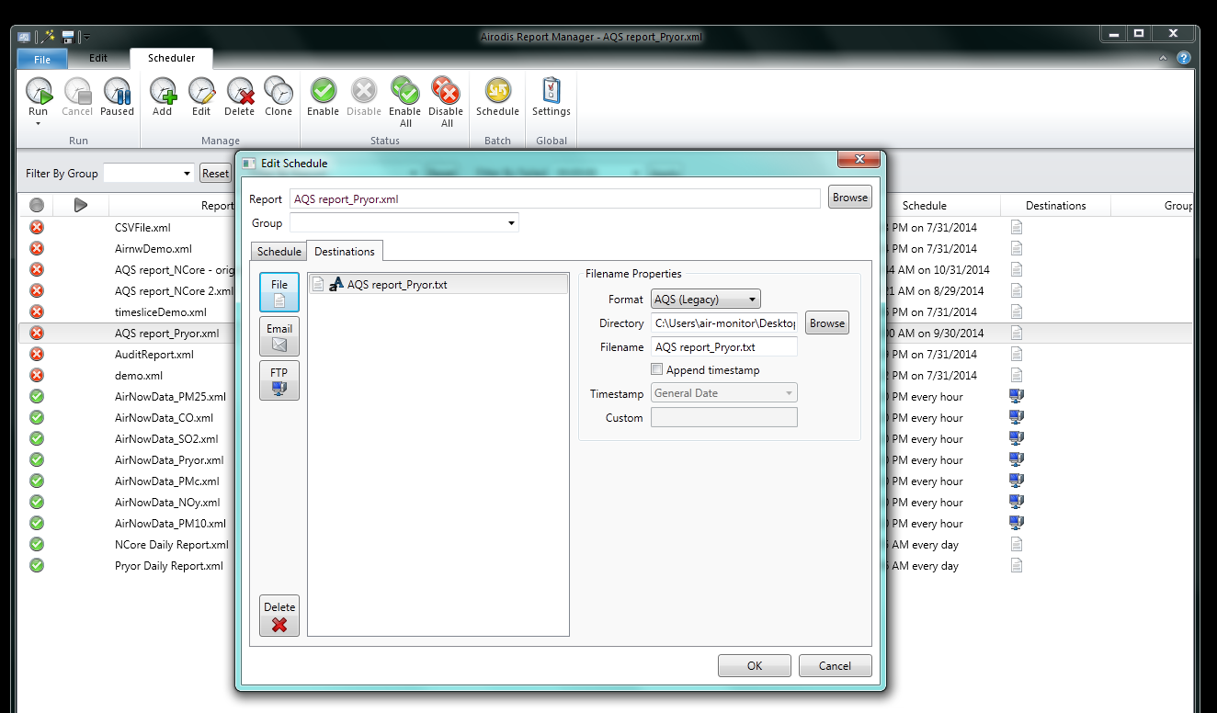

- In the Scheduler tab, select the appropriate report, right click and select Run Now. Your file will be created in the directory chosen in the previous step.

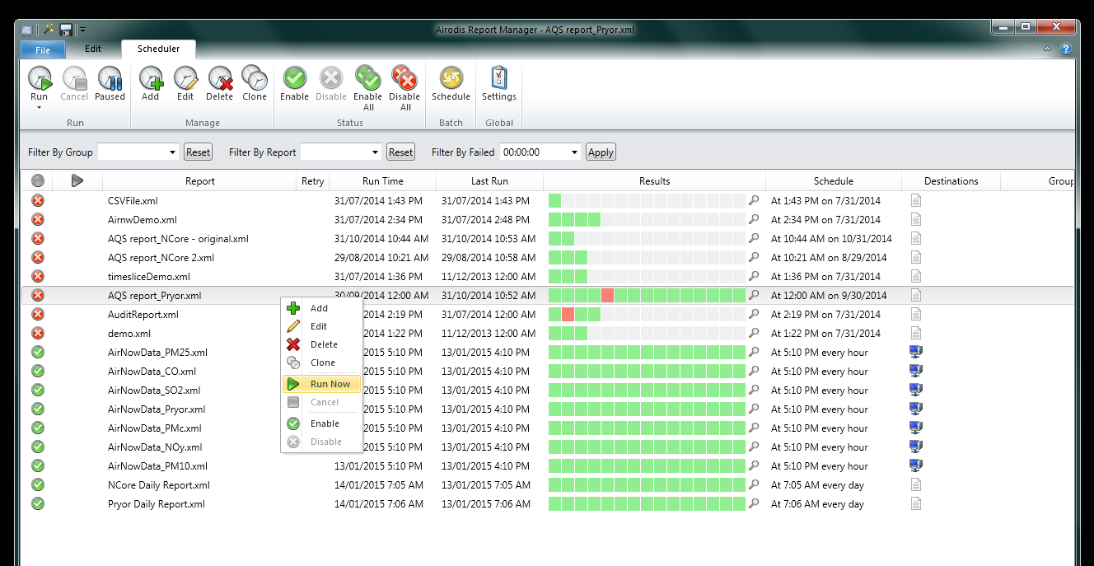
Data Entry Procedure

Cherokee Nation Environmental Programs validates data for all sites on a quarterly basis. This data is loaded into the EPA Air Quality System (AQS) using the method described in the AQS User Guide found on the EPA website at
http://www.epa.gov/ttn/airs/airsaqs/manuals/manuals.htm.

Precision and accuracy data for all sites is compiled on a quarterly basis using the AQS QA Transaction Generator. This process is outlined in the QA redesign section found on the EPA website at http://www.epa.gov/ttn/airs/airsaqs/training/.

