DOCUMENT TYPE: Standard Operating Procedure
TITLE: Flow Calibration on BAM 1020

PREPARED BY: 07/03/13
Tribal Air Program (Date)

REVIEWED BY:
Environmental Technician (Date)

APPROVED BY:
Environmental Department Manager (Date)

Table of Contents

- Scope of Application……………………………………………………………………………………………….1
- Summary of Method………………………………………………………………………………………….…….1
- Interferences/Comments……………………………………………………………………………………………1
- Supplies………………………………………………………………………………………………….………….2
- Procedures Setups………………………………………………………………………..……………………….2-3
- Troubleshooting…………………………………………………………………………….……………………….3

Scope of Application

Quality Control (QC) is the overall system of technical activities that measures the attributes and performance of a process, item, or service against defined standards to verify that they meet the stated requirements established by the tribe. Day-to-day quality control is implemented through the use of various checks or instruments that are used for comparison.

Summary of Method

Place BAM 1020 in “maintenance mode”

Correct readings

Measure volumetric flow

Reassemble BAM 1020

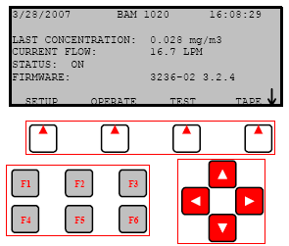
Interferences/Comments

The volumetric flow check requires the use of the BX-307 Flow Calibrator. Consult the SOP titled “Operating the BX-307”.
  - Using the BAM-1020 Keypad/Display: This main menu screen is the starting point for all functions of the BAM and can be accessed from any screen by selecting EXIT.
    - Soft keys: Four white buttons directly beneath the display changes in response to a menu option above.
    - Function keys: Used for entering password F1,F2,F3,F4
    - Arrow keys: Used to navigate up, down, left and right

Supplies

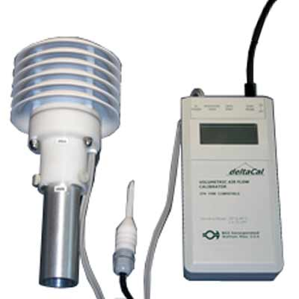
BX-307 Flow Calibrator (located in black case the workstation’s cabinet)
  - BAM-1020 Calibration Sheet (located on clipboard on west wall)

Procedure

Install BX-307Flow Calibrator

On the shelter’s roof, turn on the BX-307 Flow Calibrator (standard-STD) and set it aside to allow the unit to self stabilize (this can be done before the leak check is performed).

Remove the PM10 head (or BX-302 leak check valve, if performing after leak check) and the VSCC from inlet and install the BX-307 Flow Calibrator, wrapping the box’s cord around bi-pod’s leg as to keep the box from dangling freely.

Obtain Temperature and Barometric Pressure readings

Take note of the BX-307 temperature and barometric pressure readings and enter these two values on the BAM-1020 Calibration Sheet under “Ref. Temperature” and “Ref. Pressure”.

Enter Temperature and Barometric Reading into BAM-1020 STD field

At the BAM’s main menu screen press the TEST soft key then select FLOW.

Enter password: F1, F2, F3, F4

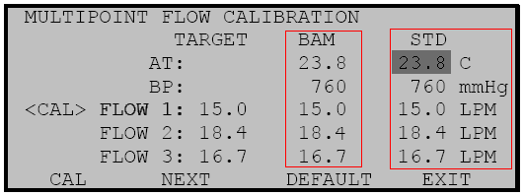
The “Multipoint Flow Calibration” screen will appear. Record the BAM’s Ambient Temperature (AT) and Barometric Pressure (BP) onto the Calibration Sheet under “BAM Temperature” and “BAM Pressure”.

Using arrow keys, select the AT (ambient temperature) parameter under the STD field, if not already selected. Enter the value from the BX-307 Flow Calibrator taken in step 5.2.1; using the arrow keys to increase or decrease value. Press the CAL soft key to calibrate the BAM reading. The BAM and STD temperature values should now be the same. Select NEXT soft key.

Next, correct the BP (barometric pressure) reading. Take the BP value in step 5.2.1 and place into the BP parameter under the STD field. Press the CAL soft key to calibrate the BAM reading. The values of the BX-307 and the BAM should now be the same.

Begin Flow 1, 2 and 3 Tests

Flow 1: On the BAM press the NEXT key to select the first flow point of 15.0 L/min. The BAM-1020 pump will turn on automatically. Allow the unit to regulate the flow until the BAM reading stabilizes at the target flow rate of 15.0 L/min.

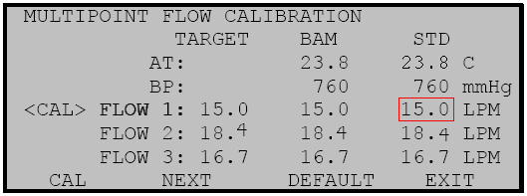
Return to the shelter’s roof and allow the BX-307 to stabilize. Once stabilized, take note of the volumetric flow rate value (Qa).

Return to the BAM-1020 and enter the BX-307 (Qa) value into the STD field for FLOW 1, using the up and down arrow keys to increase or decrease the value. Press the CAL soft key. (Note: The BAM flow reading will not change to match the STD until after you have entered all three flow calibration points, since it is done on a slope)

Flow 2: Press NEXT key to select the second flow point of 18.4 L/min. Allow the flow to stabilize again.

Take note of the new volumetric flow rate value (Qa) on the BX-307at the shelter’s roof.

At the BAM-1020 enter this value into the STD field for FLOW 2 and press the CAL key. (Note: If the BAM1020 is unable to achieve flow regulation at the 18.4 L/min point, this could be an early indication that the vacuum pump needs to be serviced.)

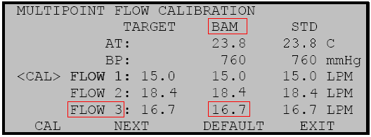
Flow 3: Press the NEXT key to select the third flow point of 16.7 L/min. Before making any adjustments, allow the flow to stabilize then write the value from the BAM column for FLOW 3 onto the Calibration sheet under “BAM Flow”.

At the shelter’s roof, check the volumetric flow rate value (Qa) on the BX-307 and enter this value into the STD field for FLOW 3at the BAM-1020, then press the CAL key. Enter the value obtained from BX-307 onto the Calibration sheet under “Ref. Flow”.

After this third flow point is calibrated, the BAM flow readings will change to show the corrected flow and the BAM1020 will quickly re-regulate the flow to 16.7 L/min based on the new calibrations. The BAM flow reading should now match the STD flow rate of 16.7 ±0.1 L/min. Exit the calibration menu.

Remove BX307 and replace both PM heads.

Complete BAM Calibration Checklist.

Troubleshooting

Refer to the BAM 102 Particulate Monitor Operation Manual

