DOCUMENT TYPE: Standard Operating Procedure
TITLE: Cleaning BAM 1020 Nozzle and Vane

PREPARED BY: 11/30/12
Tribal Air Program (Date)

REVIEWED BY:
Environmental Technician (Date)

APPROVED BY:
Environmental Department Manager (Date)

Table of Contents

- Scope of Application……………………………………………………….……………………………………….1
- Summary of Method…………………………………………………….…………………………………….…….1
- Interferences/Comments……………………………………………………….……………………………………1
- Supplies……………………………………………………………………….………………………….………….2
- Preparation…………………………...…………………………………………………..………………………….2
- Procedures………………………...…………………………….……….………………….……………………….2
- Troubleshooting…………...…………………………………….………………………….……………………….3

Scope of Application

Gather ambient air data, which have been linked to smog, ozone depletion, acid rain and global warming. Maintaining the equipment that records this data is a vital aspect of providing consistent, current and valid data.

Summary of Method

Place BAM-1020 in “maintenance mode”

Remove filter tape

Clean the Nozzle and Vane

Restart BAM-1020

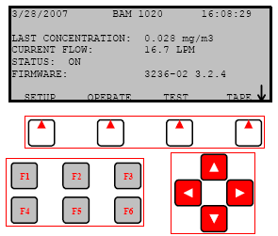
Interferences/Comments

The nozzle and vane (located under the nozzle) must be cleaned regularly to prevent leaks and measurement errors. The worst environment for nozzle for contamination seems to be hot humid environments because damp filter tape fibers stick more easily to the nozzle vane.
  - Using the BAM-1020 Keypad/Display: This main menu screen is the starting point for all functions of the BAM and can be accessed from any screen by selecting EXIT.
    - Soft keys: Four white buttons directly beneath the display changes in response to a menu option above.
    - Function keys: Used for entering password F1,F2,F3,F4
    - Arrow keys: Used to navigate up, down, left and right.

Supplies

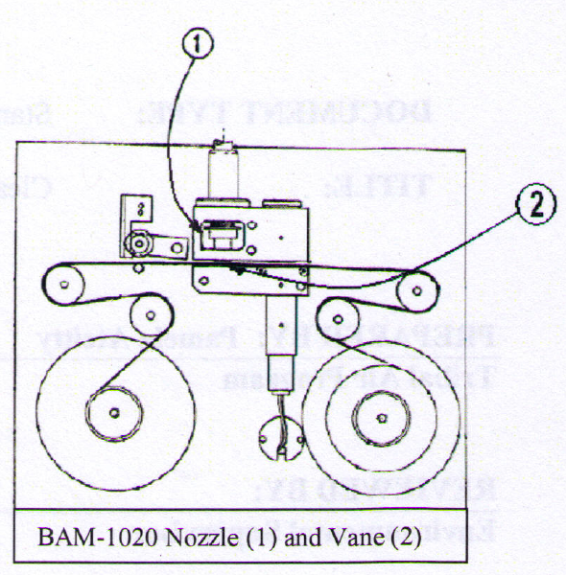
Cotton swabs

Unused portion of filter tape

Isopropyl Alcohol

Preparation
  - Remove the filter tape from the BAM (see the SOP titled Loading BAM-1020 Filter Tape)
  - The BAM nozzle should be in the UP position if cleaning is done in between tape change.
  - If the nozzle is not UP, proceed to main menu and select TEST soft key, then use arrow keys to highlight PUMP and press SELECT soft key. Press MOVE NOZZLE soft key to raise the nozzle up.

Procedure

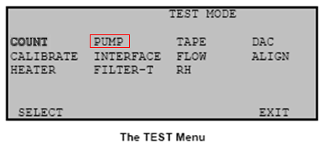
With the nozzle up, use a small flashlight to inspect the cross-hair vane (see detail image below).

The area between the nozzle and vane can be cleaned with a cotton swab and isopropyl alcohol.

Hardened deposits or tucked away filter tape may have to be carefully scraped off with the dental pick, cotton swab or similar tool.

Continue cleaning any debris or lubricant residue from nozzle and vane

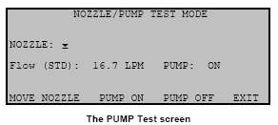
Insert a clean portion of unused filter tape, sprayed with alcohol, in between the nozzle and vane area

Lower the nozzle; from main menu press TEST soft key then navigate to PUMP using arrow keys, then push SELECT soft key. Finally, in the PUMP TEST screen, press the MOVE NOZZLE soft key.

Let the nozzle press down on the tape with its spring pressure.
    - Use your fingers to rotate the nozzle while keeping the tape in
place. A few rotations back and forth should clean the nozzle lip (see image below).

Repeat the nozzle cleaning steps with new pieces of unused filter

tape until the tape comes out clean.

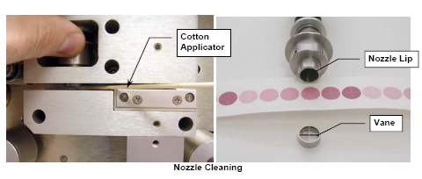
Inspect the nozzle lip and vane for any burrs which may cause leaks or tape damage.

Use your thumb or forefinger to rotate the spring pressure nozzle back and forth on unused filter tape.

PROCEED WITH SOP TITLED: Loading BAM-1020 Filter Tape or

Troubleshooting

Refer to the BAM 102 Particulate Monitor Operation Manual

